Illustrated generic gear diagrams
Version 1.3
Trawl: midwater otter | Blue text indicates a field for the gear specification exists on the
CCAMLR vessel website
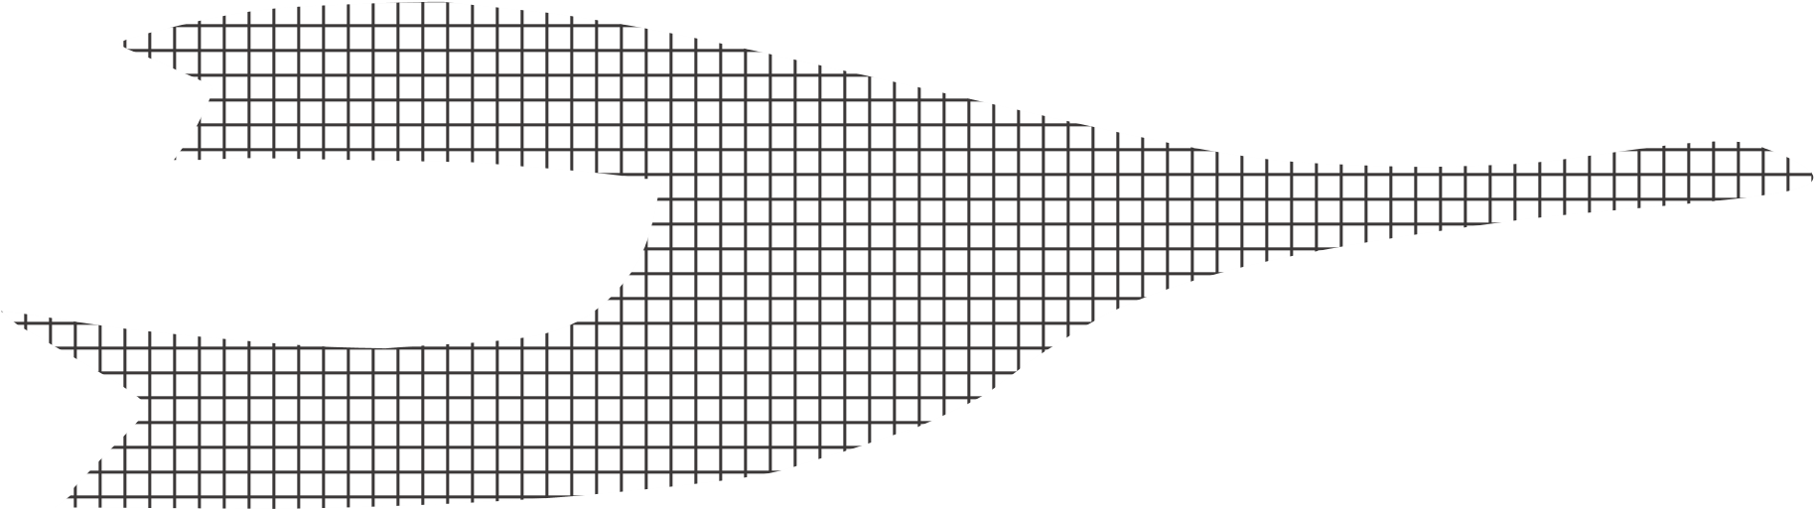
Warp
Otter board
Sweep
Lower bridle
Footrope
Codend
Headrope and floats
Upper bridle
Net mouth width
Net mouth
height
Codend length
Wing
Intermediate
Total net length
Codend
mouth height
and width
Spread
Marine mammal exclusion
device (location and type
may vary)
Codend
mesh/liner size
(
outer and inner)

Trawl: midwater beam*
Blue text indicates a field for the gear specification exists on the
CCAMLR vessel website
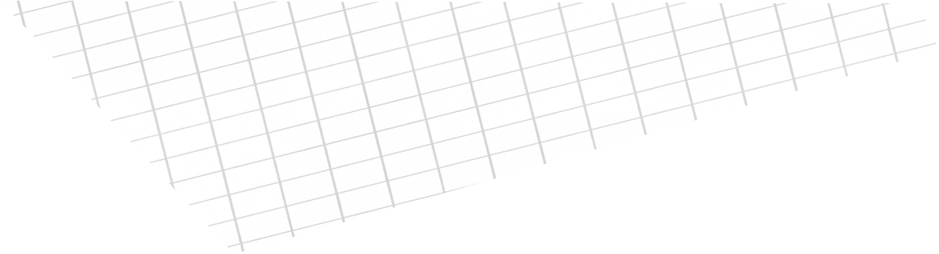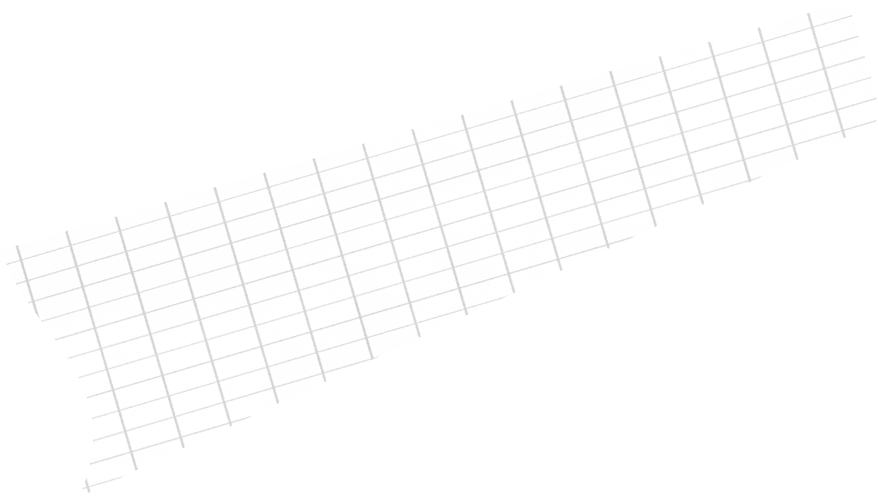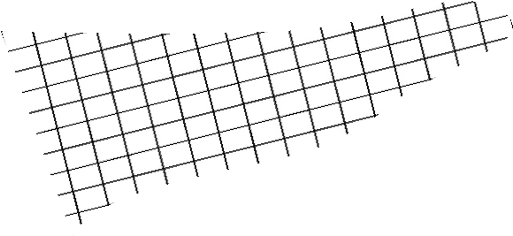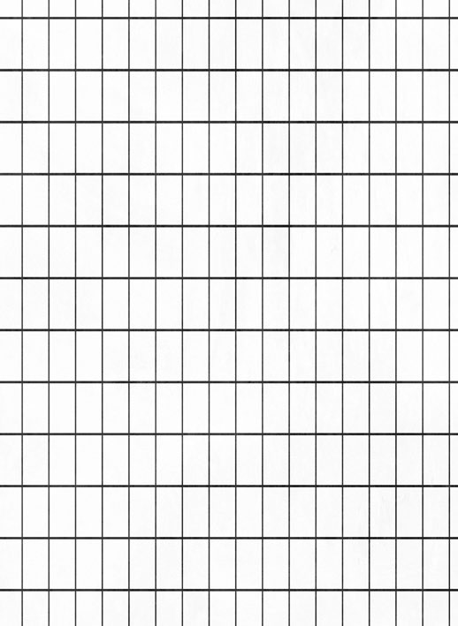
Warp
Bridle
Weights
Floats on beam (optional)
Beam
Codend
Codend mesh/liner
size (outer and inner)
Codend
mouth
height and
width
Net mouth
width
Codend length
Net mouth
height
Marine mammal exclusion
device: seal, whale or other
(
)
location and type may vary
Total net length

*One (of two) nets illustrated
Longline: autoline |  | Blue text indicates a field for the gear specification exists on the CCAMLR vessel website
Alternative line marking arrangement for working in or around ice
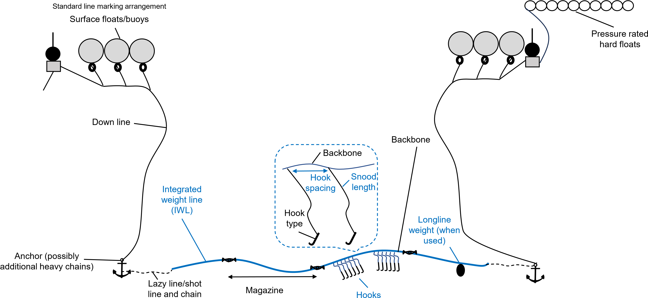
Radio beacon/position
tracking device
(optional)

Longline: Spanish | Blue text indicates a field for the gear specification exists on the CCAMLR vessel website
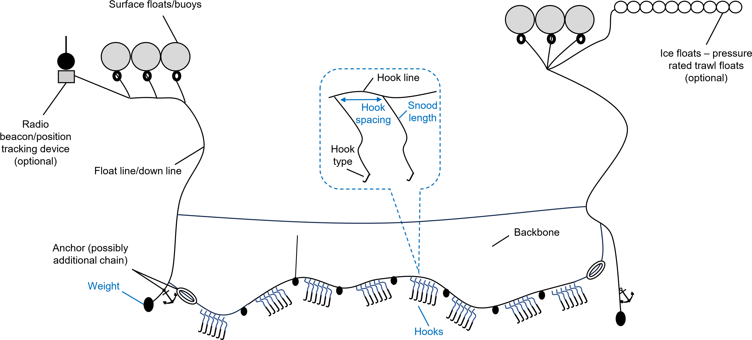
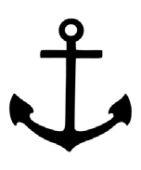






Blue text indicates a field for the
Main line
Float/down line
Drop/branch
line
Weight
Weight and/or grapnel
Branch
line
Main line
Swivel
Lazy/shot line
Hook cluster
Drop/branch line
Hook cluster
spacing
Drop/branch line
spacing
Number of clusters on a
dropline
Radio
beacon/position
tracking device
)
(
optional
Longline: trotline | gear specification exists on the CCAMLR vessel website
Surface floats/buoys

Pot
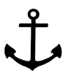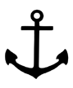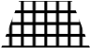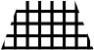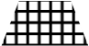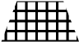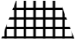
Surface floats/buoys
Down line
Extension
line
Anchor
Pot spacing
Pot
Main line
Radio
beacon/position
tracking device
(
optional
)

Pot: beehive configuration
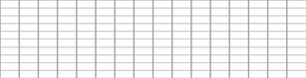
Bait box*
Escape mechanism
Pot funnel
aperture*
Pot height
Pot width
Pot mesh size
Line or
bridle

*An alternative beehive configuration may have an entrance position in the front panel (rather than the top), in addition to a bait box/bag suspended from the roof (rather than being laid on the base of the pot).

Pot: rectangular configuration
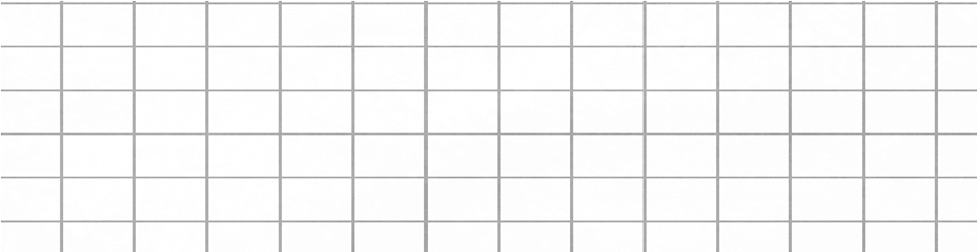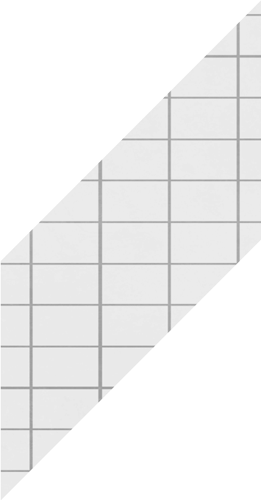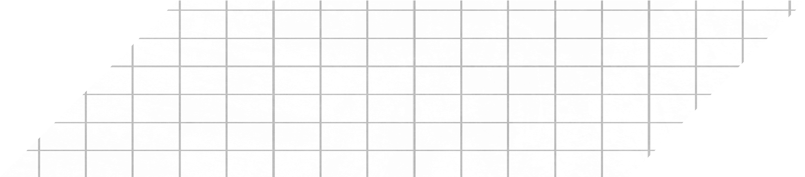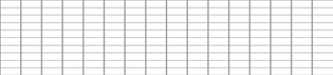
Bait box
Escape mechanism
Floats
Metal frame
Pot funnel aperture
Pot height
Pot length
Pot width
Pot mesh size

Exclusion Device (mesh panel)
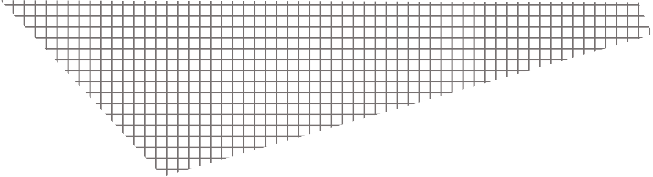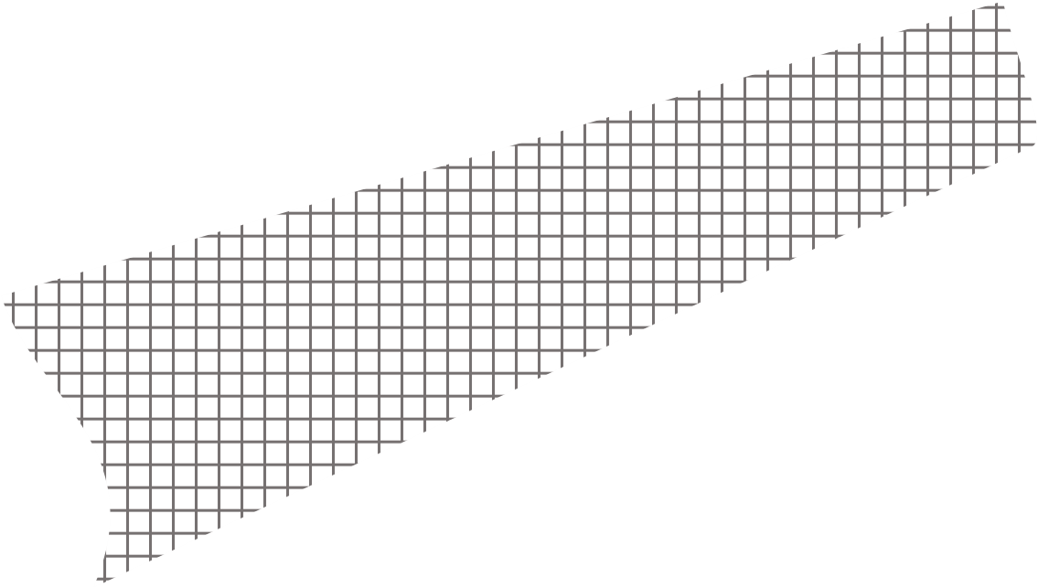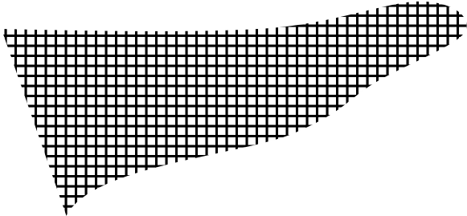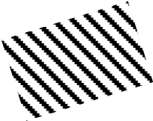
Trawl beam
Codend
Trawl mesh
Marine mammal exclusion
device (large mesh panel
across mouth/first section
of net)*

Marine mammal exclusion device:
(
oblique panel in net leading to
escape window)*

Direction of tow
*Note that while both are provided on this diagram of a trawl net as an example, one type of marine mammal exclusion device is generally selected for each gear type notified during the fishery notification process (location and type may vary). When submitting notifications, Members should provide details of each marine mammal exclusion device used, including noting whether it is a seal, whale or other exclusion device.
**Adapted from Aker Biomarine (WG-IMAF-2022/01), see ‘Trawl: midwater beam’ for additional details of this gear type.

Blue text indicates a field for the
Exclusion Device (grid)gear specification exists on the
CCAMLR vessel website
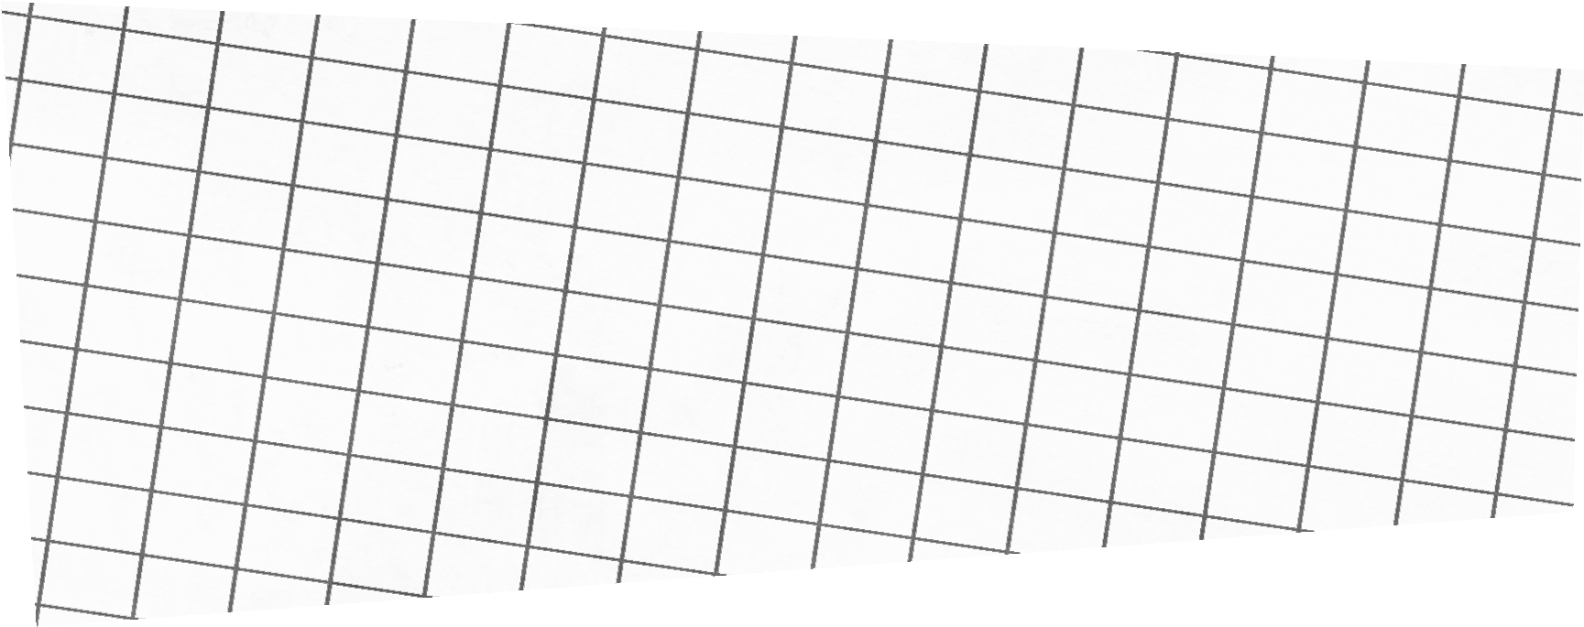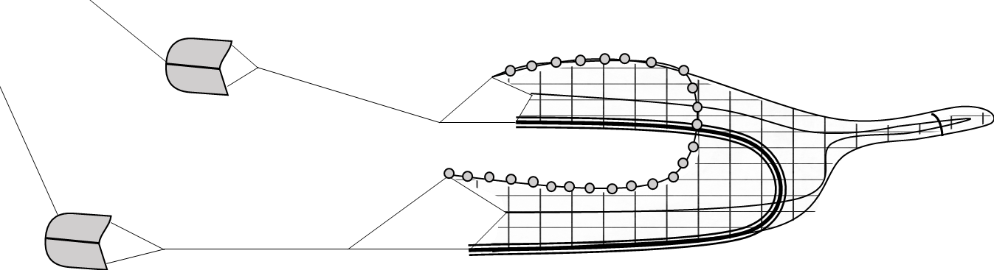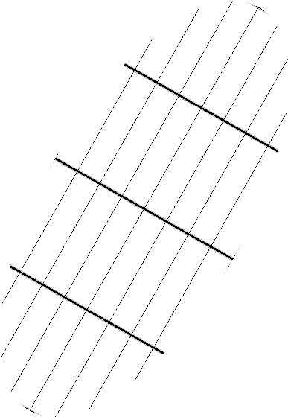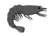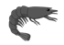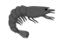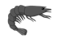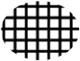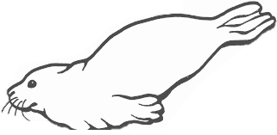
Trawl
Marine mammal exclusion device
)
(
location and type may vary
Lower grid
Upper grid
Escape hole
Kite and floats
Hood/scoop – pathway to exit or escape
Direction of tow

