CampusFix programme manual
This manual explains the implemented source and database. It is for group members who install, maintain, test, or extend CampusFix. Read README (../README.md) for setup and demo accounts. The full source is supplied in the project and in Programme Source Listing (Programme_Source_Listing.md). No credentials are included in that listing.

System structure
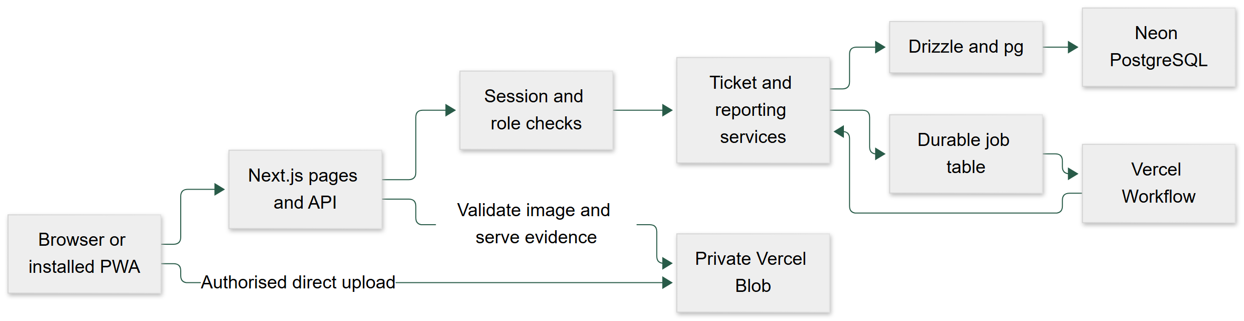
Figure 1 architecture
The companion Markdown file contains the editable diagram and exact relationships.
Local mode uses the same Next.js source, PostgreSQL schema, and services. It replaces Blob with private files in .data/uploads. A polling worker executes database jobs. PostgreSQL can run in Docker or as a private native process. The local worker makes the presentation copy independent of hosted services.
The browser renders React screens. It sends JSON to /api. The server reads the session from a secure cookie and checks the role and ticket access. The services use parameterised Drizzle SQL. Ticket mutations run in PostgreSQL transactions. The browser does not connect to PostgreSQL or receive a database secret.

Source map
File or folder | Purpose
src/app | Server pages, API route, global styles, help page
src/components | Forms, ticket screens, management screens, navigation
src/components/ui | Shared button, form, notice, and status components
src/lib/auth.ts | Login, lock checks, sessions, logout
src/lib/domain.ts | Shared input schemas, types, labels, access rules
src/lib/policies.ts | Small assessed decision routines
src/lib/tickets.ts | Creation, dispatch, work, closure, merge, audit
src/lib/storage.ts | Local files, private Blob, signature and decode checks
src/lib/notifications.ts | In-app notices and test delivery records
src/lib/reports.ts | Dashboard, reporting queries, safe CSV
src/lib/reference.ts | Accounts, availability, category and location changes
src/lib/jobs.ts | Durable job execution and Workflow launch
src/lib/offline.ts | IndexedDB drafts and submission queue
src/workflows/maintenance.ts | Durable sleep and job step
src/db | Pool, typed Drizzle schema, query helpers
db/migrations | Ordered SQL migrations
scripts | Database, local server, evidence, load, and deployment helpers
tests | Unit, database, and browser tests
public | PWA manifest, icons, service worker, offline help

Build tools
The lockfile fixes the installed dependency tree. Core versions are Next.js 16.4.3, React 19.3.0, TypeScript 5, Drizzle 0.45.4, pg 8.23.1, Zod 4.6.7, Blob 2.8.2, and Workflow 5.2.3. Read package.json and package-lock.json for exact versions and overrides. UI components use Tailwind, Radix primitives, and the shadcn component pattern. Local PostgreSQL 16.15 was tested.
npm run build compiles both the application and Workflow routes. npm start serves the production output. npm run local starts the database if required, prepares it, and starts the development server and local worker. npm run verify runs type checks, ESLint, and unit/database tests. The GitHub Actions file describes repeatable Linux checks. No remote CI pass is claimed unless an actual run is recorded.

Configuration
Variable | Use
DATABASE_URL | Private PostgreSQL connection string
TEST_DATABASE_URL | Separate campusfix_test database for integration tests
APP_URL | Optional accepted application origin
STORAGE_DRIVER | local or vercel
LOCAL_STORAGE_DIR | Private local file root, default .data/uploads
BLOB_READ_WRITE_TOKEN | Server-only private Blob token
DEMO_MODE | Shows course demonstration controls
DEMO_PASSWORD | Password used when seeding demo accounts
CRON_SECRET | Secret bearer token for hosted job recovery

No setting with a database or Blob secret has a NEXT_PUBLIC_ prefix. Environment files, local data, and generated evidence are excluded from Vercel uploads. File tracing also excludes local data and environment files. Use different files for local and cloud settings.

Database design
Migration 0001_course_baseline.sql is a copy of the supplied course SQL. Migration 0002_application.sql adds the implemented fields and tables. The migration runner takes an advisory lock, records completed files, and applies each new file in a transaction. It can be run again without applying the same migration twice. Do not edit an applied migration. Add another migration for a later schema change.
There are 15 application and migration tables, four enum types, a ticket number sequence, and two baseline reporting views.
Table | Key and main data | Relations
users | user_id UUID; unique email and institutional ID; bcrypt hash; role; preferences; lock expiry; active flag | Owns sessions, reports, comments, notices
technicians | tech_id UUID; trade; availability; active_workload | tech_id references users
locations | location_id UUID; faculty; building; room; active flag | Used by tickets
categories | category_id UUID; name; trade; default priority; active flag | Used by tickets
tickets | ticket_id text; title; description; priority; state; UTC dates; version; unique submission key | Reporter, location, category, technician, optional main ticket
ticket_subscribers | Composite ticket and user key | Explicit followers
work_order_logs | UUID; notes; parts; labour minutes; created time | Ticket and technician
audit_logs | UUID; event; details; actor; ticket; time | Append-only event history
sessions | UUID; unique SHA-256 token hash; user; expiry | Raw token stays in cookie only
attachments | UUID; owner; optional ticket; BEFORE or AFTER; private key; type; bytes; verified flag | File content stays outside the database
ticket_comments | UUID; ticket; author; text; time | Ticket discussion
notifications | UUID; user; ticket; event; body; read time | In-app view and delivery parent
notification_deliveries | UUID; channel; state; attempts; last error | Unique notification and channel
background_jobs | UUID; kind; ticket and version; due time; state; attempts; Workflow run ID | Durable deferred work
campusfix_migrations | File name; applied time | Migration history

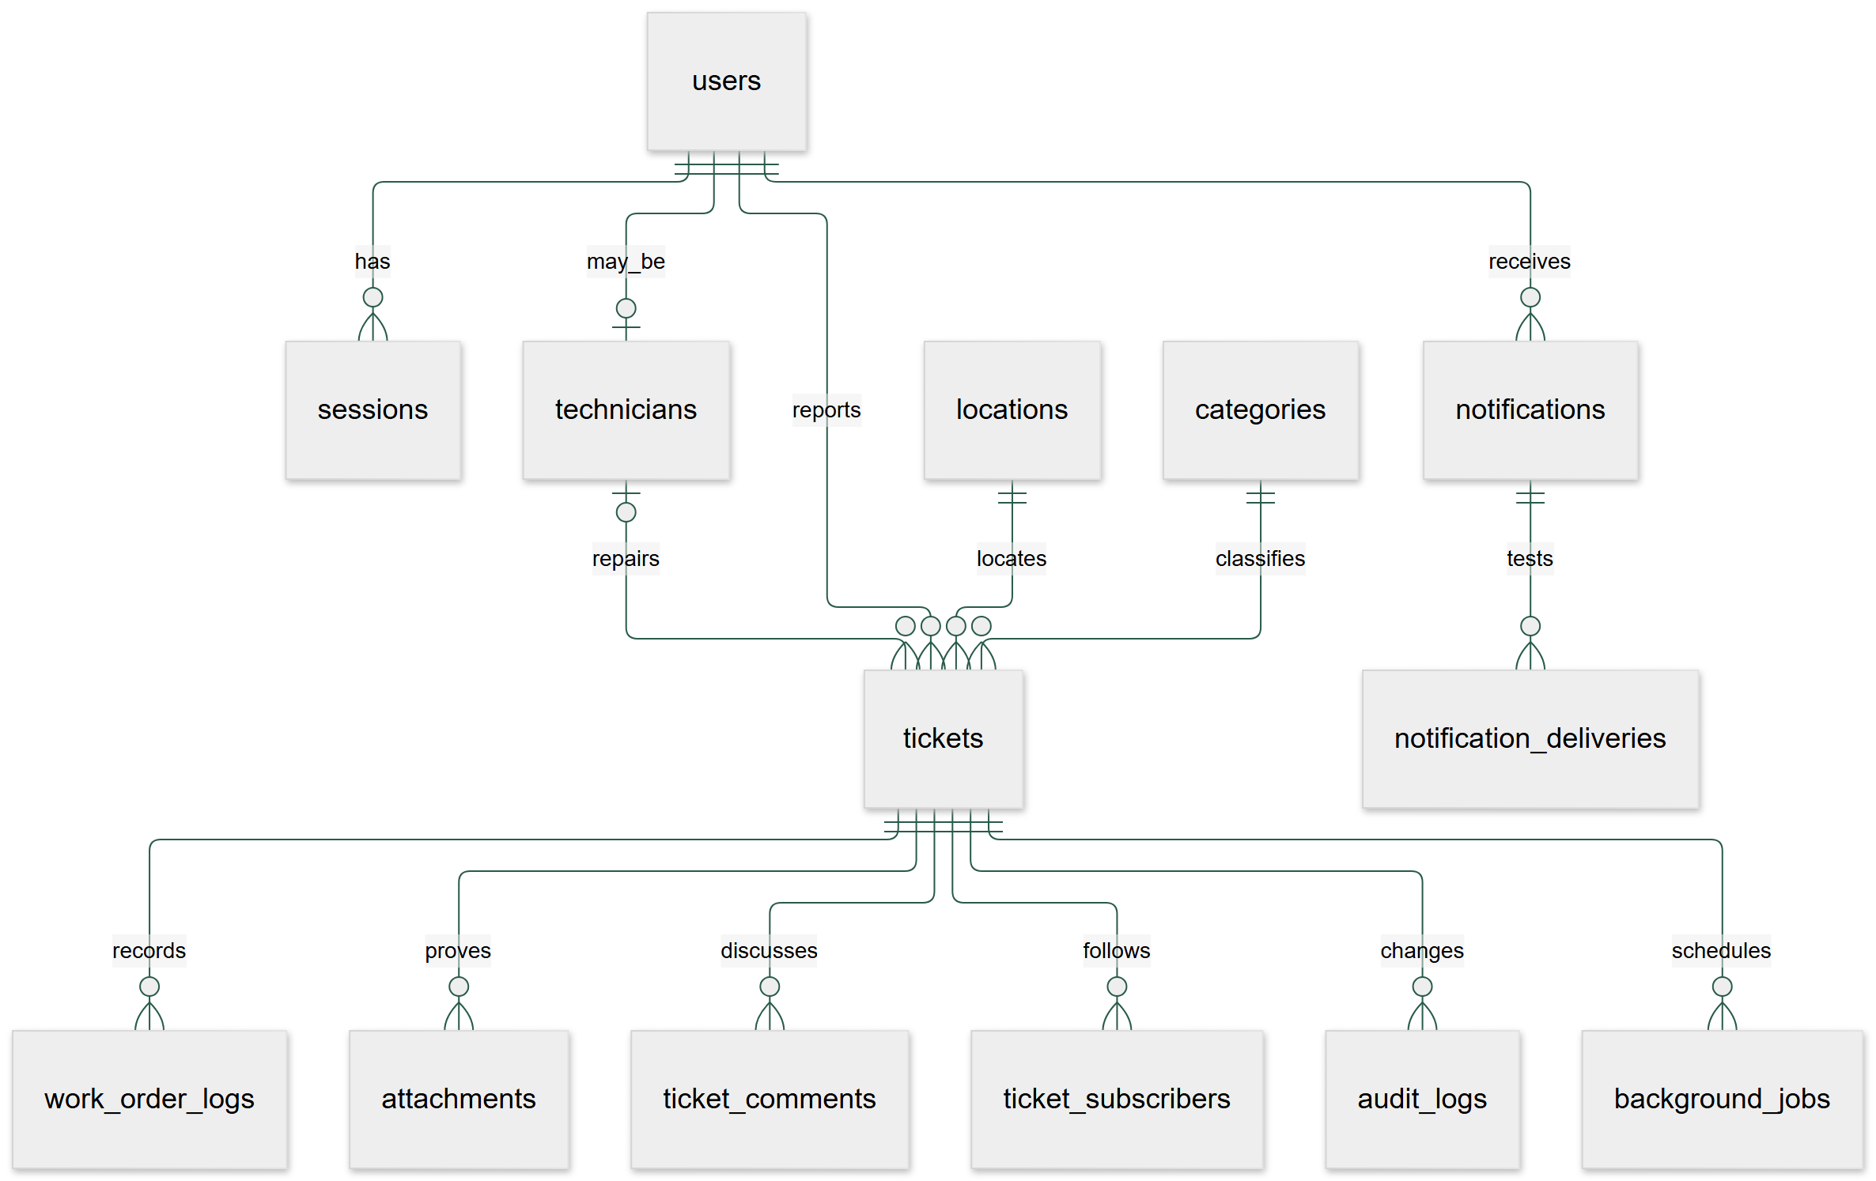
Figure 2 erd
The companion Markdown file contains the editable diagram and exact relationships.
The source SQL is the exact field-level data dictionary. src/db/schema.ts supplies the matching typed schema. UUID fields never receive a text placeholder for an unavailable technician. A missing technician is NULL. Timestamp fields use TIMESTAMPTZ. Calendar report filters use Jamaica midnight boundaries. The audit trigger rejects UPDATE and DELETE. Application account management deactivates records rather than deleting audit-linked accounts.
Important constraints include description length 15 to 500, title length 1 to 150, attachment bytes 1 to 4,500,000, work minutes 0 to 1,440, assigned technician presence for active assigned states, and completion notes, completion time, and after-proof presence for Completed and Closed states. Indexes cover active duplicate checks, sessions, subscribers, notifications, audit lookups, and due jobs.

Module inputs and outputs
Module | Input | Processing | Output
Authentication | Identifier and password | Validate, row lock, account policy, bcrypt, lock counter, session hash | Session cookie or controlled error
Reporting | Location, category, text, urgency, optional attachment, submission key | Validate, verify owner, advisory lock, insert, audit, notify | Unique ticket number
Dispatch | Ticket version, priority, technician or auto | Check role, trade, availability, row lock, deadline, workload | Assigned or Pending ticket
Repair | Version, work record, notes, after proof | Check owner and state, claim proof, update work, recalculate workload | In progress, Completed, disputed, or Closed ticket
Notifications | Ticket event and recipient preferences | Insert notice and delivery jobs in transaction, retry test transport | In-app notice and labelled delivery records
Reports | Manager session, date and area filters | Aggregate scoped data, compute durations and SLA, quote CSV | Screen, CSV, printable page

Processing narratives

Authentication
Read the account in a transaction with a row lock. Reject an inactive account or a future lock. Check the bcrypt hash. After five failed attempts, set lock expiry to 30 minutes. An expired lock starts a fresh failure count. On success, clear failures and store a SHA-256 hash of a random 32-byte token. Put the raw token in an HttpOnly, SameSite=Lax cookie. Hosted production cookies are Secure. Local HTTP loopback uses the same session checks without the Secure flag so Safari can use the presentation copy. Each request reads the current account role from the database. Deactivation revokes sessions.

Report creation and offline retry
Validate the shared Zod schema. Check active category and location records. Take an advisory lock on the submission key. If the key already exists for this user, return its ticket number. A different user cannot obtain that result. Verify the attachment owner, phase, and decoded state. Insert the ticket, attach the photo, add the audit event, and create notices in one transaction. A failed step rolls back the report.
The client saves an IndexedDB draft or queued submission with its owner and stable UUID. Reconnect processing checks /api/session. It sends only the signed-in owner's queue. It records a successful photo ID before ticket retry. It removes the queue item only after the server confirms the ticket. A full offline navigation displays help; private HTML and API data are not cached.

Dispatch
Check that the actor is facilities staff. Lock the ticket and compare its version. Take a trade advisory lock. For automatic selection, count actual active jobs for each available qualified technician. Choose the least loaded candidate. Set the deadline from the original submission time and selected priority. If there is no candidate, keep Pending with a NULL technician. Recalculate affected workloads under technician row locks. Add audit and notifications before commit.

Work and completion
Only the assigned technician can start or log work. Completion checks technician identity, In progress state, and verified AFTER proof. Claim the attachment in the same transaction. Store notes and resolved time. Change state to Completed, update workload, and schedule closure for resolved time plus 72 hours. The reporter can close or dispute. A dispute clears completion data and returns In progress. A delayed closure checks state, elapsed time, and version again, so it cannot close a changed ticket.

Duplicate merge
Suggestions use the same category and exact location within 12 hours. Suggestions return limited public metadata. Following needs an explicit action. Facilities staff can merge matching reports after submission. The merge lock prevents opposing concurrent merges. The operation moves followers, marks the extra report Duplicate, updates workload, and writes audit records in one transaction.

Notifications and reports
Ticket events add notices and EMAIL/SMS test delivery rows in the ticket transaction. Workers use locked batches so concurrent workers do not claim the same delivery. Successful records use TEST_RECORDED. The test transport sends no external messages. Failure records keep attempt and error data. Reports compute duration from created_at to resolved_at. Summary denominators exclude Duplicate and Rejected records. CSV quoting handles commas, quotes, and formula prefixes.
The exact pseudocode, source routines, control flow graphs, three complexity methods, and feasible independent paths are in White Box Tests (White_Box_Tests.md).

API interface
All responses use JSON unless stated otherwise. Read routes require a valid session except health. Mutation routes check the request origin, input schema, role, and record access. The API uses no-store for private data.
Method and path | Purpose
POST /api/auth/login or logout | Session entry and exit
GET /api/session | Current account
GET /api/reference | Allowed reference data and storage mode
GET /api/dashboard | Role-scoped overview
GET or POST /api/tickets | Filtered list or idempotent creation
GET /api/tickets/duplicates | Limited duplicate suggestions
GET /api/tickets/{id} | Authorised ticket detail
POST /api/tickets/{id}/actions | Dispatch, work, review, follow, comment, merge, reject
POST /api/uploads | Local multipart photo validation
POST /api/uploads/prepare | Create private cloud upload intent
POST /api/uploads/blob | Blob SDK token and verified callback
POST /api/uploads/confirm | Decode cloud upload before attachment
GET /api/attachments/{id} | Authorised private photo bytes
GET or PATCH /api/notifications | View or mark read
PATCH /api/settings | Notification preferences
GET /api/reports | Facilities aggregates
GET /api/reports/export | Quoted CSV download
GET, POST, PATCH /api/admin/users | Administrator account actions
POST /api/admin/reference | Administrator reference changes
GET /api/admin/audit | Administrator audit view
GET /api/admin/deliveries | Facilities test delivery view
GET /api/health | Database connection check without secrets
GET /api/jobs/recover | CRON_SECRET-protected job recovery

Typical controlled statuses are 400 for invalid data, 401 for sign-in, 403 for forbidden access, 404 for missing records, 409 for a stale version or invalid transition, and 429 for an account lock. Unexpected failures return a general server error. Inspect server logs for diagnosis. Never copy secrets into logs or course screenshots.

Storage protocol
Local uploads pass through the Node API. Hosted uploads go directly from the browser to private Blob using a short-lived server-authorised token. The token fixes type, size, path, and owner. The confirm route checks Blob size, signature, and Sharp decoding, then re-encodes the file. It marks the record verified only after this step. Ticket services accept verified records of the correct owner and phase. Private bytes are served through an access-checked API. This implements image validation, not malware scanning.

Job recovery and operations
Each job records its purpose, due time, attempts, and Workflow run ID. Vercel launches a Workflow after a ticket request commits. The Workflow sleeps until its due time and executes a step. The daily recovery route handles pending due jobs and orphan photos. Local mode polls the same table. Closure checks are idempotent and version guarded. Delivery rows have a unique channel key and locked processing.
If a provider is unavailable, keep the durable records and retry after service recovery. Check the job error and attempt count. Do not reset a job or alter a ticket directly without a recorded maintenance reason. Free plan quotas can delay processing. This build does not claim guaranteed timing or uptime.

Maintenance and recovery
Run migrations before a release. Run type, lint, unit, database, and browser checks. Build locally, deploy, then check health, login, private upload, and the repair flow. Keep the previous Vercel deployment available for application rollback. A schema change needs its own forward recovery plan; an application rollback does not undo database changes.
Back up database rows and photo files together. Restore into a separate environment first. Check ticket counts, login, history, attachments, workload totals, and job recovery. The recorded Docker check restarts both PostgreSQL and the application and verifies a persisted ticket, session, and image hash. See persistence evidence (evidence/persistence.json).
Do not use the public demo credentials for real campus records. Official university sign-in, live message delivery, a full campus pilot, malware scanning, and a formal operational backup policy are later work.

