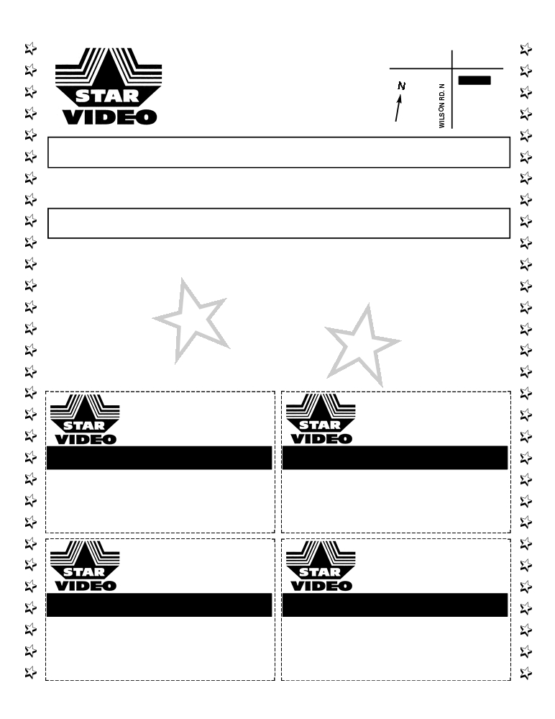

555 Rossland Road East
Unit D, Oshawa
905.433.7799

ROSSLAND RD E

“The Lowest Prices In Oshawa !”
Transfer OVERSEAS DVD to Canadian DVD
Transfer V H S to D V D
We Rent/Sell Movies
Rent 2 Get 1 Free
(Not include 1 Day rental)

DVD SALE : START $ 5.99
INK REFILL $10 + TAX

555 Rossland Road E., Oshawa
905.433.7799

Rent 1 movie, Get 1 FREE
Rent Any Movie and Get a second movie FREE
VALID MONDAY ONLY
One coupon per customer, per day. Not valid with any other offer.
Expires June 30, 2018

555 Rossland Road E., Oshawa
905.433.7799

Rent 1 movie, Get 1 FREE
Rent 1 Movie and Get a second movie FREE
VALID MONDAY ONLY
One coupon per customer, per day. Not valid with any other offer.
Expires June 30 2018

555 Rossland Road E., Oshawa
905.433.7799

Rent 1 movie, Get 1 FREE
Rent Any Movie and Get Second movie FREE
VALID MONDAY ONLY
One coupon per customer, per day. Not valid with any other offer.
Expires June 30, 2018

555 Rossland Road E., Oshawa
905.433.7799

Rent 1 movie, Get 1 FREE
Rent 1 Movie and Get a second movie FREE
VALID MONDAY ONLY
One coupon per customer, per day. Not valid with any other offer.
Expires June 30, 2018

