**Simply Blogging**

Course-end Project 1

DESCRIPTION

As a Full Stack Developer, you have to develop a blog for the company where people can post articles and customers can benefit from the content.

**Background of the problem statement:**

As the project is progressing, management has asked you to create a blog page for the company website so that newsletters and other informative articles can be posted by experts for the benefit of the customers.

**You must use the following:**

* Visual Studio Code
* Bootstrap
* HTML/CSS
* Javascript
* GitHub

**Following requirements should be met:**

* A few of the source codes should be tracked on GitHub repositories. You need to document the tracked files that are ignored during the final push to the GitHub repository.
* The submission of your GitHub repository link is mandatory. In order to track your task, you need to share the link of the repository in the document.
* The step-by-step process involved in completing this task should be documented.

Online Blogging System

Blogging System Mini-Project

Submitted by

VIKAS PANDEY

TRAINE

At Simplilearn

**1.Title of the project :**

Online Blogging System

**2. Introduction:**

A blog is a frequently updated online personal journal or diary. It is a place to express yourself to the world. A place to share your thoughts and your passions. Really, it’s anything you want it to be. For our purposes we’ll say that a blog is your own website that you are going to update on an ongoing basis. Blog is a short form for the word weblog and the two words are used interchangeably. Blogs range from the personal to the political, and can focus on one narrow subject or a whole range of subjects. It can also play an important role in student’s life. It can help in the promotion of critical and analytical thinking, increased access and exposure to quality content and a combination of solitary and social interactions with peers. Currently students in schools or colleges are unable to express their ideas, their talent or anything that can expressed for some benefits for everyone. The reason is, schools or colleges don’t have any proper medium to accomplish it. But proposed online blogging system can help in accomplish these things and even much more. We will cover the objectives of this online blogging system in next section. Internet has become reality and usage of internet become very much popular and there is tremendous increase of internet in all over the world for educational purpose. The Online Blogging System is easy to use, full-featured and much more.

**3. Objective :**

Online Blogging System is a perfect platform for students, teachers, institutional administrative purposes. The basic objective of developing this project is: • To promote collaboration between students and teachers. Mutual learning between students and teachers. • To have fun. Yes, you heard it right. It is wonderful when students think that they are having so much fun, they forget that they are actually learning. • To increase motivation for reading and writing. • To establish a home-school or home-college connection in order to make the parents/guardians aware about the happenings or events. Parents with internet access can check their child’s work and writings. • To improve the writing and digital literacy of the students

**4. Project Scope :**

The Online Blogging System will allow the users to publish the writings, videos, images or audios if he/she should have credentials to login. The main users of this project are students, teachers and administrators. From an end-user perspective, the Online Blogging System project consists of following functional elements:

• Dashboard: It is the default page of the site and we can access this option from left hand side anytime. All links are available on this page. We can also find the Quick Draft and Activity section here. • Posts: Here we can see all the published contents by clicking on “All Posts” option and we can also publish new content by “Add New” option.

• Media: We can see the uploaded media items (videos, images, audios) by clicking on “Library” option and we can also add new media item from local system with the help of “Add New” button.

• Comments: In this section, we can check that who, when and what has been commented.

• Profile: In this section, we can personalize our profile like Password Change, Profile Picture Change, Display Name, Nickname etc.

**5. Project Category :**

It is an application that can be accessed over web.

**6. Technologies:**

• Operating Environment

• The online blogging system web application will operate with the following Web Browsers: Microsoft Internet Explorer, Mozilla Firefox and Google Chrome.

• Operating System: Windows10/11

• Software requirements:

* Visual Studio Code
* Bootstrap
* HTML/CSS
* Javascript
* GitHub

• Languages used:

* Bootstrap
* HTML/CSS
* Javascript

.

• RAM: 1 GB(minimum) and we can assign maximum any size of RAM as per our requirement.

• Hard Disc: nGB depending upon the requirement to store the data. We have assigned 40 GB for our project.

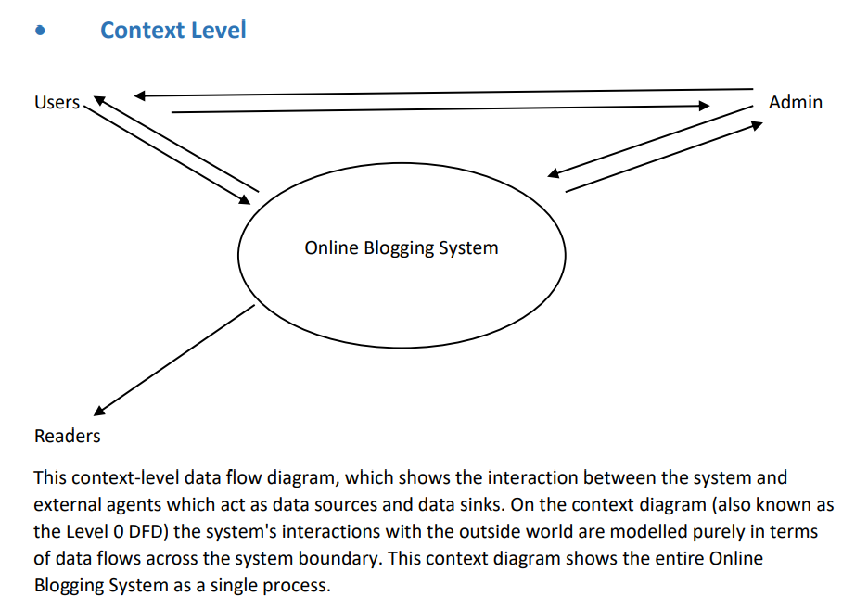

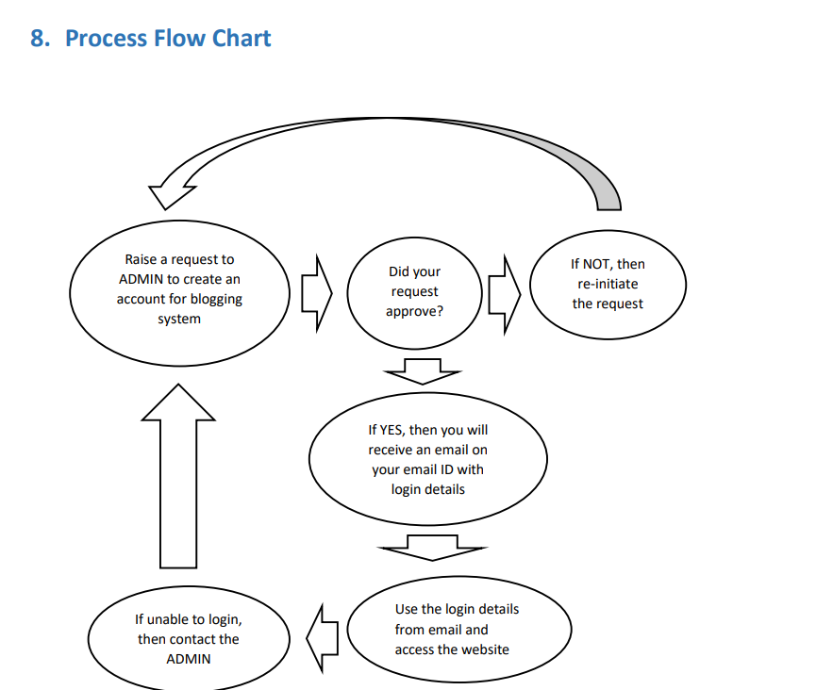

GITHUB LINK FOR SOURCE CODE:

https://github.com/starvikas1988/blogging_site