**Database Systems**

**Final Project**



|  |  |
| --- | --- |
| Names : | Talha Mukhtiar,  Mukaram Haseeb |
| Section: | BS_SE (E) |
| ID nos: | 22I-2720  22I-2488 |
| Project: | Fast Cafe Management System |
| Submitted to: | Sir Bilal Khalid Dar |

# 

Table of Contents

1. Modules of the Project: 3

1.1 Order Management: 3

1.1.1 Order Placement 3

1.1.2 Order Fulfillment: 3

1.1.3 Order Modification: 3

1.1.4 Remove Item Option: 4

1.2 Inventory Management: 4

1.2.1 Monitors Quantity and Availability: 4

1.2.1 Analyze Inventory Levels: 4

1.3 Employee Management: 4

1.3.1 Create Employee Profiles: 4

1.3.2 Read Employee Information: 4

1.3.3 Update Employee Information: 4

1.3.4 Delete Employee Profiles: 5

1.4 Customer Relationship Module: 5

1.4.1 Collect Feedback: 5

1.4.2 Feedback Rating: 5

1.4.3 View Feedback Details: 5

1.5 Reporting and Analytics 5

1.5.1 Total Products Overview: 5

1.5.2 Inventory Availability: 5

1.5.3 Total Feedback Analysis: 6

1.5.4 Customer Traffic Analysis: 6

1.5.5 Product Recommendations: 6

1.5.6 Category Search Functionality: 6

2. Entity Relational Diagram 7

3. Enhanced ERD 8

4. Relational Schema 9

# Modules of the Project:

## 

## 1.1 Order Management:

### 1.1.1 Order Placement

Customers should be able to browse products.

Customers should be able to manage products to their shopping cart by using CRUD operations.

Customers should be able to view their shopping cart.

Customers should be able to proceed to checkout.

Customers should be able to enter shipping and billing information.

Customers should be able to select a preferred payment method.

Customers should be able to review and confirm their order before finalizing the purchase.

## Order Fulfillment:

Upon order confirmation, the system should generate an Receipt for the customer.

Orders should be processed on time.

Products should be accurately picked, and prepared for shipping.

Packages should be handed over to the designated shipping carrier.

## 1.1.3 Order Modification:

Customers should be able to modify their orders before they are fulfilled.

Modification options may include updating quantities, removing items, and changing

products.

The system should reflect any changes made by the customer in real-time.

Modification requests should be validated against order status and inventory

availability

## 1.1.4 Remove Item Option:

Customers should have the option to remove items from their shopping cart or order.

The system should update the cart/order total and reflect the removal of items immediately.

Removal of items should be possible at any stage of the checkout process.

## Inventory Management:

### Monitors Quantity and Availability:

The system continuously tracks the quantity of each product in inventory.

Availability status (e.g., in stock, out of stock) is updated in real-time based on inventory changes.

Alerts are triggered when inventory levels fall below predefined thresholds.

### Analyze Inventory Levels:

The system analyzes historical sales data and current inventory levels to predict future demand.

Reorder point and reorder quantity are calculated based on demand forecasts and lead times.

Thresholds are set to trigger reorder suggestions when inventory falls below a certain level.

## Employee Management:

### Create Employee Profiles:

Admins can create new employee profiles within the system.

Required information includes employee name, contact details, job title, department, and hire

date.

Optional fields may include emergency contact information, employee ID, and photo.

### Read Employee Information:

Admins can view detailed employee profiles, including all relevant information.

Access to employee profiles is restricted based on role-based access controls.

### 1.3.3 Update Employee Information:

Admins can edit employee profiles to update information such as contact details, job title, or department.

Changes to employee profiles are logged for audit purposes.

### 1.3.4 Delete Employee Profiles:

Admins can delete employee profiles if necessary, such as when an employee leaves the company.

## Customer Relationship Module:

### Collect Feedback:

Customers can provide feedback about their experiences with products, services, or interactions with the company.

Feedback forms are available online

### Feedback Rating:

Customers rate their experience on a numerical scale or provide qualitative feedback.

Rating criteria may include satisfaction with products, services, customer support, and overall experience.

### View Feedback Details:

Feedback details include customer ratings, comments, date/time of submission, and any associated customer information (if provided).

Feedback is presented in an organized format for easy review and analysis.

Customers can select delivery as an option during the checkout process.

Delivery fees, estimated delivery times, and delivery address verification are integrated into the ordering system.

Orders are dispatched to delivery personnel or third-party carriers for fulfillment.

Admins can enable reservation booking for services offered by the company, such as appointments, tables at restaurants, or event bookings.

## Reporting and Analytics

### 1.5.1 Total Products Overview:

Admins can view a summary of the total number of products available in inventory.

Information includes product categories, quantities, and any low-stock alerts.

### 1.5.2 Inventory Availability:

Admins can monitor inventory levels in real-time.

Graphical representations and numerical data display current stock levels and highlight any items nearing depletion.

### 1.5.3 Total Feedback Analysis:

Admins can access analytics on customer feedback.

Metrics include average ratings, sentiment analysis, and trending feedback topics.

### 1.5.4 Customer Traffic Analysis:

Admins can track website or store traffic metrics.

Data includes total visits, unique visitors, popular pages, and traffic sources.

### 1.5.5 Product Recommendations:

Customers receive personalized product recommendations based on their browsing and purchase history.

Recommendations may be based on similar products, trending items, or customer preferences.

### 1.5.6 Category Search Functionality:

Customers can search for products by category using a dedicated search function.

Categories may include product types, brands, or any other predefined classification criteria.

# 2. Entity Relational Diagram

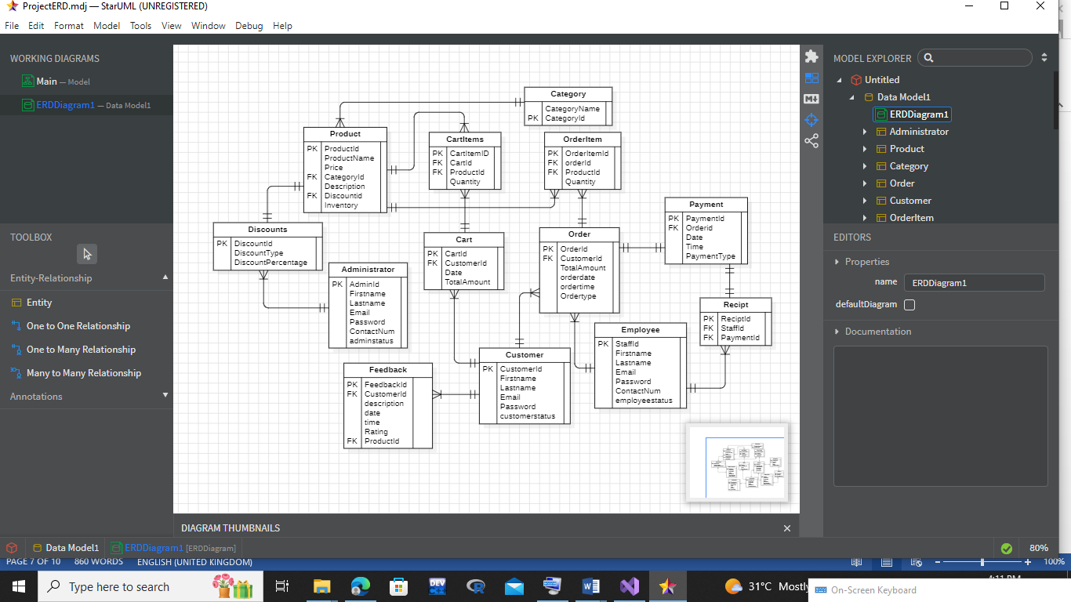

# 3. Enhanced ERD

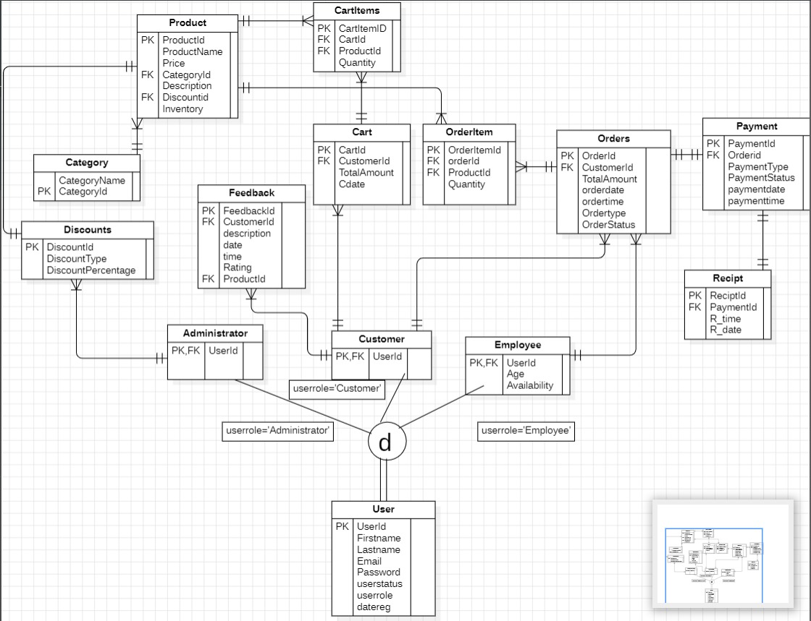

# 4. Relational Schema

Users

|  |  |  |  |  |  |  |  |
| --- | --- | --- | --- | --- | --- | --- | --- |
| PK Id | Fname | LastName | Password | Role | Status | Email | DateReg |

Administrator

|  |
| --- |
| FK PK AdminId |

Customer

|  |
| --- |
| PK FK CustomerId |

Discount

|  |  |  |
| --- | --- | --- |
| PK DiscountId | DiscountType | DiscountPer |

Product

|  |  |  |  |  |  |  |
| --- | --- | --- | --- | --- | --- | --- |
| PK PID | name | price | FK categoryId | FK DiscountId | Description | Inventory |

Category

|  |  |
| --- | --- |
| PK CategoryId | CategoryName |

FeedBack

|  |  |  |  |  |  |  |  |
| --- | --- | --- | --- | --- | --- | --- | --- |
| PK FeedBackId | Description | Date | Time | Rating | Fk PID | Fk CustomerId | Email |

Cart

|  |  |  |  |
| --- | --- | --- | --- |
| PK CartId | CartDate | TotalAmount | FK CustomerId |

CartItems

|  |  |  |  |
| --- | --- | --- | --- |
| PK CartItemsId | FK CartId | Fk PID | Quantity |

Employees

|  |  |  |
| --- | --- | --- |
| PK EmployeeId | Age | Availability |

Orders

|  |  |  |  |  |  |  |
| --- | --- | --- | --- | --- | --- | --- |
| PK OrderId | FK cutomerId | TotalAmount | OrderDate | OrderTime | OrderType | OrderStatus |

OrderItems

|  |  |  |  |
| --- | --- | --- | --- |
| PK OIId | FK OrderId | FK ProductId | Quantity |

Payment

|  |  |  |  |  |  |
| --- | --- | --- | --- | --- | --- |
| Pk PaymentId | FK OrderId | PaymentDate | PaymentType | PaymentTime | PaymentStatus |

Receipt

|  |  |  |  |
| --- | --- | --- | --- |
| PK ReceiptId | R_time | R_date | FK PaymentId |

# User Documentation And Help

**Login Screen:**

1. Three types of users can log in: customers, administrators, and employees.
2. Administrators and customers register accounts before logging in.
3. Employees' accounts are created by the administrator before they can log in.
4. Employees are directed to the main screen upon login.

**Administrator Main Screen:**

Offers various options:

Manage Products

Manage Employees

See Dashboard

Feedback Analysis

Customer Records

Discounts

**Product Management Screen:**

1. Allows admin to:

Add products

Remove products

Update products

View products

Count products in each category

**Employees Management Screen:**

1. Enables admin to:

Add employees

Remove employees

Edit employee details

View employee information

Search for employees

**Dashboard:**

1. Provides statistics on:

Total employees

Customer traffic

Product availability

Total revenue

**Customer Records:**

1. Displays:

System traffic

Top customers

Top products

Records of customer activity

**Feedback Analysis:**

1. Allows admin to:

Check all feedback

View rating counts

Analyze customer feedback for

menu and service improvement.

**Discount Screen:**

1. Displays:

Products with regular prices

Option to add discounts to specific products

Management of discount-related activities

So based on Screen funcionality admin will perform his job.