Лабораторная работа №4

Выполнил: Тарасенко Станислав

Цель работы: Изучение операторов ветвлений и циклов, логических операций в JavaScript

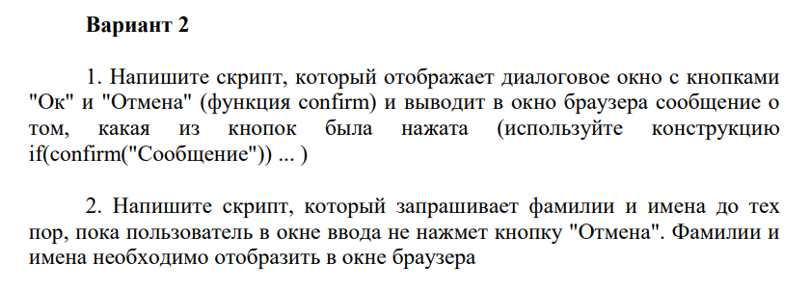

Код программы:

<div class="container">

    <div class="row">

      <div class="col-md-12 text-center">

        <h1 class="animate-charcter">Task 1: Write a script that displays a dialog box with buttons

            "OK" and "Cancel" (function confirm) and displays a message in the browser window about

            which of the buttons was pressed (use the construction

            if(confirm("Message")) ... )</h1>

        <h1 class="animate-charcter">Task 2: Write a script that requests last names and first names before

            until the user clicks the "Cancel" button in the input window. Surnames and

            names must be displayed in the browser window.</h1>

        </div>

    </div>

</div>

<div id="top" class="wrap">

    <button (click)="printButton()" class="glow-on-hover" >

        First task

    </button>

    <button (click)="printName()" class="glow-on-hover" >

        Second task

    </button>

</div>

<div id="wrapper">

    <div id="container">

        <p id="box"></p>

        <p id="fio"></p>

    </div>

</div>

import { Component } from '@angular/core';

@Component({

  selector: 'app-loops-four',

  templateUrl: './loops-four.component.html',

  styleUrls: ['./loops-four.component.css']

})

export class LoopsFourComponent {

  stroka:string="";

  printButton() {

    let result = confirm("Press any button");

    if(result){

      document.getElementById("box")!.innerHTML="Ok"

    }

    else{

      document.getElementById("box")!.innerHTML="Cancel"

    }

  }

  printName() {

  while(true)

  {

    let chat = document.getElementById("fio");

    console.log(chat);

    let result = prompt("Enter your name")

    let blockOne = document.createElement('div');

    if(result==null){

      break;

    }

    else{

      this.stroka+=result;

      this.stroka+='\n';

      console.log(this.stroka);

      blockOne.textContent = result;

      chat!.append(blockOne);

    }

    let secondResult = prompt("Enter your second name")

    let blockTwo = document.createElement('div');

    if(secondResult==null){

      break;

    }

    else{

      this.stroka+=secondResult;

      this.stroka+='\n';

      console.log(this.stroka);

      blockTwo.textContent = secondResult;

      chat!.append(blockTwo);

    }

  }

  }

}

