Лабораторная работа №5

Выполнил: Тарасенко Станислав

Цель работы: Изучение методов в JavaScript

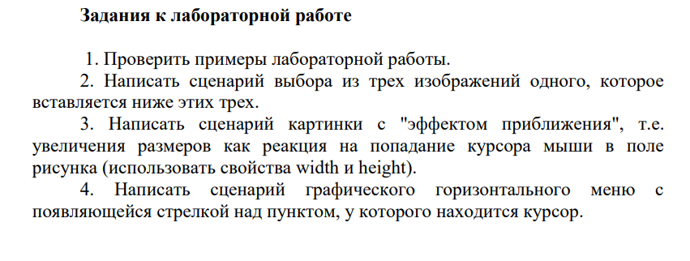

Код программы:

<div class="container">

    <div class="row">

      <div class="col-md-12 text-center">

        <h1 class="animate-charcter">Task 1: Write a script for choosing from three images one that

            inserted below these three.</h1>

        <h1 id="height" class="animate-charcter">Task 2: Write a picture script with a "zoom effect", i.e.

            increase in size as a reaction to the mouse cursor entering the field

            drawing (use the width and height properties).</h1>

        <h1 class="animate-charcter">Task 3: Write a script for a graphical horizontal menu with

            the arrow that appears above the item at which the cursor is located.</h1>

        </div>

    </div>

</div>

<section class="task1">

    <img src="./assets/picture1.jpg" alt="" (click)="pickPicture(0)">

    <img src="./assets/picture2.jpg" alt="" (click)="pickPicture(1)">

    <img src="./assets/picture3.jpg" alt="" (click)="pickPicture(2)">

</section>

<div class="left">

    <img src="" alt="">

</div>

<section class="task2">

    <img src="./assets/picture1.jpg" alt="" (mouseover)="changeScale(4, 400, 300)" (mouseout)="changeScale(4, 'auto', 200)">

    <img src="./assets/picture2.jpg" alt="" (mouseover)="changeScale(5, 400, 300)" (mouseout)="changeScale(5, 'auto', 200)">

    <img src="./assets/picture3.jpg" alt="" (mouseover)="changeScale(6, 400, 300)" (mouseout)="changeScale(6, 'auto', 200)">

</section>

<section class="task3">

    <div class="card">

        <img src="./assets/unselected.jpg" alt="" class="selector-icon">

        <img src="./assets/picture1.jpg" alt="" (mouseover)="pictureReducer(7, 1)" (mouseout)="pictureReducer(7, 0)">

    </div>

    <div class="card">

        <img src="./assets/unselected.jpg" alt="" class="selector-icon">

        <img src="./assets/picture2.jpg" alt="" (mouseover)="pictureReducer(9, 1)" (mouseout)="pictureReducer(9, 0)">

    </div>

    <div class="card">

        <img src="./assets/unselected.jpg" alt="" class="selector-icon">

        <img src="./assets/picture3.jpg" alt="" (mouseover)="pictureReducer(11, 1)" (mouseout)="pictureReducer(11, 0)">

    </div>

</section>

import { Component } from '@angular/core';

@Component({

  selector: 'app-methods-fifth',

  templateUrl: './methods-fifth.component.html',

  styleUrls: ['./methods-fifth.component.css']

})

export class MethodsFifthComponent   {

pickPicture(n:number) {

    if (document.images[3].src === document.images[n].src) {

        document.images[3].src = "";

    } else {

        document.images[3].src = document.images[n].src;

    }

}

changeScale(n:number, width:any, height:number) {

    if (width === 'auto') {

        document.images[n].style.width = width;

    } else {

        document.images[n].style.width = width + 'px';

    }

    document.images[n].style.height = height + 'px';

}

pictureReducer(n:number, action:any) {

    if (action) {

        document.images[n].src = './assets/selected.jpg';

    } else {

        document.images[n].src = './assets/unselected.jpg'

    }

}

}

