Лабораторная работа №7

Выполнил: Тарасенко Станислав

Цель работы: Изучение использования элементов управления

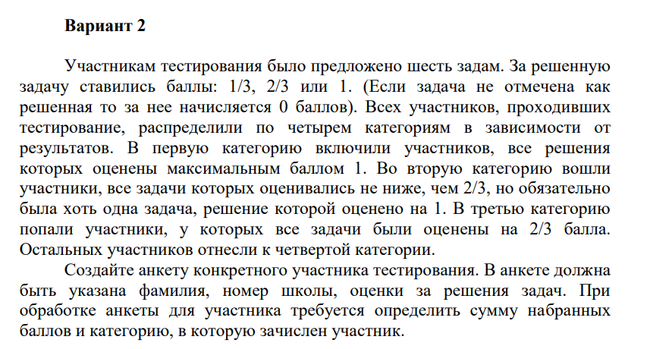

Код программы:

<body>

<div class="container">

    <div>

        <div class="col-md-12 text-center">

            <h1 class="animate-charcter">Task: Test participants were offered six tasks. For the solved

                the task was scored: 1/3, 2/3 or 1. (If the task is not marked as

                solved, then 0 points are awarded for it). All participants who passed

                testing were divided into four categories depending on

                results. The first category included participants, all solutions

                which were rated with a maximum score of 1. The second category included

                participants, all tasks of which were estimated not lower than 2/3, but it is obligatory

                there was at least one task, the solution of which was rated at 1. In the third category

                there were participants whose all tasks were rated at 2/3 points.

                The rest of the participants were assigned to the fourth category.

                Create a questionnaire for a specific test participant. The questionnaire should

                last name, school number, grades for solving problems. At

                processing the questionnaire for the participant is required to determine the amount of collected

                points and the category in which the participant is enrolled.</h1>

    </div>

    </div>

</div>

<div id="container">

    <label for="min">Second name</label>

    <input type="text" name="secondName" class="text" [(ngModel)]="secondName">

    <label for="">School number</label>

    <input type="text" name="schoolNumber" class="text" [(ngModel)]="schoolNumber">

</div>

<div id="newcon">

<table id="top">

        <tr>

            <th class="position">Task</th>

            <th class="position">Выполнено</th>

            <th class="position">Оценка</th>

        </tr>

        <tr>

            <td>Task 1</td>

            <td><input type="checkbox" class="checkbox" [(ngModel)]="check1" (click)="setDefault(check1, 'check1')"></td>

            <td>

                <input type="radio" id="grade1" value="grade1" name="grade" [(ngModel)]="grade1" (click)="portionClickHandler(check1, $event)">

                <label for="grade1">1/3</label><br>

                <input type="radio" id="grade2" value="grade2" name="grade" [(ngModel)]="grade2" (click)="portionClickHandler(check1, $event)">

                <label for="grade2">2/3</label><br>

                <input type="radio" id="grade3" value="grade3" name="grade" [(ngModel)]="grade3" (click)="portionClickHandler(check1, $event)">

                <label for="grade3">1.0</label>

            </td>

        </tr>

        <tr>

            <td>Task 2</td>

            <td><input type="checkbox" class="checkbox" [(ngModel)]="check2" (click)="setDefault(check2, 'check2')"></td>

            <td>

                <input type="radio" id="grade4" value="grade4" name="grade1" [(ngModel)]="grade4" (click)="portionClickHandler(check2, $event)">

                <label for="grade4">1/3</label><br>

                <input type="radio" id="grade5" value="grade5" name="grade1" [(ngModel)]="grade5" (click)="portionClickHandler(check2, $event)">

                <label for="grade5">2/3</label><br>

                <input type="radio" id="grade6" value="grade6" name="grade1" [(ngModel)]="grade6" (click)="portionClickHandler(check2, $event)">

                <label for="grade6">1.0</label>

            </td>

        </tr>

        <tr>

            <td>Task 3</td>

            <td><input type="checkbox" class="checkbox" [(ngModel)]="check3" (click)="setDefault(check3, 'check3')"></td>

            <td>

                <input type="radio" id="grade7" value="grade7" name="grade2" [(ngModel)]="grade7" (click)="portionClickHandler(check3, $event)">

                <label for="grade7">1/3</label><br>

                <input type="radio" id="grade8" value="grade8" name="grade2" [(ngModel)]="grade8" (click)="portionClickHandler(check3, $event)">

                <label for="grade8">2/3</label><br>

                <input type="radio" id="grade9" value="grade9" name="grade2" [(ngModel)]="grade9" (click)="portionClickHandler(check3, $event)">

                <label for="grade9">1.0</label>

            </td>

        </tr>

        <tr>

            <td>Task 4</td>

            <td><input type="checkbox" class="checkbox" [(ngModel)]="check4" (click)="setDefault(check4, 'check4')"></td>

            <td>

                <input type="radio" id="grade10" value="grade10" name="grade3" [(ngModel)]="grade10" (click)="portionClickHandler(check4, $event)">

                <label for="grade10">1/3</label><br>

                <input type="radio" id="grade11" value="grade11" name="grade3" [(ngModel)]="grade11" (click)="portionClickHandler(check4, $event)">

                <label for="grade11">2/3</label><br>

                <input type="radio" id="grade12" value="grade12" name="grade3" [(ngModel)]="grade12" (click)="portionClickHandler(check4, $event)">

                <label for="grade12">1.0</label>

            </td>

        </tr>

        <tr>

            <td>Task 5</td>

            <td><input type="checkbox" class="checkbox" [(ngModel)]="check5" (click)="setDefault(check5, 'check5')"></td>

            <td>

                <input type="radio" id="grade13" value="grade13" name="grade4" [(ngModel)]="grade13" (click)="portionClickHandler(check5, $event)">

                <label for="grade13">1/3</label><br>

                <input type="radio" id="grade14" value="grade14" name="grade4" [(ngModel)]="grade14" (click)="portionClickHandler(check5, $event)">

                <label for="grade14">2/3</label><br>

                <input type="radio" id="grade15" value="grade15" name="grade4" [(ngModel)]="grade15" (click)="portionClickHandler(check5, $event)">

                <label for="grade15">1.0</label>

            </td>

        </tr>

        <tr>

            <td>Task 6</td>

            <td><input type="checkbox" class="checkbox" [(ngModel)]="check6" (click)="setDefault(check6, 'check6')"></td>

            <td>

                <input type="radio" id="grade16" value="grade16" name="grade5" [(ngModel)]="grade16" (click)="portionClickHandler(check6, $event)">

                <label for="grade16">1/3</label><br>

                <input type="radio" id="grade17" value="grade17" name="grade5" [(ngModel)]="grade17" (click)="portionClickHandler(check6, $event)">

                <label for="grade17">2/3</label><br>

                <input type="radio" id="grade18" value="grade18" name="grade5" [(ngModel)]="grade18" (click)="portionClickHandler(check6, $event)">

                <label for="grade18">1.0</label>

            </td>

        </tr>

</table>

<div id="column" class="animate-charcter">

    <p id="secondName"></p>

    <p id="schoolNumber"></p>

    <p id="overallScore"></p>

    <p id="group"></p>

</div>

</div>

<button (click)="calculate(check1,check2,check3,check4,check5,check6,grade1,grade2,grade3,grade4,grade5,grade6,grade7,grade8,grade9,grade10,grade11,grade12,grade13,grade14,grade15,grade16,grade17,grade18)">Calculate</button>

</body>

import { Component } from '@angular/core';

@Component({

  selector: 'app-controls-seventh',

  templateUrl: './controls-seventh.component.html',

  styleUrls: ['./controls-seventh.component.css']

})

export class ControlsSeventhComponent  {

  check1:any;

  check2:any;

  check3:any;

  check4:any;

  check5:any;

  check6:any;

  grade1:any;

  grade2:any;

  grade3:any;

  grade4:any;

  grade5:any;

  grade6:any;

  grade7:any;

  grade8:any;

  grade9:any;

  grade10:any;

  grade11:any;

  grade12:any;

  grade13:any;

  grade14:any;

  grade15:any;

  grade16:any;

  grade17:any;

  grade18:any;

  secondName:any;

  schoolNumber:any;

  setDefault(checkModel:boolean, name:string) {

    if(checkModel && name === "check1"){

      this.grade1=false;

      this.grade2=false;

      this.grade3=false;

    }

    if(checkModel && name === "check2"){

      this.grade4=false;

      this.grade5=false;

      this.grade6=false;

    }

    if(checkModel && name === "check3"){

      this.grade7=false;

      this.grade8=false;

      this.grade9=false;

    }

    if(checkModel && name === "check4"){

      this.grade10=false;

      this.grade11=false;

      this.grade12=false;

    }

    if(checkModel && name === "check5"){

      this.grade13=false;

      this.grade14=false;

      this.grade15=false;

    }

    if(checkModel && name === "check6"){

      this.grade16=false;

      this.grade17=false;

      this.grade18=false;

    }

  }

  portionClickHandler(model:any, event:any) {

    if (model) {

    }

    else {

      event.preventDefault();

    }

}

  calculate(check1: any,check2: any,check3: any,check4: any,check5: any,check6: any,grade1: any,grade2: any,grade3: any,grade4: any,grade5: any,grade6: any,grade7: any,grade8: any,grade9: any,grade10: any,grade11: any,grade12: any,grade13: any,grade14: any,grade15: any,grade16: any,grade17: any,grade18: any) {

    let gradeSum:number = 0;

    let group:number = 0;

    if(check1)

    {

      if(grade1){

        gradeSum+=1/3;

      }

      else if(grade2){

        gradeSum+=2/3;

      }

      else{

        gradeSum+=1;

      }

    }

    if(check2)

    {

      if(grade4){

        gradeSum+=1/3;

      }

      else if(grade5){

        gradeSum+=2/3;

      }

      else{

        gradeSum+=1;

      }

    }

    if(check3)

    {

      if(grade7){

        gradeSum+=1/3;

      }

      else if(grade8){

        gradeSum+=2/3;

      }

      else{

        gradeSum+=1;

      }

    }

    if(check4)

    {

      if(grade10){

        gradeSum+=1/3;

      }

      else if(grade11){

        gradeSum+=2/3;

      }

      else{

        gradeSum+=1;

      }

    }

    if(check5)

    {

      if(grade13){

        gradeSum+=1/3;

      }

      else if(grade14){

        gradeSum+=2/3;

      }

      else{

        gradeSum+=1;

      }

    }

    if(check6)

    {

      if(grade16){

        gradeSum+=1/3;

      }

      else if(grade17){

        gradeSum+=2/3;

      }

      else{

        gradeSum+=1;

      }

    }

    if(gradeSum == 6) {

      group=1;

    }

    else if(gradeSum < 6 && gradeSum>4.3333){

      group=2;

    }

    else if(gradeSum < 4 && gradeSum > 3.9998 ){

      group=3;

    }

    else{

      group=4;

    }

    document.getElementById("secondName")!.innerHTML = `Second name: ${this.secondName}`;

    document.getElementById("schoolNumber")!.innerHTML = `School number: ${this.schoolNumber}`;;

    document.getElementById("overallScore")!.innerHTML = `Overall score: ${gradeSum}`;

    document.getElementById("group")!.innerHTML = `Group: ${group}`;

}

}

