Лабораторная работа №8

Выполнил: Тарасенко Станислав

Цель работы: Разобрать способы выполнения проверки формы, а также

возможности для пересылки информации по Интернет

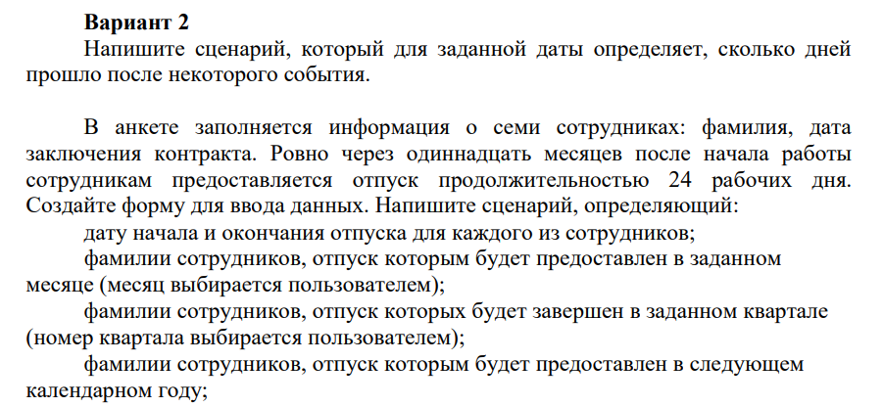

Код программы:

<body>

    <div class="container">

        <div>

            <div class="col-md-12 text-center">

                <h1 class="animate-charcter">Task: Write a script that, for a given date, determines how many days

                    passed after some event.

                    The questionnaire contains information about seven employees: last name, date

                    conclusion of a contract. Exactly eleven months after the start of work

                    Employees are granted leave of 24 working days.

                    Create a data entry form. Write a script that defines:

                    vacation start and end dates for each employee;

                    names of employees who will be granted leave in a given

                    month (month is selected by the user);

                    names of employees whose vacation will be completed in a given quarter

                    (number of the quarter is selected by the user);

                    names of employees who will be granted leave in the next

                    calendar year;</h1>

            </div>

        </div>

    </div>

    <div id="newcon">

    <div id="top">

        <form>

            <div class="forma">

                <div class="cell">Number employee</div>

                <div class="cell">Second Name</div>

                <div class="cell">The date conclusion of a contract</div>

                <div class="cell">Vacation</div>

            </div>

        </form>

        <form [formGroup]="form1" class="form">

            <div class="forma">

                <div class="cell">Employee 1</div>

                <input class="cell" type="text"  formControlName="secondName">

                <input class="cell" type="date" formControlName="date">

                <div class="cell" formControlName="vacation">{{ form1.value.vacation }}</div>

            </div>

        </form>

        <form [formGroup]="form2">

            <div class="forma">

                <div class="cell">Employee 2</div>

                <input class="cell" type="text"  formControlName="secondName">

                <input class="cell" type="date" formControlName="date">

                <div class="cell" formControlName="vacation">{{ form2.value.vacation }}</div>

            </div>

        </form>

        <form [formGroup]="form3">

            <div class="forma">

                <div class="cell">Employee 3</div>

                <input class="cell" type="text"  formControlName="secondName">

                <input class="cell" type="date" formControlName="date">

                <div class="cell" formControlName="vacation">{{ form3.value.vacation }}</div>

            </div>

        </form>

        <form [formGroup]="form4">

            <div class="forma">

                <div class="cell">Employee 4</div>

                <input class="cell" type="text"  formControlName="secondName">

                <input class="cell" type="date" formControlName="date">

                <div class="cell" formControlName="vacation">{{ form4.value.vacation }}</div>

            </div>

        </form>

        <form [formGroup]="form5">

            <div class="forma">

                <div class="cell">Employee 5</div>

                <input class="cell" type="text"  formControlName="secondName">

                <input class="cell" type="date" formControlName="date">

                <div class="cell" formControlName="vacation">{{ form5.value.vacation }}</div>

            </div>

        </form>

        <form [formGroup]="form6">

            <div class="forma">

                <div class="cell">Employee 6</div>

                <input class="cell" type="text"  formControlName="secondName">

                <input class="cell" type="date" formControlName="date">

                <div class="cell" formControlName="vacation">{{ form6.value.vacation }}</div>

            </div>

        </form>

        <form [formGroup]="form7">

            <div class="forma">

                <div class="cell">Employee 7</div>

                <input class="cell" type="text"  formControlName="secondName">

                <input class="cell" type="date" formControlName="date">

                <div class="cell" formControlName="vacation">{{ form7.value.vacation }}</div>

            </div>

        </form>

        <form>

            <div class="forma1">

                <div class="cell">Month number</div>

                <div class="cell">Quarter</div>

            </div>

        </form>

        <form [formGroup]="form8">

            <div class="forma">

                <input class="cell" type="text" formControlName="monthNumber">

                <input class="cell" type="text" formControlName="kvartal">

            </div>

        </form>

    </div>

    <form>

    <div id="column" class="animate-charcter">

        <p id="secondName">In selected month</p>

        <p id="kvartal">Ends in this quarter</p>

        <p id="year">In next year</p>

    </div>

    </form>

    </div>

    <button (click)="calculateVacation()">Calculate</button>

    </body>

import { Component } from '@angular/core';

import { FormGroup, FormControl } from '@angular/forms';

@Component({

  selector: 'app-forms-eighth',

  templateUrl: './forms-eighth.component.html',

  styleUrls: ['./forms-eighth.component.css']

})

export class FormsEighthComponent {

  form1 = new FormGroup({

    secondName: new FormControl(),

    date: new FormControl(),

    vacation: new FormControl()

  });

  form2 = new FormGroup({

    secondName: new FormControl(),

    date: new FormControl(),

    vacation: new FormControl()

  });

  form3 = new FormGroup({

    secondName: new FormControl(),

    date: new FormControl(),

    vacation: new FormControl()

  });

  form4 = new FormGroup({

    secondName: new FormControl(),

    date: new FormControl(),

    vacation: new FormControl()

  });

  form5 = new FormGroup({

    secondName: new FormControl(),

    date: new FormControl(),

    vacation: new FormControl()

  });

  form6 = new FormGroup({

    secondName: new FormControl(),

    date: new FormControl(),

    vacation: new FormControl()

  });

  form7 = new FormGroup({

    secondName: new FormControl(),

    date: new FormControl(),

    vacation: new FormControl()

  });

  form8 = new FormGroup({

    monthNumber: new FormControl(),

    kvartal: new FormControl(),

  });

  forms:FormGroup[]=[

    this.form1,

    this.form2,

    this.form3,

    this.form4,

    this.form5,

    this.form6,

    this.form7

  ];

  printSecondNameInMonth(){

    document.getElementById("secondName")!.innerHTML = 'In selected month';

    for(let form of this.forms) {

      let date = new Date(form.value.date)

      if(date.getMonth() === (this.form8.value.monthNumber-1)) {

        document.getElementById("secondName")!.innerHTML += ` ${form.value.secondName}`;

      }

   }

};

  getVacationNextYear(vacationStart:Date, secondName:string){

  let date = new Date();

  if(date.getFullYear() < vacationStart.getFullYear()){

    document.getElementById("year")!.innerHTML += ` ${secondName}`;

  }

  }

printSecondNameInQuarter(vacationEnd:Date) {

  for(let form of this.forms) {

    let date = new Date(form.value.vacation)

    console.log(date.getMonth())

    console.log(this.form8.value.monthNumber)

    if(this.form8.value.kvartal == 1){

      if(vacationEnd.getMonth() === 0 || vacationEnd.getMonth()==1 || vacationEnd.getMonth() == 2) {

        document.getElementById("kvartal")!.innerHTML += ` ${form.value.secondName}`;

        continue;

      }

    }

    if(this.form8.value.kvartal == 2){

      if(vacationEnd.getMonth() == 3 || vacationEnd.getMonth()==4 || vacationEnd.getMonth() == 5) {

        document.getElementById("kvartal")!.innerHTML += ` ${form.value.secondName}`;

        continue;

      }

    }

    if(this.form8.value.kvartal == 3){

      if(vacationEnd.getMonth() == 6 || vacationEnd.getMonth()==7 || vacationEnd.getMonth() == 8) {

        document.getElementById("kvartal")!.innerHTML += ` ${form.value.secondName}`;

        continue;

      }

    }

    if(this.form8.value.kvartal == 4){

      if(vacationEnd.getMonth() === 9 || vacationEnd.getMonth()===10 || vacationEnd.getMonth() === 11) {

        document.getElementById("kvartal")!.innerHTML += ` ${form.value.secondName}`;

        continue;

      }

    }

 }

}

calculateVacation(){

  let currentDate:any = new Date();

  document.getElementById("year")!.innerHTML = `In next year`;

  document.getElementById("kvartal")!.innerHTML = "";

  document.getElementById("kvartal")!.innerHTML = `Ends in this quarter`;

  this.printSecondNameInMonth()

  for(let form of this.forms) {

      let startDate:any = new Date(form.value.date)

      let vacationStart = new Date(startDate);

      vacationStart.setFullYear(currentDate.getFullYear())

      vacationStart.setMonth(vacationStart.getMonth()+11);

      let vacationEnd = new Date(vacationStart);

      this.printSecondNameInQuarter(vacationEnd);

      this.getVacationNextYear(vacationStart, form.value.secondName);

     vacationEnd.setMonth(vacationEnd.getMonth()+1)

      form.setValue({

      secondName: form.value.secondName,

      date:form.value.date,

      vacation: vacationStart.toDateString()

     })

    }

  };

}

Результат работы программы:

