State Level Mobility Report
Brian Harrold

Overview
This short report summarizes trends in student cohorts and mobility, focusing on participation in the state mathematics assessment during the 2023-2024 academic year. While 2023-2024 serves as the primary lens, the dataset spans from 2019-2020 to 2023-2024, allowing for the identification of longer-term patterns across academic years. The analysis is based on the presence or absence of individual student assessment records in each year, which serves as a proxy for enrollment or participation. However, it may not fully capture students represented in the system in other ways—such as through partial-year enrollment or administrative records without assessment data—and therefore may underrepresent true enrollment. Future analyses may benefit from incorporating dedicated enrollment records for more complete insights. This report draws on 67,406 unique students from the sgpData_Long dataset.

Student Population
This section provides an overview of the available student data, including enrollment counts by grade and year. These figures establish the foundation for understanding cohort patterns, mobility trends, and the scope of analysis in subsequent sections.
The table below provides the number of students by year and grade levels based on the available data. In 2023-2024, total enrollment was 37,965, an increase of 0.9% from the previous year. 2023-2024 had the highest enrollment on record. On average, enrollment by grade changed about 4% compared to the same grade’s feeder level in the prior year. The largest change was in grade 9 with a 10.3% increase. Grades with consistently higher enrollment across years included 9 . Changes in enrollment were fairly consistent across grades. No unusual enrollment patterns were detected in any grade. Enrollment varied by about 939 students across years.
Student enrollment summary by grade and year. Diagonals may be interpreted as cohorts.
Grade Level | 2019-2020 | 2020-2021 | 2021-2022 | 2022-2023 | 2023-2024
3 | 4323 | 4502 | 4477 | 4695 | 4863
4 | 4405 | 4444 | 4574 | 4575 | 4792
5 | 4282 | 4498 | 4532 | 4646 | 4618
6 | 4462 | 4370 | 4518 | 4598 | 4756
7 | 4579 | 4673 | 4541 | 4538 | 4634
8 | 4427 | 4703 | 4742 | 4536 | 4598
9 | 4894 | 4808 | 5104 | 5231 | 5001
10 | 4248 | 4460 | 4553 | 4821 | 4703
Total | 35620 | 36458 | 37041 | 37640 | 37965

Definitions
A student has a mobility status of:
- Leave: Enrolled last year but not enrolled this year.
- Stay: Enrolled in both last year and this year.
- Join: Enrolled this year but not last year.
- Repeat: In the same grade two years in a row.
- Advance: Skipped one or more grades between years.

General Trends in Student Mobility and Cohorts
To better understand student mobility, consider the heatmap below, which tracks how long students remain in their expected educational trajectory. Each row represents a different grade level, and each column shows the number or percentage of students from the original cohort who are still enrolled in that grade in subsequent years. One cohort includes 4,323 students who were first observed in Grade 3 during the 2019–2020 school year. One year later, 89.8% of those students progressed to Grade 4. This number gradually declines each year, with only 74.4% of the original group reaching Grade 7 by 2023–2024.
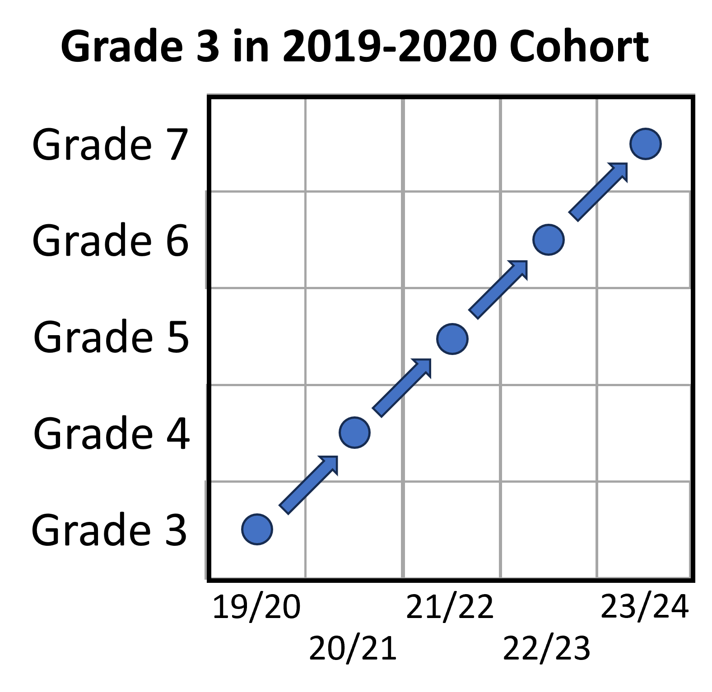
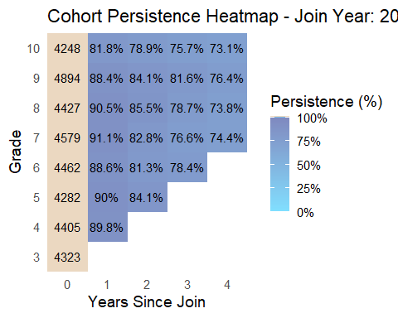
Based on the table below, the overall trend for students for the 2023-2024 academic year seem to be that there is little difference in the mobility of students based on the grade level. Approximately 80% of students from each grade in 2023-2024 continued from the previous grade during the previous academic year. Students appear to be joining at a slightly higher rate than leaving.
Mobility Distribution by Grade for 2023-2024
 | Grade 3 | Grade 4 | Grade 5
Leave | 8.5% | 8.0% | 9.3%
Stay | 81.0% | 83.2% | 79.4%
Join | 10.4% | 8.8% | 11.4%
Also of interest is how these cohorts of students compare to one another and to previous cohorts of students. This is evident in the plot shown below. Until more recently, it was common for the percent proficient to increase from Grade 3 to Grade 4. However, this appears to have reversed post-COVID. Additionally, it appears that the percent proficient decreases between Grade 4 and Grade 5, with a much sharper decline in the recent years. It also appears that while most cohorts start with approximately the same proficiency rate in Grade 3, the gap tends to widen as the grade levels increase.
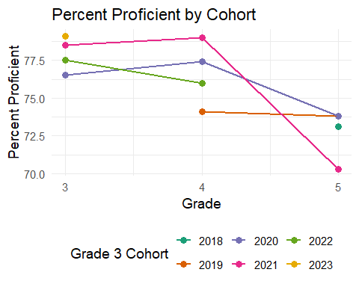

Deep Dive into Student Mobility and Cohorts
This section focuses on the students who were in Grade 4 during the 2022-2023 academic year and are currently Grade 5 during the 2023-2024 academic year. The alluvial diagram shows the interaction between student mobility, gender, and ethnicity for those students. From this diagram it appears that there is little difference in student mobility by gender, however there are some concerns regarding student mobility and ethnicity.
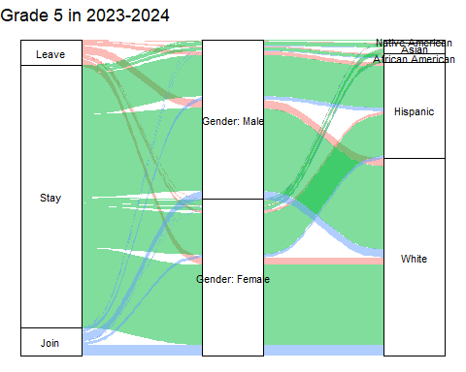
As shown in the table below, the non-white student population generally experiences a higher rate of student mobility. This is incredibly evident with a much higher proportion of African American students leaving between the 2022-2023 and 2023-2024 academic years. Similarly, students who are Native American also experience a higher rate of student mobility in both directions.
Demographics of Students from Grade 4 in 2022-2023 to Grade 5 in 2023-2024
 | Native American | Asian | African American | Hispanic | White
Leave | 17.8% | 7.7% | 21.4% | 6.8% | 7.8%
Stay | 64.4% | 83.4% | 69.0% | 86.3% | 82.6%
Join | 17.8% | 8.9% | 9.7% | 6.8% | 9.6%
As research suggests, student mobility has an impact on student performance. To further see these results, consider the plots below which show the achievement levels for the students who were in Grade 4 during 2022-2023 and Grade 5 during 2023-2024. That is, the “stay” mobility status are the same cohort of students. As expected, their achievement levels change slightly from one academic year to the next. However, there is a big difference in the achievement levels between the students who stayed as compared to those students who experience mobility. Those students who either left or joined between the 2022-2023 and 2023-2024 school years had lower proficiency and advanced rates, than their counterparts.
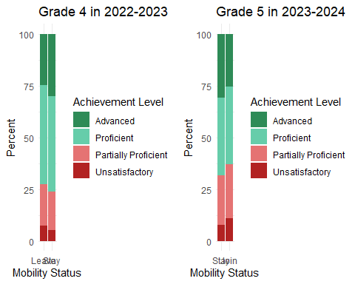

Data Notes
Note: This report is based on a demonstration dataset derived from the sgpData_Long dataset in the SGPData R package. The data has been subset to include only mathematics content area records. While it does not reflect actual student attendance, it preserves realistic patterns of student entry and exit. This allows the analysis to focus on student mobility, including those who join or leave the dataset over time.

