REVIEW PROBLEMS
QUESTION 1 : A study examined whether a nicotine lozenge can help a smoker to quit. The research article reports on many background variables, such as age, weight, gender, number of cigarettes smoked, and whether the person made a previous attempt to quit smoking (Shiffman et al., 2002). Suppose the researchers want to compare the distributions of the background variables between the two treatment groups (nicotine lozenge or placebo lozenge).
- a. For each of the five variables listed, indicate whether it calls for a comparison of means or a comparison of proportions.
- Age (quantitative variable) – comparison of means
- Weight (quantitative variable) – comparison of means
- Gender (categorical variable) – comparison of proportions
- Number of cigarettes smoked (quantitative variable) – comparison of means
Whether the person made a previous attempt to quit smoking (categorical variable) – comparison of proportions
- b. Would the researchers hope to reject the null hypotheses or fail to reject the null hypotheses in these tests? Explain.
- The researchers would hope to fail to reject the null hypotheses in these tests because the null hypotheses would be that the two groups (those that use the nicotine lozenge and those that don’t) are identical with regard to each of these background variables. The researchers would be hoping that they would not find a statistically significant difference between the groups on any of these variables so that a difference between the groups on the response variable could be attributed to the nicotine lozenge.

- QUESTION 2: For several years in the 1990s, Kristen Gilbert worked as a nurse in the intensive care unit (ICU) of the Veteran’s Administration hospital in Northampton, Massachusetts. Over the course of her time there, other nurses came to suspect that she was killing patients by injecting them with the heart stimulant epinephrine. Gilbert was eventually arrested and charged with these murders. Part of the evidence presented against Gilbert at her murder trial was a statistical analysis of 1641 eight-hour shifts during the time Gilbert worked in the ICU. For each of these shifts, researchers recorded two variables: whether or not Gilbert worked on the shift, and whether or not at least one patient died during the shift.
a. Identify the observational units in this study.

- The observational unit is an eight-hour shift in the intensive care unit of the Veteran’s Administration hospital in Northampton, Massachusetts.
b. Which variable are you considering the explanatory variable?
- Whether or not Gilbert worked the shift

- c. Calculate the statistic.

- 𝑝̂DEATH_GilbertWorking - 𝑝̂DEATH_GilbertNOTWorking = 40/257 – 34/1384 = 0.131
d. The graph simulates randomly assigning the 1641 shifts to be with or without Gilbert. Based on the following output, will you reject or fail to reject the null hypothesis? Explain.
Our observed statistic, 0.131, is nowhere near this graph. If we were to extend the x-axis, the statistic of 0.131 would appear in the extreme right of the graph. This would lead to a very small p-value, close to zero. The p-value would be two-sided, but there would be no data at or equal to the statistic of 0.131 or not extreme values on both tails. Such a small p-value would constitute strong evidence against the null hypothesis, so we would reject the null hypothesis.
- e. Is this convincing evidence that Gilbert caused the higher probability of death of her shifts? Explain (as if her lawyer!).
- No, despite the very small p-value, this is still an observational study and we cannot draw cause-and-effect conclusions because of the presence of confounding variables (random assignment was not used in this study). Her lawyer could suggest a confounding variable about the shifts she worked/didn’t work. Perhaps she tended to work the “graveyard” (overnight) shifts and not the regular shifts and suppose the graveyard shift tends to see more deaths than the other shifts.
- f. Suggest another way of measuring how extreme the observed statistic is in the null distribution.
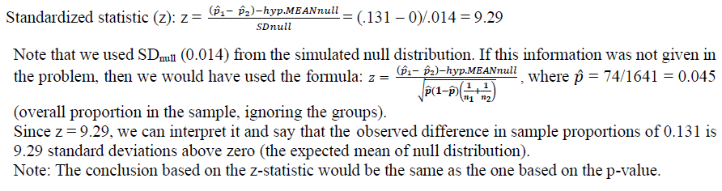
QUESTION 3: 4. In a 1993 study, researchers took a sample of people who claimed to have had an intense experience with an unidentified flying object (UFO) and a sample of people who did not claim to have had such an experience (Spanos et al., 1993). They then compared the two groups on a wide variety of variables, including IQ. Suppose you want to test whether or not the average IQ of those who have had such a UFO experience is higher than 100. The mean IQ of the 25 people in the study who claimed to have had an intense experience with a UFO was 101.6; the standard deviation of these IQs was 8.9.
- a. State the null and alternative hypothesis in symbols.
Ho: μ = 100 vs. Ha: μ > 100.
- b. Identify clearly what the symbol μ represents in this context.
In this context μ represents the average IQ of all people who claim to have had an intense experience with an UFO.

- c. Is this a one-sided or a two-sided test? Explain how you can tell.
This is a one-sided test, because we wish to test whether or not the average IQ of this group is greater than 100. So there is a clear direction in the research question.
- d. Are the validity conditions met to conduct a one-sample t-test? Explain.
The sample size is greater than 20, but we do not know what is the shape of the sample distribution of IQs (the shape of the sample distribution cannot be strongly skewed). So, at this point we are not sure if the validity conditions are met or not.
- e. Regardless of your answer to the previous question, calculate the test statistic and use technology (either R or applet) to find the theory-based p-value.
- Test statistic = t-statistic: = 0.90

- f. Write a sentence interpreting the p-value in the context of this sample and these hypotheses.
The p-value of 0.1888 is the probability of observing a sample mean of 101.6 or larger values, if the average IQ in the population is really 100 (null hypothesis is true).
- g. Give a conclusion in context, make sure you refer to the parameter.
We cannot claim that the mean IQ of the population of those who claim to have had an intense experience with an UFO is greater than 100. In other words, it is plausible to say that the mean IQ of the population (those who claim to have had an intense experience with an UFO) is 100.

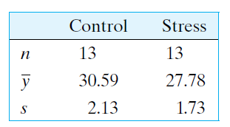
QUESTION 4: A plant physiologist conducted an experiment to determine whether mechanical stress can retard the growth of soybean plants. Young plants were randomly allocated to two groups of 13 plants each. Plants in one group were mechanically agitated by shaking for 20 minutes twice daily, while plants in the other group were not agitated. After 16 days of growth, the total stem length (cm) of each plant was measured, with the results given in the accompanying table.
Consider a t test to compare the treatments with the alternative hypothesis that stress tends to retard growth. Which t-test would we use? What is the value of the t test statistic for comparing the means?
Test statistic, t = 3.69. (Find the independent samples t test formula for test statistic)

