STAT 218 – Handout – Week 3 Lecture 2 Sampling Distributions

Recall the important terms parameter and statistic.
- A number describing a population is a parameter.
  - A parameter’s value is fixed but typically not known.
  - Symbols: μ for population mean, σ for population std dev, π for population proportion
- A number describing a sample is a statistic.
  - A statistic’s value can vary from sample to sample.
  - A statistic is often used to estimate a population parameter.
  - Symbols: $\overline{x}$ for sample mean, s for sample std dev, $\hat{p}$ for sample proportion

Example 1: Candy colors
Suppose that you take a random sample of 24 Reese’s Pieces candies and record the number and proportion of each color: orange, yellow, brown.
- What are the observational units and variable?

- Is the candy’s color a quantitative or categorical variable?

- Is the proportion of orange candies among your 24 candies a parameter or a statistic? What symbol should we use for it?

- Is the proportion of orange candies manufactured by Hershey a parameter or a statistic? What symbol should we use for it?

- Do you know the value of the proportion of orange candies manufactured by Hershey?

- Would you know the value of the proportion of orange candies among the 24 candies that you selected?

- Would every student obtain the same proportion of orange candies in their sample?

- If every student was to estimate the population proportion of orange candies by the proportion of orange candies in their sample, would everyone arrive at the same estimate?

- The values of statistics vary from sample to sample. This phenomenon is called sampling variability. Fortunately, if we look at the results of many samples, there is a predictable pattern to this variability.
  - Because random sampling is unbiased, the actual value of the population proportion should be close to the center of these sample proportions.

We will use an applet called “Reese’s Pieces” to simulate selecting many random samples. For now we will suppose that 50% of the population is orange.

- Use the “Reese’s Pieces” applet to draw 10,000 samples of 24 candies each, assuming that the population proportion of orange is 0.50. (Pretend that this is 10,000 students, each taking 24 candies and counting the number of orange ones.) Describe the distribution of the sample proportions obtained.

- Is there an obvious pattern to the distribution of the sample proportions of orange candies? Is it approximately normal?

- Even though the sample proportion of orange candies varies from sample to sample, there is a recognizable long-term pattern to that variation. This pattern is called the sampling distribution of the statistic.

- What are the mean and standard deviation of the 10,000 simulated sample proportions of orange candies?

- Now assume that the population proportion of orange candies is 0.55. What do you think will change in the sampling distribution? Again use the applet to draw 10,000 samples of 24 candies each. How has the distribution changed?

shape:
center:
variability:
- How do you predict the distribution of sample proportions to change if we take many random samples of 100 candies rather than 24? (Assume that the population proportion of orange candies is 0.55.)

- Use the applet to select 10,000 samples of 100 candies each. How has the distribution of sample proportions changed (or not changed) from when the sample size was only 24 candies?

shape:
center:
variability:

- A larger sample size produces less variability in sample statistics.

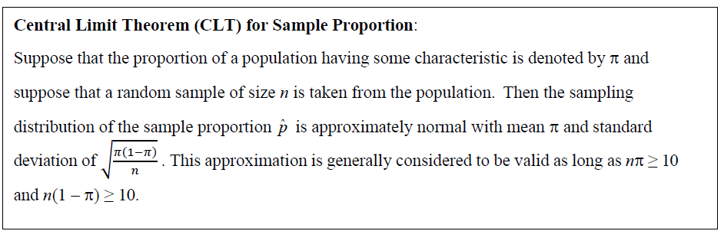
- Draw a sketch to represent this result, first in general and then applied to the candy example with n = 100 and assuming that the population proportion of orange is 0.55. Is this consistent with what the simulation revealed?

Example 2: Voter registration (Optional: Independent Work if time permits)

According to the California Secretary of State (https://elections.cdn.sos.ca.gov/ror/ror-odd-year- 2023/complete-ror.pdf), the number of Californians who were registered to vote as of February 10, 2023 was 21,980,768. This report also indicated that 22.5% of registered voters in California expressed no party preference (NPP) when they registered to vote.

- Is this number 0.225 a parameter or a statistic? Also identify it with the appropriate symbol.

Now consider selecting a simple random sample of 400 registered voters in California and determining the proportion of them who expressed no party preference.

- Is this number a parameter or a statistic? Also identify it with the appropriate symbol.

- How would the sample proportion who expressed no party preference vary from sample to sample? Describe its shape, center, and variability.

- Use One Proportion applet to select 10,000 samples of 400 registered voters each, assuming that the population proportion is 0.225. Describe the distribution of the sample proportions obtained. (Hint: Select “use spinners” and uncheck “Show animation”)

shape:
center:
variability:

- Draw a well-labeled sketch to illustrate how this sample proportion would vary by using the centra limit theorem for sample proportion. Also check the conditions for whether the approximation is reasonable.

