Approximation of Normal Distribution by Monte Carlo in R Markdown

Yiyi Xu

9/11/2018

#Abstrict

This

#Introduction

The main goal of this report is to

##Define a function which satisfy Monte Carlo Method.   
##create N iid r.v., use Monte Carlo method to find the probability of Xi>t   
F <- function(n,t){  
 set.seed(1)  
 (length(which(rnorm(n,0,1)<t)))/n  
}

|  |  |  |  |  |  |  |  |  |  |
| --- | --- | --- | --- | --- | --- | --- | --- | --- | --- |
| F(n,t) | t=0.000 | t=0.670 | t=0.840 | t=1.280 | t=1.650 | t=2.320 | t=2.580 | t=3.090 | t=3.720 |
| n=10 | 0.4600 | 0.7399 | 0.8199 | 0.9100 | 0.9699 | 0.9899 | 1 | 1 | 1 |
| n=100 | 0.5180 | 0.7419 | 0.8040 | 0.8920 | 0.9409 | 0.9899 | 0.9959 | 0.9989 | 0.9989 |
| n=1000 | 0.5068 | 0.7481 | 0.8015 | 0.8941 | 0.9494 | 0.9906 | 0.9959 | 0.9992 | 0.9999 |
| True Value | 0.5000 | 0.7486 | 0.7995 | 0.8997 | 0.9505 | 0.9898 | 0.9951 | 0.9990 | 0.9999 |

#G- function that blablab   
  
G <- function(n,t,p){  
 a <- c(0)  
 for(i in 1:n){  
 a[i] <- ((length(which(rnorm(n,0,1)<t)))/n)-p  
 }  
 a  
}  
  
#n=100, t=0.0 ,p=0.5  
a1 <- G(100,0.0,0.5)  
  
#n=100, t=0.67,p=0.7486  
a2 <- G(100,0.67,0.7486)  
  
#n=100, t=0.84,p=0.7995  
a3 <- G(100,0.84,0.7995)  
   
#n=100, t=1.28,p=0.8997  
a4 <- G(100,1.28,0.8997)  
   
#n=100, t=1.65,p=0.9505  
a5 <- G(100,1.65,0.9505)  
   
#n=100, t=2.32,p=0.9898  
a6 <- G(100,2.32,0.9898)  
   
#n=100, t=2.58,p=0.9951  
a7 <- G(100,2.58,0.9951)  
   
#n=100, t=3.09,p=0.9990  
a8 <- G(100,3.09,0.9990)  
  
#n=100, t=3.72,p=0.9999  
a9 <- G(100,3.72,0.9999)  
tValue <- c("t=0.0","t=0.67","t=0.84","t=1.28","t=1.65","t=2.32","t=2.58","t=3.09","t=3.72")  
boxplot(a1,a2,a3,a4,a5,a6,a7,a8,a9,names=tValue,main="Side-by-Side Boxplot of Bias of n=100",ylab="bias")

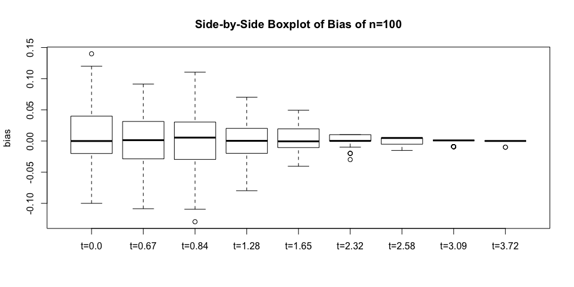

summary(cars)

## speed dist   
## Min. : 4.0 Min. : 2.00   
## 1st Qu.:12.0 1st Qu.: 26.00   
## Median :15.0 Median : 36.00   
## Mean :15.4 Mean : 42.98   
## 3rd Qu.:19.0 3rd Qu.: 56.00   
## Max. :25.0 Max. :120.00

## Including Plots

You can also embed plots, for example:

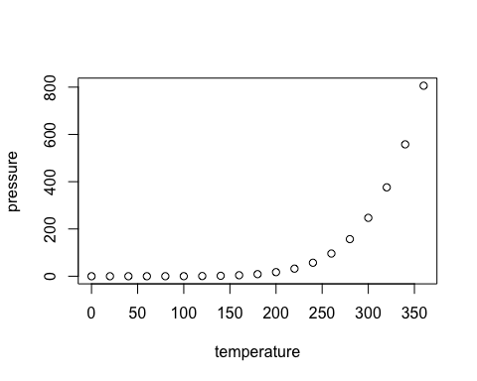

Note that the echo = FALSE parameter was added to the code chunk to prevent printing of the R code that generated the plot.