This problem is about abstract classes and it is requested to make an abstract class in the name of ClusteringOverSampler in base.py

The following steps were considered for attacking to the problem:

* Preparing a github ID by using my new PhD identifications and clone the project from Github.

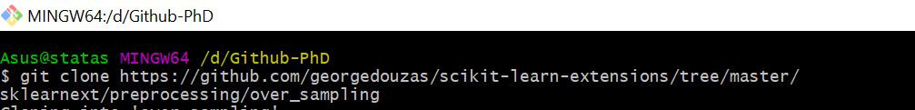

* Then upgrading all python packages

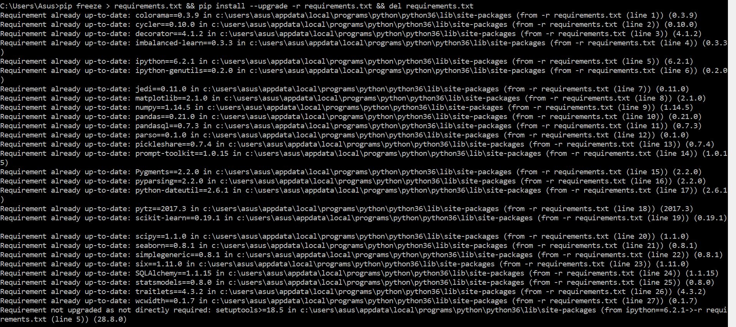

However the imbalanced-learn module was not recognized in python and as the result, the next steps were proceeded.

* installing the imbalanced-learn module for python and also Anacoda in two different steps

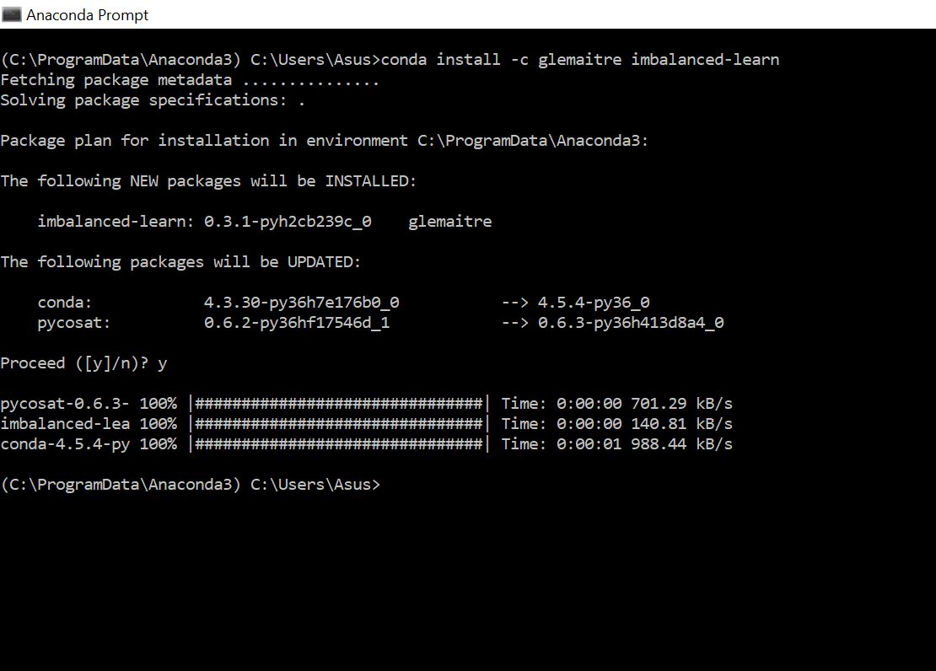

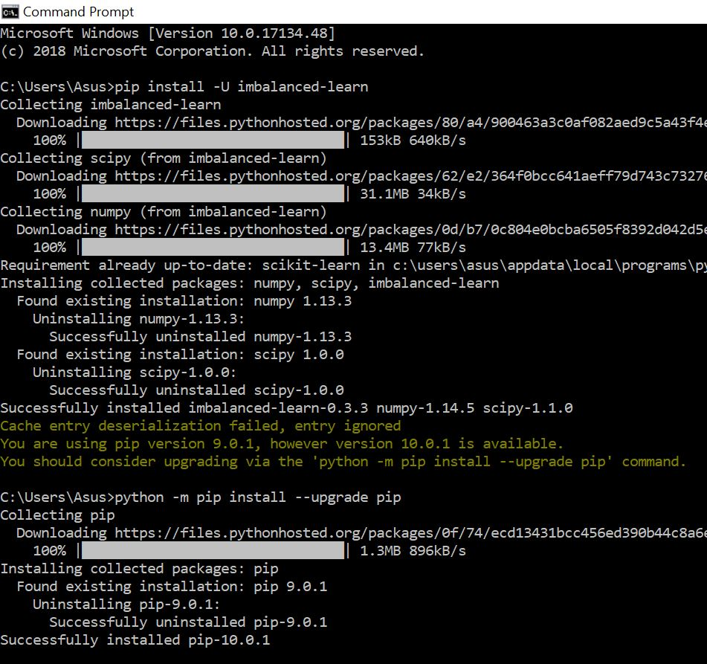

* Finally, checking that if the imbalanced-learn module and also imblearn are available for python by using the command (pip freez)

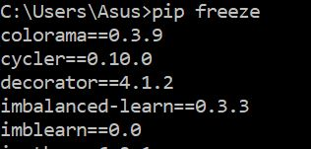

At this step, the python gets ready to deal with the problem. The base.py created and a test added to the tests folder.

|  |
| --- |
| from dbscan_smote import DBSCANSMOTE  from kmeans_smote import KMeansSMOTE  class ClusteringOverSampler(KMeansSMOTE,DBSCANSMOTE):  def __init__(self):  #super(Cluver, self).__init__()  super().__init__() |

|  |
| --- |
| """  Test base  """  import numpy as np  from base import ClusterOverSampler  # (or) from ..base import ClusterOverSampler  from sklearn.datasets import load_breast_cancer  rnd_seed = 0  X = np.array([[0.11622591, -0.0317206], [0.77481731, 0.60935141],  [1.25192108, -0.22367336], [0.53366841, -0.30312976],  [1.52091956, -0.49283504], [-0.28162401, -2.10400981],  [0.83680821, 1.72827342], [0.3084254, 0.33299982],  [0.70472253, -0.73309052], [0.28893132, -0.38761769],  [1.15514042, 0.0129463], [0.88407872, 0.35454207],  [1.31301027, -0.92648734], [-1.11515198, -0.93689695],  [-0.18410027, -0.45194484], [0.9281014, 0.53085498],  [-0.14374509, 0.27370049], [-0.41635887, -0.38299653],  [0.08711622, 0.93259929], [1.70580611, -0.11219234]])  y = np.array([0, 1, 0, 0, 0, 1, 1, 1, 1, 1, 1, 0, 0, 1, 1, 1, 1, 0, 1, 0])  over = ClusterOverSampler()  over.fit_sample(X,y) |