Assignment 2 - Compiling Advanced R

Chamundeswari Koppisetti

9/11/2020

## Firtsly, have set the current working directory

setwd("D:/Courses/Stat 5361 - Statistical Computing/Assignment 2/adv-r")

## Upgraded RStudio from older version to 4.0.2 and installed packages to the latest version

# install.packages("installr")  
# installr::updateR()  
R.version

## _   
## platform x86_64-w64-mingw32   
## arch x86_64   
## os mingw32   
## system x86_64, mingw32   
## status   
## major 4   
## minor 0.2   
## year 2020   
## month 06   
## day 22   
## svn rev 78730   
## language R   
## version.string R version 4.0.2 (2020-06-22)  
## nickname Taking Off Again

## Steps to build the book using Rstudio

## 1. Downloaded the sourcefile [*Compile Hadley’s Advanced R to a PDF*]

“<https://brettklamer.com/diversions/statistical/compile-hadleys-advanced-r-programming-to-a-pdf/>”

## 2. Installed R Package Dependencies:

# install.packages('bookdown')   
# install.packages("devtools")  
  
# devtools::install_github("hadley/sloop")  
# devtools::install_github("hadley/emo")

## 3. Used the below to compile the book:

# bookdown::render_book("index.Rmd", output_format = "bookdown::pdf_book")

## Below are the error messages I received and how I have solved them, during the building process

1. Missing packages: Used ‘install.packages()’ to install all these mentioned: *lobstr*, *ggplot2*, *dplyr*, *DBI*, *RSQLite*, *zeallot*, *dbplyr*, *profvis*, *bench*, *tidyr*, *ggbeeswarm*
2. ‘make’ not found: Installed *Rtools* manually and added the path (‘C:40’) to Evironment variables

knitr::include_graphics("D:/Courses/Stat 5361 - Statistical Computing/Assignment 2/Make.JPG")

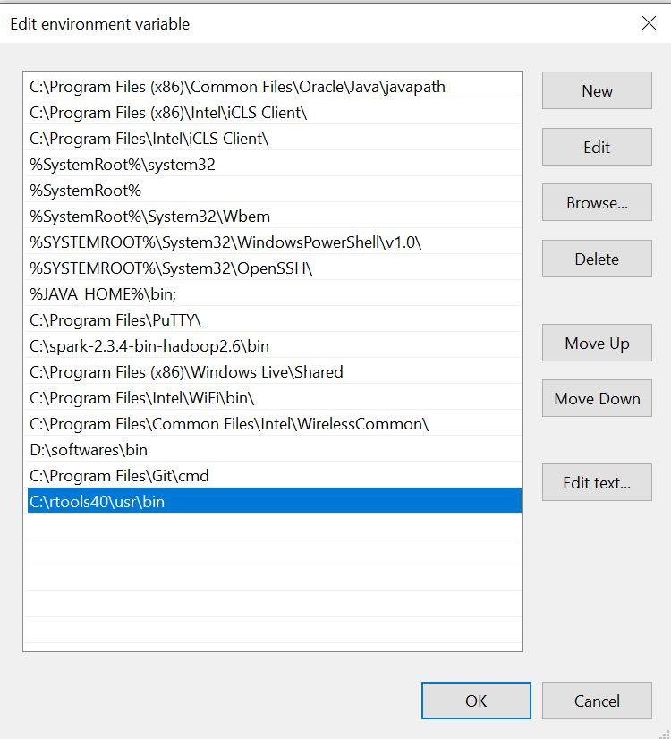

## Cross checked the path name of 'make' after installation  
  
Sys.which('make')

## make   
## "C:\\rtools40\\usr\\bin\\make.exe"

## 3. Font “Inconsolata” and “AndaleMono” not found:

3.1. Installed “Tex Liv” as it’s much more stable to “tinytex”

3.2. Downloaded ‘.ttf’ and ‘.otf’ files for “Inconsolata”, and ‘.ttf’ file for “AndaleMono”

3.3. Saved Opentype file(.otf) into latex folder: “C:/texlive/2020/texmf-dist/fonts/opentype/public/inconsolata”

True typefile(.ttf) into latex folder: “C:/texlive/2020/texmf-dist/fonts/truetype/public/inconsolata”, “C:/texlive/2020/texmf-dist/fonts/truetype/public/andalemono”

Note: .tex file can also be compiled using TeXworks editor of Tex Live

# Final ’_main.pdf’ is generated