Assignment 2 – Hybrid Images

First, I thought about which images I should try to merge into hybrid images. Since wrinkles in someone’s face appear to be high level features, I chose to use a photo of a young woman for the low pass image and an old woman for the high pass one.

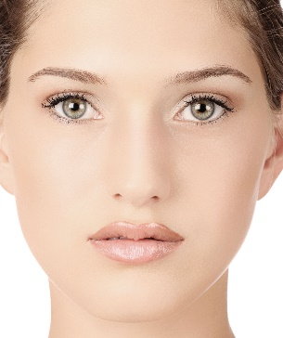 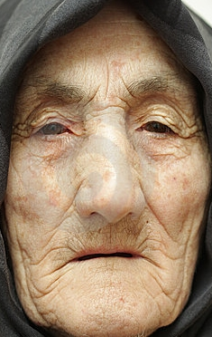

I also wanted to try one of the classic examples using Marilyn Monroe and Einstein. I mainly used this as a benchmark to see if I could make mine look like some of the other Einstein/Monroe hybrid images I have seen. Note that I have not seen these exact images combined into a hybrid image by anyone else.

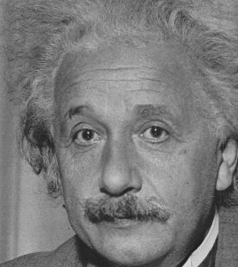 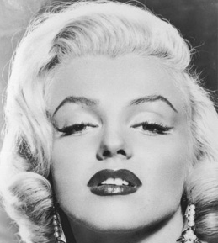

Finally, I found a picture of the same woman making different facial expressions and thought that would be interesting.

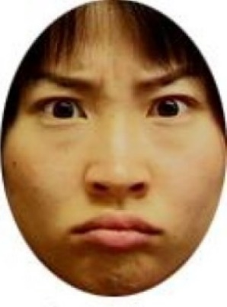 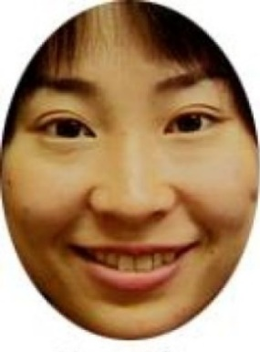

I will admit that this assignment was a bit confusing to me, especially the part about assembling the hybrid image in the reverse process of constructing the Gaussian/Laplacian pyramids. My code generates those pyramids but they are not what I ultimately use to create the hybrid image. I simply ran a Gaussian filter over one image with the desired blur (standard deviation) and also ran it on the other image with its own standard deviation and took the difference of it and the original image to create my Laplacian difference image. I got the impression that this is what was being done in the related paper too. All I had to do is play around with the standard deviations for each image filter and I was able to get some pretty cool looking hybrid image results. To create good-looking hybrid images, I sought out the best combinations of low/high pass filters to achieve the proper visual effect. This was manually tuned on a per image set basis. I consider a “good” hybrid image to be one where the two images are properly aligned and you can actually see both of the original image components depending on your distance or the image size. Below are the hybrid images and their pyramids.

Young/Old Woman:



   

Einstein/Monroe

   

Happy/Upset Woman

    

**Some other observations:** I noticed from some earlier trials that if you try and do this with cartoons with large areas of unchanging color, there is often not enough high frequency information to use in the illusion. That is why my attempt to merge Bulbasaur and Squirtle from Pokémon did not work out as initially planned. It kind of works but that is only because these images line up very well.

 

    