Title

(Author) $​^{1,*}$

**1** (Affiliation)

$*$ Correspondence:

(Name, Degree)

(Affiliation)

* (Address)

Tel: (Tel)

Fax: (Fax)

E-mail: [(Email)](mailto:%3CEmail%3E)

**keywords** : (Keywords)

## Abstract

(Abstract)

## Introduction

(Introduction)

## Data

### MissingData

| variable | n_miss | pct_miss |
| --- | --- | --- |

### Data Attributes

| 1 Column name: | mpg |
| --- | --- |
| Unique non-mission value count: | 25 |
| Missing value count: | 0 |

| Min | Mean | Median | Max | SD |
| --- | --- | --- | --- | --- |
| 10.4 | 20.09062 | 19.2 | 33.9 | 6.026948 |

| 2 Column name: | cyl |
| --- | --- |
| Unique non-mission value count: | 3 |
| Missing value count: | 0 |

| cat | n | com_freq | percent |
| --- | --- | --- | --- |
| 4 | 11 | 11 | 34.375 |
| 6 | 7 | 18 | 21.875 |
| 8 | 14 | 32 | 43.750 |

| 3 Column name: | disp |
| --- | --- |
| Unique non-mission value count: | 27 |
| Missing value count: | 0 |

| Min | Mean | Median | Max | SD |
| --- | --- | --- | --- | --- |
| 71.1 | 230.7219 | 196.3 | 472 | 123.9387 |

| 4 Column name: | hp |
| --- | --- |
| Unique non-mission value count: | 22 |
| Missing value count: | 0 |

| Min | Mean | Median | Max | SD |
| --- | --- | --- | --- | --- |
| 52 | 146.6875 | 123 | 335 | 68.56287 |

| 5 Column name: | drat |
| --- | --- |
| Unique non-mission value count: | 22 |
| Missing value count: | 0 |

| Min | Mean | Median | Max | SD |
| --- | --- | --- | --- | --- |
| 2.76 | 3.596563 | 3.695 | 4.93 | 0.5346787 |

| 6 Column name: | wt |
| --- | --- |
| Unique non-mission value count: | 29 |
| Missing value count: | 0 |

| Min | Mean | Median | Max | SD |
| --- | --- | --- | --- | --- |
| 1.513 | 3.21725 | 3.325 | 5.424 | 0.9784574 |

| 7 Column name: | qsec |
| --- | --- |
| Unique non-mission value count: | 30 |
| Missing value count: | 0 |

| Min | Mean | Median | Max | SD |
| --- | --- | --- | --- | --- |
| 14.5 | 17.84875 | 17.71 | 22.9 | 1.786943 |

| 8 Column name: | vs |
| --- | --- |
| Unique non-mission value count: | 2 |
| Missing value count: | 0 |

| cat | n | com_freq | percent |
| --- | --- | --- | --- |
| 0 | 18 | 18 | 56.25 |
| 1 | 14 | 32 | 43.75 |

| 9 Column name: | am |
| --- | --- |
| Unique non-mission value count: | 2 |
| Missing value count: | 0 |

| cat | n | com_freq | percent |
| --- | --- | --- | --- |
| 0 | 19 | 19 | 59.375 |
| 1 | 13 | 32 | 40.625 |

| 10 Column name: | gear |
| --- | --- |
| Unique non-mission value count: | 3 |
| Missing value count: | 0 |

| cat | n | com_freq | percent |
| --- | --- | --- | --- |
| 3 | 15 | 15 | 46.875 |
| 4 | 12 | 27 | 37.500 |
| 5 | 5 | 32 | 15.625 |

| 11 Column name: | carb |
| --- | --- |
| Unique non-mission value count: | 6 |
| Missing value count: | 0 |

| cat | n | com_freq | percent |
| --- | --- | --- | --- |
| 1 | 7 | 7 | 21.875 |
| 2 | 10 | 17 | 31.250 |
| 3 | 3 | 20 | 9.375 |
| 4 | 10 | 30 | 31.250 |
| 6 | 1 | 31 | 3.125 |
| 8 | 1 | 32 | 3.125 |

## Body Paragraph 1

### First Point about Topic

(First Point about Topic)

### Second Point about Topic

(Second Point about Topic)

## Body Paragraph 2

### First Point about Topic

(First Point about Topic)

### Second Point about Topic

(Second Point about Topic)

## Discussion

(Discussion)

## Figures

### Correlation

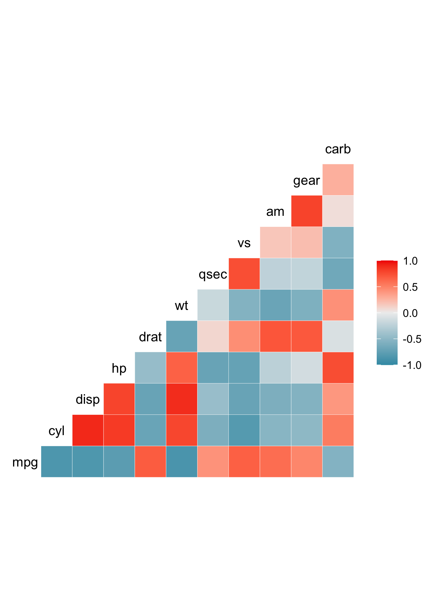

### MissingData

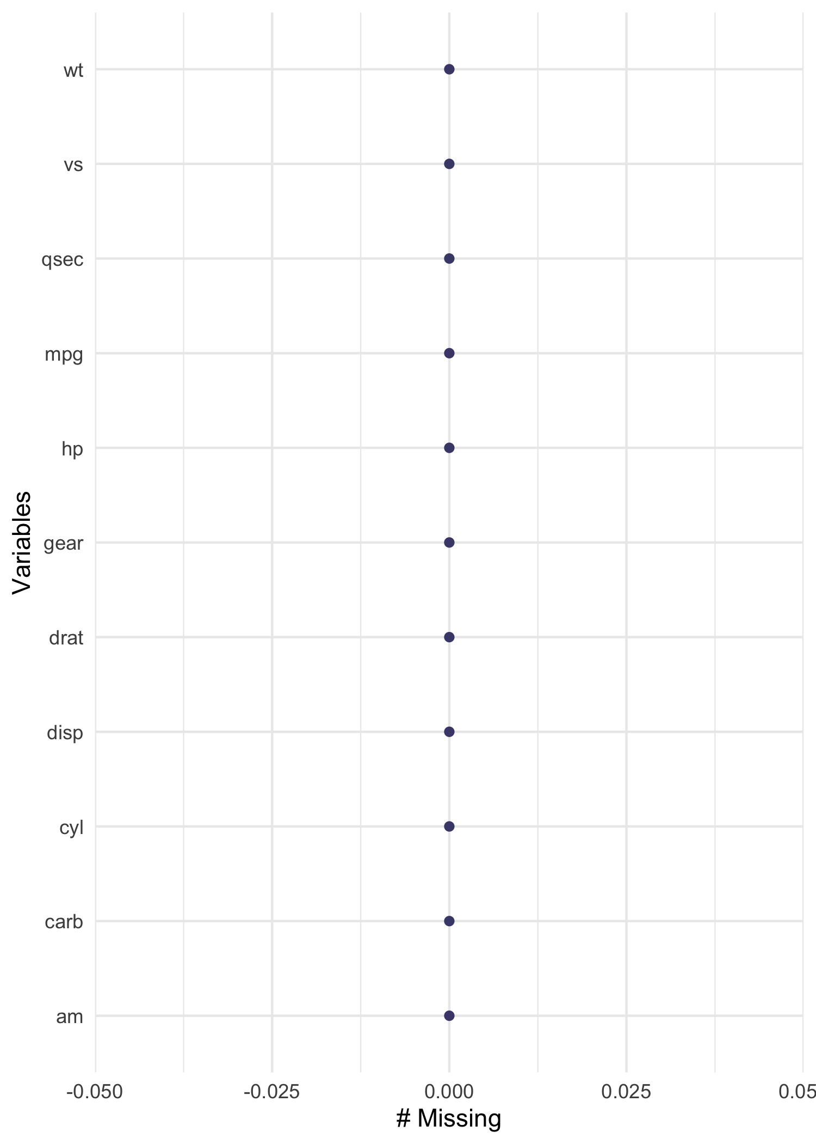

### Scatterplot

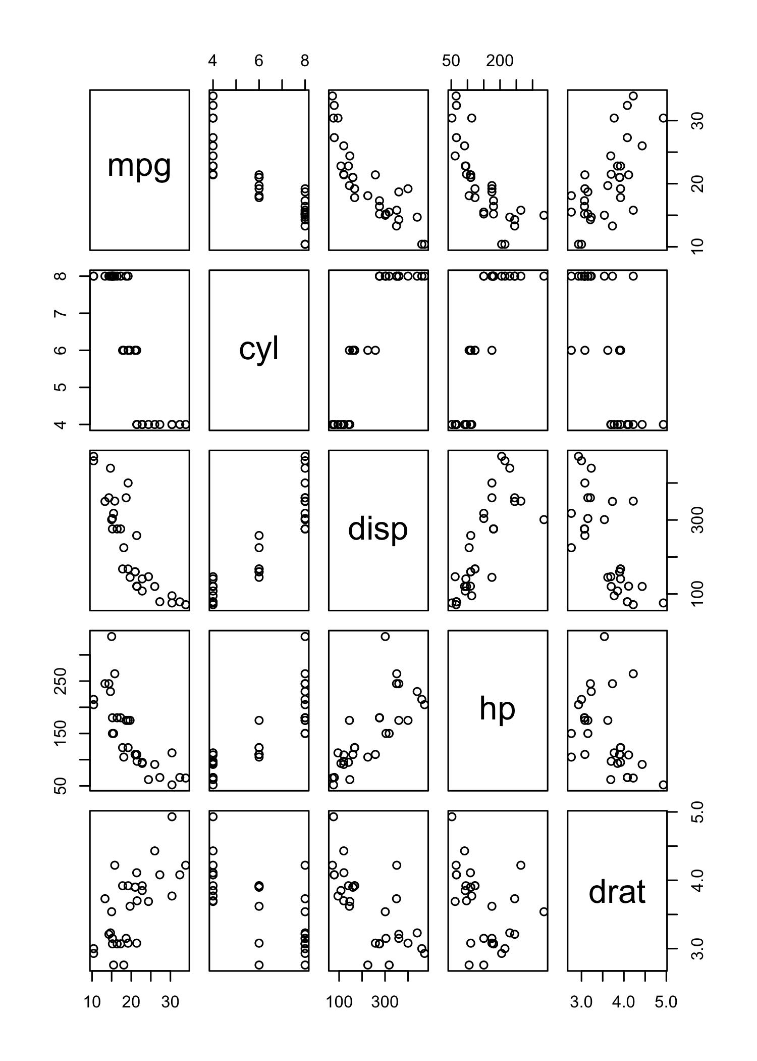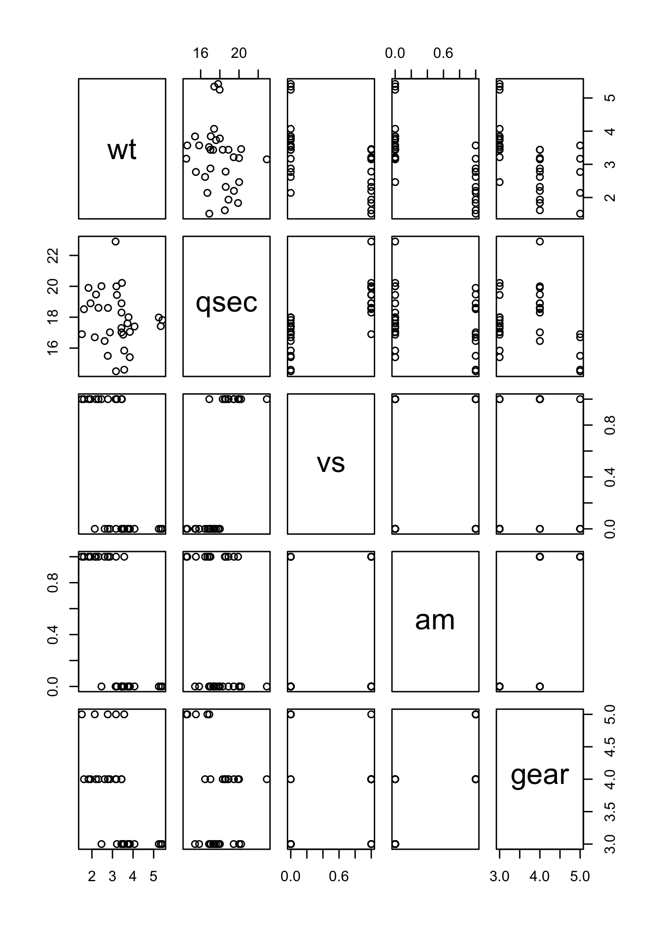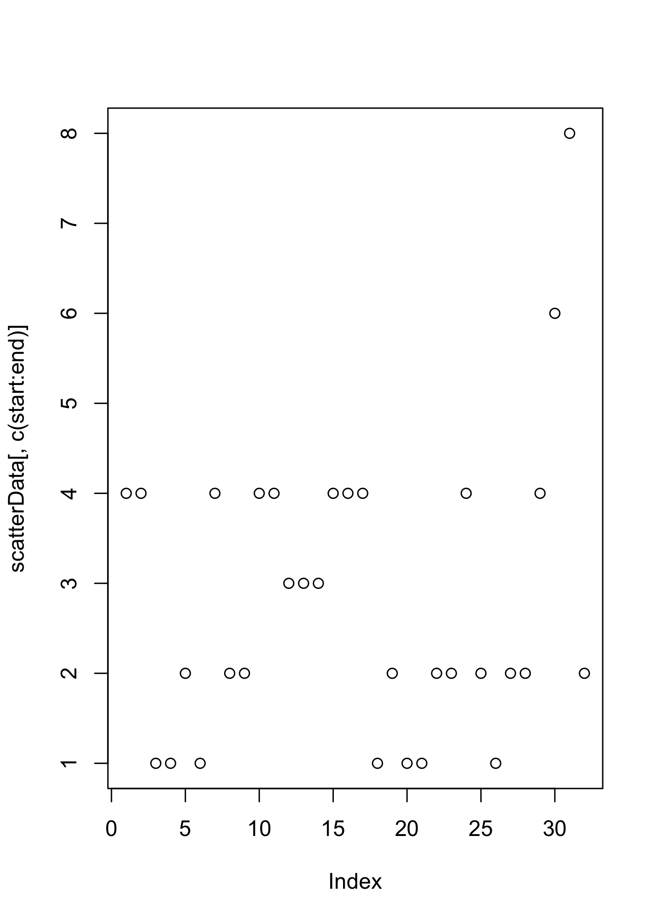

### Machine Learning Result

Machine Learning Result is not available.

## Reference

(Reference)