Simulation of Pedigrees and Analysis to Evaluate Power

Copyrighted © 2019 Suzanne M. Leal

- Exercises with Slink and MSIM

For documentation please refer to the webpage http://www.jurgott.org/linkage/SLINK.htm. You will probably have to refer to the documentation if you have not previously used the SLINK and MSIM programs. The flow chart on the last page of the documentation is especially useful.

Exercise 1A
When planning a linkage study or after collecting families it is often required to elucidate the amount of linkage information which can be obtained from a data set. Consider this situation, you have ascertained two autosomal dominant pedigrees.

Pedigree 1
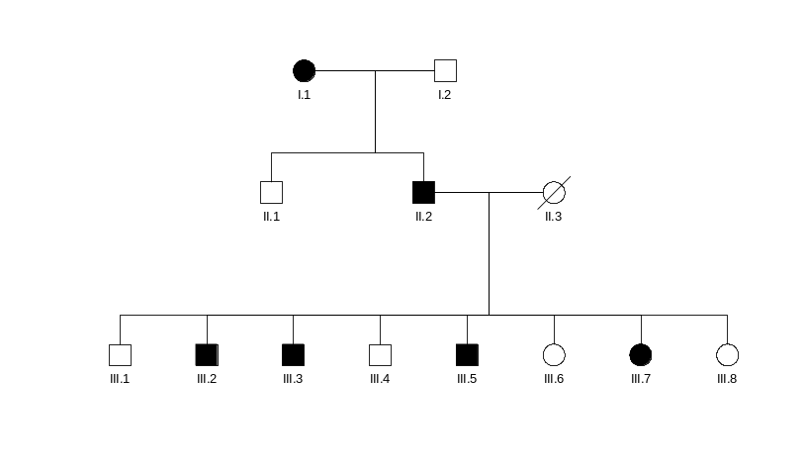
Pedigree 2
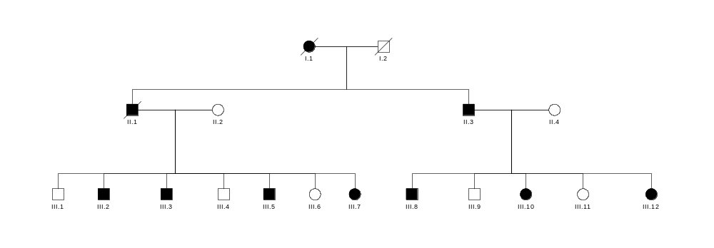

The disease phenotype is fully penetrant with no phenocopies. The disease allele frequency is 0.001. You estimate that the average heterozygosity of the markers you will use in your linkage study (genome scan) is 0.8 (use 5 alleles of equal frequency at the marker locus for the simulation study). You want to know what the power and ELOD is for a genome scan for the worst case scenario that your disease locus is 5 cM from the nearest marker. Therefore you wish to generate the data with the recombination fraction, θ= 0.05 between the disease and marker loci. Using preplink create a parameter file (datafile) called “simdata.dat”.

2 0 0 5 << NO. OF LOCI, RISK LOCUS, SEXLINKED (IF 1) PROGRAM
0 0.0 0.0 0 << MUT LOCUS, MUT MALE, MUT FEM, HAP FREQ (IF 1)
1 2
1 2 << AFFECTION, NO. OF ALLELES
0.99900 0.00100 << GENE FREQUENCIES
1 << NO. OF LIABILITY CLASSES
0 1.0000 1.0000 << PENETRANCES
3 5 << ALLELE NUMBERS, NO. OF ALLELES
0.20000 0.20000 0.20000 0.20000 0.20000 << GENE FREQUENCIES
0 0 << SEX DIFFERENCE, INTERFERENCE (IF 1 OR 2)
0.0500 << RECOMBINATION VALUES
1 0.10000 0.45000 << REC VARIED, INCREMENT, FINISHING VALUE

Enter the pedigree data in linkage file format. Please enter the pedigrees by examining the drawings above. You will notice that you can create the second pedigree drawing by coping the first pedigree drawing and adding additional numbers. It is easiest to number the individuals in the pedigrees 1, 2, 3, etc.. Make a pre-makeped file called “simped.pre” then run makeped with the following command at the prompt

makeped simped.pre simped.dat n

to create a post makeped file called “simped.dat”.

Note that there are two difference in your pedigree file then when carrying out linkage analysis. For each marker you wish to generate there are two columns of 0s (for this example only 1 marker will be generated). The last column you must supply the availability code - for the individuals who are deceased and you will never be able to obtain a DNA sample for them - use the availability code 0. No genotype data will be generated for these individuals. Assume that you will be able to obtain DNA samples on all other family members - use an availability code of 2. Although sample “simped.pre” and “simped.dat” files are provided for you do not enter in the data by looking at these two files. Please enter in the pedigree files based upon the two pedigrees you will use for the exercises. Please note that it is easiest to number the individuals 1, 2 , 3 etc. You will observe that you can simply make pedigree 2 by copying pedigree 1 changing the id number to two, change the affection status of individual and 3 give him a wife. Then make sure each one of the brothers has the appropriate number of children.

Simped.dat

1 1 0 0 3 0 0 2 0 2 0 0 2 Ped: 1 Per: 1
1 2 0 0 3 0 0 1 1 1 0 0 2 Ped: 1 Per: 2
1 3 2 1 0 4 4 1 0 1 0 0 2 Ped: 1 Per: 3
1 4 2 1 6 0 0 1 0 2 0 0 2 Ped: 1 Per: 4
1 5 0 0 6 0 0 2 0 1 0 0 0 Ped: 1 Per: 5
1 6 4 5 0 7 7 1 0 1 0 0 2 Ped: 1 Per: 6
1 7 4 5 0 8 8 1 0 2 0 0 2 Ped: 1 Per: 7
1 8 4 5 0 9 9 1 0 2 0 0 2 Ped: 1 Per: 8
1 9 4 5 0 10 10 1 0 1 0 0 2 Ped: 1 Per: 9
1 10 4 5 0 11 11 1 0 2 0 0 2 Ped: 1 Per: 10
1 11 4 5 0 12 12 2 0 1 0 0 2 Ped: 1 Per: 11
1 12 4 5 0 13 13 2 0 2 0 0 2 Ped: 1 Per: 12
1 13 4 5 0 0 0 2 0 1 0 0 2 Ped: 1 Per: 13
2 1 0 0 3 0 0 2 0 2 0 0 0 Ped: 2 Per: 1
2 2 0 0 3 0 0 1 1 1 0 0 0 Ped: 2 Per: 2
2 3 2 1 1 4 4 4 1 0 2 0 0 2 Ped: 2 Per: 3
2 4 2 1 6 0 0 1 0 2 0 0 0 Ped: 2 Per: 4
2 5 0 0 6 0 0 2 0 1 0 0 2 Ped: 2 Per: 5
2 6 4 5 0 7 7 1 0 1 0 0 2 Ped: 2 Per: 6
2 7 4 5 0 8 8 1 0 2 0 0 2 Ped: 2 Per: 7
2 8 4 5 0 9 9 1 0 2 0 0 2 Ped: 2 Per: 8
2 9 4 5 0 10 10 1 0 1 0 0 2 Ped: 2 Per: 9
2 10 4 5 0 11 11 1 0 2 0 0 2 Ped: 2 Per: 10
2 11 4 5 0 12 12 2 0 1 0 0 2 Ped: 2 Per: 11
2 12 4 5 0 0 0 2 0 2 0 0 2 Ped: 2 Per: 12
2 13 0 0 14 0 0 2 0 1 0 0 2 Ped: 2 Per: 13
2 14 3 13 0 15 15 1 0 2 0 0 2 Ped: 2 Per: 14
2 15 3 13 0 16 16 1 0 1 0 0 2 Ped: 2 Per: 15
2 16 3 13 0 17 17 2 0 2 0 0 2 Ped: 2 Per: 16
2 17 3 13 0 18 18 2 0 1 0 0 2 Ped: 2 Per: 17
2 18 3 13 0 0 0 2 0 2 0 0 2 Ped: 2 Per: 18

simped.pre

1 1 0 0 2 2 0 0 2
1 2 0 0 1 1 0 0 2
1 3 2 1 1 1 0 0 2
1 4 2 1 1 2 0 0 2
1 5 0 0 2 1 0 0 0
1 6 4 5 1 1 0 0 2
1 7 4 5 1 2 0 0 2
1 8 4 5 1 2 0 0 2
1 9 4 5 1 1 0 0 2
1 10 4 5 1 2 0 0 2
1 11 4 5 2 1 0 0 2
1 12 4 5 2 2 0 0 2
1 13 4 5 2 1 0 0 2
2 1 0 0 2 2 0 0 0
2 2 0 0 1 1 0 0 0
2 3 2 1 2 1 0 0 2
2 4 2 1 1 2 0 0 0
2 5 0 0 2 1 0 0 2
2 6 4 5 1 1 0 0 2
2 7 4 5 1 2 0 0 2
2 8 4 5 1 2 0 0 2
2 9 4 5 1 1 0 0 2
2 10 4 5 1 2 0 0 2
2 11 4 5 2 1 0 0 2
2 12 4 5 2 2 0 0 2
2 13 0 0 2 1 0 0 2
2 14 3 13 1 2 0 0 2
2 15 3 13 1 1 0 0 2
2 16 3 13 2 2 0 0 2
2 17 3 13 2 1 0 0 2
2 18 3 13 2 2 0 0 2

For this example you will generate 100 replicates. You will need to make a file named “slinkin.dat”. This file contains three seeds for the random number generator each <30,000 (8149 28764 24202), the number of replicates (100), loci number for the disease locus (1) and the proportion of unlinked families (0.0). When running the program under Unix, Slink requires a slightly different file format for “slinkin.dat”. Only one seed should be supplied. The file format is seed, number of replicates, disease locus, and proportion of unlinked families with each parameter on a separate line. If you use the same seeds your results will always be the same, using different seeds will produce slightly different results. Please note that after each run slink will rewrite the “slinkin.dat” file with new seed values.

Slinkin.dat (DOS)

8149 28764 24202 100 1 0.000000

Slinkin.dat (UNIX)

8149
100
1
0

Begin the SLINK program by typing slink at the prompt. After a few seconds you will have generated a file with 200 pedigrees (100 replicates for each pedigree) – “pedfile.dat”. Using an editor program (e.g. notepad, edit) open “pedfile.dat” and examine its contents. You will now need to analyze the generated pedigrees. First use the program unknown which will create the “ipedfile.dat”. Before you can analyze the pedigrees you will need to create a “datafile.dat” which contains the parameter values which you wish to use in the analysis of these pedigrees. For this example the pedigrees will be generated and analyzed using the same parameters. You wish to evaluate theta from 0 to 0.15 [note that since msim uses interpolation to calculate the power and average maximum lod score, the value of theta can be small but not equal to 0 (e.g. 0.00001)]. You will also need to create a “limit.dat” file. This file should contain three values (e.g. 1 2 3 or 2 3 3.3.), which are cut-off values for the power calculations. The program will calculate the number of replicates which have a lod score equal or greater than these values. For example if you wish to calculate the power of obtain a lod score of ≥3 or greater you would include this value in your limit.dat file. If 50 of 100 replicates has a lod score of
≥3 your power estimate would equal 0.50. Note the limit file must specify three numbers.

Datafile.dat
2 0 0 5 << NO. OF LOCI, RISK LOCUS, SEXLINKED (IF 1) PROGRAM
0 0.0 0.0 0 << MUT LOCUS, MUT MALE, MUT FEM, HAP FREQ (IF 1)
1 2
1 2 << AFFECTION, NO. OF ALLELES
0.99900 0.00100 << GENE FREQUENCIES
1 << NO. OF LIABILITY CLASSES
0 1.0000 1.0000 << PENETRANCES
3 5 << ALLELE NUMBERS, NO. OF ALLELES
0.20000 0.20000 0.20000 0.20000 0.20000 << GENE FREQUENCIES
0 0 << SEX DIFFERENCE, INTERFERENCE (IF 1 OR 2)
0.000001 << RECOMBINATION VALUES
1 0.01000 0.15000 << REC VARIED, INCREMENT, FINISHING VALUE

Limit.dat
1 2 3

To run the MSIM program simply type msim at the prompt. You can find the results from the MSIM program in the file “msim.dat”
Questions

- With which pedigree should you be able to establish linkage________.

- If you use the criterion of a lod score of 3 or greater to establish linkage what is the power for:
  - Pedigree 1 ____________
  - Pedigree 2 _____________
  - Pedigrees 1 & 2 _________.

3.) Use the binom program to calculate the 95% confidence interval for the power estimate for:
- Pedigree 2 _____________
- c.) Pedigrees 1 & 2 _________.

4.) What is the expected lod score (ELOD) for both pedigrees at 0.05 ____________

- What is the expected maximum lod score (EMLOD) for:
  - Pedigree 1 ____________
  - Pedigree 2 _____________
c.) Pedigrees 1 & 2 _________.

- Would you consider carrying out a genome scan with these two pedigrees. yes/no

- If you ascertained two additional pedigrees and carried out a simulation study, could you sum the

a.) ELODs from the two studies yes/no
b.) EMLODs from the two studies yes/no

Answers

1. With which pedigree should you be able to establish linkage pedigree two
2. If you use the criterion of a lod score of 3 or greater to establish linkage what is the power for:
    - Pedigree 1 0.0
    - Pedigree 2 0.36
    - Pedigrees 1 & 2 0.63
3. Use the binom program to calculate the 95% confidence interval for the power estimate for:
    - Pedigree 2 0.27, 0.46
    - Pedigrees 1 & 2 0.53 , 0.72
4. What is the expected lod score (ELOD) for both pedigrees at 0.05 3.21
5. What is the expected maximum lod score (EMLOD) for:
  - Pedigree 1 1.53
  - Pedigree 2 2.12
c.) Pedigrees 1 & 2 3.44
6.) Would you consider carrying out a genome scan with these two pedigrees? yes
7.) If you ascertained two additional pedigrees and carried out a simulation study, could you sum the
a.) ELODs from the two studies yes
b.) EMLODs from the two studies no

Output for msim.dat (edited) – your results will differ slightly if you used different random seeds.

********* Data from most recent SIMOUT.DAT *********
The random number seeds are: 8149 28764 24202
The number of replications is: 100
The requested proportion of unlinked families is: 0.000
The trait locus is locus number: 1
Summary Statistics about simped.dat
Number of pedigrees 2
Number of people 31
Number of females 13
Number of males 18
There were 4 in category: Marker Unknown; Trait original
There were 0 in category: Marker Available; Trait simulated
There were 27 in category: Marker Available; Trait original
There were 0 in category: Marker Unknown; Trait simulated
LINKAGE/SLINK (V2.65) WITH 2-POINT AUTOSOMAL DATA
-----------------------------------
LINKED ORDER OF LOCI: 1 2
-----------------------------------
-----------------------------------
-----------------------------------
TRUE THETAS FOR LINKED ORDER 0.050000
-----------------------------------
-----------------------------------
UNLINKED ORDER OF LOCI: 1 2
-----------------------------------
-----------------------------------
TRUE THETAS FOR UNLINKED ORDER 0.500000
-----------------------------------
Elapsed Time for one replicate = 0.06 seconds

Elapsed Time = 0.09 min. or 0.00 hours
-----------------------------------
Actual proportion of unlinked families: 0.000
********* End of most recent SIMOUT.DAT *********

ORDER OF LOCI: 1 2
Average Lod Scores at Given Thetas

Number of replicates = 100

------------------------------------------------------------------
THETAS 0.000
------------------------------------------------------------------
Pedigree Average StdDev Min Max
1 -0.696564 4.120186 -16.795881 2.709266
2 -0.192273 4.112022 -14.479072 3.520926

Study -0.888837 6.014614 -25.330001 6.230192
------------------------------------------------------------------
THETAS 0.010
------------------------------------------------------------------
Pedigree Average StdDev Min Max
1 1.112458 1.503211 -4.804436 2.665662
2 1.734101 1.528157 -2.525151 3.461623

Study 2.846559 2.171860 -5.389043 6.127285
------------------------------------------------------------------
------------------------------------------------------------------
THETAS 0.150
------------------------------------------------------------------
Pedigree Average StdDev Min Max
1 1.191908 0.812691 -1.395442 2.016773
2 1.653270 0.854942 0.110272 2.575000

Study 2.845178 1.155336 -0.381981 4.591773
------------------------------------------------------------------
------------------------------------------------------------------
Average Maximum Lod Scores based on quadratic interpolation
------------------------------------------------------------------
Pedigree Average StdDev Min Max
1 1.526861 1.033875 0.000000 2.709266
2 2.119487 1.199971 0.190864 3.520926

Study 3.478750 1.564406 0.000000 6.230192
------------------------------------------------------------------

------------------------------------------------------------------
Number of (interpolated) maximum lod scores greater than
a given constant
------------------------------------------------------------------
Constant Pedigree Number Percent
1.000 1 66 66.000
1.000 2 83 83.000
1.000 Study 95 95.000
2.000 1 43 43.000
2.000 2 45 45.000
2.000 Study 79 79.000
3.000 1 0 0.000
3.000 2 36 36.000
3.000 Study 63 63.000
------------------------------------------------------------------
Please use these two references when reporting results based on SLINK:

Ott J (1989) Computer-simulation methods in human linkage analysis.
Proc Natl Acad Sci USA 86:4175-4178

Weeks DE, Ott J, Lathrop GM (1990) SLINK: a general simulation
program for linkage analysis. Am J Hum Genet 47(3):A204 (Supplement)

