Title of the Paper: Title Case Times New Roman 14 Bold Max. 90 Char. incl. spaces
Abstract No. Theme No-To be filled by the organizers

A.B. Author1(Times New Roman 11)
Designation, Department /Institution, City – PINCODE, Email: …(TNR 9)…………
C.D. Author2
Designation, Department, Institution, City -PINCODE, Email: ……………
E.F. Author3
Designation, Department, Institution, City -PINCODE, Email: ……………

ABSTRACT: Max. 250 words; Times New Roman 10 pt. Single spacing. The present article presents the style in which papers should be submitted to Aakruthi-2012. This has been done to relieve the authors of the painstaking style of cutting and pasting. In order that all papers shall have a similar typography, it is important that authors follow the instructions listed below. Line drawings can be printed on the laser printer or they can be pasted in the text. Photographs should not be scanned and screened. Appropriate open space should be left in the text and the original good quality photographs pasted therein. The paper should be of A4 size (210 × 297 mm).Verbatim repetition of the matter in the abstract in the introduction to be avoided.
19.5mm
19.5mm

KEY WORDS: Maximum of 5 key words which are most relevant to the paper.
83 mm 5 mm 83 mm

INTRODUCTION (10 pt BOLD CAPS)
This is the format for full length papers (general, keynote and theme papers) of Aakruthi’12, to be held at Osmania University, Hyderabad, during March 9th-10th. Restrict the length of the paper to 6 pages.

Type Area (10 pt BOLD Title Case)
Use only one side of the paper. The total width of the type area has to be 171 mm and the height of the text on each page 247 mm. The text and figures should fit exactly into the type area (171 × 247 mm). The paper should be typed in two columns. The width of each column should be 83 m and leave a gutter of 5 mm between the two columns.

Typeface, Type size and Indenting
Use Times New Roman font of 10-point size with single spacing. Use Times New Roman font of standard type except for the headings (see below) and parameters in equations ( log, sin, cos, ln, max., d (in dx), etc.).

Do not indent any line or paragraph.

LAYOUT OF TEXT

Title of the paper
Type the title of the paper in upper case (Times New Roman, 14- point) at the top of the first page. The title should not be longer than 90 characters. Justify the title at the centre. Title should be concise and informative. Titles are often used in information-retrieval systems. Avoid abbreviations and formulae where possible.

Type the name(s) of the author(s) underneath the title. Initials should precede the surname. The author’s affiliation should follow in the next line. Type names of authors with the same affiliation after each other, use comma or & between the names.

Abstract
Begin the paper with an abstract of not more than 250 words. Type the first line of the abstract 50 mm from the top of the type area. Type the word ABSTRACT: followed directly by the abstract itself, which should run across both the columns. Leave two blank lines before starting the text (or first heading) of the paper.
A concise and factual abstract is required. The abstract should state briefly the purpose of the research, the principal results and major conclusions. An abstract is often presented separately from the article, so it must be able to stand alone. For this reason, References should be avoided, but if essential, then cite the author(s) and year(s). Also, non-standard or uncommon abbreviations should be avoided, but if essential they must be defined at their first mention in the abstract itself.

Headings
Type primary headings in CAPITAL BOLD letters in Times New Roman font (size 10) and secondary headings in Title Case (First letter of each word in capital except words like at, on, the, of, and etc.). Leave one blank line above and none beneath all the headings. Do not indent the heading or the first line of text following the heading. If a primary heading is immediately followed by a secondary heading, place one blank line above the primary heading and none beneath. For the secondary heading, leave one blank line above and none beneath. If a heading falls at the bottom of a column, transfer it to the top of the next column/page and leave an open space at the bottom. No blank space should appear above a heading at the top of a page or column.

Third Level Heading
The third level heading will be in Title Case, Italics, bold with first letter of each word Capital. Type headings flush against the left margin of the relevant column. Leave one line blank above and none below the third level heading.

Photographs, Figures, Equations and Tables
Number the figures consecutively in the order in which reference is made to them in the text, making no distinction between diagrams and photographs. Figures and tables may be either 83 mm wide (one column) or 171 mm wide (two columns).
Figures, photographs, etc. should be in black and white only. Paste them on the typescript after the paragraph in which reference is made to them in the text. Centre the figures and the photographs either in a single column or two columns. Leave about two lines of space between the actual text and the figure (including caption). While pasting the figures, place the actual lines of the figure immediately against the top of the type area: ignore the open space which may be present above the lines of the figure. Line drawings (as well as photographic reproductions of these) should be in black (not grey) on white. Ensure that the legend in the figures is clear and legible.

Photographs should be in black and white, with good contrast and printed on a glossy paper. Photographic reproductions cut from books or journals or photocopies of photographs and screened photographs are unacceptable. Scanned photographs can be printed in the text, but the original photographs should always be provided.
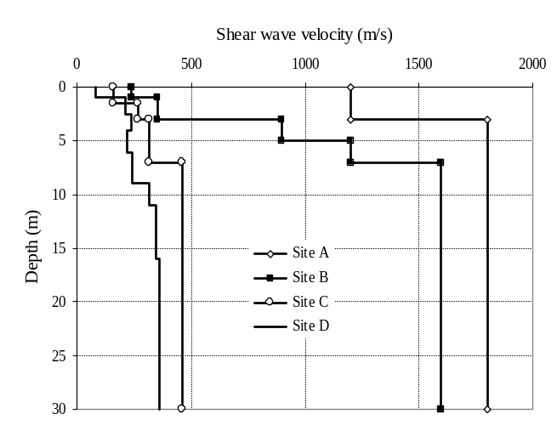

Fig. 1 Representative shear wave velocity profiles at Delhi
Number the tables consecutively and place them close to the first reference to them in the text. Give explanations at the foot of the table and not within the table itself. Use only horizontal lines; align all headings to the left of their column and start these headings with an initial capital. Type the caption in title case above the table to the same width as the table. Results should be presented either in the form of graphs or in the form of tables but not both.

Table 1 Margin settings for A4 size paper
Margin | Size (cm)
Top Margin | 2.39
Bottom | 2.41
Left | 1.88
Right | 1.85
All other | 0.0
Column width | 8.0
Column spacing | 1.27

Equation

Set equations against the left margin of the column and number them consecutively. Refer to equations by these numbers in the text. Leave one blank line between equations and the text, and between two equations.

Equations must be typed in the equation editor. Equations should NOT be typed in regular text. Equations are not indented and should be in Times New Roman, 10pt. Align the equation to the left and keep one open line before and one open line beneath the equation. Number equations consecutively and place the number at the end of the line, between parentheses. Refer to equations by these numbers in the text.

Example:
The maximum contact moment, M_{max}, is quantified by
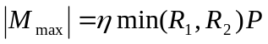 (1)
where R = particle radius; P = contact normal force; and
η = coefficient of rotational sliding. Eq. (1) suggests that the generated rotational moment and its maximum value depend on the normal contact force. Please define all the parameters in the equation and use SI unit.

CONCLUSIONS
State concisely the most important findings of the work presented in the paper as well as the author’s views on the practical implications / applications of the results in the conclusions.

REFERENCES, SYMBOLS AND UNITS
The references should be typed in 10 pt on single line spacing, following the alphabetical order, in the following style.
Brown, E.T. and Trollope, D.H. (2009). Strength of a model of jointed soil. Soils and Foundations, 96(SM2), 685-704.
Einstein, H.H., Choudhury, D. and Viswanadham, B.V.S. (1998). Model studies on mechanics of engineering. Journal of Geotechnical and Geoenvironmental Engineering, ASCE, 90(3), 229-248.

Right, K.H., Murty, D.S. and Venkatachalam, G. (1995). Review of reliability engineering in geotechnics. Proc. 4th International Conference on Reliability Engineering, Feb. 3-5, 1995, Madrid, Spain, J.H.Lu, M.V.Chin, A.Juneja (eds.), Balkema (Pubs.), Vol. 1, 201-210.
Violet, I., Mhaiskar, S.M. and Mandal, J.N. (2008). Geosynthetics Practices. 3rd Ed., Prentice Hall, New Delhi, India.
Singh, D. (1991). Static response of fibre reinforced soil, Doctoral Thesis, Indian Institute of Technology Bombay, Mumbai, India.

Write the references in the text as shown in the examples below.

- References in the text: Figure 1, Figures 2-4, 6, 8a, b.
- References between parentheses: (Fig.1), (Figs 2-4, 6, 8a, b).
- Author & Author (1989) instead of Author and Author (1989).
- (Author 1989a, b, Author & Author 1987) instead of (Author, 1989a,b; Author and Author, 1987).
- (Author et al. 1989) instead of (Author, Author & Author 1989)

ACKNOWLEDGMENTS
The organizing committee is really grateful for your cooperation to follow this template in preparing your manuscript.

Copyright Permissions
For any material which is not original, copyright permission to reproduce the material must be obtained in advance in writing by the author(s) from those concerned. Appropriate acknowledgements should be included in the text.

- Always use the official SI notations.

