three systems:

* smart infrastructure
* smart management
* smart protection

defining smart and conventional

Difference between smart and conventional

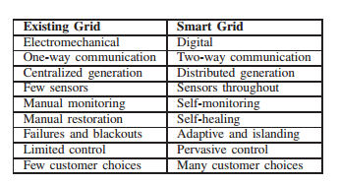

National Institute of Standards and Technology (NIST)

anticipated benefits and requirements of SG are the following:

1. Improving power reliability and quality;
2. Optimizing facility utilization and averting construction of back-up (peak load) power plants;
3. Enhancing capacity and efficiency of existing electric power networks;
4. Improving resilience to disruption;
5. Enabling predictive maintenance and self-healing responses to system disturbances;
6. Facilitating expanded deployment of renewable energy sources;
7. Accommodating distributed power sources;
8. Automating maintenance and operation;
9. Reducing greenhouse gas emissions by enabling electric vehicles and new power sources;
10. Reducing oil consumption by reducing the need for inefficient generation during peak usage periods;
11. Presenting opportunities to improve grid security;
12. Enabling transition to plug-in electric vehicles and new energy storage options;
13. Increasing consumer choice;
14. Enabling new products, services, and markets

NIST provided a conceptual model

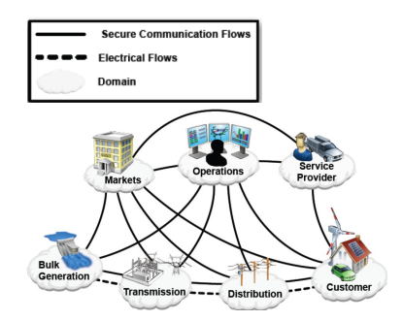

Smart infrastructure:

* Smart energy subsystem
  + two way flow of electricity
  + power generation grid
    - Distributed generation
      * Solar panels
      * Wind turbines
      * 3k - 10,000 kilowatt range
    - Provides the same if not more reliability as a central generation
    - implementing is the problem
      * Power output of renewable generators is not standard and fluctuates
      * Operation cost of DG can be high
    - Concept called Virtual Power Plant VPP
      * large group of DG with the output of a CPG
      * cluster of DG are controlled centrally
      * able to generate peak or load aware generation at short notice.
  + power transmission grid
    - an integrated system that functionally consists of:
      * smart control centers
        + enable new features such as analytical capabilities:

monitoring

visualisation

* + - * smart power transmission
        + use existing transmission systems
      * smart substations
        + Characteristics:

digitized

automated

self healing

* + power distribution grid
    - the system proposed in [235]
  + Information and metering
    - smart metering
      * used for obtaining information from end user
    - AMI automated metering infrastructure
      * Different to that of a AMR automated metering reading
      * enables two way communication
      * automatically collect diagnosis, consumption and status information
  + Smart monitoring and metering
    - two major approaches
      * sensors and phasor measurement unit
    - Sensors
      * power sensors must be embedded into the system
      * monitor physical and electrical properties in real time
      * Using wireless sensor networks (WSN)
        + cheap and efficient monitoring system
        + the collection of these WSN can detect and isolate any problems before they happen
      * Needs to maintain certain requirements
        + Quality-of-Service (QoS) requirements:
        + Resource constraints:
        + Remote maintenance and configuration:
        + High security requirements:
        + Harsh environmental conditions:
    - Phasor Measurement Unit
      * measures the electrical waves
      * PMU
  + Information Management
    - Data modeling
    - Information Analytics, integration and Optimization
      * Dealing with new and old data to help implement improvements in the new system interactions.
  + summary and Future research
    - Effective information store
    - utilization of cloud computing
* Smart communication system
  + Wireless Technologies
    - wireless mesh network
    - cellular communication system
    - cognitive radio
    - wireless communications based on 802.15.4
    - satellite communications
    - Microwave or free-space optical communication
  + Wired communication
    - fiber optics
    - powerline communication
* Smart management system