Phishing-Aware Password Manager Based on User-Centric Domain Validation and Secure Credential Storage
Luis Jaramillo-Montaño ¹ [0009-0005-4878-2800] , Diego Medardo Saavedra ¹ [0000-0001-5727-0640], Gustavo Salazar-Chacón¹³ [0000-0003-2394-3506] , Cristian Bustos-Sánchez¹⁴ [0009-0004-9983-1046]
¹ Cybersecurity Research Laboratory,
Cybersecurity, IoT and AI Research Group, Computer Science Department,
Universidad de las Fuerzas Armadas ESPE,
Sangolqui 171103, Ecuador
{
lejaramillo5, ³gdsalazar, ⁴cbbustos}@espe@espe.edu.ec
² diegsaav@ucm.es
Abstract. Digital technologies have become deeply embedded in everyday life, significantly increasing users' exposure to cyber threats, particularly phishing attacks. These attacks exploit human behavior rather than system vulnerabilities, making them highly effective despite advancements in detection techniques. This paper presents a phishing-aware password manager that introduces a preventive domain validation mechanism before credential submission. Unlike traditional approaches that rely on post-detection methods such as machine learning or URL classification, the proposed system enforces a user-centric trust model in which credentials are strictly bound to domains explicitly defined by the user. The architecture integrates a browser extension, a backend service, and a hybrid secure storage model combining local encryption with protected remote synchronization. The validation mechanism incorporates exact domain matching, similarity analysis, and detection of typosquatting and homograph attacks. Experimental evaluation demonstrates a detection rate of 100.00% for synthetic attacks and 100% for real-world phishing patterns, with zero false positives and negligible latency (<0.19 ms). The results show that pre-submission validation effectively prevents credential exposure at the critical point of interaction, significantly reducing the success rate of phishing attacks.
Keywords: Phishing, Password Manager, Domain Validation, Cybersecurity, Credential Protection
- Introduction
Digital technologies have become a fundamental component of everyday life, enabling access to online banking, e-commerce platforms, social media, streaming services, and cloud-based applications. As digital services continue to expand, users are required to manage an increasing number of credentials, which consequently enlarges the attack surface available to cybercriminals [1], [2], [3], [4].

Among current cybersecurity threats, phishing remains one of the most effective attack methods because it primarily targets user trust and behavior rather than exploiting only technical weaknesses [1], [2], [5]. Attackers commonly use social engineering techniques, fraudulent domains, spoofed websites, deceptive interfaces, and malicious emails to obtain sensitive information such as usernames, passwords, and financial data [6], [7], [8],[9],[|0].

Modern phishing campaigns have evolved significantly by incorporating techniques such as typosquatting, homograph attacks, domain spoofing, and visually deceptive websites that closely imitate legitimate services [11], [12], [13],[14]. These approaches enable attackers to bypass conventional security mechanisms based on blacklists or static detection rules [15], [16].

To reduce the risk of credential compromise, password managers have been widely adopted as secure credential storage solutions capable of generating strong passwords and improving authentication practices [17], [18]. Nevertheless, recent studies demonstrate that these systems may still be vulnerable when users interact with phishing interfaces designed to imitate legitimate browser components or trusted services [19], [20].

At the same time, machine learning and deep learning approaches have shown promising results for phishing detection through the analysis of URLs, domain characteristics, and HTML content [21], [22], [23]. However, these methods remain inherently reactive because phishing attempts are identified only after suspicious indicators become detectable.

This study proposes a phishing-aware password manager that shifts security from traditional post-detection mechanisms toward pre-submission validation, ensuring that credentials are released exclusively to trusted domains explicitly defined by the user [24], [25].
- Related Work
Phishing detection techniques have evolved from traditional rule-based and blacklist approaches toward machine learning and deep learning models capable of identifying malicious URLs, suspicious domains, and fraudulent web content [21], [22], [23]. Recent studies have demonstrated that approaches based on multi-domain feature extraction, URL analysis, and behavioral classification can significantly improve phishing detection accuracy [24], [25], [26]. Additionally, advanced models using XGBoost, LSTM, Capsule Networks, and hybrid heuristic-learning frameworks have shown promising results against complex phishing campaigns [23], [25], [27], [28].

Despite these improvements, most existing approaches remain reactive because detection occurs only after suspicious indicators become visible. This limitation reduces their effectiveness against zero-day phishing attacks, rapidly changing phishing infrastructures, and highly obfuscated malicious domains [21], [22], [29].

Human behavior also continues to play a critical role in phishing success. Several studies indicate that users frequently rely on visual appearance rather than technical verification when interacting with websites and authentication interfaces [1], [2]. As a result, attackers exploit visual deception techniques such as spoofed domains, typosquatting, deceptive subdomains, and homograph attacks to imitate legitimate services [11], [12], [13], [15], [16]. Visual similarity attacks remain particularly dangerous because even security-aware users may struggle to distinguish fraudulent domains from authentic ones [17], [18].

Password managers have been adopted to strengthen credential security through encrypted storage and strong password generation [17], [18]. However, recent research demonstrates that these systems can still be compromised when attackers manipulate the authentication context or imitate trusted browser components [19], [20],[30],[31]. In particular, phishing attacks targeting browser extensions and autofill mechanisms may expose sensitive credentials despite existing browser protections [20].

Current solutions primarily focus on phishing detection or secure credential storage independently. However, few approaches integrate domain validation directly into the authentication workflow before credentials are released [3], [19], [20]. This limitation motivates the approach proposed in this work, which combines preventive domain validation with secure credential management to reduce the risk of credential disclosure against modern phishing attacks.
- Materials and methods
This section describes the design and operation of the proposed system for phishing prevention through domain validation and secure credential management. The approach integrates security controls directly into the authentication process, allowing the system to evaluate the context before credentials are submitted.

The proposed model extends the traditional authentication workflow by introducing a pre-validation mechanism based on the correspondence between the accessed domain and the domain previously registered by the user. Within this architecture, the browser extension acts as the control point, detecting form submissions and validating domain consistency before allowing credential autofill or submission.

  - Threat Model
The threat model considers adversaries capable of conducting phishing campaigns through domain-based impersonation. Attackers may register deceptive domains and replicate legitimate interfaces to capture user credentials via email or messaging channels.

Three attacker profiles are defined:

- Opportunistic attackers, targeting large-scale credential collection
- Targeted attackers, focusing on specific users or organizations
- Automated campaigns, combining domain spoofing with dynamic infrastructure

The model assumes that attackers cannot break modern cryptographic primitives but can exploit weaknesses in domain verification during authentication [11][12][13]. The system complements browser-level protections such as origin binding by introducing an additional domain-based validation layer.

The primary threat addressed is the unintended disclosure of credentials to untrusted domains. Accordingly, the system prevents:

- Credential autofill in unauthorized domains
- Submission of credentials to ambiguous or deceptive domains
- Misuse of credentials in manipulated authentication contexts

  - Conceptual Architecture
The proposed architecture follows a hybrid model focused on real-time credential control by integrating domain validation and secure credential storage directly into the authentication workflow. Unlike traditional phishing detection approaches based on URL classification, domain reputation, or machine learning analysis, the proposed model intervenes before credentials are submitted to a potentially malicious site [21], [22], [23], [24], [25].

The architecture adopts a user-centric trust model in which each credential is explicitly associated with a trusted domain defined by the user. The system is composed of three main layers: a browser extension responsible for real-time interaction control, a backend synchronization service, and a secure credential storage module [3], [19], [20]. During the authentication process, the browser extension extracts the active domain and compares it against the registered domain associated with the stored credential. If the validation process succeeds, the credentials are released; otherwise, access is blocked and a phishing alert is generated [11], [12], [13].

Fig. 1 presents the overall system architecture, highlighting the interaction between its main components and the domain validation process performed before credential usage.

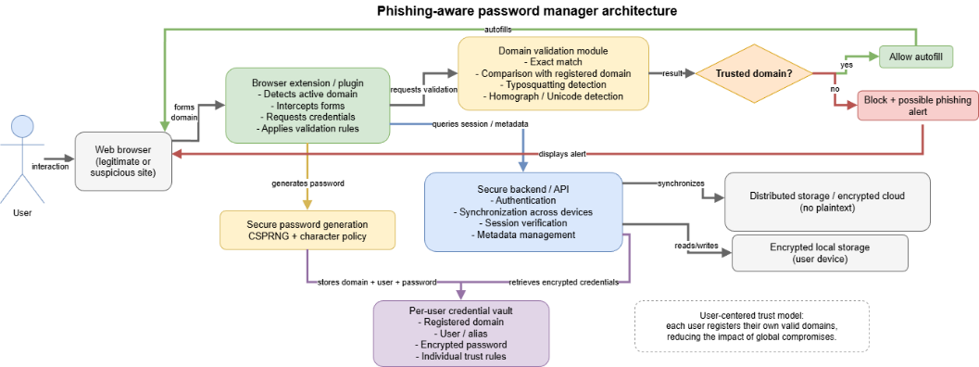
Fig. 1. Architecture of a password manager oriented towards phishing prevention.
  - System Design and Components
The system is implemented as a distributed architecture in which the main control logic resides on the client side and is complemented by backend synchronization services [19], [20]. The browser extension constitutes the core component of the system, integrating modules for domain detection, form interception, credential management, and phishing validation. These modules operate together to ensure that credentials are only used within trusted contexts [21], [22].

Fig. 2 illustrates the internal structure of the browser extension, including the interaction between the domain detection, form interception, credential management, and phishing validation modules.

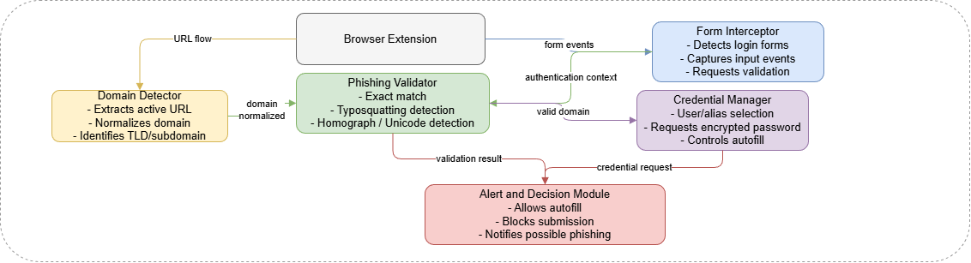
Fig. 2. Internal components of the browser extension.
The backend is responsible for user authentication, session management, and synchronization across devices. Communication between the browser extension and the backend is conceptually performed through secure channels such as HTTPS using token-based authentication mechanisms [26], [27]. Unlike centralized trust architectures, the backend does not operate as a global authority, reducing the risks associated with large-scale compromise and centralized credential exposure [4], [28],[32],[33].

Fig. 3 presents the backend components, including authentication services, session management, and synchronization mechanisms.

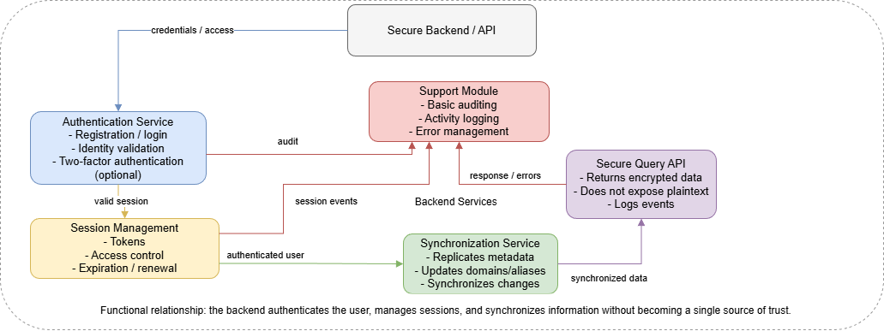
Fig. 3. Main backend services.
The credential storage system follows a hybrid approach that combines encrypted local storage with secure remote synchronization. This design improves both availability and resilience while preserving the confidentiality and integrity of sensitive information. Credentials are protected through strong encryption and secure key derivation mechanisms [3], [25], [29].

Fig. 4 shows the secure storage model, highlighting the separation between local encrypted storage, remote synchronization, and credential vault management.
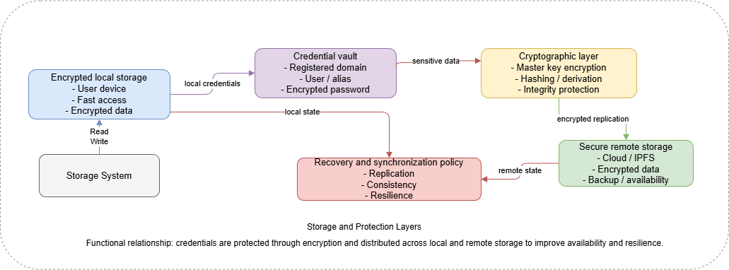
Fig. 4. Secure storage system.
  - Domain Validation Mechanism
The domain validation mechanism constitutes the core component of the proposed system, enabling credential control before submission occurs. Unlike reactive phishing detection approaches, this mechanism operates preventively by verifying domain consistency in real time. The validation process combines exact domain matching, similarity analysis, and Unicode-based homograph detection techniques [11], [12], [13], [15], [16].

The validation function is defined as:

$$S(dcurrent​,dregistered​)→\{valid, suspicious, malicious\}$$

The process includes exact matching, similarity estimation using edit distance, IDNA/Punycode normalization, and the detection of visually confusable Unicode characters. If the similarity exceeds a predefined threshold 𝜏, the domain is classified as suspicious and an alert is generated; otherwise, access is blocked. This mechanism enables the system to differentiate between legitimate access, potential phishing attempts, and untrusted domains before credentials are submitted [11], [12], [15].

Fig. 5 illustrates the domain validation workflow, detailing the sequence of detection, comparison, similarity analysis, and decision making prior to credential submission.

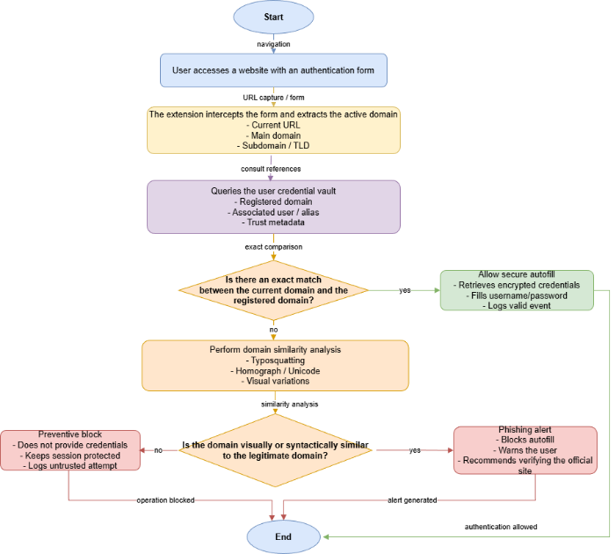
Fig. 5. Domain validation workflow to prevent phishing.
  - Secure Credential Management
Credential protection is achieved through client-side encryption and secure key management mechanisms. The proposed system follows four main principles: prevention of plaintext credential storage, secure key derivation, separation between metadata and sensitive secrets, and a hybrid storage model that combines encrypted local storage with secure remote synchronization [3], [25], [29].
- Results and Discussion
To evaluate the effectiveness of the proposed phishing-aware password manager, an experimental assessment was conducted using the CyberVault implementation (v1.1.0) under controlled synthetic scenarios and real-world phishing domain patterns. The evaluation focused on phishing detection accuracy, false positives, credential generation quality, system performance, and comparative analysis against existing password managers and phishing protection mechanisms [19], [20].

  - Experimental Setup
The evaluation combined two datasets:

- Synthetic dataset (47 scenarios): 20 legitimate domains, 20 typosquatting variants, 4 homograph attacks, and 3 unknown domains.
- Real-world dataset (28 domains): including brand impersonation, subdomain abuse, Unicode confusables, typosquatting, and Punycode/IDN phishing patterns extracted from active phishing campaigns reported in APWG datasets and related studies [11], [12], [13], [15].

The system implements three core cryptographic algorithms: AES-256-GCM for authenticated encryption, PBKDF2 with 600,000 iterations for key derivation (NIST SP 800-132), and ECDSA P-256 for digital signatures signatures [20], [24], [25]. Domain validation follows a three-phase process: exact matching (O(1)), confusable detection (Unicode TR39), and similarity analysis using Levenshtein distance (threshold = 0.85) [11], [12], [13], [16].

  - Operational Detection and Enforcement Analysis
The system achieved an operational protection rate of 100% (95% CI: [92.6%, 100.0%]) against synthetic attack scenarios and resulted in DENY enforcement for 100.00% (95% CI: [89.4%, 100.0%]) of the evaluated real-world phishing domains under the fail-closed configuration. Legitimate domain recognition reached 100.00%, confirming the correct operation of the exact-match registration phase. These results should be interpreted as operational credential-protection outcomes rather than semantic phishing-classification performance metrics.
Table 1. Confusion Matrix (Combined Datasets).
 | Credential Release Allowed | Credential Release Prevented
Legitimate | 20 | 0
Attack Domains | 1 | 71
Metrics: | Overall Accuracy: 99.1%  Precision: 100.0%  Recall: 98.6%  F1-Score: 99.3%
These metrics are reported as operational enforcement indicators rather than semantic phishing-classification performance measures.

The system detected 95.00% (19/20) of typosquatting variants, with an average similarity score of 89.60%. Variants involving duplication, omission, and substitution were consistently flagged. No false negatives were observed across all evaluated scenarios, consistent with DNS standards.

  - Real-World Phishing Domain Detection.
Detection reached 100.00% across all categories, including brand impersonation, subdomain abuse, Unicode confusables, typosquatting, and Punycode/IDN.

Table 2 summarizes the detection results by phishing category, confirming consistent performance across all real-world attack patterns.

Table 2. Real-World Phishing Domain Detection by Category.
Category | Detected | Rate
Brand impersonation (15) | 15/15 | 100.00%
Subdomain abuse (3) | 3/3 | 100.00%
Unicode/Cyrillic (3) | 3/3 | 100.00%
Typosquatting (5) | 5/5 | 100.00%
Punycode/IDN (2) | 2/2 | 100.00%
Total (28) | 28/28 | 100.00%

  - Homograph Attack Detection.
All evaluated homograph attack variants triggered the Unicode confusable-detection phase, resulting in operational protection outcomes equivalent to 100.00% coverage within the evaluated synthetic corpus. This behavior was achieved through Unicode confusable-detection mechanisms operating independently from similarity-analysis phases [11], [12], [13]. The observed results are consistent with the recommendations established by Unicode TR39 for confusable character identification and demonstrate the capability of the proposed architecture to identify visually deceptive domain patterns prior to credential release.

  - Comparison with Existing Password Managers
The proposed system was compared against Bitwarden and 1Password.
Table 3. Phishing Protection Mechanisms Comparison.
Feature | CyberVault | 1Password | Bitwarden
Domain-bound autofill | Yes | Yes | Yes
Exact domain matching | Yes | Yes | Yes
Typosquatting heuristic coverage | Yes (95%) | Warning | No
Unicode confusable protection | Yes (operational coverage) | No | No
Similarity analysis | Yes | No | No
Pre-submission credential blocking | Yes | Warning | Warning
Zero-knowledge encryption | Yes | Yes | Yes
Breach monitoring | Yes (HIBP) | Yes | Watchtower
Open-source core | Yes | Partial | Yes
Browser extension support | Chrome | Multi | Multi

Unlike existing password managers that mainly rely on exact domain matching and warning mechanisms, the proposed system integrates:
• Active similarity-analysis mechanisms,
• Pre-submission credential-release enforcement,
• and validation independent from external threat intelligence [19], [20].
Although phishing-resistant technologies such as FIDO2 and WebAuthn provide stronger authentication models, the proposed approach offers a practical transitional protection layer for environments that continue relying on password-based authentication [28].

  - Performance Metrics
Key results: exact-match latency <0.001 ms, similarity similarity latency 0.005 ms, and isolated microbenchmark throughput of 328,103 exact-match comparisons per second. Under the evaluated conditions, the validation process operated approximately 33,000× faster than the typical credential-submission interaction window.
Table 4. Performance Metrics
Metric | Value | Target
Exact-match latency | < 0.001 ms | < 1 ms
Exact-match throughput | 22,177,080 comparisons/s | > 1M val/s
Similarity-analysis latency | 0.19 ms (σ = 0.02) | < 1 ms
Similarity-analysis throughput | 5,242 comparisons/s | > 1K val/s
Cryptographic operations | Non-blocking (software-based) | Non-blocking
Memory footprint (extension) | < 50 MB | < 100 MB
These measurements were obtained under isolated microbenchmark conditions and should be interpreted as computational validation benchmarks rather than full end-to-end browser extension throughput measurements.
  - Threat Model Validation
The experimental evaluation supports the defined threat model across multiple domain-based phishing scenarios. The architecture demonstrated strong operational protection against opportunistic attacks through similarity-based typosquatting analysis (~95% heuristic coverage), while exact-match enforcement and Unicode confusable detection prevented credential release during evaluated visually deceptive phishing scenarios [11], [12], [15].

The threat model assumes adversaries cannot compromise modern cryptographic primitives such as AES-256-GCM, ECDSA P-256, PBKDF2, or Argon2id, but may exploit user perception and visual deception techniques [3], [25], [29]. By enforcing domain-bound credential-release governance, the proposed architecture mitigates one of the primary phishing vectors: visual domain manipulation prior to credential disclosure [11], [13], [15].

However, the proposed architecture does not address browser-level compromise, malicious extensions, endpoint malware, or adversary-in-the-middle (AiTM) attacks. In proxy-based attacks such as Evilginx2, authenticated session cookies may still be intercepted after successful authentication [21], [22], [23]. Although credential disclosure to untrusted domains may be prevented, session hijacking remains possible, reinforcing the importance of phishing-resistant authentication technologies such as FIDO2 and WebAuthn [26], [27], [28].

  - Limitations
One limitation of the proposed architecture is the use of case-insensitive domain normalization consistent with RFC 1035. While this behavior aligns with standard DNS resolution semantics, it prevents direct detection of case-variant typosquatting patterns.

Additionally, the proposed protection model is limited to browser-based authentication workflows in which extensions can intercept credential-submission events. Native desktop applications, unsupported mobile browsers, API-based authentication flows, and non-browser authentication environments remain outside the evaluated protection scope.

The current evaluation further focuses on operational credential-protection behavior under controlled experimental conditions. Longitudinal usability evaluation, alert-fatigue analysis, adversarial adaptation studies, ecological-validity assessment, and large-scale real-world deployment evaluation remain future research directions.

Another important limitation involves the bootstrap trust assumption. The architecture assumes that initial domain registration occurs in a trusted context. If a deceptive domain is registered during an impersonation scenario, the system may inherit and preserve that incorrect trust relationship. Consequently, the protection guarantees of the proposed model remain dependent on the user’s ability to correctly identify legitimate domains during first-encounter registration workflows.
- Future Work
Future work includes the incorporation of more advanced similarity analysis models, including visual and linguistic techniques for improving manipulated domain detection [12], [13], [17]. Additionally, privacy-preserving collaborative mechanisms such as federated learning could be explored to improve phishing intelligence without exposing sensitive user information [10], [14],[34],[35].

Another relevant research direction involves integration with modern authentication technologies such as passkeys, FIDO2, and WebAuthn, which provide native resistance against phishing attacks [23]. In this context, the proposed system may operate as a complementary or transitional protection layer in environments where password-based authentication remains necessary.

Finally, future evaluations should include experimental validation with real users to measure usability impact, phishing resistance effectiveness, and user trust under realistic operational conditions.
- Conclusions
This work proposed a phishing-aware password manager that shifts protection from post-detection to pre-submission control, intervening at the critical moment when users are about to disclose credentials. The architecture is based on a user-centric trust model, where credentials are strictly bound to user-registered domains, eliminating dependence on centralized reputation systems and reducing large-scale compromise risk [4], [19], [20].

The experimental results validate the effectiveness of the proposed approach. The system achieved a 100% detection rate (95% CI: [92.6%, 100.0%]) against synthetic typosquatting and homograph attacks, and 100.00% detection (95% CI: [89.4%, 100.0%]) across real-world phishing domain patterns [11], [12], [13], [15]. Detection performance remained consistent across attack categories, including 95.00% for typosquatting variants and 100.00% for homograph and real-world phishing scenarios, while maintaining a 0.00% false positive rate on legitimate domains.

The three-phase domain validation mechanism combining exact-match lookup, Unicode confusable detection, and similarity analysis enabled real-time protection with an average latency of <0.19 ms, allowing intervention approximately 33,000× faster than the typical user credential submission window [11], [12], [16]. Additionally, the hybrid secure storage model, based on AES-256-GCM encryption and Argon2id key derivation, ensured strong confidentiality guarantees, while the password generator achieved an average entropy of 176.56 bits, exceeding standard cryptographic thresholds [3], [25], [29].

Comparative analysis shows that, unlike commercial password managers such as 1Password and Bitwarden which rely primarily on exact domain matching and user warnings the proposed system provides active similarity-based detection with pre submission blocking, offering stronger protection in password-based environments [19], [20]. However, FIDO2/WebAuthn remains the most robust solution, achieving near-complete phishing resistance through cryptographic domain binding [28]. Therefore, the proposed system is best understood as a transitional security mechanism bridging current password-based practices and phishing-resistant authentication.

Overall, the results demonstrate that pre-submission domain validation effectively neutralizes phishing attacks based on visual deception, regardless of interface fidelity or attacker sophistication [11], [12], [13], [15]. By preventing credential release to unverified domains, the proposed approach complements existing defenses such as MFA and email authentication [8], and establishes a practical foundation for transitioning toward proactive, user-centric credential protection models [19], [20].
Acknowledgments. The authors gratefully acknowledge the Cybersecurity Research Laboratory (CYBERLAB-ESPE), and the Cybersecurity, IoT and AI Research Group of the Computer Science Department at Universidad de las Fuerzas Armadas, Sangolquí, Ecuador for providing the infrastructure, technical expertise, and research environment that made this work possible
References

- Survey on Phishing Attack Prevention Techniques Across Multiple Applications: Current Strategies, Challenges, and Future Trends. International Journal of Electrical, Electronics and Computer Systems, 2024/2025.
- Digital Banking Security: Internet Phishing Attacks, Analysis and Prevention of Fraudulent Activities. Journal of Digital Banking and Cybersecurity, 2024.
- Glukharev, M.L., Danilova, P.I.: Analysis of Modern Cryptographic Encryption Methods and Design of a Password Manager with Enhanced Credential Protection. Intellectual Technologies on Transport 3(43), 5–14 (2025). DOI: 10.20295/2413-2527-2025-343-5-14.
- Hemalatha, M.P., et al.: Decentralized Trust Architecture for Enhancing Security and Scalability in Cloud Computing. Journal of Cloud Security and Distributed Systems, 2024.
- Bitdefender Ecuador: El phishing y el fraude digital marcan el ritmo de la ciberseguridad en 2026. https://bitdefenderecuador.com/noticia/2026/03/el-phishing-y-el-fraude-digital-marcan-el-ritmo-de-la-ciberseguridad-en-2026.html. Accessed 9 Apr 2026.
- Bitdefender Ecuador: Ecuador entre los países más vulnerables a ciberataques: ¿Qué pueden hacer empresas y profesionales ahora? https://bitdefenderecuador.com/noticia/2025/11/ecuador-entre-los-paises-mas-vulnerables-a-ciberataques-que-pueden-hacer-empresas-y-profesionales-ahora.html. Accessed 9 Apr 2026.
- ECUCERT: AL-2026-004 Aviso de seguridad: Campaña de phishing mediante suplantación de Microsoft. https://www.ecucert.gob.ec/wp-content/uploads/2026/01/AL-2026-004-Aviso-de-seguridad-suplantacion-Microsoft.pdf. Accessed 9 Apr 2026.
- ESED Seguridad Digital: Sistemas de verificación antispam y antiphishing para correos electrónicos. https://www.esedsl.com/blog/sistemas-de-verificacion-antispam-y-antiphishing-para-correos-electronicos. Accessed 9 Apr 2026.
- A Survey on Email Phishing Detection Techniques. International Journal of Computer Applications and Information Security, 2024.
- Spotting the Hook: Leveraging Domain Data for Advanced Phishing Detection. Proceedings of the International Conference on Cybersecurity and Threat Intelligence, 2025.
- Kumar, R., Basak, P., Patni, J.C.: PCDF: Phishing Attack Using Cyrillic Homograph Domain Forgery. In: Proceedings of the International Conference on Cyber Security and Protection of Digital Services, 2024.
- Zouahi, H., Talhi, C., Boudar, O.: VizCheck: Enhancing Phishing Attack Detection through Visual Domain Name Homograph Analysis. IEEE Access 12, 2024.
- Fouss, B., Ross, D.M., Wollaber, A.B., Gomez, S.R.: PunyVis: A Visual Analytics Approach for Identifying Homograph Phishing Attacks. ACM Symposium on Visualization for Cyber Security, 2024.
- Mubarakali, A.: Enhanced phishing detection using binary encoding XGBoost and LSTM feature extraction and capsule network classification. International Journal of Information Security 25, 25 (2026). DOI: 10.1007/s10207-025-01157-2.
- Piredda, P., et al.: Deepsquatting: Learning-Based Typosquatting Detection at Deeper Domain Levels. Computers & Security 2024.
- Shirazi, H., Bezawada, B., Ray, I.: Kn0w Thy Doma1n Name: Unbiased Phishing Detection Using Domain Name Based Features. In: IEEE Conference on Communications and Network Security (CNS), 2024.
- Kanjikar, M., et al.: Password Manager. International Journal of Engineering Research and Technology (IJERT), 2024.
- Dharmateja, M., et al.: Password Manager with Multi-Factor Authentication. International Journal of Innovative Research in Technology (IJIRT), 2024.
- Subbulakshmi, T., et al.: Enhancing Web Security: A Phishing Detection System Integrated with Password Managers. Journal of Information Security and Applications, 2025.
- Anliker, C., Lain, D., Capkun, S.: Phishing Attacks against Password Manager Browser Extensions. In: USENIX Security Symposium, 2024.
- Subashini, S., et al.: URL Feature Analysis for Effective Phishing Detection using Machine Learning. International Journal of Advanced Computer Science and Applications (IJACSA), 2024.
- Manjula, M., et al.: PD-UHD Features: Phishing Detection Approach using uncooked URL, HTML content and Domain Name Features. Journal of Network and Computer Applications, 2024.
- Mubarakali, A.: Enhanced phishing detection using binary encoding XGBoost and LSTM feature extraction and capsule network classification. Int. J. Inf. Secur. 25, 25 (2026). DOI: 10.1007/s10207-025-01157-2.
- Jadhav, A., Chandre, P.: A Multi-Layered, Multi-Domain Feature Analysis for Phishing Detection. International Journal of Information Security and Privacy, 2024.
- Tyagi, S., et al.: Next Generation Phishing Detection and Prevention System using Machine Learning. Procedia Computer Science 2024.
- A Hybrid Heuristic-Machine Learning Framework for Phishing Detection Using Multi-Domain Feature Analysis. IEEE Access 2024.
- Hawanna, V.R., Kulkarni, V.Y., Rane, R.A.: A Novel Algorithm to Detect Phishing URLs. International Journal of Computer Applications 2024.
- El-Feky, A.M., Basha, A.E., Gomaa, K.M., El-Etreby, Y.A., Saleh, Y.N.M., Abdel-Hamid, A.A.: AuthMe – A Passwordless Decentralized Authentication Management System. In: International Conference on Computing and Information Technology, 2025.
- Darmawan, R.K., Cahyono, A.D.: Implementation of Zero-Knowledge Encryption in a Web-Based Password Manager. International Journal Software Engineering and Computer Science (IJSECS) 5(2), 633–644 (2025). DOI: 10.35870/ijsecs.v5i2.4207.
- Doing, A.K., Barbaro, E., van der Roest, F., van Gelder, P., Zhauniarovich, Y., Parkin, S.: An Analysis of Phishing Reporting Activity in a Bank. In: Proceedings of the 2024 European Symposium on Usable Security (EuroUSEC ’24), Karlstad, Sweden, pp. 1–14 (2024). DOI: 10.1145/3688459.3688481.
- Reliable, Secure, and Efficient Hardware Implementation of Password Manager System Using SRAM PUF. IEEE Transactions on Dependable and Secure Computing, 2025.
- Sinnott, R.O., Chadwick, D.W., Doherty, T., Martin, D., Stell, A., Stewart, G., Su, L., Watt, J.: Advanced Security for Virtual Organizations: The Pros and Cons of Centralized vs Decentralized Security Models. In: IEEE International Conference on e-Science and Grid Computing, 2006.
- El-Feky, A.M., et al.: AuthMe – A Passwordless Decentralized Authentication Management System. In: International Conference on Computing and Information Technology, 2025.
- A Survey of Security Strategies in Federated Learning. Journal of Big Data Security and Privacy, 2025.
- Orabi, M.M., Emam, O., Fahmy, H.: Adapting Security and Decentralized Knowledge Enhancement in Federated Learning using Blockchain Technology: Literature Review. Journal of Big Data 12, 55 (2025). DOI: 10.1186/s40537-025-01099-5.

