# Reproducible Research: Peer Assessment 1

## Loading and preprocessing the data

unzip("activity.zip")  
activity <- read.csv("activity.csv", header = TRUE)  
head(activity)

## steps date interval  
## 1 NA 2012-10-01 0  
## 2 NA 2012-10-01 5  
## 3 NA 2012-10-01 10  
## 4 NA 2012-10-01 15  
## 5 NA 2012-10-01 20  
## 6 NA 2012-10-01 25

activity.full=activity[!is.na(activity$steps),]

## What is mean total number of steps taken per day?

### Making a histogram of the total number of steps taken each day using

aggregate.date <- aggregate(activity.full$steps,  
 by=list(activity.full$date),FUN=sum)  
hist(aggregate.date$x, breaks = 35)

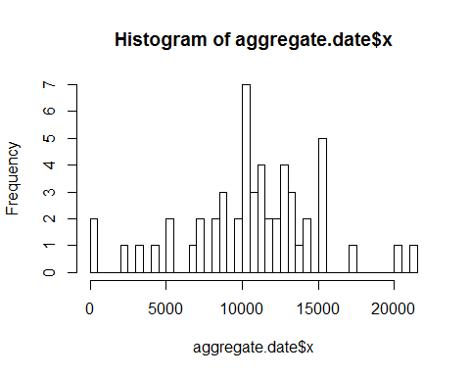

## What is the average daily activity pattern?

## Imputing missing values

## Are there differences in activity patterns between weekdays and weekends?