Optimized gradients based on a custom retention time distribution
(64 bit, Ubuntu assumed)

- Pasting the retention times in the Text Area

  - The input parameters would be
- Paste the retention times from data/custom/rts-identified-peptides.txt

- Start gradient time → 10
- End gradient time → 250
- Start gradient %B→ 2
- End gradient %B → 40
- Lag time → 6.2

- Time step → 2.5
- Decimals → 1
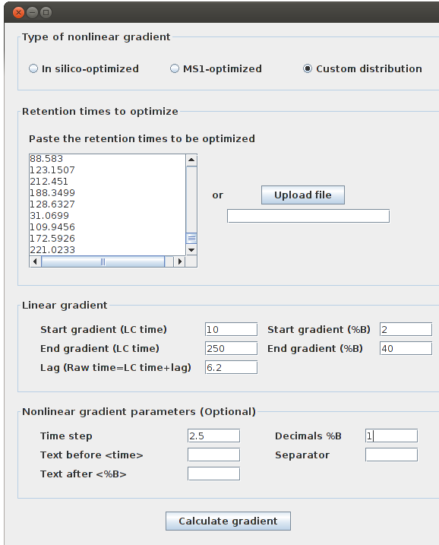

  - The optimized gradient that should be obtained is given in the file
custom-optimized-paste-rts.txt

The graphical window displaying the result should look as shown below
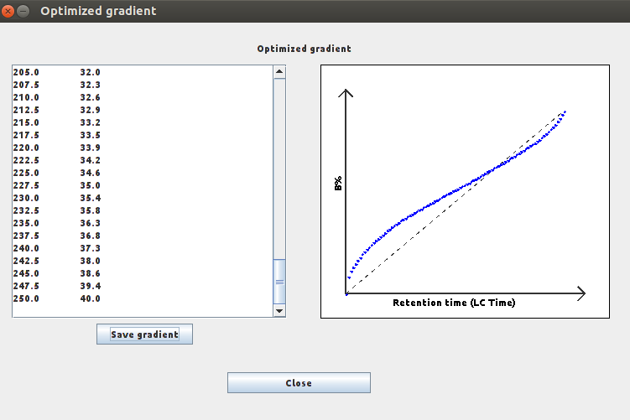

- Loading retention times from an input file

2.1 The input parameters would be
- Text Area – leave empty
- Input file: data/custom/rts-identified-peptides.txt

- Start gradient time → 10
- End gradient time → 250
- Start gradient %B→ 2
- End gradient %B → 40
- Lag time → 6.2

- Time step → 5.0
- Decimals → 2
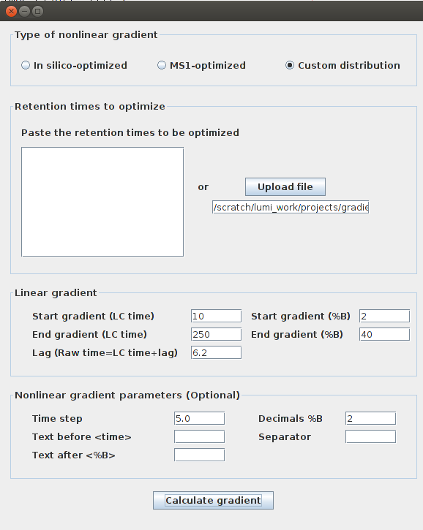

2.2 The optimized gradient that should be obtained is given in the file
custom-optimized-upload-file.txt

The graphical window displaying the result should look as shown below

