In silico-optimized gradients (64 bit, Ubuntu assumed)

NOTE: Slightly different results are obtained under Windows (Eludes gives different predictions)!
- Use of a list of theoretical peptides

  - The input parameters would be
- Elude path → data/insilico/elude-ubuntu-64
- Training peptide → data/insilico/training-peptides.txt
- Theoretical peptides (In silico peptides) → data/insilico/insilico-human-8-50.txt

- Start gradient time → 10
- End gradient time → 250
- Start gradient %B→ 2
- End gradient %B → 40
- Lag time → 6.2

- Time step → 1.0
- Decimals → 1

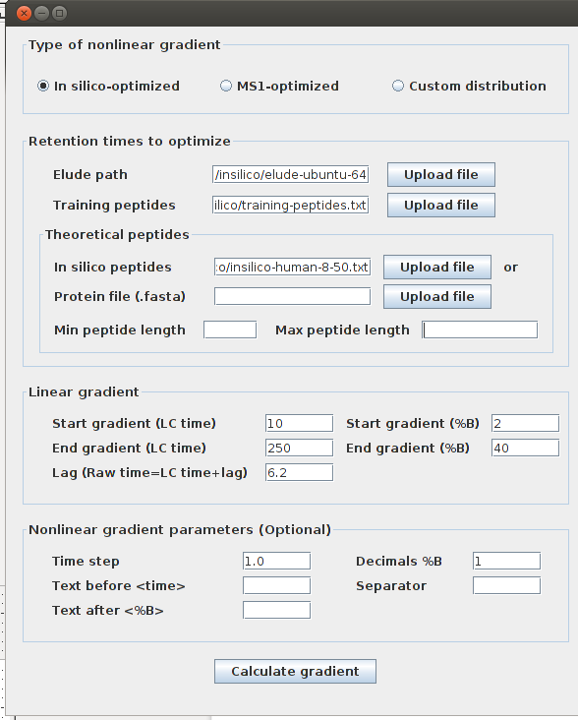

  - The optimized gradient that should be obtained is given in the file
insilico-optimized-insilico-human-8-50.txt

The graphical window displaying the result should look as shown below
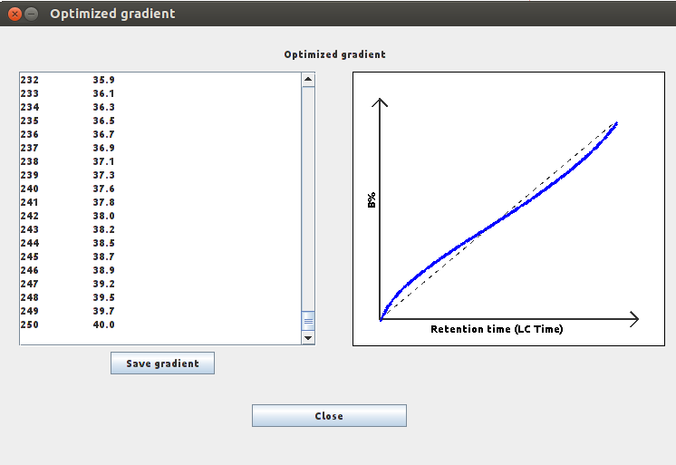

- Use of a fasta file
2.1 The input parameters would be
- Elude path → data/insilico/elude-ubuntu-64
- Training peptide → data/insilico/training-peptides.txt
- Theoretical peptides (In silico peptides) → Leave the field empy
- Protein file → data/insilico/sp_201209_human.fasta
- Min peptide length → 30
- Max peptide length → 50

- Start gradient time → 10
- End gradient time → 250
- Start gradient %B→ 2
- End gradient %B → 40
- Lag time → 6.2
- Time step → 2.0

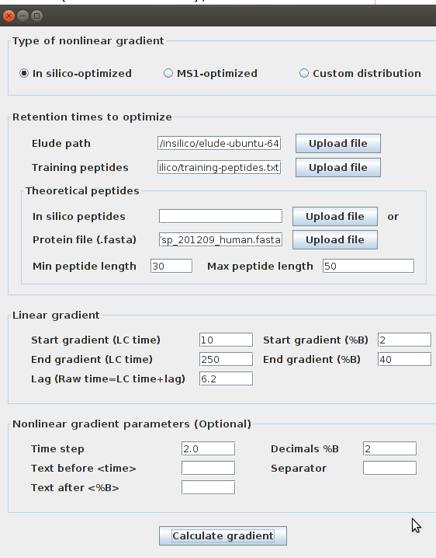
- Decimals → 2

2.2 The optimized gradient that should be obtained is given in the file
insilico-optimized-sp-201209-human-fasta-30-50.txt

The graphical window displaying the result should look as shown below
