In silico-optimized gradients (64 bit, Ubuntu assumed)

- Optimized gradient calculation

  - The input parameters would be
- Spectral data → data/ms1/121107QEx2_RSLC_beta_HeLa_500ng_Linear_v2.mzML
- Peak intensity above→ 1e6

- Start gradient time → 10
- End gradient time → 250
- Start gradient %B→ 2
- End gradient %B → 40
- Lag time → 6.2

- Time step → 4.0
- Decimals → 1

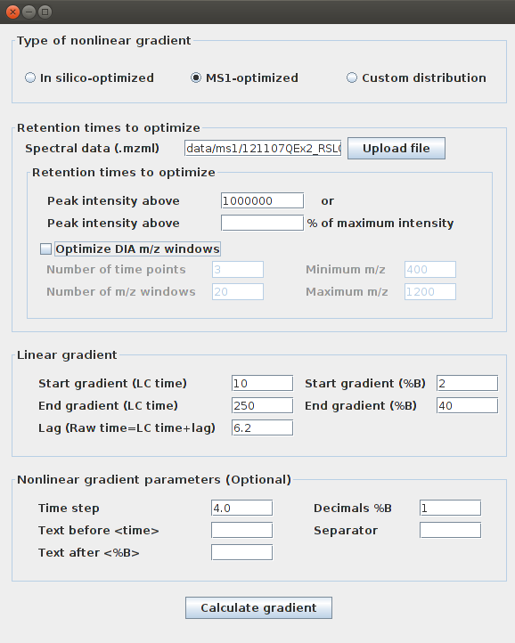

  - The optimized gradient that should be obtained is given in the file
ms1-optimized-gradient-human-4h.txt

The graphical window displaying the result should look as shown below
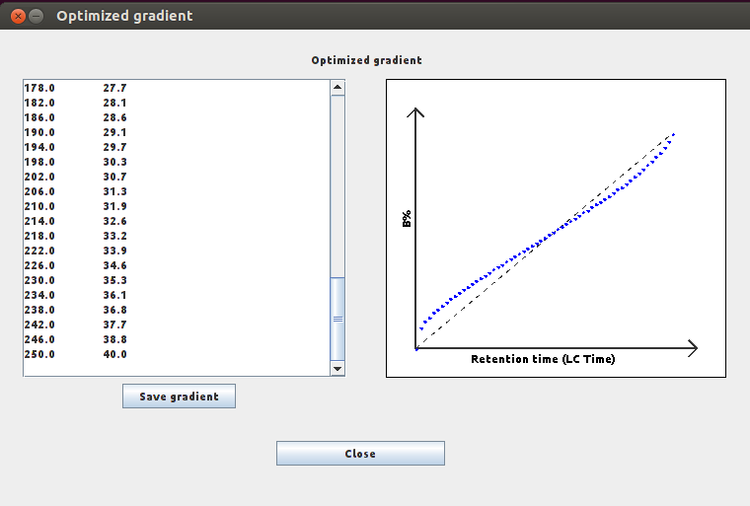

- Optimized gradient calculation & optimization of DIA m/z windows
2.1 The input parameters would be
- Spectral data → data/ms1/121107QEx2_RSLC_beta_HeLa_500ng_Linear_v2.mzML
- Peak intensity above→ 1e6

- Number of time points → 4
- Number of m/z windows → 10
- Minimum m/z → 400
- Maximum m/z → 1200

- Start gradient time → 10
- End gradient time → 250
- Start gradient %B→ 2
- End gradient %B → 40
- Lag time → 6.2

- Time step → 4.0
- Decimals → 1

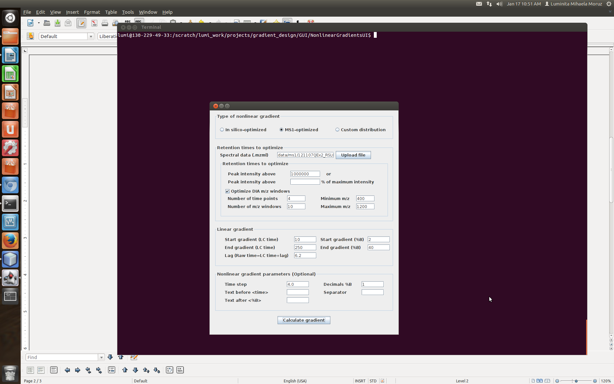
2.2 The optimized gradient that should be obtained is given in the file
ms1-optimized-gradient-human-4h-DIA.txt
The DIA m/z windows are given in
ms1-optimized-mz-windows-human-4h-DIA.txt

The two graphical windows displaying the results should look as shown below
