**Final Project**

**project VB.NET Final Project**

**100 points**

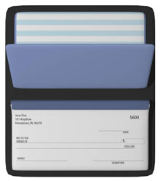For your final project you are going to write a couple of complex programs. Doing so will require you to use all concepts presented in this course from planning the project to fixing errors. You may also have to do some research on new codes to use. Make sure you follow all the rules found in the Course Overview unit. You will submit each of the following for each of the two projects (i.e. you are essentially doing this project twice):

1. Flow chart design draft
2. Program code in Notepad document
3. Program code in Visual Basic Express format (.vb)
4. Flow chart revisions
5. Log of errors encounters while debugging program
6. Plan for maintenance

Your programs must include the following key features:

1. Comment block at the top with key information
2. Single and multi-line comments
3. Basic program fundamentals
4. User-defined exception handling (i.e. anticipate user errors)
5. Instructions that print for user’s understanding of program

**Choose two of the four programs below:**

**Option 1**  
Write a program to find the average grade given 15 user-inputted scores on tests. The program should also provide the following feedback according to the final score (i.e. A, B, C, D, F).

**Option 2**  
Write a program that would resemble a checkbook register that will ask for input, both deposits and debits, and keep a running total in that person’s bank account. That total would be given upon request of the user.

**Option 3**  
Write a program to run two separate threads printing numbers (or words) in ascending and descending orders. The numbers (or words) should be given by the user.

**Option 4**Write a program that has a function to give someone their age if they input their date of birth. Along with their age, the user should receive some trivia about the decade they were born.