Filmspotting

Yue Cai, Renjie Zhao

1. Project description

Many movie goers like to visit their favorite movie scenes in reality. While real trips could be enjoyable and rewarding, most people may lack necessary time and money. For such reason, we decide to develop a website, in which users could search movie names to see possible famous scenes of this movie on a map.

There do exist similar websites which already provide users with the locations of some famous scenes in some movies, however, when only offering addresses, they could not give users a direct look at these locations. So our project is innovative in that when users search for a movie, all the famous scenes appearing in this movie would pop themselves out on the map and on clicking one location, its current street scene and possibly the movie clip of such scene would appear on the website for users to have a virtual visit.

The difficulty of our project, as far as we are concerned, lies in the scattered distribution of information. Unlike other aspects of movies, its actual filming spots are not so official and are most discovered and posted online by fans, meaning that we have to sift through vast amount of information from various websites to gather useful information.

The basic GUI of our project will be a world map, with menus to provide searching and filtering functionality. When user chooses a place on the map, he will be shown famous movies that were filmed in that area. For every selected film and location, we will try to provide a side-by-side view of relevant video clips or photos, along with the street view picture of that location, for example:

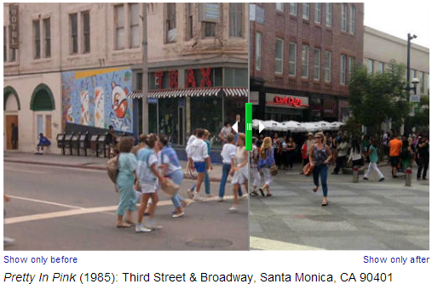

1. Data sources

* Information of movies in IMDb
* ‘Filming Locations’ section in IMDb

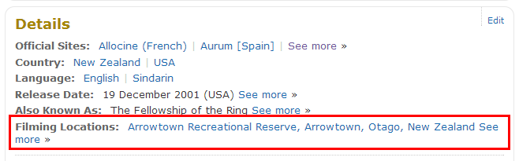

* Movie-Locations.com

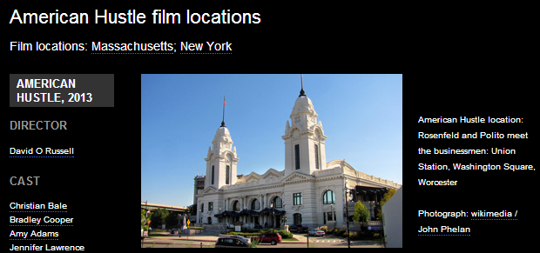

* Articles found in google using keyword ‘filming locations’, such as:
  + ‘Top 10 US movie locations’
  + ‘25 Cool Movie Locations’
  + ‘See 10 Famous Los Angeles Filming Locations Then And Now’
* Video clips of movies in youtube.com
* Google Maps, Google Street View

1. Presentation date

We chose April 28 as our presentation date.