Chapter 3

library(datasets)  
library(tidyverse)

## -- Attaching core tidyverse packages ------------------------ tidyverse 2.0.0 --  
## v dplyr 1.1.2 v readr 2.1.4  
## v forcats 1.0.0 v stringr 1.5.0  
## v ggplot2 3.4.2 v tibble 3.2.1  
## v lubridate 1.9.2 v tidyr 1.3.0  
## v purrr 1.0.1   
## -- Conflicts ------------------------------------------ tidyverse_conflicts() --  
## x dplyr::filter() masks stats::filter()  
## x dplyr::lag() masks stats::lag()  
## i Use the conflicted package (<http://conflicted.r-lib.org/>) to force all conflicts to become errors

library(MASS)

##   
## Attaching package: 'MASS'  
##   
## The following object is masked from 'package:dplyr':  
##   
## select

library(scatterplot3d)  
library(ggplot2)  
library(GGally)

## Registered S3 method overwritten by 'GGally':  
## method from   
## +.gg ggplot2

## Histogram

hist(airquality$Temp, xlab = "Temperature", main = "Temperatures in NYC May 1 - Sep 30 1973") #plot histogram with labels

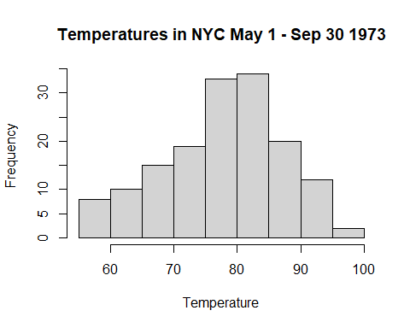

#plot histogram with probability, column represents area  
hist(airquality$Temp, xlab = "Temperature", main = "Temperatures in NYC May 1 - Sep 30 1973", probability = TRUE)  
lines(density(airquality$Temp)) #add line for trend

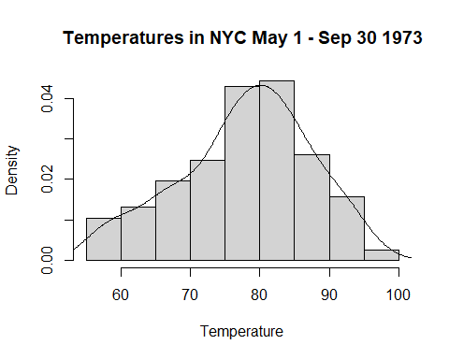

## Bar plot

table(Cars93$Type)

##   
## Compact Large Midsize Small Sporty Van   
## 16 11 22 21 14 9

barplot(table(Cars93$Type), ylim = c(0,25), xlab = "Type", ylab = "Frequency", axis.lty = "solid", space = 0.5)

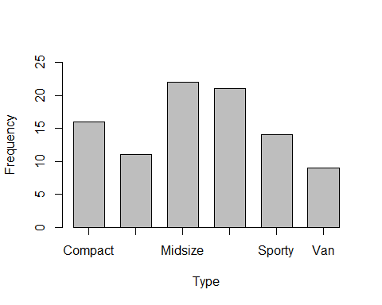

#ylim limit size of y axis  
#axis.lty put solid line  
#space put space between bars

ex1 = filter(Cars93, Origin == "USA")  
barplot(table(ex1$Type))

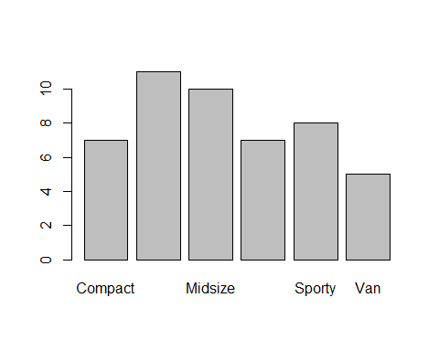

ex2 = filter(Cars93, Origin != "USA")  
barplot(table(ex2$Type))

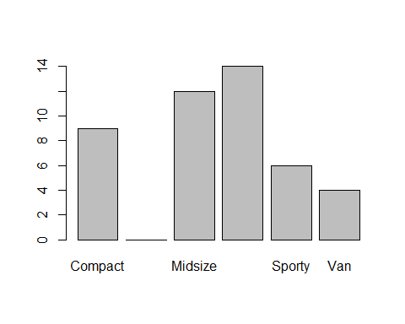

females = HairEyeColor[,,2]  
females

## Eye  
## Hair Brown Blue Hazel Green  
## Black 36 9 5 2  
## Brown 66 34 29 14  
## Red 16 7 7 7  
## Blond 4 64 5 8

colornames = c("brown","blue", "salmon2", "green")  
t(females)

## Hair  
## Eye Black Brown Red Blond  
## Brown 36 66 16 4  
## Blue 9 34 7 64  
## Hazel 5 29 7 5  
## Green 2 14 7 8

barplot(t(females), beside = T, ylim=c(0,70), xlab="Hair Color", ylab="Frequency of eye color", col = colornames, axis.lty = "solid")  
legend("top", rownames(t(females)), cex = 0.8, fill = colornames, title = "Eye Color")

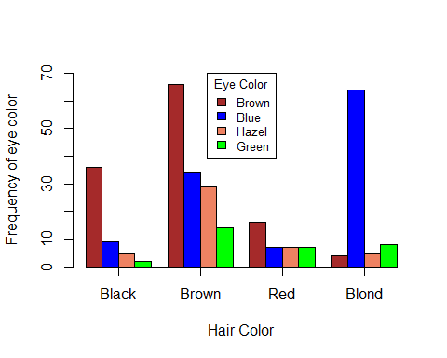

colors()

## [1] "white" "aliceblue" "antiquewhite"   
## [4] "antiquewhite1" "antiquewhite2" "antiquewhite3"   
## [7] "antiquewhite4" "aquamarine" "aquamarine1"   
## [10] "aquamarine2" "aquamarine3" "aquamarine4"   
## [13] "azure" "azure1" "azure2"   
## [16] "azure3" "azure4" "beige"   
## [19] "bisque" "bisque1" "bisque2"   
## [22] "bisque3" "bisque4" "black"   
## [25] "blanchedalmond" "blue" "blue1"   
## [28] "blue2" "blue3" "blue4"   
## [31] "blueviolet" "brown" "brown1"   
## [34] "brown2" "brown3" "brown4"   
## [37] "burlywood" "burlywood1" "burlywood2"   
## [40] "burlywood3" "burlywood4" "cadetblue"   
## [43] "cadetblue1" "cadetblue2" "cadetblue3"   
## [46] "cadetblue4" "chartreuse" "chartreuse1"   
## [49] "chartreuse2" "chartreuse3" "chartreuse4"   
## [52] "chocolate" "chocolate1" "chocolate2"   
## [55] "chocolate3" "chocolate4" "coral"   
## [58] "coral1" "coral2" "coral3"   
## [61] "coral4" "cornflowerblue" "cornsilk"   
## [64] "cornsilk1" "cornsilk2" "cornsilk3"   
## [67] "cornsilk4" "cyan" "cyan1"   
## [70] "cyan2" "cyan3" "cyan4"   
## [73] "darkblue" "darkcyan" "darkgoldenrod"   
## [76] "darkgoldenrod1" "darkgoldenrod2" "darkgoldenrod3"   
## [79] "darkgoldenrod4" "darkgray" "darkgreen"   
## [82] "darkgrey" "darkkhaki" "darkmagenta"   
## [85] "darkolivegreen" "darkolivegreen1" "darkolivegreen2"   
## [88] "darkolivegreen3" "darkolivegreen4" "darkorange"   
## [91] "darkorange1" "darkorange2" "darkorange3"   
## [94] "darkorange4" "darkorchid" "darkorchid1"   
## [97] "darkorchid2" "darkorchid3" "darkorchid4"   
## [100] "darkred" "darksalmon" "darkseagreen"   
## [103] "darkseagreen1" "darkseagreen2" "darkseagreen3"   
## [106] "darkseagreen4" "darkslateblue" "darkslategray"   
## [109] "darkslategray1" "darkslategray2" "darkslategray3"   
## [112] "darkslategray4" "darkslategrey" "darkturquoise"   
## [115] "darkviolet" "deeppink" "deeppink1"   
## [118] "deeppink2" "deeppink3" "deeppink4"   
## [121] "deepskyblue" "deepskyblue1" "deepskyblue2"   
## [124] "deepskyblue3" "deepskyblue4" "dimgray"   
## [127] "dimgrey" "dodgerblue" "dodgerblue1"   
## [130] "dodgerblue2" "dodgerblue3" "dodgerblue4"   
## [133] "firebrick" "firebrick1" "firebrick2"   
## [136] "firebrick3" "firebrick4" "floralwhite"   
## [139] "forestgreen" "gainsboro" "ghostwhite"   
## [142] "gold" "gold1" "gold2"   
## [145] "gold3" "gold4" "goldenrod"   
## [148] "goldenrod1" "goldenrod2" "goldenrod3"   
## [151] "goldenrod4" "gray" "gray0"   
## [154] "gray1" "gray2" "gray3"   
## [157] "gray4" "gray5" "gray6"   
## [160] "gray7" "gray8" "gray9"   
## [163] "gray10" "gray11" "gray12"   
## [166] "gray13" "gray14" "gray15"   
## [169] "gray16" "gray17" "gray18"   
## [172] "gray19" "gray20" "gray21"   
## [175] "gray22" "gray23" "gray24"   
## [178] "gray25" "gray26" "gray27"   
## [181] "gray28" "gray29" "gray30"   
## [184] "gray31" "gray32" "gray33"   
## [187] "gray34" "gray35" "gray36"   
## [190] "gray37" "gray38" "gray39"   
## [193] "gray40" "gray41" "gray42"   
## [196] "gray43" "gray44" "gray45"   
## [199] "gray46" "gray47" "gray48"   
## [202] "gray49" "gray50" "gray51"   
## [205] "gray52" "gray53" "gray54"   
## [208] "gray55" "gray56" "gray57"   
## [211] "gray58" "gray59" "gray60"   
## [214] "gray61" "gray62" "gray63"   
## [217] "gray64" "gray65" "gray66"   
## [220] "gray67" "gray68" "gray69"   
## [223] "gray70" "gray71" "gray72"   
## [226] "gray73" "gray74" "gray75"   
## [229] "gray76" "gray77" "gray78"   
## [232] "gray79" "gray80" "gray81"   
## [235] "gray82" "gray83" "gray84"   
## [238] "gray85" "gray86" "gray87"   
## [241] "gray88" "gray89" "gray90"   
## [244] "gray91" "gray92" "gray93"   
## [247] "gray94" "gray95" "gray96"   
## [250] "gray97" "gray98" "gray99"   
## [253] "gray100" "green" "green1"   
## [256] "green2" "green3" "green4"   
## [259] "greenyellow" "grey" "grey0"   
## [262] "grey1" "grey2" "grey3"   
## [265] "grey4" "grey5" "grey6"   
## [268] "grey7" "grey8" "grey9"   
## [271] "grey10" "grey11" "grey12"   
## [274] "grey13" "grey14" "grey15"   
## [277] "grey16" "grey17" "grey18"   
## [280] "grey19" "grey20" "grey21"   
## [283] "grey22" "grey23" "grey24"   
## [286] "grey25" "grey26" "grey27"   
## [289] "grey28" "grey29" "grey30"   
## [292] "grey31" "grey32" "grey33"   
## [295] "grey34" "grey35" "grey36"   
## [298] "grey37" "grey38" "grey39"   
## [301] "grey40" "grey41" "grey42"   
## [304] "grey43" "grey44" "grey45"   
## [307] "grey46" "grey47" "grey48"   
## [310] "grey49" "grey50" "grey51"   
## [313] "grey52" "grey53" "grey54"   
## [316] "grey55" "grey56" "grey57"   
## [319] "grey58" "grey59" "grey60"   
## [322] "grey61" "grey62" "grey63"   
## [325] "grey64" "grey65" "grey66"   
## [328] "grey67" "grey68" "grey69"   
## [331] "grey70" "grey71" "grey72"   
## [334] "grey73" "grey74" "grey75"   
## [337] "grey76" "grey77" "grey78"   
## [340] "grey79" "grey80" "grey81"   
## [343] "grey82" "grey83" "grey84"   
## [346] "grey85" "grey86" "grey87"   
## [349] "grey88" "grey89" "grey90"   
## [352] "grey91" "grey92" "grey93"   
## [355] "grey94" "grey95" "grey96"   
## [358] "grey97" "grey98" "grey99"   
## [361] "grey100" "honeydew" "honeydew1"   
## [364] "honeydew2" "honeydew3" "honeydew4"   
## [367] "hotpink" "hotpink1" "hotpink2"   
## [370] "hotpink3" "hotpink4" "indianred"   
## [373] "indianred1" "indianred2" "indianred3"   
## [376] "indianred4" "ivory" "ivory1"   
## [379] "ivory2" "ivory3" "ivory4"   
## [382] "khaki" "khaki1" "khaki2"   
## [385] "khaki3" "khaki4" "lavender"   
## [388] "lavenderblush" "lavenderblush1" "lavenderblush2"   
## [391] "lavenderblush3" "lavenderblush4" "lawngreen"   
## [394] "lemonchiffon" "lemonchiffon1" "lemonchiffon2"   
## [397] "lemonchiffon3" "lemonchiffon4" "lightblue"   
## [400] "lightblue1" "lightblue2" "lightblue3"   
## [403] "lightblue4" "lightcoral" "lightcyan"   
## [406] "lightcyan1" "lightcyan2" "lightcyan3"   
## [409] "lightcyan4" "lightgoldenrod" "lightgoldenrod1"   
## [412] "lightgoldenrod2" "lightgoldenrod3" "lightgoldenrod4"   
## [415] "lightgoldenrodyellow" "lightgray" "lightgreen"   
## [418] "lightgrey" "lightpink" "lightpink1"   
## [421] "lightpink2" "lightpink3" "lightpink4"   
## [424] "lightsalmon" "lightsalmon1" "lightsalmon2"   
## [427] "lightsalmon3" "lightsalmon4" "lightseagreen"   
## [430] "lightskyblue" "lightskyblue1" "lightskyblue2"   
## [433] "lightskyblue3" "lightskyblue4" "lightslateblue"   
## [436] "lightslategray" "lightslategrey" "lightsteelblue"   
## [439] "lightsteelblue1" "lightsteelblue2" "lightsteelblue3"   
## [442] "lightsteelblue4" "lightyellow" "lightyellow1"   
## [445] "lightyellow2" "lightyellow3" "lightyellow4"   
## [448] "limegreen" "linen" "magenta"   
## [451] "magenta1" "magenta2" "magenta3"   
## [454] "magenta4" "maroon" "maroon1"   
## [457] "maroon2" "maroon3" "maroon4"   
## [460] "mediumaquamarine" "mediumblue" "mediumorchid"   
## [463] "mediumorchid1" "mediumorchid2" "mediumorchid3"   
## [466] "mediumorchid4" "mediumpurple" "mediumpurple1"   
## [469] "mediumpurple2" "mediumpurple3" "mediumpurple4"   
## [472] "mediumseagreen" "mediumslateblue" "mediumspringgreen"   
## [475] "mediumturquoise" "mediumvioletred" "midnightblue"   
## [478] "mintcream" "mistyrose" "mistyrose1"   
## [481] "mistyrose2" "mistyrose3" "mistyrose4"   
## [484] "moccasin" "navajowhite" "navajowhite1"   
## [487] "navajowhite2" "navajowhite3" "navajowhite4"   
## [490] "navy" "navyblue" "oldlace"   
## [493] "olivedrab" "olivedrab1" "olivedrab2"   
## [496] "olivedrab3" "olivedrab4" "orange"   
## [499] "orange1" "orange2" "orange3"   
## [502] "orange4" "orangered" "orangered1"   
## [505] "orangered2" "orangered3" "orangered4"   
## [508] "orchid" "orchid1" "orchid2"   
## [511] "orchid3" "orchid4" "palegoldenrod"   
## [514] "palegreen" "palegreen1" "palegreen2"   
## [517] "palegreen3" "palegreen4" "paleturquoise"   
## [520] "paleturquoise1" "paleturquoise2" "paleturquoise3"   
## [523] "paleturquoise4" "palevioletred" "palevioletred1"   
## [526] "palevioletred2" "palevioletred3" "palevioletred4"   
## [529] "papayawhip" "peachpuff" "peachpuff1"   
## [532] "peachpuff2" "peachpuff3" "peachpuff4"   
## [535] "peru" "pink" "pink1"   
## [538] "pink2" "pink3" "pink4"   
## [541] "plum" "plum1" "plum2"   
## [544] "plum3" "plum4" "powderblue"   
## [547] "purple" "purple1" "purple2"   
## [550] "purple3" "purple4" "red"   
## [553] "red1" "red2" "red3"   
## [556] "red4" "rosybrown" "rosybrown1"   
## [559] "rosybrown2" "rosybrown3" "rosybrown4"   
## [562] "royalblue" "royalblue1" "royalblue2"   
## [565] "royalblue3" "royalblue4" "saddlebrown"   
## [568] "salmon" "salmon1" "salmon2"   
## [571] "salmon3" "salmon4" "sandybrown"   
## [574] "seagreen" "seagreen1" "seagreen2"   
## [577] "seagreen3" "seagreen4" "seashell"   
## [580] "seashell1" "seashell2" "seashell3"   
## [583] "seashell4" "sienna" "sienna1"   
## [586] "sienna2" "sienna3" "sienna4"   
## [589] "skyblue" "skyblue1" "skyblue2"   
## [592] "skyblue3" "skyblue4" "slateblue"   
## [595] "slateblue1" "slateblue2" "slateblue3"   
## [598] "slateblue4" "slategray" "slategray1"   
## [601] "slategray2" "slategray3" "slategray4"   
## [604] "slategrey" "snow" "snow1"   
## [607] "snow2" "snow3" "snow4"   
## [610] "springgreen" "springgreen1" "springgreen2"   
## [613] "springgreen3" "springgreen4" "steelblue"   
## [616] "steelblue1" "steelblue2" "steelblue3"   
## [619] "steelblue4" "tan" "tan1"   
## [622] "tan2" "tan3" "tan4"   
## [625] "thistle" "thistle1" "thistle2"   
## [628] "thistle3" "thistle4" "tomato"   
## [631] "tomato1" "tomato2" "tomato3"   
## [634] "tomato4" "turquoise" "turquoise1"   
## [637] "turquoise2" "turquoise3" "turquoise4"   
## [640] "violet" "violetred" "violetred1"   
## [643] "violetred2" "violetred3" "violetred4"   
## [646] "wheat" "wheat1" "wheat2"   
## [649] "wheat3" "wheat4" "whitesmoke"   
## [652] "yellow" "yellow1" "yellow2"   
## [655] "yellow3" "yellow4" "yellowgreen"

males = HairEyeColor[,,1]  
males

## Eye  
## Hair Brown Blue Hazel Green  
## Black 32 11 10 3  
## Brown 53 50 25 15  
## Red 10 10 7 7  
## Blond 3 30 5 8

colornames = c("brown","blue", "salmon2", "green")  
t(males)

## Hair  
## Eye Black Brown Red Blond  
## Brown 32 53 10 3  
## Blue 11 50 10 30  
## Hazel 10 25 7 5  
## Green 3 15 7 8

barplot(t(males), beside = T, ylim=c(0,70), xlab="Hair Color", ylab="Frequency of eye color", col = colornames, axis.lty = "solid")  
legend("top", rownames(t(males)), cex = 0.8, fill = colornames, title = "Eye Color")

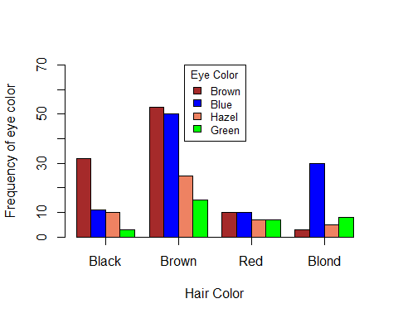

## Pie Chart

pie(table(Cars93$Type))

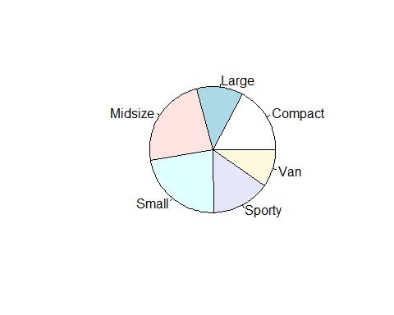

## Scatterplot

plot(airquality$Wind~airquality$Temp, pch=16, xlab="Wind Velocity (MPH)", ylab="Temperature (Fahrenheit)", main="Temperature vs Wind Velocity")

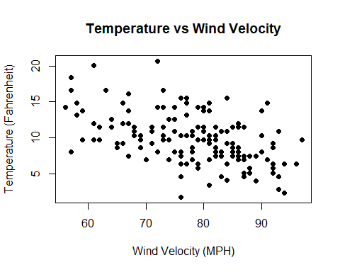

## Matrix Plot

oz.tp.wd <- subset(airquality, select = c(Ozone, Temp, Wind))  
pairs(oz.tp.wd)

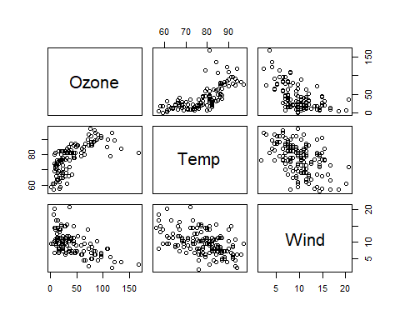

## Box plot

boxplot(Temp ~ Month, data=airquality, xaxt = "n")  
axis(1, at=1:5, label=c("May", "June", "July", "August", "September"))

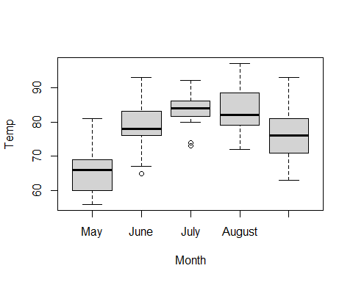

## ggplot

ggplot(airquality, aes(x=Temp)) + geom_histogram(binwidth = 5,color= "black", fill = "grey80") + theme_bw() +   
 labs(x="Temperature", y="Frequency", title = "Temperature in airquality data frame") #histogram

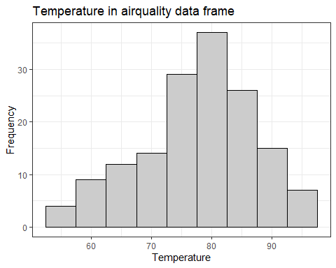

ggplot(Cars93,aes(x=Type))+geom_bar()+labs(y="Frequency", title = "Car Type and Frequency in Cars93") #bar graph

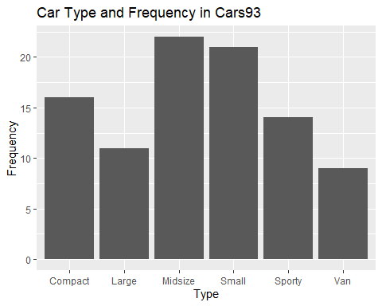

ggplot(Cars93,aes(x=Type,fill=Origin))+geom_bar(position = "dodge", color = "black")+scale_fill_grey(start=0,end=1) #grouped bar graph

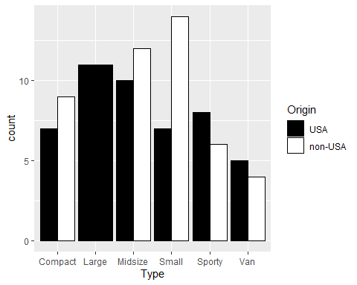

female.df = data.frame(females)  
ggplot(female.df,aes(x=Hair,y=Freq,fill=Eye))+geom_bar(position = "dodge", color = "black",stat="identity")+scale_fill_grey(start=0,end=1) #grouped bargraph

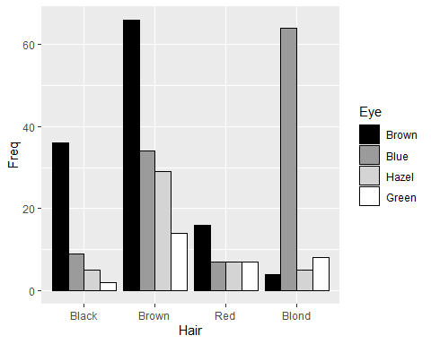

ggplot(airquality,aes(x=Wind,y=Temp)) + geom_point() #scattertplot

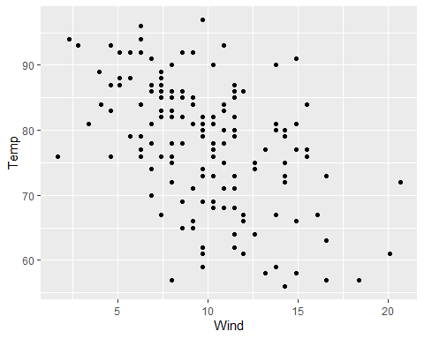

airnona = drop_na(airquality)  
median.ozone = median(airnona$Ozone)  
ozonelvl = NULL  
for(i in 1:nrow(airnona)){  
 if(airnona$Ozone[i] <= median.ozone){  
 ozonelvl[i] = "Low"}  
 else{ozonelvl[i] = "High"}  
}  
nOzonelevel = cbind(airnona,ozonelvl)  
ggplot(nOzonelevel,aes(x=Wind,y=Temp, color=ozonelvl)) + geom_point(size=3) + scale_color_grey(start=0, end=1) #plot scatter plot based on class

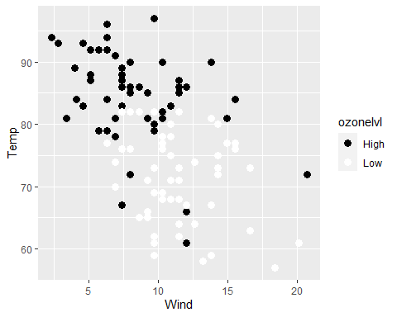

with(nOzonelevel,scatterplot3d(Wind~Temp+Ozone, pch = 19)) #3d scatter plot

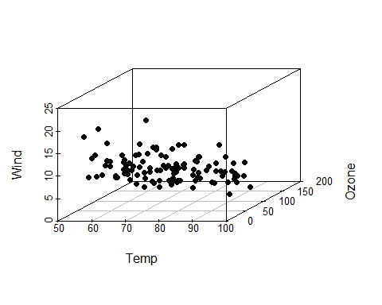

airset = subset(airnona, select = c(Ozone, Wind, Temp, Solar.R)) #ggplot with correlation matrix  
ggpairs(airset)

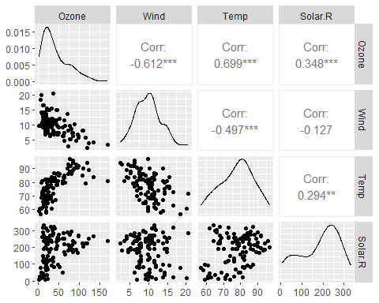

ggplot(airquality, aes(x=as.factor(Month),y=Temp)) + geom_boxplot() + geom_point() + labs(y="Temperature", x="Month") +  
 scale_x_discrete(labels=c("May", "June", "July", "August", "September")) #ggplot with boxplot

