Decision Tree

library(datasets)  
library(tidyverse)

## -- Attaching core tidyverse packages ------------------------ tidyverse 2.0.0 --  
## v dplyr 1.1.2 v readr 2.1.4  
## v forcats 1.0.0 v stringr 1.5.0  
## v ggplot2 3.4.2 v tibble 3.2.1  
## v lubridate 1.9.2 v tidyr 1.3.0  
## v purrr 1.0.1   
## -- Conflicts ------------------------------------------ tidyverse_conflicts() --  
## x dplyr::filter() masks stats::filter()  
## x dplyr::lag() masks stats::lag()  
## i Use the conflicted package (<http://conflicted.r-lib.org/>) to force all conflicts to become errors

library(caret)

## Loading required package: lattice  
##   
## Attaching package: 'caret'  
##   
## The following object is masked from 'package:purrr':  
##   
## lift

library(grid)  
library(gridExtra)

##   
## Attaching package: 'gridExtra'  
##   
## The following object is masked from 'package:dplyr':  
##   
## combine

library(GGally)

## Registered S3 method overwritten by 'GGally':  
## method from   
## +.gg ggplot2

library(ggplot2)  
library(rattle)

## Loading required package: bitops  
## Rattle: A free graphical interface for data science with R.  
## Version 5.5.1 Copyright (c) 2006-2021 Togaware Pty Ltd.  
## Type 'rattle()' to shake, rattle, and roll your data.

library(MASS)

##   
## Attaching package: 'MASS'  
##   
## The following object is masked from 'package:dplyr':  
##   
## select

library(rpart)  
library(rpart.plot)  
library(randomForest)

## randomForest 4.7-1.1  
## Type rfNews() to see new features/changes/bug fixes.  
##   
## Attaching package: 'randomForest'  
##   
## The following object is masked from 'package:rattle':  
##   
## importance  
##   
## The following object is masked from 'package:gridExtra':  
##   
## combine  
##   
## The following object is masked from 'package:dplyr':  
##   
## combine  
##   
## The following object is masked from 'package:ggplot2':  
##   
## margin

iris.tree = rpart(Species~Sepal.Length + Sepal.Width+Petal.Length+Petal.Width,iris,method="class")  
iris.tree

## n= 150   
##   
## node), split, n, loss, yval, (yprob)  
## * denotes terminal node  
##   
## 1) root 150 100 setosa (0.33333333 0.33333333 0.33333333)   
## 2) Petal.Length< 2.45 50 0 setosa (1.00000000 0.00000000 0.00000000) *  
## 3) Petal.Length>=2.45 100 50 versicolor (0.00000000 0.50000000 0.50000000)   
## 6) Petal.Width< 1.75 54 5 versicolor (0.00000000 0.90740741 0.09259259) *  
## 7) Petal.Width>=1.75 46 1 virginica (0.00000000 0.02173913 0.97826087) *

prp(iris.tree, type=2,extra="auto",nn=TRUE,branch=1,varlen=0,yesno=2)

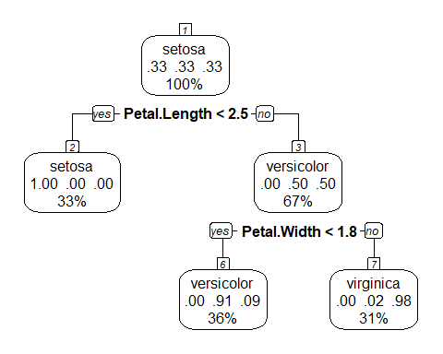

prp(iris.tree, cex=1,varlen=0,branch=0)

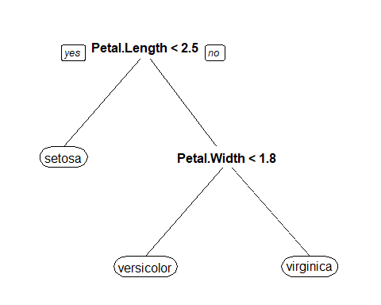

## Random Forest

set.seed(800)  
training.set = sample(nrow(iris),0.7*nrow(iris))  
iris.forest = randomForest(formula=Species~Petal.Width+Sepal.Length+Sepal.Width,data=iris,ntree=500,subset=training.set,importance=TRUE)  
print(iris.forest)

##   
## Call:  
## randomForest(formula = Species ~ Petal.Width + Sepal.Length + Sepal.Width, data = iris, ntree = 500, importance = TRUE, subset = training.set)   
## Type of random forest: classification  
## Number of trees: 500  
## No. of variables tried at each split: 1  
##   
## OOB estimate of error rate: 6.67%  
## Confusion matrix:  
## setosa versicolor virginica class.error  
## setosa 34 0 0 0.00000000  
## versicolor 0 30 3 0.09090909  
## virginica 0 4 34 0.10526316

plot(iris.forest)  
legend("topright",legend = c(levels(iris$Species),"QOB"),lty=c("dashed","dotted","dotdash","solid"), cex=.8,bty = "n")

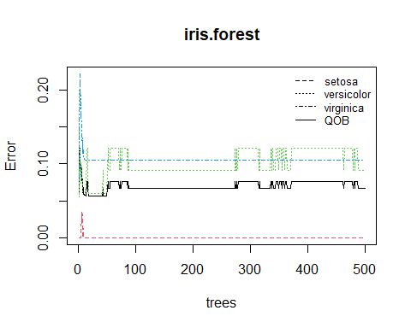

ggVarImp(iris.forest)

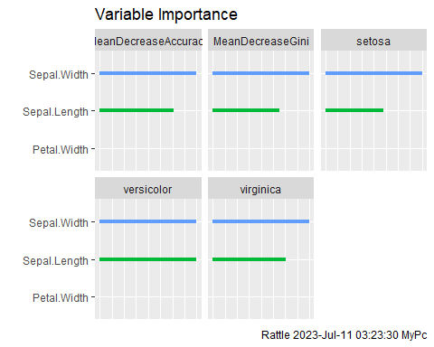

printRandomForests(iris.forest,models=c(1,500))

## Random Forest Model 1   
##   
## -------------------------------------------------------------  
## Tree 1 Rule 1 Node 4 Decision setosa  
##   
## 1: Sepal.Length <= 5.55  
## 2: Petal.Width <= 0.75  
## -----------------------------------------------------------------  
## Tree 1 Rule 2 Node 8 Decision versicolor  
##   
## 1: Sepal.Length <= 5.55  
## 2: Petal.Width > 0.75  
## 3: Petal.Width <= 1.6  
## -----------------------------------------------------------------  
## Tree 1 Rule 3 Node 9 Decision virginica  
##   
## 1: Sepal.Length <= 5.55  
## 2: Petal.Width > 0.75  
## 3: Petal.Width > 1.6  
## -----------------------------------------------------------------  
## Tree 1 Rule 4 Node 10 Decision virginica  
##   
## 1: Sepal.Length > 5.55  
## 2: Sepal.Width <= 3.9  
## 3: Sepal.Width <= 2.55  
## -----------------------------------------------------------------  
## Tree 1 Rule 5 Node 14 Decision versicolor  
##   
## 1: Sepal.Length > 5.55  
## 2: Sepal.Width <= 3.9  
## 3: Sepal.Width > 2.55  
## 4: Petal.Width <= 1.75  
## 5: Sepal.Length <= 6.15  
## -----------------------------------------------------------------  
## Tree 1 Rule 6 Node 18 Decision virginica  
##   
## 1: Sepal.Length > 5.55  
## 2: Sepal.Width <= 3.9  
## 3: Sepal.Width > 2.55  
## 4: Petal.Width <= 1.75  
## 5: Sepal.Length > 6.15  
## 6: Petal.Width <= 1.55  
## 7: Sepal.Width <= 2.95  
## -----------------------------------------------------------------  
## Tree 1 Rule 7 Node 19 Decision versicolor  
##   
## 1: Sepal.Length > 5.55  
## 2: Sepal.Width <= 3.9  
## 3: Sepal.Width > 2.55  
## 4: Petal.Width <= 1.75  
## 5: Sepal.Length > 6.15  
## 6: Petal.Width <= 1.55  
## 7: Sepal.Width > 2.95  
## -----------------------------------------------------------------  
## Tree 1 Rule 8 Node 17 Decision versicolor  
##   
## 1: Sepal.Length > 5.55  
## 2: Sepal.Width <= 3.9  
## 3: Sepal.Width > 2.55  
## 4: Petal.Width <= 1.75  
## 5: Sepal.Length > 6.15  
## 6: Petal.Width > 1.55  
## -----------------------------------------------------------------  
## Tree 1 Rule 9 Node 13 Decision virginica  
##   
## 1: Sepal.Length > 5.55  
## 2: Sepal.Width <= 3.9  
## 3: Sepal.Width > 2.55  
## 4: Petal.Width > 1.75  
## -----------------------------------------------------------------  
## Tree 1 Rule 10 Node 7 Decision setosa  
##   
## 1: Sepal.Length > 5.55  
## 2: Sepal.Width > 3.9  
## -----------------------------------------------------------------  
## Number of rules in Tree 1: 10  
##   
## Random Forest Model 500   
##   
## -------------------------------------------------------------  
## Tree 500 Rule 1 Node 18 Decision setosa  
##   
## 1: Sepal.Width <= 3.35  
## 2: Sepal.Length <= 6.15  
## 3: Sepal.Width <= 3.05  
## 4: Petal.Width <= 1.7  
## 5: Sepal.Length <= 4.65  
## -----------------------------------------------------------------  
## Tree 500 Rule 2 Node 19 Decision versicolor  
##   
## 1: Sepal.Width <= 3.35  
## 2: Sepal.Length <= 6.15  
## 3: Sepal.Width <= 3.05  
## 4: Petal.Width <= 1.7  
## 5: Sepal.Length > 4.65  
## -----------------------------------------------------------------  
## Tree 500 Rule 3 Node 15 Decision virginica  
##   
## 1: Sepal.Width <= 3.35  
## 2: Sepal.Length <= 6.15  
## 3: Sepal.Width <= 3.05  
## 4: Petal.Width > 1.7  
## -----------------------------------------------------------------  
## Tree 500 Rule 4 Node 9 Decision setosa  
##   
## 1: Sepal.Width <= 3.35  
## 2: Sepal.Length <= 6.15  
## 3: Sepal.Width > 3.05  
## -----------------------------------------------------------------  
## Tree 500 Rule 5 Node 20 Decision versicolor  
##   
## 1: Sepal.Width <= 3.35  
## 2: Sepal.Length > 6.15  
## 3: Petal.Width <= 1.75  
## 4: Sepal.Width <= 3.05  
## 5: Sepal.Width <= 2.9  
## -----------------------------------------------------------------  
## Tree 500 Rule 6 Node 22 Decision versicolor  
##   
## 1: Sepal.Width <= 3.35  
## 2: Sepal.Length > 6.15  
## 3: Petal.Width <= 1.75  
## 4: Sepal.Width <= 3.05  
## 5: Sepal.Width > 2.9  
## 6: Sepal.Length <= 6.95  
## -----------------------------------------------------------------  
## Tree 500 Rule 7 Node 23 Decision virginica  
##   
## 1: Sepal.Width <= 3.35  
## 2: Sepal.Length > 6.15  
## 3: Petal.Width <= 1.75  
## 4: Sepal.Width <= 3.05  
## 5: Sepal.Width > 2.9  
## 6: Sepal.Length > 6.95  
## -----------------------------------------------------------------  
## Tree 500 Rule 8 Node 17 Decision versicolor  
##   
## 1: Sepal.Width <= 3.35  
## 2: Sepal.Length > 6.15  
## 3: Petal.Width <= 1.75  
## 4: Sepal.Width > 3.05  
## -----------------------------------------------------------------  
## Tree 500 Rule 9 Node 11 Decision virginica  
##   
## 1: Sepal.Width <= 3.35  
## 2: Sepal.Length > 6.15  
## 3: Petal.Width > 1.75  
## -----------------------------------------------------------------  
## Tree 500 Rule 10 Node 12 Decision setosa  
##   
## 1: Sepal.Width > 3.35  
## 2: Sepal.Width <= 3.45  
## 3: Sepal.Length <= 5.55  
## -----------------------------------------------------------------  
## Tree 500 Rule 11 Node 13 Decision versicolor  
##   
## 1: Sepal.Width > 3.35  
## 2: Sepal.Width <= 3.45  
## 3: Sepal.Length > 5.55  
## -----------------------------------------------------------------  
## Tree 500 Rule 12 Node 7 Decision setosa  
##   
## 1: Sepal.Width > 3.35  
## 2: Sepal.Width > 3.45  
## -----------------------------------------------------------------  
## Number of rules in Tree 500: 12