Misc.

library(datasets)  
library(tidyverse)

## -- Attaching core tidyverse packages ------------------------ tidyverse 2.0.0 --  
## v dplyr 1.1.2 v readr 2.1.4  
## v forcats 1.0.0 v stringr 1.5.0  
## v ggplot2 3.4.2 v tibble 3.2.1  
## v lubridate 1.9.2 v tidyr 1.3.0  
## v purrr 1.0.1   
## -- Conflicts ------------------------------------------ tidyverse_conflicts() --  
## x dplyr::filter() masks stats::filter()  
## x dplyr::lag() masks stats::lag()  
## i Use the conflicted package (<http://conflicted.r-lib.org/>) to force all conflicts to become errors

library(caret)

## Loading required package: lattice  
##   
## Attaching package: 'caret'  
##   
## The following object is masked from 'package:purrr':  
##   
## lift

library(grid)  
library(gridExtra)

##   
## Attaching package: 'gridExtra'  
##   
## The following object is masked from 'package:dplyr':  
##   
## combine

library(GGally)

## Registered S3 method overwritten by 'GGally':  
## method from   
## +.gg ggplot2

library(ggplot2)  
library(SentimentAnalysis)

##   
## Attaching package: 'SentimentAnalysis'  
##   
## The following object is masked from 'package:base':  
##   
## write

states = map_data("state")

ggplot(data=states,aes(long,y=lat))+geom_polygon(color="black",fill="white",group=states$group)

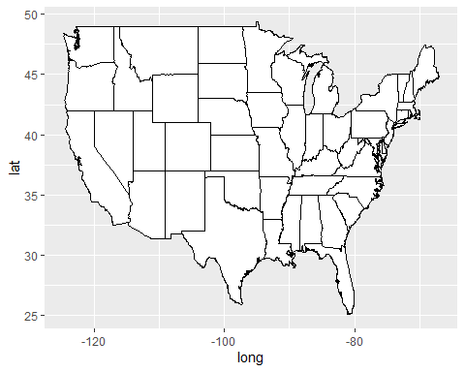

ex4 = c("Baruch is unique mixture of students and faculty, very representative of New York City.",  
 "It is centrally located, in a gread neighborhood with helpful students, professors and support staff",  
 "i'm very happy i've returned after quite some time and look firward to returning next semester.")  
  
sentiment = analyzeSentiment(ex4)  
sentiment$SentimentGI

## [1] 0.1111111 0.1111111 0.2000000

convertToDirection(sentiment$SentimentGI)

## [1] positive positive positive  
## Levels: negative neutral positive