Global Terrorism - Final Project

MATH 4685/6685 (Fall 2019)

**Group Members:**

James Willson (*Data Scientist*)

Sean Kugele (*Data Scientist/Team Lead*)

# Introduction

Our objective for this project was to create statistical models for the purposes of prediction and inference using the Global Terrorism Database[1] as our data set. Each data scientist independently selected several questions of interest. The questions selected included:

(1) predicting if an attack will be successful based on a variety of different factors (**Section 3.1**)

(2) estimating the number of casualties resulting from a successful terrorist attack (**Section 3.2**)

(3) predicting the terrorist group responsible for perpetrating a terrorist attack (**Section 3.3**)

(4) estimating the risk of attack based on temporal and geospatial variables (**Section 3.4**)

The remainder of the paper is organized into the following sections: Section 2 provides additional detail on the Global Terrorism Database (our dataset). Section 3 describes the modeling efforts for each research question, including question-specific data cleansing, generated statistical models, model comparisons, and summaries of findings. Section 4 concludes the paper with a discussion of our findings, general observations about our data modeling efforts, and possible directions for future work.

# Background

The Global Terrorism Database (GTD) contains over 180,000 observations and 135 variables. Each observation corresponds to a terrorist event that occurred between 1970 and 2017 (excluding 1993). Terrorism is broadly defined as “the threatened or actual use of illegal force and violence by a non-state actor to attain a political, economic, religious, or social goal through fear, coercion, or intimidation." Data in the GTD is sourced from unclassified media articles (e.g., electronic news archives), and it is currently maintained by the National Consortium for the Study of Terrorism and Responses to Terrorism (START) group at the University of Maryland.

The type of information available for each event includes, but is not limited to, *temporal variables* (e.g., year, month, day, etc.), *geospatial variables* (e.g., latitude and longitude, region, country, city, province, etc.), *event descriptive variables* (e.g., attack type, duration of incident, weapons used, targets, etc.), *perpetrator descriptive variables* (e.g., terrorist group name, number of perpetrators, etc.), and *event outcome variables* (e.g., total number of fatalities, total number injured, extent of property damage, success or failure indicator, etc.).

## Geospatial and Temporal Distribution of Data

As expected, the spatial and temporal distribution of the terrorist events in the GTD are highly non-uniform.

Figure 2-1 shows the temporal distribution of the events from 1970 to 2017. The number of events appears to increase dramatically from 1970 to the 2010s; however, this is likely driven by differences in media coverage and data collection rather than a reflection of actual underlying trends.

Figure ‑ – Histogram showing frequency of terrorist events between 1970 and 2017.

Figure 2-2 shows the geospatial distribution of terrorist incidents. The highest density of events occurred in the Middle East & North Africa ($50,474$) followed by South Asia ($44,974$). The lowest density of events occurred in North America ($282$) followed by Eastern Europe ($563$). The countries with the greatest number of terrorist events were Iraq ($24,636$), Pakistan ($14,368$), Afghanistan ($12,731$), India ($11,960$), and Colombia ($8,306$).

|  |  |
| --- | --- |
| Terrorist Events (1970 – 2017) | |
|  |  |
|  | |
|  | |

Figure ‑ – Geospatial distribution of terrorist events.

Figure 2-3 shows changes in the geospatial distribution of terrorist events over time. Note that the areas of highest concentration have shifted considerably. Between 1970 and 1989, the greatest number of attacks occurred in South America ($9,322$) and Western Europe ($9,017$). Between 1990 and 2009, the Middle East & North Africa emerged as the region with the highest density of attacks ($11,681$) and that trend continues into the 2010s where the Middle East & North Africa accounts for $32,965$ terrorist events. By comparison, South America accounted for only $1,359$ terrorist events in the same time period.

|  |  |  |
| --- | --- | --- |
| Changes in Terrorist Event Density Over Time | | |
|  | | |
|  |  |  |
| *Time* | | |

Figure ‑ – Changes in terrorist incident density with time. Note that not only do high-density areas change with time, but the density’s variance decreases with time.

## Data Quality

While the GTD contains 135 variables, only a subset of these variables can be easily used for model creation. 41 variables contain redundant, free-form textual descriptions of the codes used in other variables and were, therefore, unusable. Among the 94 remaining variables, 44 have over 90% NA values. (Not surprisingly, running na.omit on the data set results in 0 rows.) Most of the “usable” variables are categorical; however, many numerical variables are also present (e.g., nwounded, nkill, nperps, etc.). Some of the categorical variables contain many distinct categories (e.g., country that contains 205 distinct values), making them challenging to use directly because of the large number of variables they will generate after encoding. Finally, the frequency with which each category occurs in most of these categorical variables is highly unbalanced, complicating our efforts.

Due to these complications, we tailored our data cleansing and feature selection to each problem rather than trying to cleanse the data up-front in a problem-agnostic fashion, which would have sacrificed too many observations. The specifics of these problem-specific data cleansing efforts are described in Section 3.

# Modeling

In this section we will discuss the following research questions, describing challenges encountered and results obtained:

Q1 predicting if an attack will be successful based on a variety of different factors (**Section 3.1**)

Q2 estimating the number of casualties resulting from a successful terrorist attack (**Section 3.2**)

Q3 predicting the terrorist group responsible for perpetrating a terrorist attack (**Section 3.3**)

Q4 estimating the risk of attack based on temporal and geospatial variables (**Section 3.4**)

James Willson was assigned to Q1 and Q2, and Sean Kugele to Q3 and Q4.

## Q1—Predicting Successful Attacks

After loading in the data, I looked at the features. Simply using backwards selection to remove variables was not going to work as there were no rows with all values included; models would not find the data usable in its current state. Just deleting one or two columns was not enough to make the data usable, so I looked at the number of NAs per column; I removed anything with over 10000 NAs as most of these were either secondary or tertiary variables measuring the same thing (e.g. “targtype2” and “targtype3”) or variables that were only relevant to a very small subset of the data (e.g. “ransomamt” or “ransompaid”, which are only relevant if there was a ransom) or finally, variables that didn’t align with the goals of the model (e.g. “nkill” or “nwound” which wouldn’t be helpful for predicting future attacks, as they aren’t relevant until after the attack). After removing the variables, I hot encoded the remaining ones so that an incorrect idea of the category’s relationship was not derived from the fact that many of the categorical variables were recorded as numbers. I also noted that the target variable “success” was unbalanced (only 11% failures); however, I decided to see what I could be done leaving it in its original state.

Since most of the remaining variables were categorical (everything but “latitude” and “longitude”), I decided to use decision trees. This seemed like the most natural decision, as making left/right decisions with binary variables seemed appropriate. Originally, I used the “tree” package however the results were less the stellar (see *Figure 3-1*).

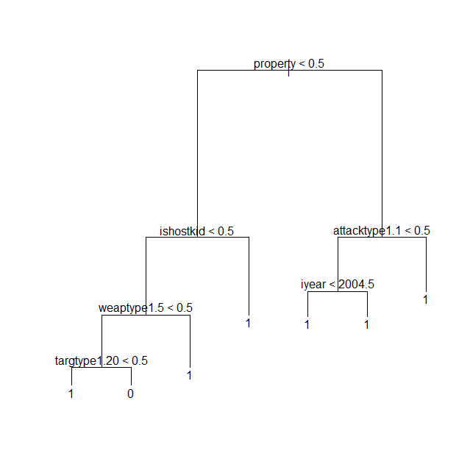

One problem is that this tree is obviously not well balanced; it will only predict failure in one case, that of “targtype1.20” being true (after other variable queries of course). It turns out that “targtype1.20” stands for the target type being unknown, which makes it useless (you get the same information by noting that all the other targtype1 columns are false). After removing the column, I got a new tree as seen in *Figure 3-2*.

Figure 3-1 – Initial tree model

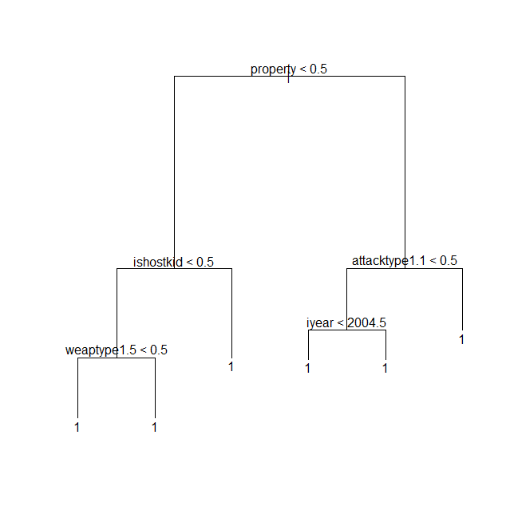

*Figure 3-2 –* *Tree model after deleting “targtype1.20”*

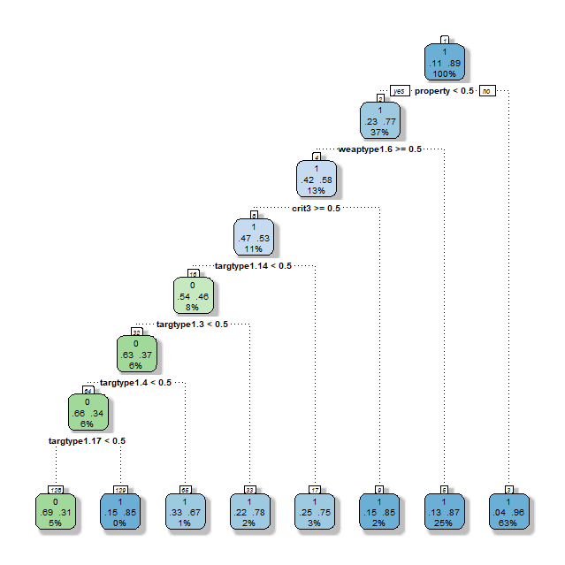Now the tree only predicted success, never failure. While this gives reasonably high accuracy, it is not a very informative model. In an attempt to find the probability of success at each leaf, I found a package called “rpart.” This package was an equivalent package to “tree” however, it had additional information on some of its plots. There must have been a subtle difference in how it calculated the tree, as when I ran it on the same data a got a different tree (*Figure 3-3*).

*Figure 3-3 –* *Tree created with the “rpart” package*

This model still has issues. Its precision and recall on testing data are 0.685 and 0.337 respectively (with 0 as the positive class), which is not the best. On top of that, the accuracy it does have seems derive from a quirk in how success is defined then anything truly meaningful. Notice the two highest nodes: “property” is a binary variable indicating whether there was any property damage as a result of the attack, “weaptype1.6” corresponds to attacks with explosive weapons. If you look in the documentation for the dataset, it states that “A bombing is successful if the bomb or explosive device detonates. Bombings are considered unsuccessful if they do not detonate. The success or failure of the bombing is not based on whether it hit the intended target.” Clearly in many cases, if there is no property damage and the weapon is an explosive, then it will have not been successful. This gives us very little information about success/failure in general.

The problem that seemed the easiest to fix was the issue of unbalanced data. I tried a technique called oversampling, where you duplicate instances of the data from the underrepresented class. The result was the following tree (*Figure 3-4*).

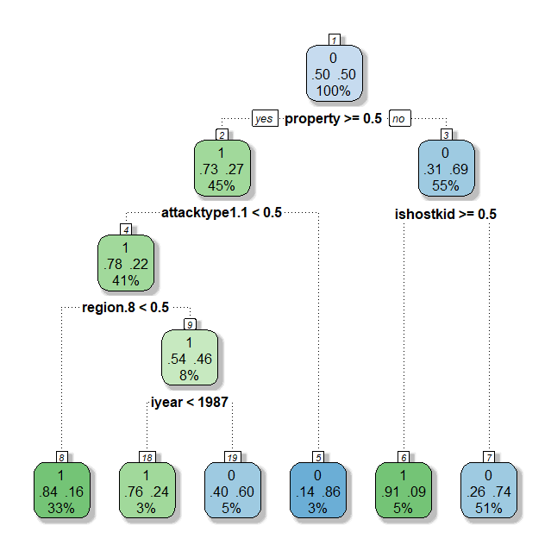

*Figure 3-4 – New* *tree created with balanced data*

This model had a precision and recall of 0.213 and 0.864 respectively. It seemed to have overcorrected in the opposite direction. Neither of the two tree models can be improved significantly by altering the thresholds. This new model is a bit better than the previous one as can be seen by looking at the ROC curves (*Figure 3-5*).

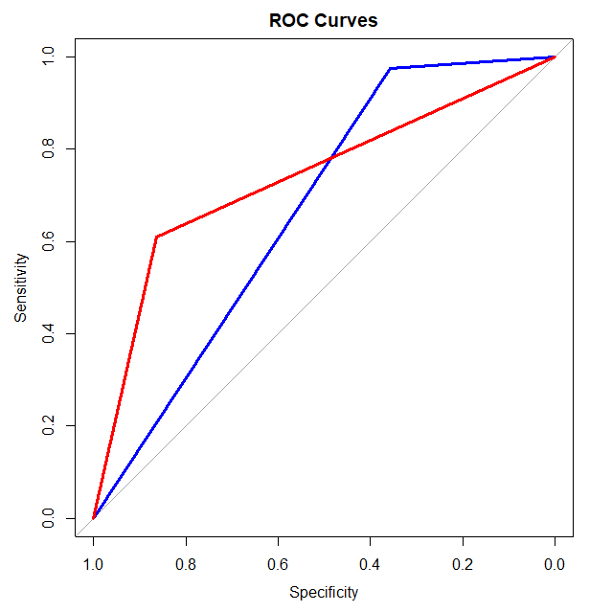  
*Figure 3-5 – ROC curves; Blue: unbalanced tree model, Red: balanced tree model.*

The AUC for the first and second respectively is 0.667 and 0.7367.

Next, I decided to try out some different types of models, first Logistic Regression. I started with the unbalanced data and used backward selection to select the best variables. I picked 30 variables based off the following plot (*Figure 3-6*).

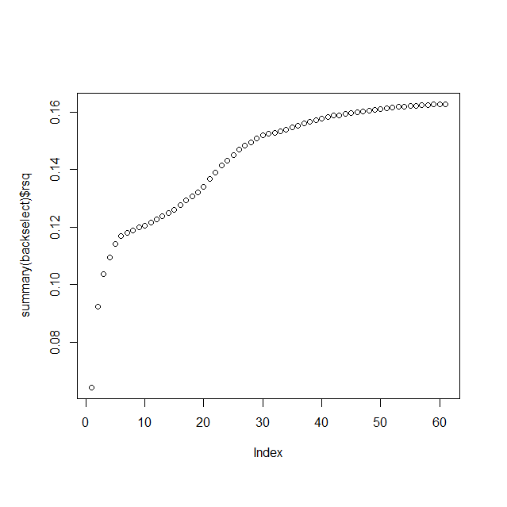

*Figure 3-6 – Number of variables vs. R-squared*

The results were:

Call:  
glm(formula = success ~ ., family = "binomial", data = data.selected)  
  
Deviance Residuals:   
 Min 1Q Median 3Q Max   
-4.1486 0.1687 0.2604 0.4120 2.0687   
  
Coefficients:  
 Estimate Std. Error z value Pr(>|z|)   
(Intercept) -1.09071 0.07308 -14.925 < 2e-16 ***  
region.6 0.40873 0.03452 11.840 < 2e-16 ***  
region.11 0.60679 0.04979 12.187 < 2e-16 ***  
attacktype1.1 1.09595 0.05195 21.098 < 2e-16 ***  
attacktype1.2 1.35816 0.05009 27.116 < 2e-16 ***  
attacktype1.3 2.22194 0.07321 30.349 < 2e-16 ***  
attacktype1.6 -0.32326 0.19378 -1.668 0.095282 .   
attacktype1.7 0.34666 0.08019 4.323 1.54e-05 ***  
targtype1.1 1.34196 0.07408 18.116 < 2e-16 ***  
targtype1.2 1.06465 0.07127 14.938 < 2e-16 ***  
targtype1.3 1.62197 0.06929 23.409 < 2e-16 ***  
targtype1.4 1.56869 0.06578 23.846 < 2e-16 ***  
targtype1.6 0.87450 0.14295 6.118 9.50e-10 ***  
targtype1.7 0.77704 0.10222 7.602 2.92e-14 ***  
targtype1.8 1.52167 0.11964 12.719 < 2e-16 ***  
targtype1.9 0.76934 0.27037 2.845 0.004434 **   
targtype1.10 1.69781 0.14349 11.832 < 2e-16 ***  
targtype1.11 1.02639 0.30233 3.395 0.000687 ***  
targtype1.12 1.60504 0.25804 6.220 4.97e-10 ***  
targtype1.14 1.90767 0.06749 28.265 < 2e-16 ***  
targtype1.15 1.86101 0.13835 13.452 < 2e-16 ***  
targtype1.16 1.28116 0.20019 6.400 1.56e-10 ***  
targtype1.17 2.01486 0.11742 17.160 < 2e-16 ***  
targtype1.18 0.94274 0.25077 3.759 0.000170 ***  
targtype1.19 1.02183 0.09257 11.039 < 2e-16 ***  
targtype1.21 1.75442 0.10605 16.543 < 2e-16 ***  
targtype1.22 1.39467 0.15435 9.036 < 2e-16 ***  
weaptype1.6 -1.87432 0.05872 -31.920 < 2e-16 ***  
property 2.35592 0.03481 67.680 < 2e-16 ***  
ishostkid 4.28417 0.20892 20.506 < 2e-16 ***  
INT_LOG -0.53078 0.04417 -12.018 < 2e-16 ***  
---  
Signif. codes: 0 ‘***’ 0.001 ‘**’ 0.01 ‘*’ 0.05 ‘.’ 0.1 ‘ ’ 1  
  
(Dispersion parameter for binomial family taken to be 1)  
  
 Null deviance: 50455 on 79650 degrees of freedom  
Residual deviance: 39050 on 79620 degrees of freedom  
(102040 observations deleted due to missingness)  
AIC: 39112  
  
Number of Fisher Scoring iterations: 7

A quick look at the ROC curve indicates that this model was not particularly effective (*Figure 3-7*).

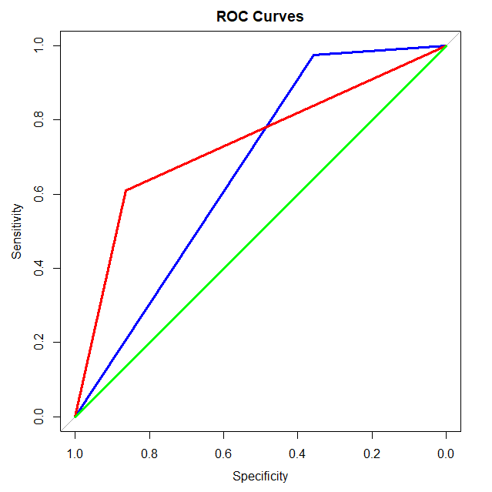  
*Figure 3-7 – ROC curves; Blue: unbalanced tree model, Red: balanced tree model, Green: logistic regression model*

I then tried logistic regression on the balanced data, using similar methods as before.

Call:  
glm(formula = success ~ ., family = "binomial", data = data.selected.2)  
  
Deviance Residuals:   
 Min 1Q Median 3Q Max   
-2.9358 -0.7775 0.1648 0.7868 3.1412   
  
Coefficients:  
 Estimate Std. Error z value Pr(>|z|)   
(Intercept) -1.827e+01 1.360e+00 -13.441 <2e-16 ***  
iyear 1.116e-02 6.785e-04 16.454 <2e-16 ***  
extended -2.190e+00 9.809e-02 -22.330 <2e-16 ***  
country 1.429e-03 6.667e-05 21.436 <2e-16 ***  
region.1 7.187e-01 4.502e-02 15.965 <2e-16 ***  
region.2 -1.077e+00 4.449e-02 -24.214 <2e-16 ***  
region.3 -3.865e-01 2.552e-02 -15.149 <2e-16 ***  
region.6 -6.709e-01 2.390e-02 -28.074 <2e-16 ***  
region.10 -3.667e-01 2.226e-02 -16.473 <2e-16 ***  
region.11 -7.792e-01 2.838e-02 -27.451 <2e-16 ***  
crit3 -1.388e+00 6.375e-02 -21.781 <2e-16 ***  
doubtterr -8.777e-01 5.201e-02 -16.875 <2e-16 ***  
attacktype1.1 -6.278e-01 4.054e-02 -15.486 <2e-16 ***  
attacktype1.2 -9.684e-01 3.782e-02 -25.604 <2e-16 ***  
attacktype1.3 -1.957e+00 4.867e-02 -40.202 <2e-16 ***  
attacktype1.6 2.047e-01 8.594e-02 2.381 0.0173 *   
attacktype1.7 -7.858e-01 3.992e-02 -19.685 <2e-16 ***  
attacktype1.8 -1.291e+00 9.132e-02 -14.133 <2e-16 ***  
targtype1.1 -4.436e-01 2.429e-02 -18.263 <2e-16 ***  
targtype1.3 -6.598e-01 2.237e-02 -29.490 <2e-16 ***  
targtype1.4 -1.018e+00 4.039e-02 -25.194 <2e-16 ***  
targtype1.8 -6.692e-01 5.252e-02 -12.743 <2e-16 ***  
targtype1.14 -1.023e+00 2.137e-02 -47.893 <2e-16 ***  
targtype1.15 -1.032e+00 5.717e-02 -18.055 <2e-16 ***  
targtype1.21 -7.897e-01 4.084e-02 -19.334 <2e-16 ***  
natlty1 -1.656e-03 1.016e-04 -16.297 <2e-16 ***  
weaptype1.5 -4.694e-01 3.084e-02 -15.223 <2e-16 ***  
weaptype1.6 1.437e+00 4.240e-02 33.879 <2e-16 ***  
property -2.223e+00 1.670e-02 -133.112 <2e-16 ***  
ishostkid -3.219e+00 8.591e-02 -37.469 <2e-16 ***  
INT_LOG 4.312e-01 2.417e-02 17.839 <2e-16 ***  
---  
Signif. codes: 0 ‘***’ 0.001 ‘**’ 0.01 ‘*’ 0.05 ‘.’ 0.1 ‘ ’ 1  
  
(Dispersion parameter for binomial family taken to be 1)  
  
Null deviance: 187339 on 135136 degrees of freedom  
Residual deviance: 134985 on 135106 degrees of freedom  
AIC: 135047  
  
Number of Fisher Scoring iterations: 6

This gave a slightly better result, however nowhere near as good as the decision tree models (*Figure 3-8*).

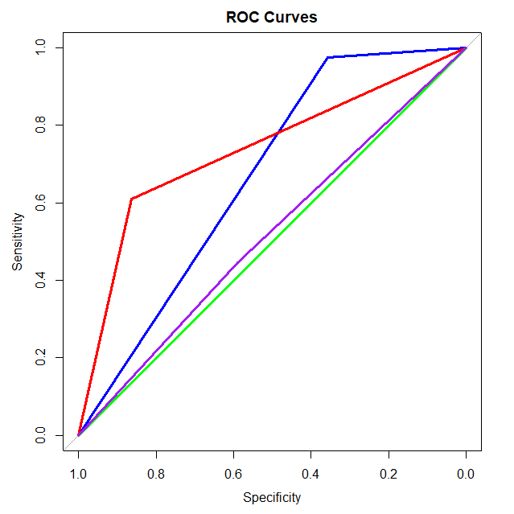  
*Figure 3-8 – ROC curves; Blue: unbalanced tree model, Red: balanced tree model, Green: logistic regression model, Purple: balanced logistic regression model*

At this point I decided that logistic regression did not seem to be going anywhere. The second tree model (the one with the balanced data) seemed to be the best, so I decided to see what could be done to refine it. First, I looked at the variable importance of the balanced tree model (*Figure 3-9*).

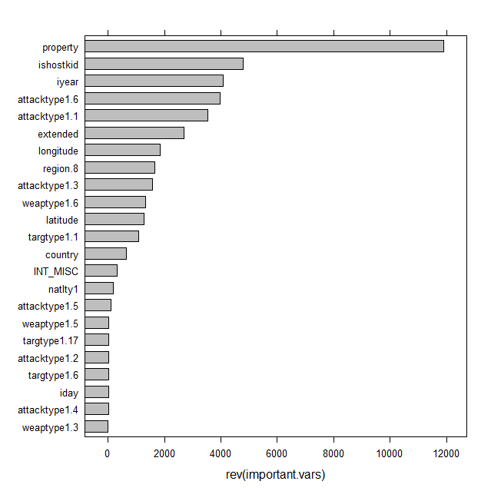

*Figure 3-9 – Variable importance of variables in balanced tree model*

First off, the variable “property” seems to be vastly more important in predictions than any of the other variables. This might be because weapon types and attacks that cause property damage are more likely to result in success. However, another possibility is this derives from the fact that, for many definitions of success, property damage might be sufficient to designate the attack as successful. Additionally, many variables overlap and are somewhat redundant. For instance, “ishostkid” is a boolean feature measuring whether hostages were taken, “attacktype1.6” are kidnappings.

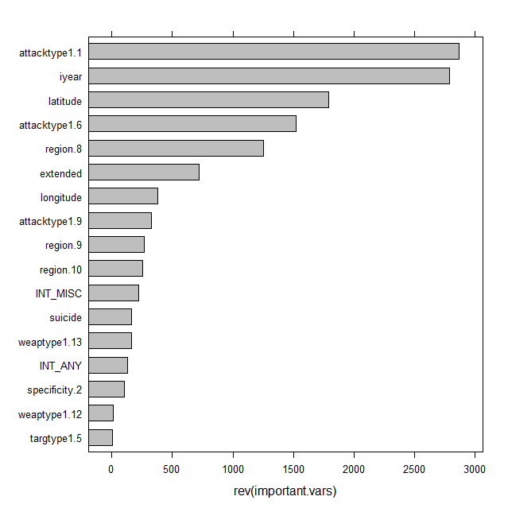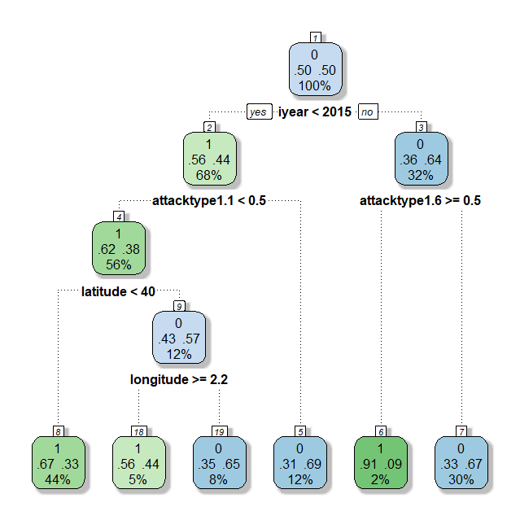Considering all this, I decided to remove a few of the variables and see how the model performed. I

*Figure 3-10 and 3-11 – New tree with removed variables and new variable importance plot*

removed, “country” and “natlty1” (both redundant with region, a subtle difference between nationality and region exists, however the difference is slight enough that I didn’t see any reason to keep it for this question in particular). I removed “property” and “ishostkid” for the reason mentioned above; I also removed “weaptype1.6” (Explosives) as there already existed an attack type (“attacktype1.3”) that corresponded with explosive attacks. Running “rpart” with the changes gets us the following two figures (*Figure 3-10* and *3-11*).

The two attack types in the tree (Figure 3-10) are assassinations to the left and kidnappings to the right. As for the new model’s accuracy, its precision and recall on testing data were 0.2031986 and 0.6045894 respectively with an accuracy score of 0.6888043. “iyear” is a curious variable to be on top; the main question that comes to mind is whether its importance is due a major shift in how attacks are carried out, or just a shift in how and which attacks are recorded.

Both the longitude and latitude are interesting features of this tree model; however, I was not convinced that they were necessary and not the result of overfitting. I used rsq.rpart() to measure the error against the number of splits obtaining the following plot (*Figure 3-12*).

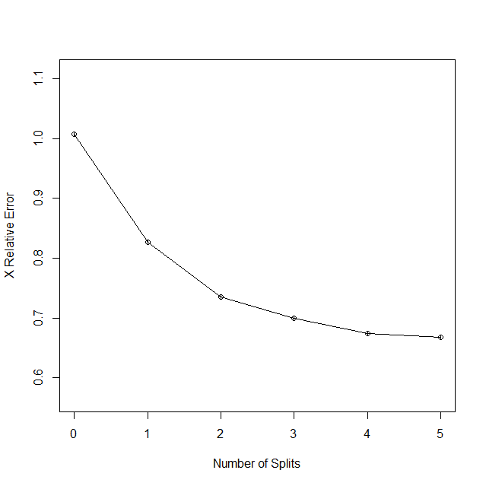

*Figure 3-12 – Error vs. Number of Splits*

This plot seems to indicate that between two and four splits are needed. Two splits leave only “iyear” and the assassination attack type; four leaves everything but longitude. The two-split model has the following results: *precision:* 0.1970123, *recall:* 0.5415459, *accuracy:* 0.7001087 and *AUC:* 0.6344, while the the four-split model results are: *precision:* 0.1888562, *recall:* 0.6516908, *accuracy:* 0.6459239, and *AUC:* 0.6634. Due to the AUC, the four-split model seems to be the best of the two.

If we compare all the models, we get the following ROC curves (*Figure 3-13*):

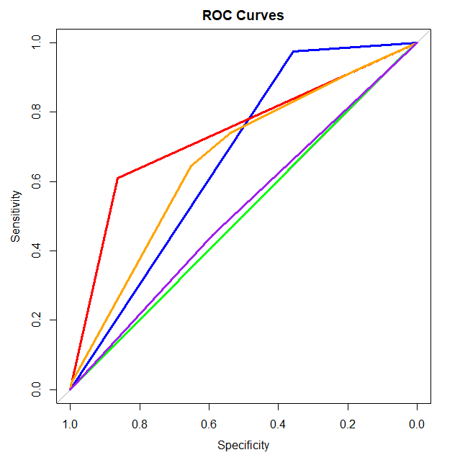*Figure 3-13 – Blue Model (unbalanced tree) AUC: 0.667; Red Model (balanced tree) AUC: 0.7367; Orange Model (final tweaked tree) AUC: 0.6634; Green Model (unbalanced logistic regression) AUC: 0.5027; Purple Model (balanced logistic regression) AUC: 0.5183.*

Judging purely by the AUC, the balanced tree model is by far the best. It’s also interesting to note that the tweaked model (orange) and the balanced model (red) are actually very similar if you look at their trees. The primary difference is the root node, however the rest of the nodes are very similar; in place of “ishostkid” (boolean true for hostages/kidnapping) we have “attacktype1.6” (attack type for kidnapping) and in place of latitude < 40 we have region.8 (region 8 is Western Europe; above the 40th parallel is dominated mostly by Europe though it has the north half of North America as well).

In summary, the main results were that attacks involving techniques that might cause property damage (especially explosives) and attacks involving hostages tended to have higher success. On the other hand, assassination (especially in first world countries such as most of Europe and North America) were much less likely to be successful. Surprisingly variables such as the ones relating to weapon type were not very relevant. It is important to note that the accuracy, even on the best model, was not particularly high. This might be due to a variety of reasons. Terrorist attacks are complicated and rely on many different factors; some of these factors might have been outside the scope of the data we had to work with.

## Q2—Estimating Number of Casualties

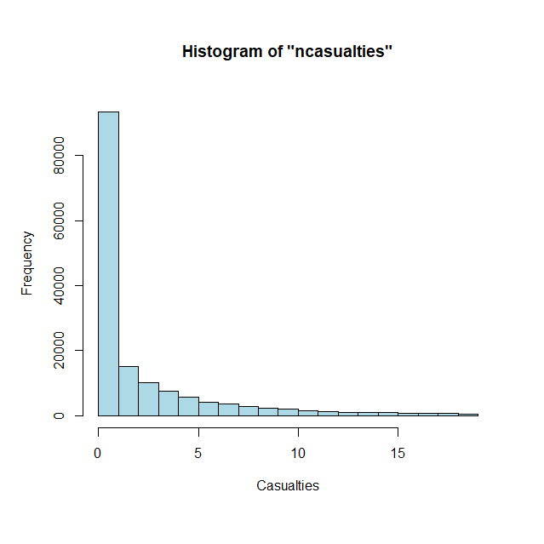Upon loading in the dataset, I created a new column “ncasualties” by adding together the values in the “nkill” and “nwounded” columns. I then removed all values from the dataset where “ncasualties” was NA or “success” equaled 0 (as we were only looking at casualties in successful attacks). I then looked at the distribution of the casualty values (*Figure 3-14*). We can see that the data is very skewed towards 0; since we know that all these attacks are success, that means that the majority of attacks are fairly small scale.

Using similar methods as before I eliminated variables that had too many NAs etc. until I was left with the following columns: “iyear”, “imonth”, “iday”, “extended”, “region”, “latitude”, “longitude”, “specificity”, “vicinity”, “crit1”, “crit2”, “crit3”, “doubtterr”, “multiple”, “suicide”, “attacktype1”, “targtype1”, “targsubtype1”, “guncertain1”, “individual”, “weaptype1”, “property”, “ishostkid”, “INT_LOG”, “INT_IDEO”, “INT_MISC”, “INT_ANY”, and “ncasualties”.

*Figure 3-14 – Histogram of “ncasualties”*

My first idea was to use linear regression. After some simple backwards selection, this was the result:

Call:  
lm(formula = ncasualties ~ iyear + region + doubtterr + suicide +   
 attacktype1 + weaptype1 + property, data = data.reduced)  
  
Residuals:  
Min 1Q Median 3Q Max   
-253.8 -4.7 -2.1 1.1 9317.2   
  
Coefficients:  
 Estimate Std. Error t value Pr(>|t|)   
(Intercept) 213.10736 28.51301 7.474 7.82e-14 ***  
iyear -0.06943 0.01310 -5.298 1.17e-07 ***  
region2 -4.46732 0.99273 -4.500 6.80e-06 ***  
region3 -5.71651 0.92051 -6.210 5.31e-10 ***  
region4 5.62777 1.93936 2.902 0.003710 **   
region5 -3.42710 0.97944 -3.499 0.000467 ***  
region6 -2.23579 0.91833 -2.435 0.014908 *   
region7 -2.49325 2.15763 -1.156 0.247868   
region8 -6.10576 0.93419 -6.536 6.35e-11 ***  
region9 -3.40691 1.11726 -3.049 0.002294 **   
region10 -1.54492 0.91766 -1.684 0.092272 .   
region11 -0.74989 0.96563 -0.777 0.437409   
region12 -6.10587 3.01056 -2.028 0.042547 *   
doubtterr0 4.13478 0.46674 8.859 < 2e-16 ***  
doubtterr1 3.57055 0.53652 6.655 2.84e-11 ***  
suicide1 30.72977 0.64205 47.862 < 2e-16 ***  
attacktype12 2.11076 0.48842 4.322 1.55e-05 ***  
attacktype13 -0.33209 0.76624 -0.433 0.664720   
attacktype14 36.33662 2.00327 18.139 < 2e-16 ***  
attacktype15 2.87128 1.58366 1.813 0.069823 .   
attacktype16 1.01797 0.67555 1.507 0.131847   
attacktype17 -3.37531 0.89968 -3.752 0.000176 ***  
attacktype18 -17.68287 1.92286 -9.196 < 2e-16 ***  
attacktype19 4.86736 0.98620 4.935 8.00e-07 ***  
weaptype12 -1.44303 12.12562 -0.119 0.905271   
weaptype13 -79.44702 33.18771 -2.394 0.016673 *   
weaptype15 -71.22404 11.90049 -5.985 2.17e-09 ***  
weaptype16 -70.40969 11.91669 -5.908 3.46e-09 ***  
weaptype17 -98.22634 15.82346 -6.208 5.39e-10 ***  
weaptype18 -72.42853 11.91641 -6.078 1.22e-09 ***  
weaptype19 -67.19917 11.87838 -5.657 1.54e-08 ***  
weaptype110 110.06501 12.45258 8.839 < 2e-16 ***  
weaptype111 -70.65288 12.52367 -5.642 1.69e-08 ***  
weaptype112 -65.69406 12.74178 -5.156 2.53e-07 ***  
weaptype113 -72.25010 11.91555 -6.064 1.34e-09 ***  
property0 -2.58906 0.41002 -6.314 2.72e-10 ***  
property1 1.38415 0.38757 3.571 0.000355 ***  
---  
Signif. codes: 0 ‘***’ 0.001 ‘**’ 0.01 ‘*’ 0.05 ‘.’ 0.1 ‘ ’ 1  
  
Residual standard error: 43.87 on 145380 degrees of freedom  
(1 observation deleted due to missingness)  
Multiple R-squared: 0.03811, Adjusted R-squared: 0.03788   
F-statistic: 160 on 36 and 145380 DF, p-value: < 2.2e-16

The R-squared very low. Clearly this model will need some work.

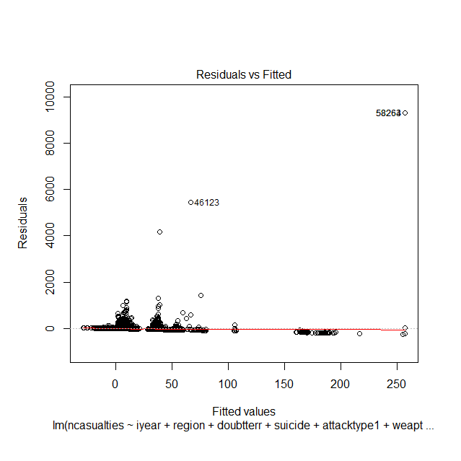

*Figure 3-15 – Residual Plot*

Looking at residuals plot (*Figure 3-15*), we notice some extreme outliers. It turns out that point 58264 (and 58263) correspond to 9/11, and the other outlying points are other major attacks. In total there are only 12 attacks with over 1000 casualties out of the over 100,000 attacks remaining in the dataset. Since it does not seem reasonable that we could ever predict attacks that fall outside the normal casualty range by so much, I removed the 12 points from the dataset. Rerunning the model, I got the following results:

Call:  
lm(formula = ncasualties ~ iyear + region + doubtterr + suicide +   
 attacktype1 + weaptype1, data = data.reduced.2)  
  
Residuals:  
Min 1Q Median 3Q Max   
-60.24 -4.64 -2.55 0.42 909.19   
  
Coefficients:  
 Estimate Std. Error t value Pr(>|t|)   
(Intercept) 262.77283 10.94803 24.002 < 2e-16 ***  
iyear -0.10688 0.00499 -21.420 < 2e-16 ***  
region2 2.05599 0.39423 5.215 1.84e-07 ***  
region3 0.77755 0.36561 2.127 0.03345 *   
region4 5.48763 0.77185 7.110 1.17e-12 ***  
region5 2.91011 0.38937 7.474 7.83e-14 ***  
region6 4.20847 0.36508 11.527 < 2e-16 ***  
region7 4.39938 0.85798 5.128 2.94e-07 ***  
region8 0.24785 0.37144 0.667 0.50460   
region9 2.66134 0.44413 5.992 2.07e-09 ***  
region10 5.16334 0.36498 14.147 < 2e-16 ***  
region11 5.69176 0.38362 14.837 < 2e-16 ***  
region12 1.31177 1.19733 1.096 0.27326   
doubtterr0 3.47393 0.18561 18.717 < 2e-16 ***  
doubtterr1 3.12688 0.21334 14.657 < 2e-16 ***  
suicide1 25.23968 0.25544 98.809 < 2e-16 ***  
attacktype12 3.95146 0.18289 21.605 < 2e-16 ***  
attacktype13 1.58591 0.29736 5.333 9.66e-08 ***  
attacktype14 1.15050 0.79741 1.443 0.14908   
attacktype15 4.58751 0.62573 7.331 2.29e-13 ***  
attacktype16 1.32022 0.26812 4.924 8.49e-07 ***  
attacktype17 1.11295 0.34404 3.235 0.00122 **   
attacktype18 4.59734 0.76252 6.029 1.65e-09 ***  
attacktype19 6.25976 0.38504 16.257 < 2e-16 ***  
weaptype12 -26.72508 4.82397 -5.540 3.03e-08 ***  
weaptype13 -68.16785 13.20023 -5.164 2.42e-07 ***  
weaptype15 -53.80673 4.73306 -11.368 < 2e-16 ***  
weaptype16 -51.92758 4.73898 -10.958 < 2e-16 ***  
weaptype17 -54.93696 6.29412 -8.728 < 2e-16 ***  
weaptype18 -54.99424 4.73892 -11.605 < 2e-16 ***  
weaptype19 -53.44174 4.72445 -11.312 < 2e-16 ***  
weaptype110 -49.41042 4.95702 -9.968 < 2e-16 ***  
weaptype111 -53.15076 4.98055 -10.672 < 2e-16 ***  
weaptype112 -54.77565 5.06758 -10.809 < 2e-16 ***  
weaptype113 -54.60392 4.73920 -11.522 < 2e-16 ***  
---  
Signif. codes: 0 ‘***’ 0.001 ‘**’ 0.01 ‘*’ 0.05 ‘.’ 0.1 ‘ ’ 1  
  
Residual standard error: 17.45 on 145370 degrees of freedom  
(1 observation deleted due to missingness)  
Multiple R-squared: 0.09148, Adjusted R-squared: 0.09127   
F-statistic: 430.5 on 34 and 145370 DF, p-value: < 2.2e-16

While the R-squared is more than double the previous model, it is still far from good.

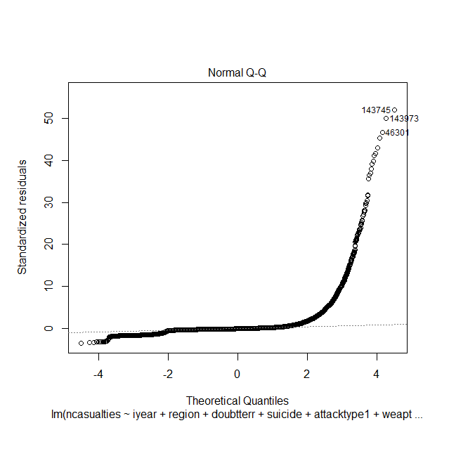

*Figure 3-16 – Normal Q-Q plot for linear regression model*

We can clearly see from the above plot that the error is not normally distributed. Since we know from before that the casualty values are severely right skewed, I attempted a log transformation on y.

Call:  
lm(formula = log(ncasualties) ~ iyear + region + doubtterr +   
 suicide + attacktype1 + weaptype1, data = data.reduced.2)  
  
Residuals:  
 Min 1Q Median 3Q Max   
-3.6547 -0.7535 -0.1097 0.6325 6.3843   
  
Coefficients:  
 Estimate Std. Error t value Pr(>|t|)   
(Intercept) 38.5660985 0.8014083 48.123 < 2e-16 ***  
iyear -0.0191543 0.0003804 -50.347 < 2e-16 ***  
region2 0.5161453 0.0398330 12.958 < 2e-16 ***  
region3 0.3752907 0.0383190 9.794 < 2e-16 ***  
region4 0.7545299 0.0762236 9.899 < 2e-16 ***  
region5 0.3284338 0.0386982 8.487 < 2e-16 ***  
region6 0.5115517 0.0373911 13.681 < 2e-16 ***  
region7 0.4368656 0.0667876 6.541 6.14e-11 ***  
region8 -0.1139399 0.0400401 -2.846 0.00443 **   
region9 0.2562456 0.0424318 6.039 1.56e-09 ***  
region10 0.5644484 0.0374099 15.088 < 2e-16 ***  
region11 0.7222902 0.0382417 18.888 < 2e-16 ***  
region12 0.3141168 0.1177996 2.667 0.00767 **   
doubtterr0 0.3580619 0.0153206 23.371 < 2e-16 ***  
doubtterr1 0.3194174 0.0165441 19.307 < 2e-16 ***  
suicide1 1.1566424 0.0151576 76.308 < 2e-16 ***  
attacktype12 0.8505029 0.0112768 75.420 < 2e-16 ***  
attacktype13 0.7238033 0.0207265 34.922 < 2e-16 ***  
attacktype14 0.6755933 0.0853396 7.917 2.47e-15 ***  
attacktype15 1.2180299 0.0634637 19.193 < 2e-16 ***  
attacktype16 0.5429563 0.0204749 26.518 < 2e-16 ***  
attacktype17 0.7525432 0.0434218 17.331 < 2e-16 ***  
attacktype18 0.6898279 0.0518974 13.292 < 2e-16 ***  
attacktype19 1.2648407 0.0277521 45.576 < 2e-16 ***  
weaptype12 0.7668915 0.2834906 2.705 0.00683 **   
weaptype13 -1.0817681 1.0515435 -1.029 0.30360   
weaptype15 -0.7113235 0.2775516 -2.563 0.01038 *   
weaptype16 -0.1504465 0.2781002 -0.541 0.58852   
weaptype18 -0.6217755 0.2795682 -2.224 0.02615 *   
weaptype19 -0.7853500 0.2769776 -2.835 0.00458 **   
weaptype110 0.0423404 0.2930375 0.144 0.88512   
weaptype111 0.6673424 0.3964585 1.683 0.09233 .   
weaptype112 -0.7349479 0.3089684 -2.379 0.01738 *   
weaptype113 -0.8011802 0.2783216 -2.879 0.00400 **   
---  
Signif. codes: 0 ‘***’ 0.001 ‘**’ 0.01 ‘*’ 0.05 ‘.’ 0.1 ‘ ’ 1  
  
Residual standard error: 1.014 on 95812 degrees of freedom  
(1 observation deleted due to missingness)  
Multiple R-squared: 0.2297, Adjusted R-squared: 0.2295   
F-statistic: 866 on 33 and 95812 DF, p-value: < 2.2e-16

While the R-squared is substantially better, that cannot be accurately compared as we transformed y.

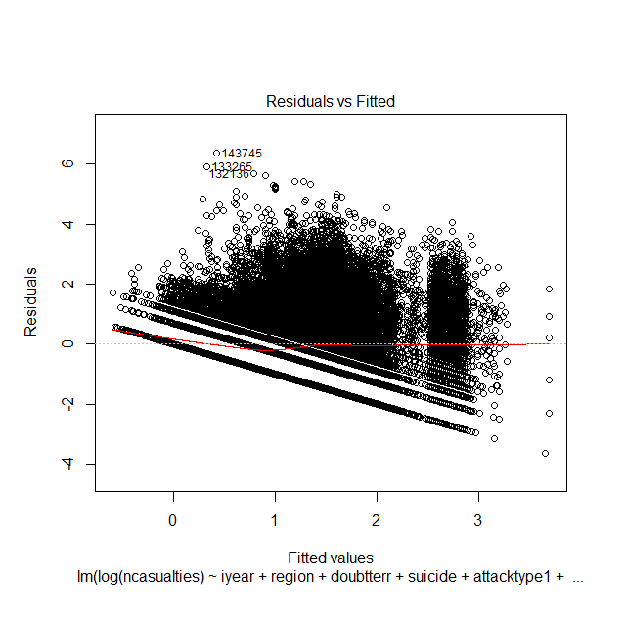

*Figure 3-17 – Residuals plot for log transformed linear regression model*

Looking at the residuals plot (*Figure 3-17*), it was clear that there was some sort of pattern in the error, implying that the model was not accurately representing the data. Interaction terms were tried to very little effect, so it seemed clear at this point that linear regression was probably not the best model to answer this question.

Next, I tried tree models. Using both y and log(y) as the response, I ended up with the following two trees (*Figure 3-18* and 3-*19*).

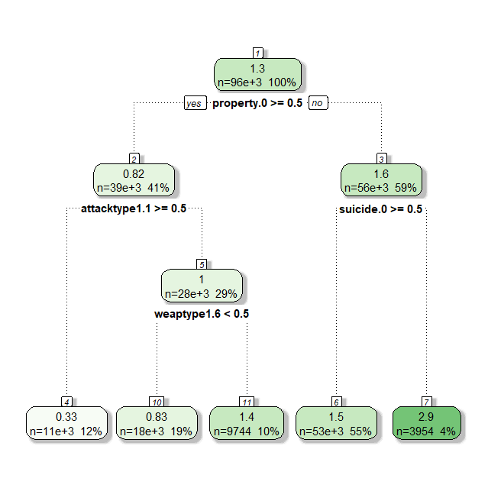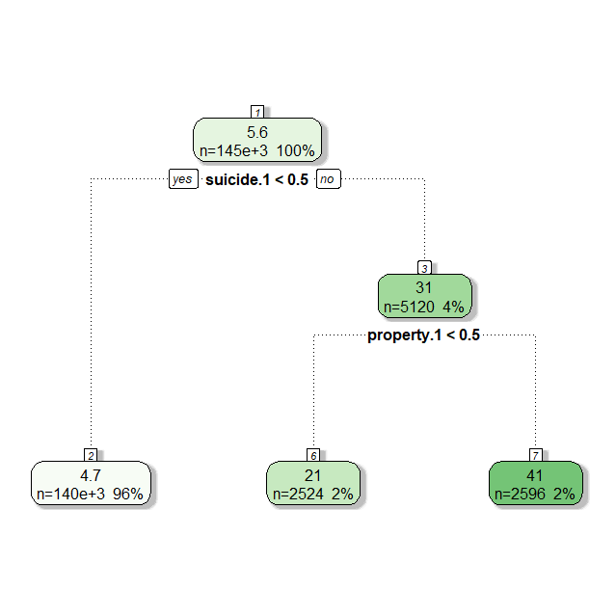

*Figure 3-18 and 3-19 – Left: unbalanced tree model; right: log transformed tree model.*

Their R-squared values are: 0.08451011 and 0.06648582 respectively, so neither are very good on that front. However, the variables the model finds important are interesting. Suicide attacks seem to result in higher casualties, as well as property damage. Explosive weapons (“weaptype1.6”) increases casualties, while assassinations (“attacktype1.1”) decreases casualties. All these observations do make intuitive sense, however there is not much more we can get out of a single tree.

Before moving on to random forest, I decided to give SVMs a try. Using a radial kernel, I got the following results:



Cost factor of 100 seems to be the best, as that is where the R-squared on the testing data maxes out. Not a huge amount was learned here, however it was an interesting experiment that resulted in the best model so far.

Next, I moved on to random forest.

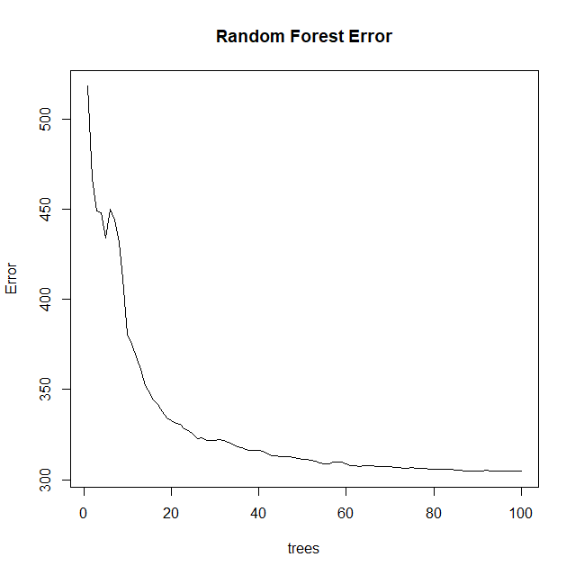

*Figure 3-20 – Plot that shows error vs. different number of trees for random forest*

Looking at the amount of error vs. the number of trees (*Figure 3-20*), around 60 trees seemed like the right number. With 60 trees I got an R-squared of 0.2019902 (on testing data as always), the best model so far.

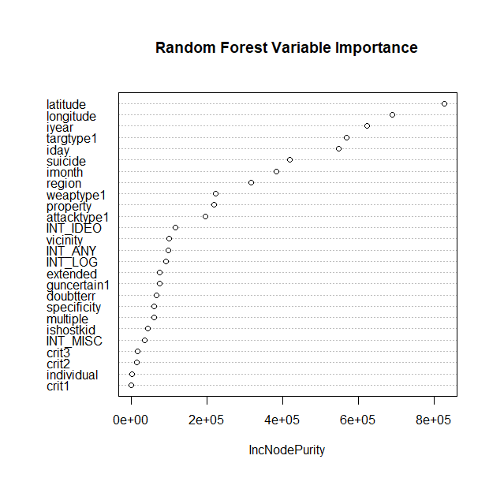

*Figure 3-21 – Variable importance plot for random forest model*

Very few of the variables that were important in the basic tree models or in linear regression show up here, an exception being “suicide” and “property” though both seem drastically less important then they were in previous models. Most of the important variables in this model are time/location based, the target type also seems to be an important factor. This started to make me a bit suspicious that perhaps the random forest was overfitting the data by using the time and place to pinpoint the specific attack; an R-squared of 0.8545023 on training data seemed to confirm this. Setting the “nodesize” parameter to 100, gave much different results. The R-squared on testing data was a bit lower (0.1606361) however, as you can see below, the variable importance levels were much closer to what would be expected (notice suicide has about the same level of importance as the previous model, however longitude and latitude don’t have overinflated importance).

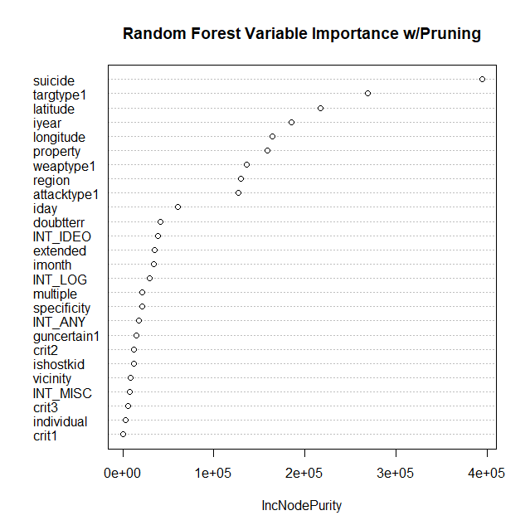

*Figure 3-22 – Variable importance plot for pruned random forest model*

In summary, it seems that predicting the exact value for casualties is difficult problem. Both random forest and SVMs seem to have the best results; suicide attacks seemed to be the most significant indicator, followed by target and location (temporal and special) variables, finally followed by factors such as weapon and attack type.

## Q3—Predicting Responsible Terrorist Groups

The goal of this research question is to develop statistical models that predict the terrorist group name (gname) based on a subset of the GTD’s available features. The GTD contains terrorist events attributed to over 3,500 different groups, however, many of these groups correspond to general classes of perpetrators (for example, “gunman” and “anarchists”) and not terrorist organizations, such as the Taliban or Al-Qaida. Furthermore, only 122 of these groups have over 100 attacks attributed to them, and, among these, only 13 operate in more than a single region. These 13 terrorist groups, that is, organizations having over 100 associated terrorist events and operating in at least 2 regions, will be the focus of this modeling effort. Table 3-1 lists these terrorist organizations and the number of attacks attributed to each between 1997-2017.

|  |  |  |
| --- | --- | --- |
| Terrorist Group | Identifier | # of Attacks (%) |
| Al-Qaida in Iraq | A | 606 (3.35%) |
| Al-Qaida in the Arabian Peninsula (AQAP) | B | 877 (4.84%) |
| Al-Qaida in the Islamic Maghreb (AQIM) | C | 225 (1.24%) |
| Hamas (Islamic Resistance Movement) | D | 297 (1.64%) |
| Hezbollah | E | 107 (0.59%) |
| Islamic State of Iraq and the Levant (ISIL) | F | 4,274 (23.61%) |
| Kurdistan Workers' Party (PKK) | G | 1,074 (5.93%) |
| Liberation Tigers of Tamil Eelam (LTTE) | H | 614 (3.39%) |
| New People's Army (NPA) | I | 1,573 (8.69%) |
| Revolutionary Armed Forces of Colombia (FARC) | J | 1,121 (6.19%) |
| Salafist Group for Preaching and Fighting (GSPC) | K | 182 (1.01%) |
| Taliban | L | **5,912 (32.66%)** |
| Tehrik-i-Taliban Pakistan (TTP) | M | 1,240 (6.85%) |

Table 3- – Terrorist organizations with over 100 attributed attacks and operating in at least 2 regions. Note that the number of terrorist events per group is very unbalanced with the Taliban and ISIL accounting for over half of the total events. A character identifier has been assigned to each group to serve as an alias (used later in confusion matrices).

### Feature Selection

The features used for this modeling effort were limited to those with relatively low percentages of NA / unknown values to prevent the loss of too much data following data cleansing. Variables with over 30 distinct categorical values were also eliminated from consideration[2]. Table 3-2 summarizes the features selected as *candidates* for consideration—not all of these features were used in the final models.

|  |  |  |
| --- | --- | --- |
| Variable Name | Description | Data Type  (with cardinality for categorical variables) |
| attacktype1 | method of attack (e.g., assassination, hijacking, kidnapping) | categorical (9) |
| claimed | group claimed responsibility (“Yes” or “No”) | categorical (2) |
| extended | incident extended more than 24 hours (“Yes” or “No”) | categorical (2) |
| iday | day of the month | numerical |
| imonth | month | numerical |
| iyear | year | numerical |
| latitude | latitude | numerical |
| longitude | longitude | numerical |
| multiple | part of multiple incidents (“Yes” or “No”) | categorical (2) |
| nkill | number of fatalities (both perpetrator and victim) | numerical |
| nkillter | number of terrorists fatalities | numerical |
| nperps | number of perpetrators | numerical |
| nwound | number of non-fatal injuries (both perpetrator and victim) | numerical |
| property | property damage occurred during incident (“Yes” or “No”) | categorical (2) |
| region | geographic region (e.g., North America) | categorical (12) |
| success | attack successful (“Yes” or “No”), where definition depends on attack type | categorical (2) |
| suicide | suicide attack (“Yes” or “No”) | categorical (2) |
| targtype1 | type of target/victim (e.g., business, police, military) | categorical (22) |
| weaptype1 | general type of weapon used (e.g., biological, chemical, firearms) | categorical (12) |

Table 3- – Features selected for use in initial modeling effort.

### Data Cleansing

In addition to limiting the observations to those corresponding to terrorist organizations operating in at least 2 regions and with over 100 attacks, we also removed any data for incidents prior to 1997. This decision was made for two reasons: (1) several variables of interest were not available prior to 1997 (2) data collection methodology was different prior to 1997.

The values for each selected feature were scrubbed to ensure that no “unknown” or NA values remained after data cleansing. Generally, this involved dropping observations with NA or “unknown” values; however, for several of the numerical variables (nkill, nkillter, nwound), NA values were transformed to 0. In addition, “unknown” or NA values for claimed were transformed to “no” rather than dropping those observations.

Following cleansing, the data set contained 18,102 observations over 19 features and 1 response variable (gname). The data set was then split into a training and test data set using an 80/20 split.

### Methods and Evaluation

Linear Discriminant Analysis (LDA), Quadratic Discriminant Analysis (QDA), Decision Tree, Random Forest, and SVMs were applied to the cleansed data set. Linear kernels produced the best SVM performance (when compared to “tuned” radial, polynomial, and sigmoid kernels); therefore, only linear SVMs are presented below.

The initial formulas used for all models (other than QDA) consisted of all variables listed in Table 3-2. QDA produced “rank deficiency” errors when using most of the categorical variables, so it was limited to only numerical variables.

During initial modeling, it was determined that balancing the observations over the response variable improved performance. Both *undersampling* and *oversampling* strategies were attempted, but oversampling was found to provide the best model performance. Note that oversampling increased the training data set to 62,010 observations (though only 14,481 of those represented distinct events).

Figure ‑23 – Plot of terrorist events per group by latitude / longitude. This plot shows a clear geographic clustering of attacks by group.

Initial results showed that all classifiers obtained high accuracies (up to 98.5% for Random Forest) on the test data when the models were trained using all features in Table 3-2. Analysis of the most significant variables showed that latitude, longitude, region, and iyear were highly predictive of the group name and that other variables were far less significant predictors of the response variable. Plotting the distribution of attacks for each terrorist organization by latitude/longitude (see Figure 3-23) makes it clear why this is the case. Each terrorist group has a relatively distinct area of operation, which the algorithms were able to use to their advantage. The plot of the decision tree in Figure 3-24 demonstrates this clearly, as the algorithm appears to be isolating year-sensitive “bounding boxes” for the terrorist events attributed to each groups and ignoring all other variables.

Figure ‑4 – Visualization of decision tree. Notice that the decision tree only uses latitude, longitude, region, and iyear.

Ideally, we would like to identify an “attack signature” for each of these groups that transcends a particular place and time. For example, if a terrorist organization expanded operations into a new region we would like to be able to continue to have a useful classifier. To this end, a second set of models was created that removed latitude, longitude, region, and iyear. All other variables were retained. The original models (that used all features) are referred to below as “Model Set 1”. The later models (with the reduced feature set) are referred to below as “Model Set 2”.

|  |  |
| --- | --- |
| *Model Set 1* | *Model Set 2* |
|  |  |
| Accuracy | Accuracy |

Figure 3-25 – Accuracy on test data for each model set.

Figure 3-25 shows a comparison of the accuracy of each algorithm (LDA, QDA, Decision Trees, Random Forests, and SVM with linear kernel) on Model Set 1 and 2. Most algorithms performed well (greater than 80% accuracy) on Model Set 1, but considerably worse (less than 55% accuracy) on Model Set 2. Random Forests obtained the best performance for both model sets based on prediction accuracy on the test data—98.5% accuracy on Model Set 1 and 51.6% accuracy on Model Set 2.

In spite of this, one could argue that the sacrifice in performance resulting from Model Set 2 may be warranted in order to remove the models’ dependency on geospatial variables and the year of attack. Unfortunately, the confusion matrix for the Random Forest algorithm on Model Set 2 (see Table 3-3) shows that the false positive rate (FPR) varies greatly between predicted groups. In most cases, the classifier’s performance appears to be directly proportional to the number of terrorist events per group; that is, the classifier performs best on groups with the most events (in spite of data balancing). Given these high FPRs for most classes, it’s highly questionable whether this model would be useful for prediction in practice.

Figure 3-26 shows importance plots for the Random Forests from Model Sets 1 and 2. As previously mentioned, latitude, longitude, region, and iyear were the most important features on Model Set 1. Interestingly, iday and imonth were the most important features on Model Set 2 followed closely by targtype1. This would suggest that different groups prefer to attack on different days of the month and different months of the year. While this would be an interesting finding, it is not clear that this is the case. Removing iday and imonth does reduce the Random Forest’s accuracy to 40% (from 50%) suggesting some correlation, but additional analysis is needed to determine the cause of this effect.

|  |  |  |  |  |  |  |  |  |  |  |  |  |  |  |
| --- | --- | --- | --- | --- | --- | --- | --- | --- | --- | --- | --- | --- | --- | --- |
|  |  | Predicted Terrorist Group | | | | | | | | | | | | |
|  |  | **A** | **B** | **C** | **D** | **E** | **F** | **G** | **H** | **I** | **J** | **K** | **L** | **M** |
| ­­­Actual Terrorist Group | **A** | **77** | 5 | 1 | 2 | 0 | 7 | 3 | 6 | 1 | 2 | 1 | 12 | 6 |
| **B** | 3 | **58** | 3 | 2 | 5 | 20 | 14 | 16 | 14 | 14 | 6 | 23 | 9 |
| **C** | 2 | 3 | **4** | 1 | 1 | 0 | 3 | 2 | 4 | 3 | 0 | 8 | 5 |
| **D** | 0 | 3 | 1 | **26** | 3 | 9 | 1 | 1 | 1 | 1 | 1 | 9 | 3 |
| **E** | 1 | 2 | 0 | 1 | **9** | 2 | 2 | 1 | 0 | 1 | 0 | 2 | 2 |
| **F** | 34 | 31 | 8 | 27 | 12 | **513** | 16 | 21 | 16 | 25 | 8 | 115 | 37 |
| **G** | 2 | 9 | 1 | 0 | 6 | 2 | **85** | 14 | 20 | 27 | 12 | 16 | 8 |
| **H** | 2 | 8 | 4 | 1 | 2 | 9 | 21 | **36** | 9 | 19 | 8 | 21 | 1 |
| **I** | 6 | 19 | 5 | 2 | 9 | 3 | 30 | 10 | **195** | 18 | 8 | 28 | 5 |
| **J** | 1 | 12 | 1 | 1 | 2 | 7 | 28 | 15 | 22 | **100** | 11 | 20 | 5 |
| **K** | 1 | 2 | 0 | 0 | 0 | 1 | 5 | 4 | 8 | 4 | **7** | 9 | 2 |
| **L** | 17 | 27 | 13 | 29 | 24 | 105 | 71 | 63 | 41 | 36 | 15 | **632** | 69 |
| **M** | 8 | 13 | 2 | 6 | 3 | 17 | 3 | 13 | 19 | 11 | 2 | 61 | **81** |
|  |  |  |  |  |  |  |  |  |  |  |  |  |  |  |
| FPR |  | 50.0% | 69.8% | 90.7% | 73.5% | 88.2% | 26.2% | 69.9% | 82.2% | 44.3% | 61.7% | 91.1% | 33.9% | 65.2% |

*Table 3-3 - Confusion matrix for Random Forest on test data for Model Set 2. Groups F (ISIL) and L (Taliban) have the greatest number of terrorist events and lowest false positive rates (FPRs). Groups E (Hezbollah) and K (GSPC) had the least number of associated events and had very high FPRs.*

|  |  |
| --- | --- |
| *Model Set 1* | *Model Set 2* |
|  |  |

Figure 3-26 – The importance of features determined by the Random Forest algorithm on both model sets.

## Q4—Estimating Attack Risk Using Temporal and Geospatial Features

The goal of this research question is to develop statistical models that predict the “risk of attack” based on geospatial and temporal variables. The data set was filtered to only include terrorist incidents occurring between 2010 – 2017, as we are only focused on the “current” risk pattern and not historical risk patterns.

### Feature Selection

Our models were limited to three features: imonth, weekday, and cluster_id. weekday (day of week) was derived from iday, imonth, and iyear. cluster_id was derived by applying kmeans to the latitude and longitude of each event using 32 clusters (see Figure 3-27).

The response variable (risk_level) was derived by (1) grouping terrorist events into “event groups” by imonth, weekday, and cluster_id, (2) summing up the number of attacks in each event group, (3) applying a low/high risk-threshold to classify each event group as “low” or “high”. The low/high risk threshold value used was , where is the sample mean of the number of terrorist events over all event groups and the sample standard deviation. Figure 3-28 (left panel) shows a histogram with a vertical line depicting this threshold value.

### Data Cleansing

All NA values were removed from imonth, iday, iyear, latitude, and longitude. After grouping by imonth, weekday, and cluster_id, the training set consisted of 2,594 observations. 91% of these observations were classified as “high risk”. Oversampling was applied to the dataset, which resulted in 3,813 observations with approximately equal percentages of low and high classifications.

Figure 3-27 – World map with cluster_ids (determined by kmeans from latitude and longitude of terrorist events).

|  |  |  |  |  |  |  |  |
| --- | --- | --- | --- | --- | --- | --- | --- |
|  | |  |  | | --- | --- | | Risk Level | # Event Groups | | low | 2,361 (91%) | | high | 233 (9%) | |

Figure ‑28 – Separation of event groups into high risk and low risk groups.

### Methods and Evaluation

Linear Discriminant Analysis (LDA), Decision Tree, Random Forest, and SVMs were applied to the cleansed data set. Radial kernels produced the best SVM performance (when compared to “tuned” linear, polynomial, and sigmoid kernels); therefore, only radial SVMs are presented below.

Figure 3-29 shows the ROC curves for all models. The AUC for Random Forest was 0.981, which was slightly higher than for other methods. The confusion matrices for Random Forest and SVM (radial) are shown in 3-30.

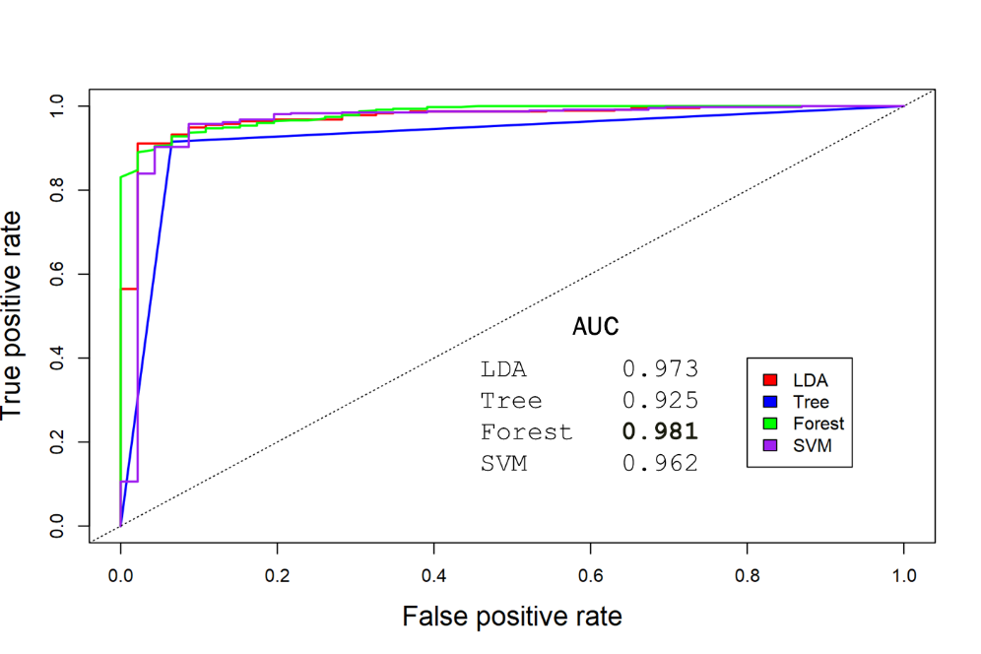

Figure ‑29 – ROC curves showing model performance for Q4. AUC values for each attempted model appear inside of the graph.

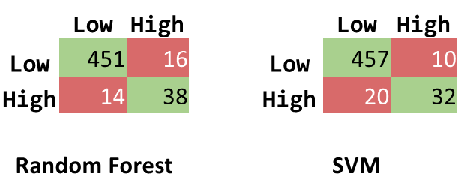

Figure ‑30 – Confusion matrices for Random Forest and SVM for Q4.

Examining the importance plot (Figure 3-31) for the Random Forest shows that cluster_id considerably more important than imonth and weekday. This is not surprising given the density plots over terrorist events that we saw earlier in Figures 2-2 and 2-3.

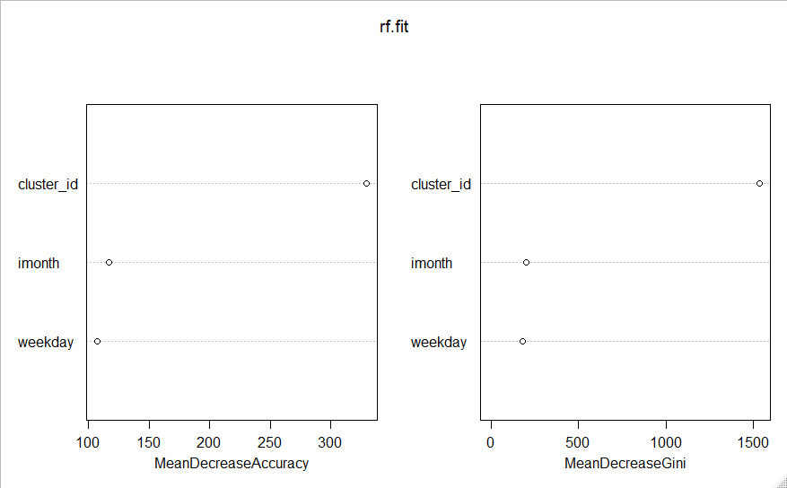

Figure ‑31—The importance of features determined by the Random Forest algorithm for Q4.

The decision tree chose to only use cluster_id, ignoring imonth and weekday (see Figure 3-32).

Table ‑32—Decision Tree for Q4 using formula with cluster_id, imonth, and weekday. Note that only cluster_id was considered significant.

While cluster_id is clearly the best predictor of an attack, there does seem to be non-random variability in the number of attacks per weekday (see Figure 3-33) and imonth (see Figure 3-34). For example, assuming an equal probability of attack per weekday, the mean of a multinomial distribution over the 86,207 terrorist events from 2010-2017 would be approximately 12,315 events per day with a standard deviation of approximately 103. That places Tuesdays at almost 9 standard deviations above the population mean and Mondays at over 13 standard deviations below the population mean. This is strong evidence that the probability of attack is not equal for each weekday. Based on this, a second set of models was created using the formula risk_level~imonth + weekday. The resulting Decision Tree (depicted in Figure 3-34) had an AUC of 0.56. SVM (radial kernel) had the best performance with an AUC of 0.59 and an accuracy of 61%. While the performance of these models is not good enough to be used as a reliable classifier, it is interesting that different weekdays and months are correlated with higher frequencies of attack.

|  |  |  |  |  |  |  |  |  |  |  |  |  |  |  |  |  |  |  |  |  |  |  |
| --- | --- | --- | --- | --- | --- | --- | --- | --- | --- | --- | --- | --- | --- | --- | --- | --- | --- | --- | --- | --- | --- | --- |
| |  |  |  | | --- | --- | --- | | **1** | Monday | **10,954** | | **2** | Tuesday | **13,226** | | **3** | Wednesday | 11,925 | | **4** | Thursday | 12,672 | | **5** | Friday | 12,026 | | **6** | Saturday | 12,693 | | **7** | Sunday | 12,711 | |  |
|  | Terrorist Events per Weekday |

*Figure 3‑33—Number of attacks per day of week over terrorist events from 2010-2017. The blue line in the right panel represents the population mean for a multinomial distribution with and .*

*Figure 3‑33—Number of attacks per month over terrorist events from 2010-2017. The blue line in the right panel represents the population mean for a multinomial distribution with and .*

Figure ‑34—Decision Tree for Q4 using formula with only imonth and weekday as features.

# Discussion

1. https://www.kaggle.com/START-UMD/gtd
2. Most algorithms failed when presented with a formula containing a categorical variable with more than a few dozen values. The only exception was SVMs. LDA returned a “variable appears to be constant within groups” error, QDA returned a “rank deficiency” error , decision trees returned “factor predictors must have at most 32 levels”, and random forests returned “can not handle categorical predictors with more than 53 categories”.