Instructions to get up and running with R.
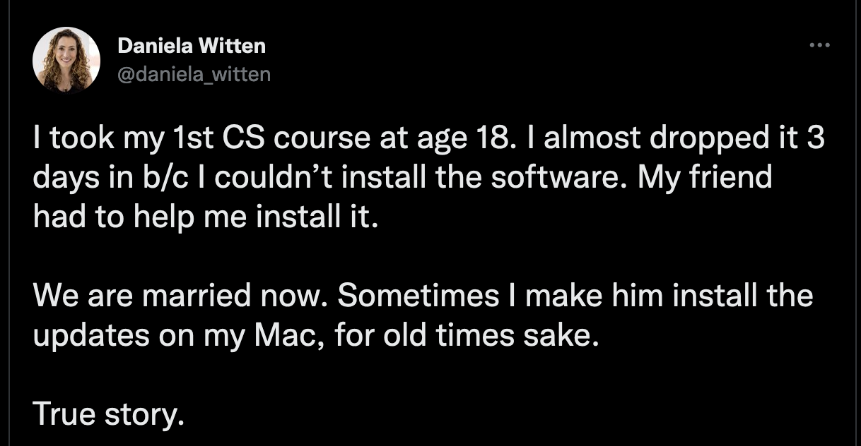
Download R

- Go to: https://www.r-project.org/
- Click download R.
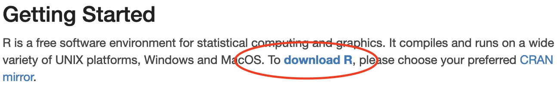
- Click 0-Cloud
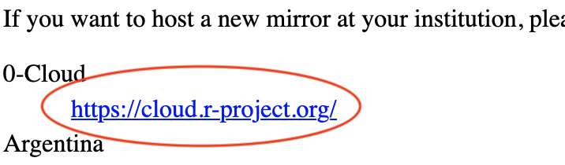
- Download the R appropriate for your operating system.

Download RStudio:

- Go to: https://www.rstudio.com/products/rstudio/download/#download
- The website recognizes your operating system.
- Click download and wait for download to finish
- Click on the installer in your download folder
- In MAC:
  - Click the RStudio icon and drag it into applications
  - Accept any and all prompts
- In WINDOWS
  - Accept defaults and all prompts
  - Accept term and conditions

Install tidyverse and tidymodels:

- Open RStudio
- In MAC: Click yes when prompted to install command line developer tools.
- In WINDOWS: Say no to automatic crash reporting to ensure privacy
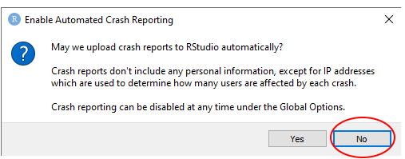
- Go to Tools > Install packages
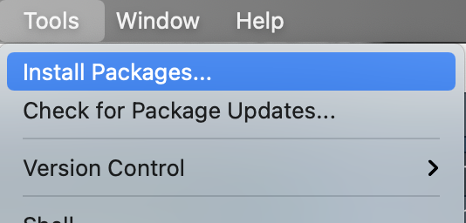
- Input tidyverse and tidymodels, make sure that Install dependencies is checked and allow the computer to run the installation process.
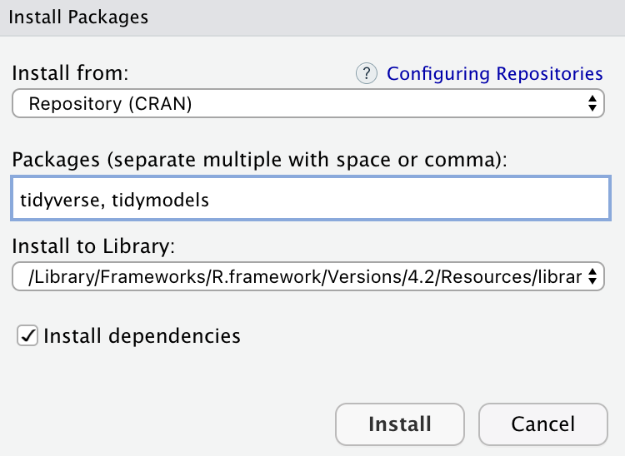
- In the R console type:
  - library(tidyverse)
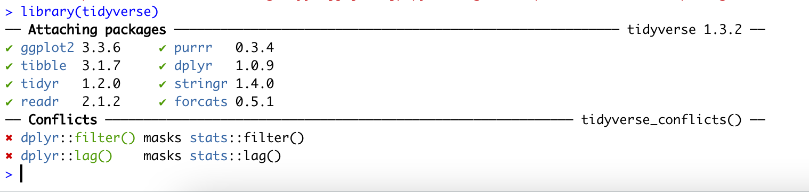
  - library(tidymodels)

  - The conflicts indicate that there are 2 filter functions: one in the dplyr package and the other in stats package. This is not a problem.

If there are problems please document with screenshots and email them to the instructor with information about your operating system.

