This document illustrates how to deploy a Laravel application to a Laravel site in Laravel Forge.   
E.g., create a new site for CCRP soil health data platform staging env.

We will need to create a new site when we setup a new staging env or live env for an application.

Visit Laravel Forge

<https://forge.laravel.com/servers>

It shows all servers being hosted in Forge. Click your desired server that you would like to build a new site.

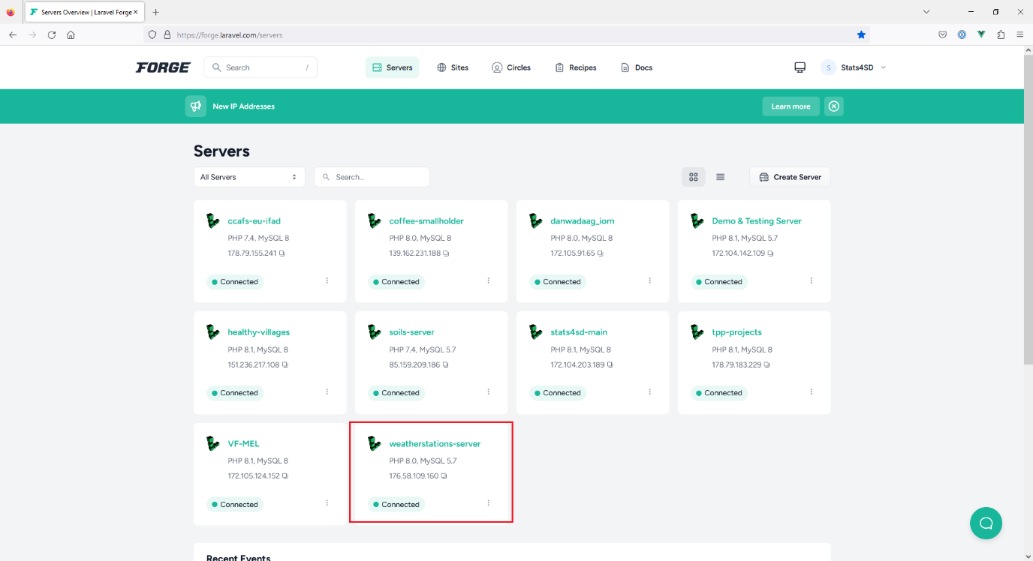

It shows all sites under this server. Click “New Site” to create a new site.

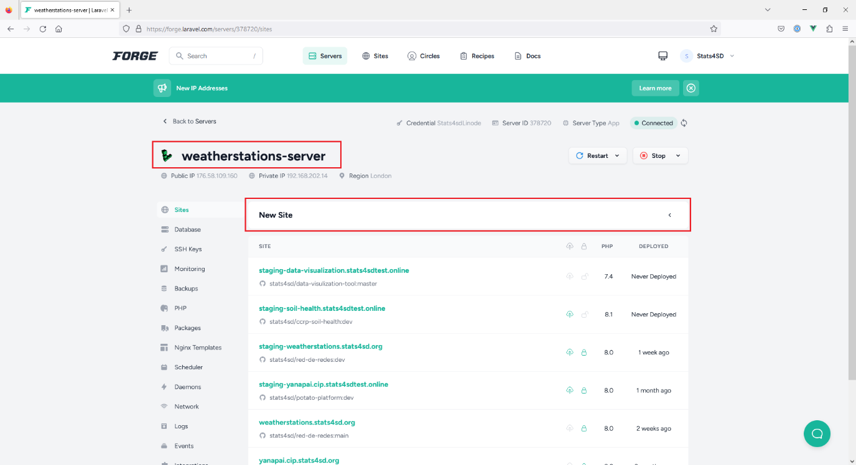

Fill in details for below fields:

“Root Domain”, fill in “staging-soil-health.stats4sdtest.online”

“PHP Version”, select the appropriate PHP version for your application. E.g., PHP 8.1

Click “Add” button

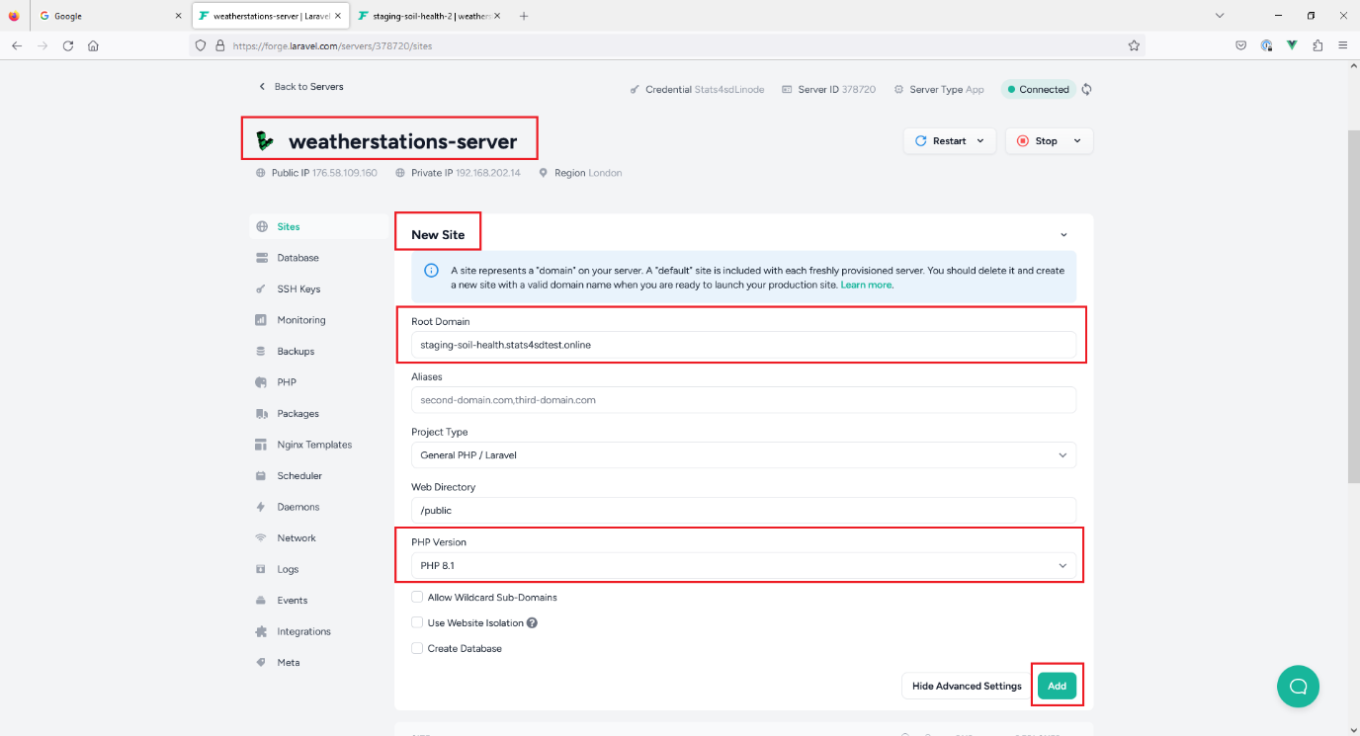

It takes a little while to create your new site

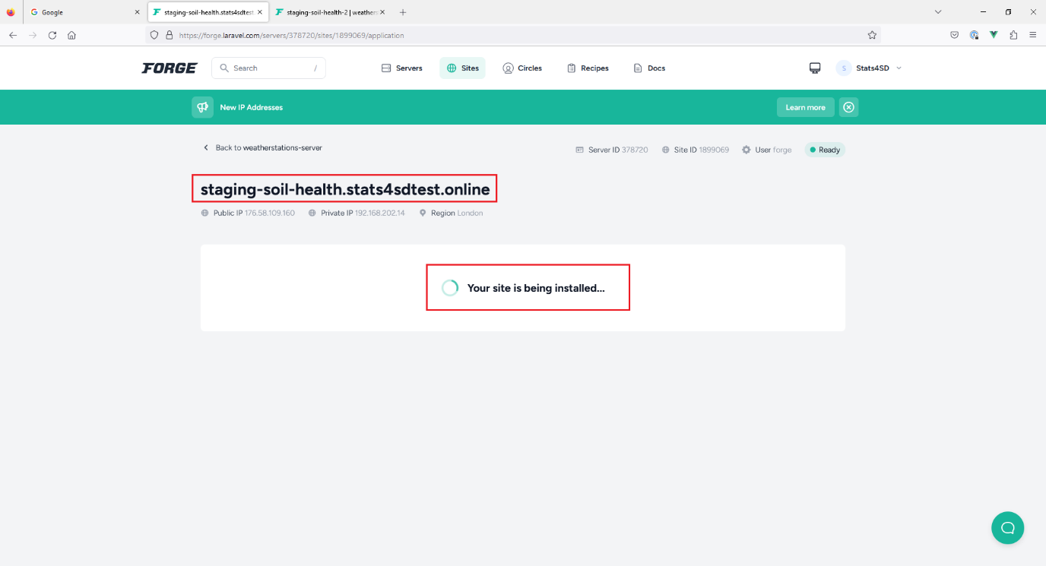

New site “staging-soil-health.stats4sdtest.online” is created.

We are about to install application into this new site.

Click “Git Repository” to select the corresponding GitHub repo for this application.

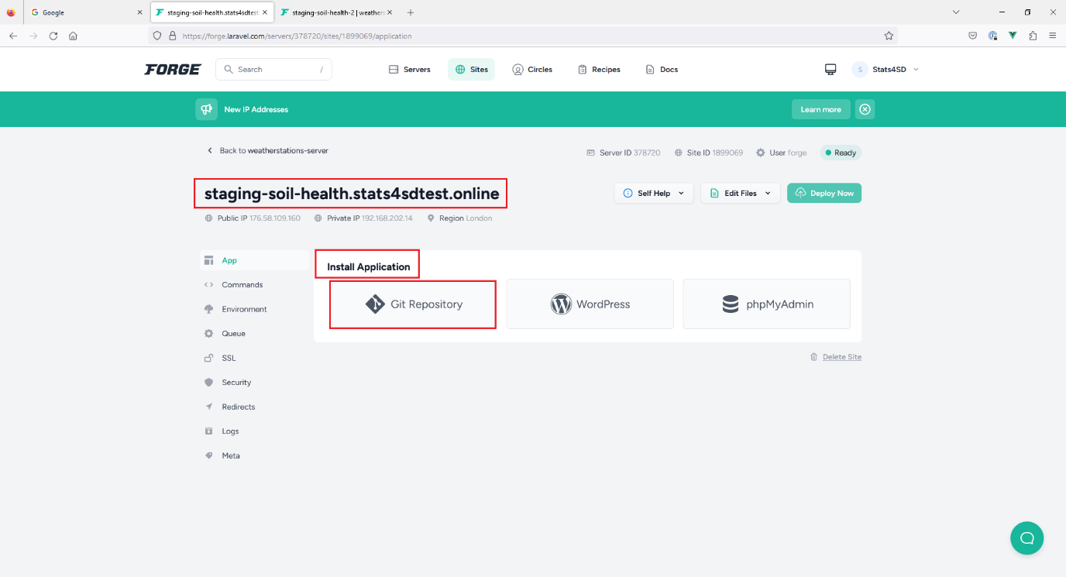

Fill in details for below fields:

“Repository”: stats4sd/ccrp-soil-health

“Branch”: select “dev” as dev branch is for staging env

“Install Composer Dependencies”, tick this checkbox

Click “Install Repository” button

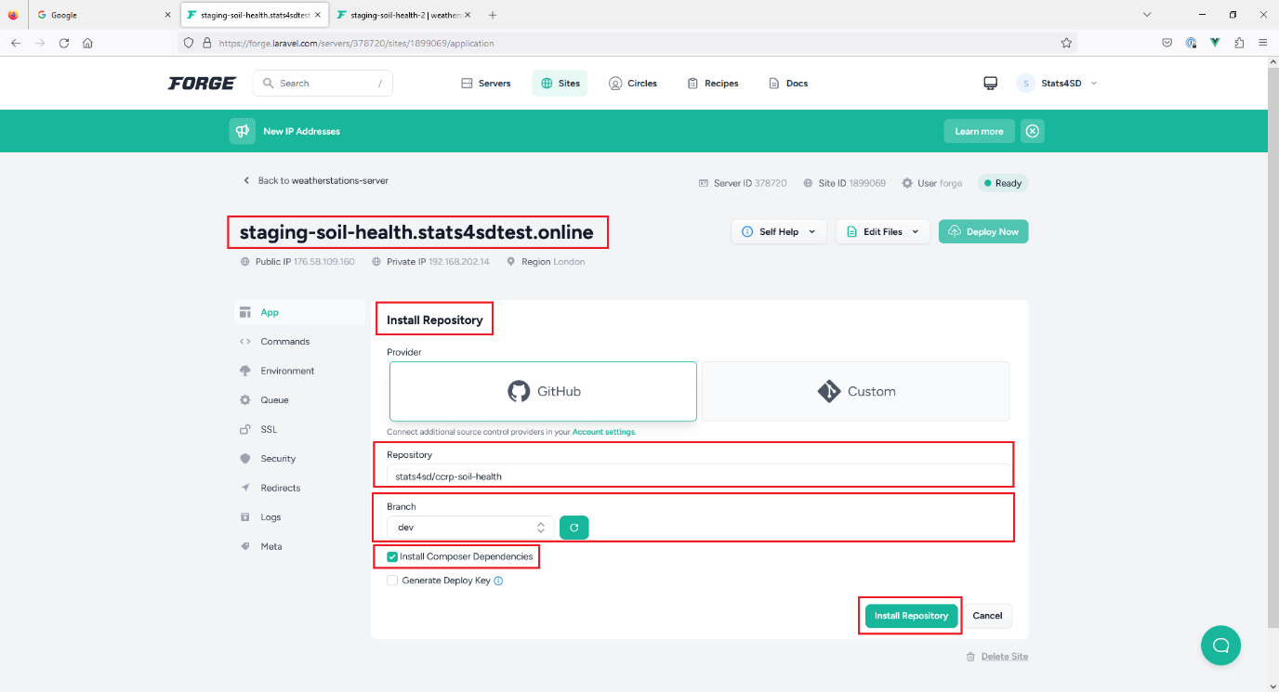

It takes a while for the installation…

Installation successfully completed. Now we have more items in sidebar menu.

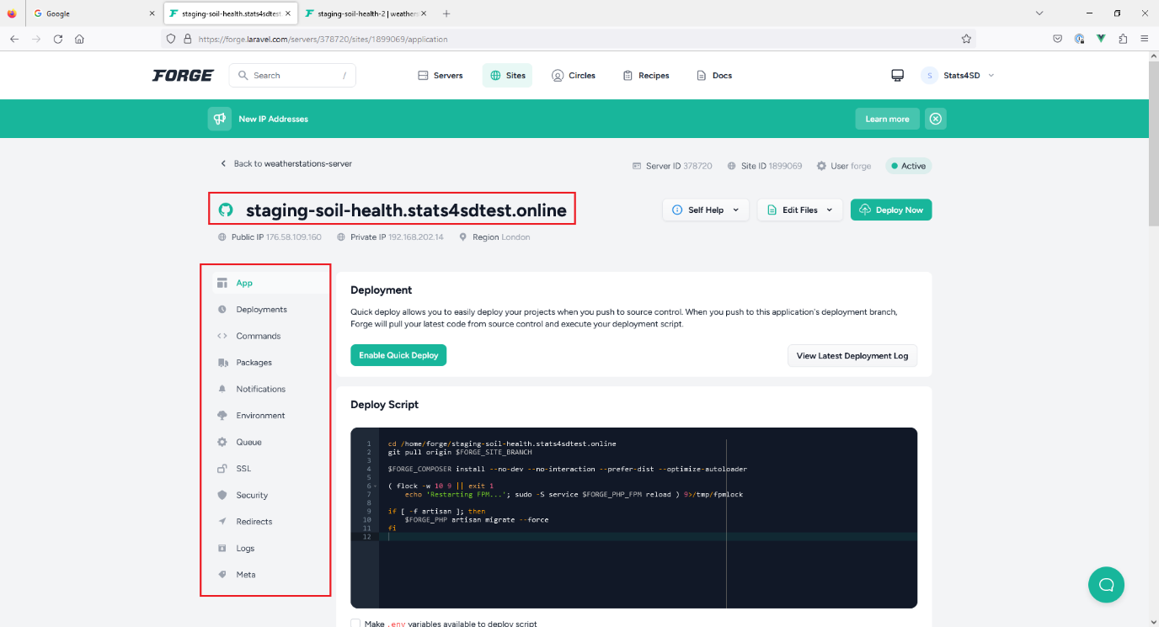

In Deployment section, click “Enable Quick Deploy” button to enable quick deploy feature. Deployment will start automatically when any branch merged into dev branch.

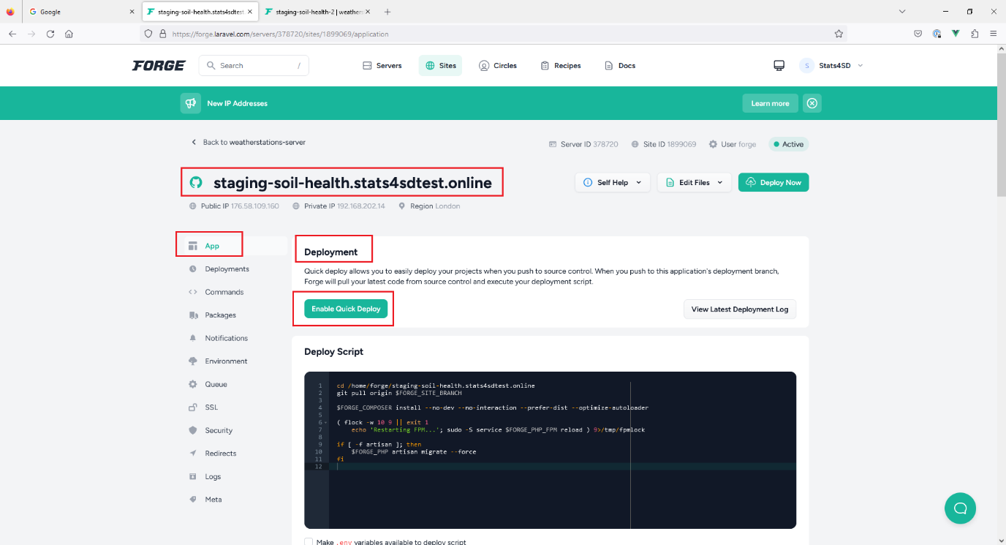

In Deploy Script section, it shows a default deploy script created by Forge.

We will update the deploy script to our own version.

Click “Update” button

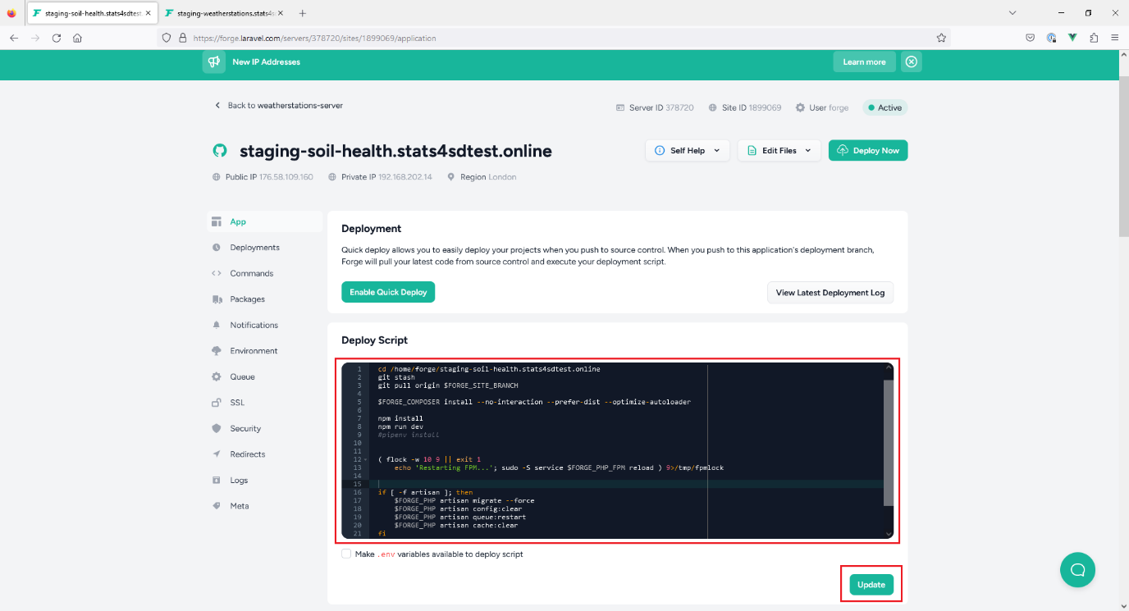

In “Environment” tab, an environment file is prepared from .env.example.

Fill in actual values for config items.

Click “Save” button.

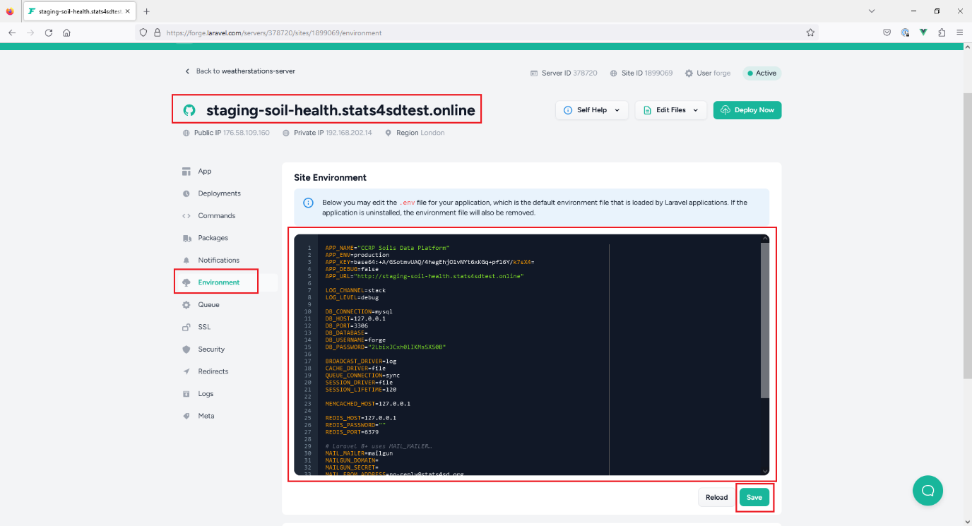

In “Queue” tab, create a new queue with default values.

Click “Start Worker” button

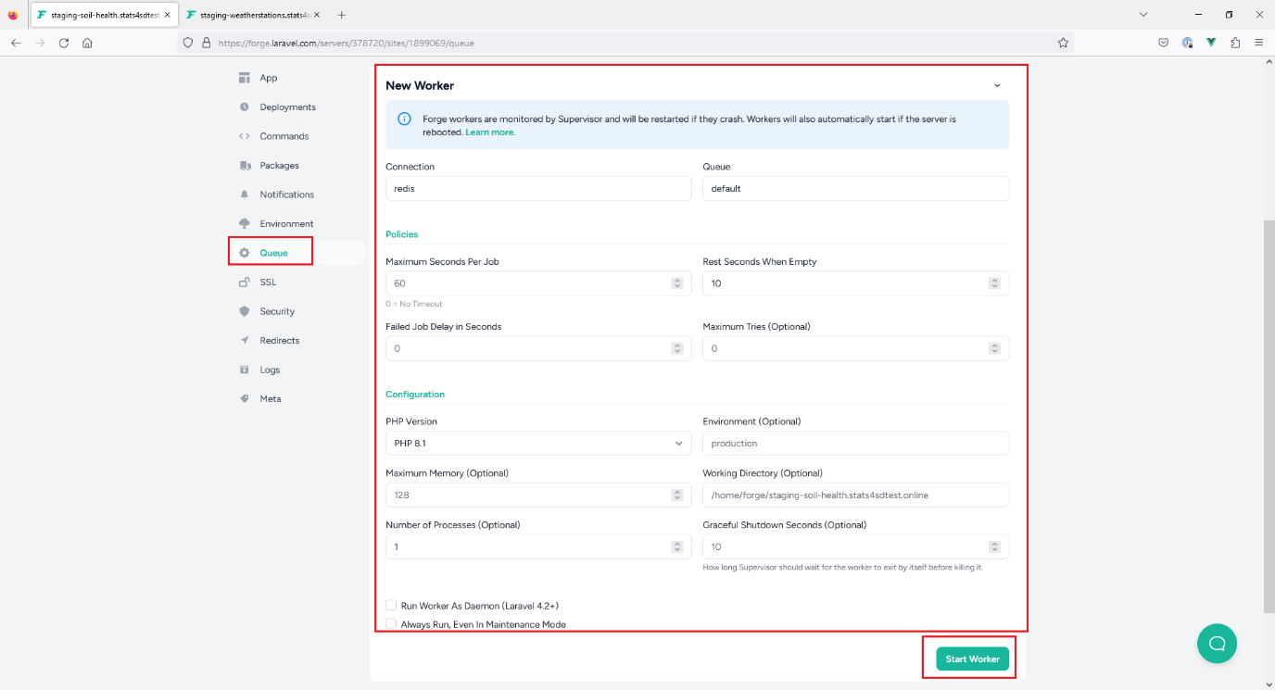

A new queue is created successfully. The site can now support queued jobs.

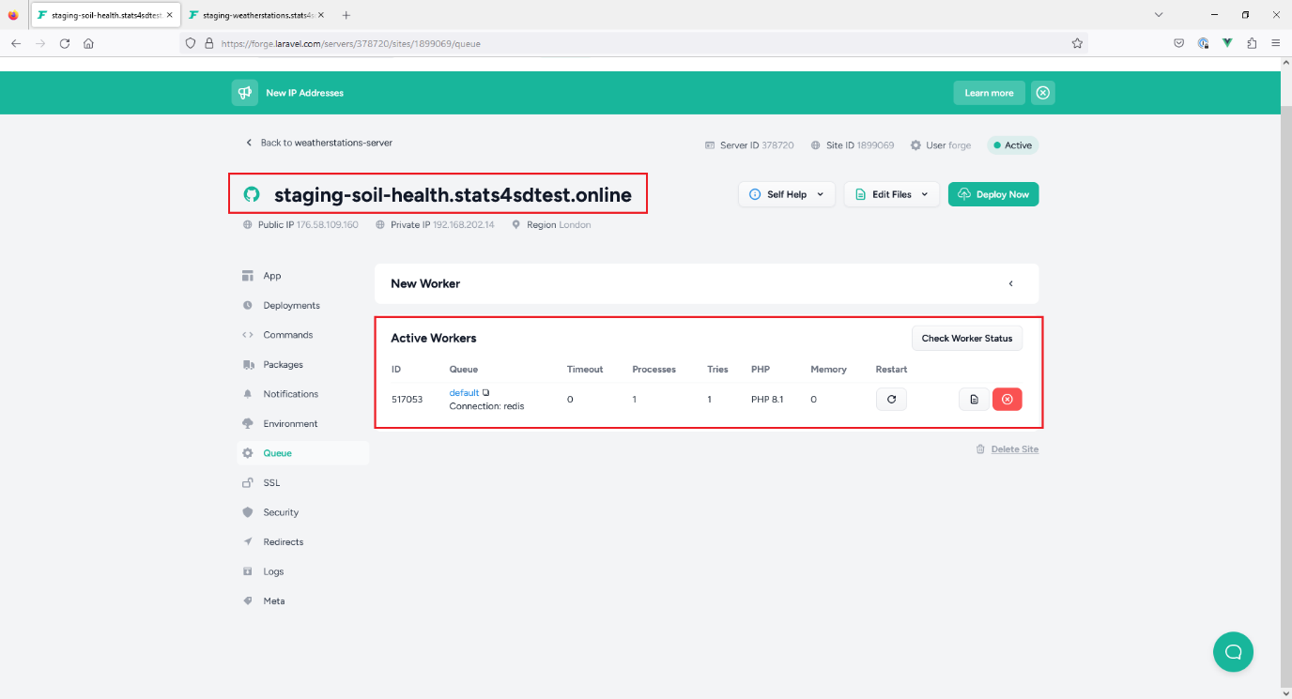

Go back to server level, click “Scheduler” tab.

Click “New Scheduled Job”

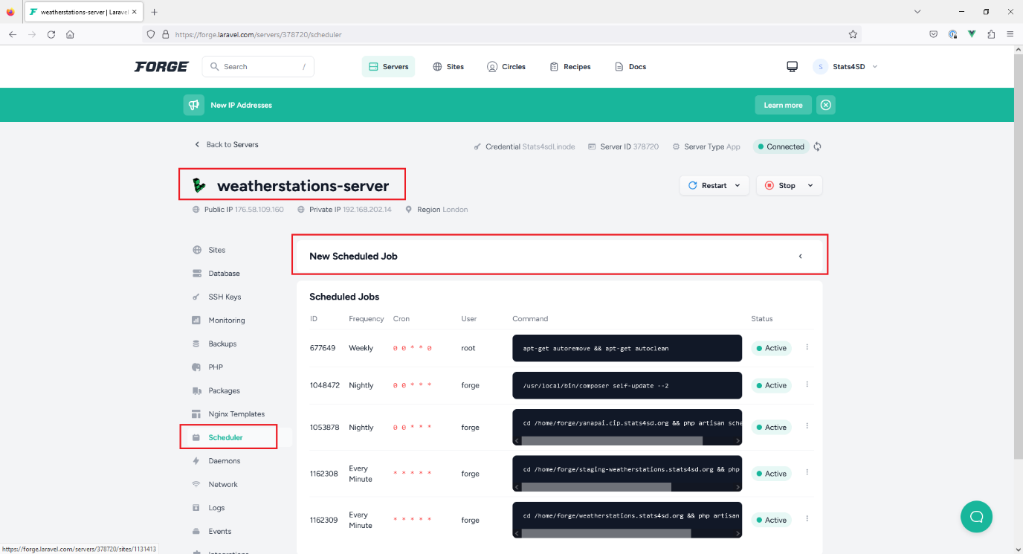

For “Command”, fill in “php8.1 /home/forge/staging-soil-health.stats4sdtest.online/artisan schedule:run”

Leave other fields with default values.

Click “Create” button

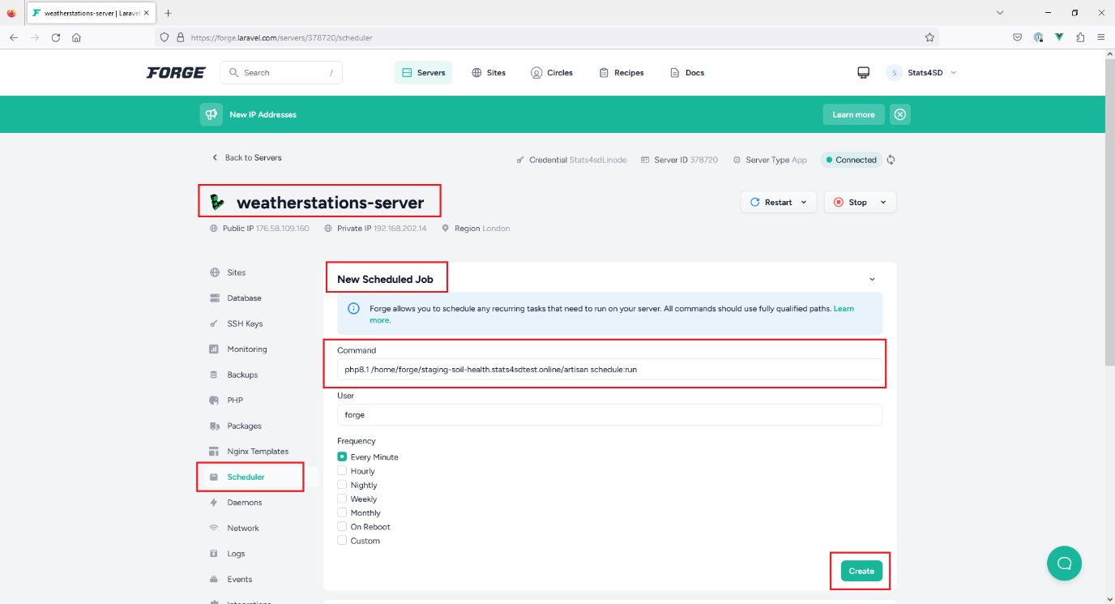

A new scheduled job is created.

