**This document is prepared as a reference.**

When we have a new data platform, it is not necessary to create a new Power Automate flow.

Instead, please create new monitors for staging env and live env respectively in Uptime Robot.

**Uptime Robot Email Alert**

We use Uptime robot to monitor our data platforms, simply to check whether it is alive or died.

Uptime robot sends DOWN or UP alert email to a pre-defined email address when the monitored web site is died or alive.

**Company Email Address for Receiving Uptime Robot Email Alert**

We configured [support@stats4sd.org](mailto:support@stats4sd.org) for STAGING env, and [alerts@stats4sd.org](mailto:alerts@stats4sd.org) for LIVE env.

In case any staging env is died, it is not too urgent to fix.

Email will be sent to [support@stats4sd.org](mailto:support@stats4sd.org). It will be follow-up when any engineering team members check email in [support@stats4sd.org](mailto:support@stats4sd.org).

In case any live data platform is died, it requires our attention to fix it as soon as possible.

Instead of checking email proactively, engineering team members need to be informed passively.

For live env, it is urgent to fix for minimal downtime and impact.

Email will be sent to engineering team members. We will discuss and decide who will perform what investigations. We can keep track the investigation result, root cause, solution, preventive actions etc in the Github issue.

The Github issue can be closed when problem resolved and the related data platform alive again.

**MS Power Automate**

We use MS Power Automate to connect all these together as a workflow.

MS Power Automate allows us to define a workflow and execute it automatically when pre-defined conditions fulfilled.

We have four use cases:

1. When we receive STAGING ENV DOWN email alert from Uptime Robot, creates a new Github issue and send email to support@stats4sd.org

2. When we receive STAGING ENV UP email alert from Uptime Robot, send email to support@stats4sd.org

3. When we receive LIVE ENV DOWN email alert from Uptime Robot, creates a new Github issue and send email to engineering team members

4. When we receive LIVE ENV UP email alert from Uptime Robot, send email to engineering team members

The following excel file screen shots summaries all four use cases:



**MS Power Automate Flow**

Here are screen shots for “Live Env Down” flow.

Essential configurations are highlighted in RED.

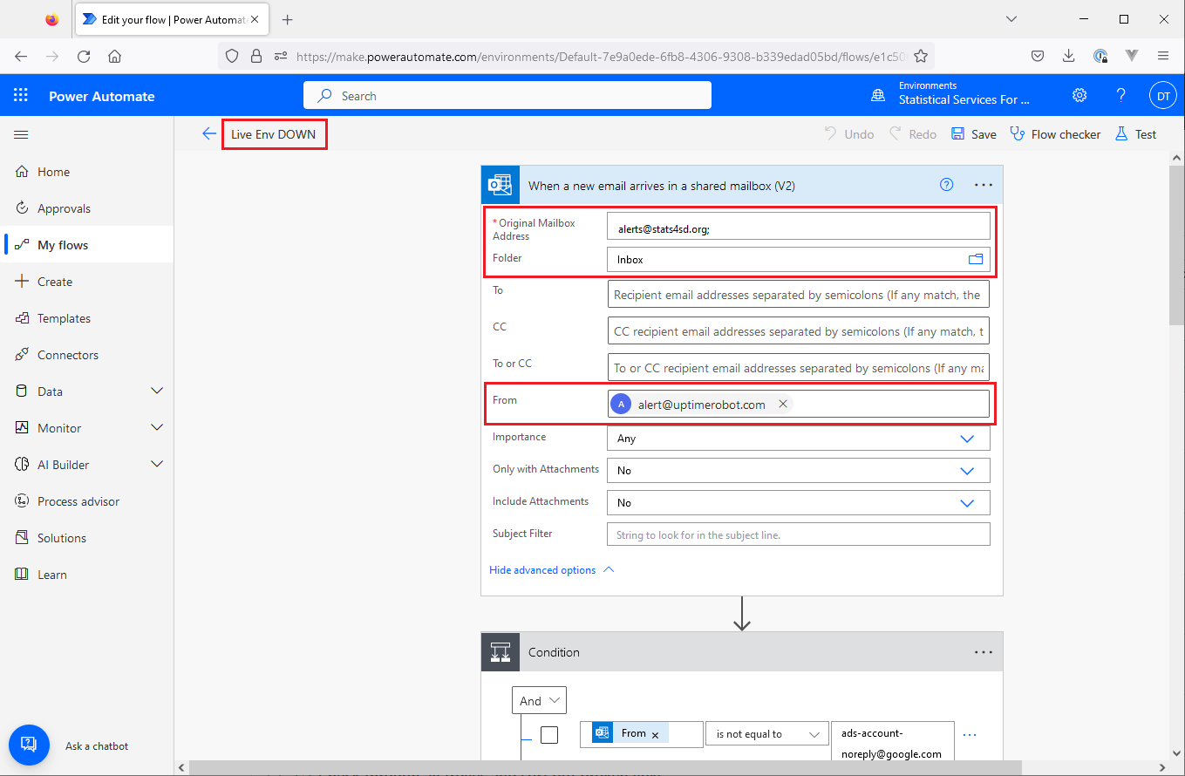

Conditions to identify Uptime robot monitor email alert:

Email recipient: [alerts@stats4sd.org](mailto:alerts@stats4sd.org)

Email folder: Inbox

Email sender: [alert@uptimerobot.com](mailto:alert@uptimerobot.com)

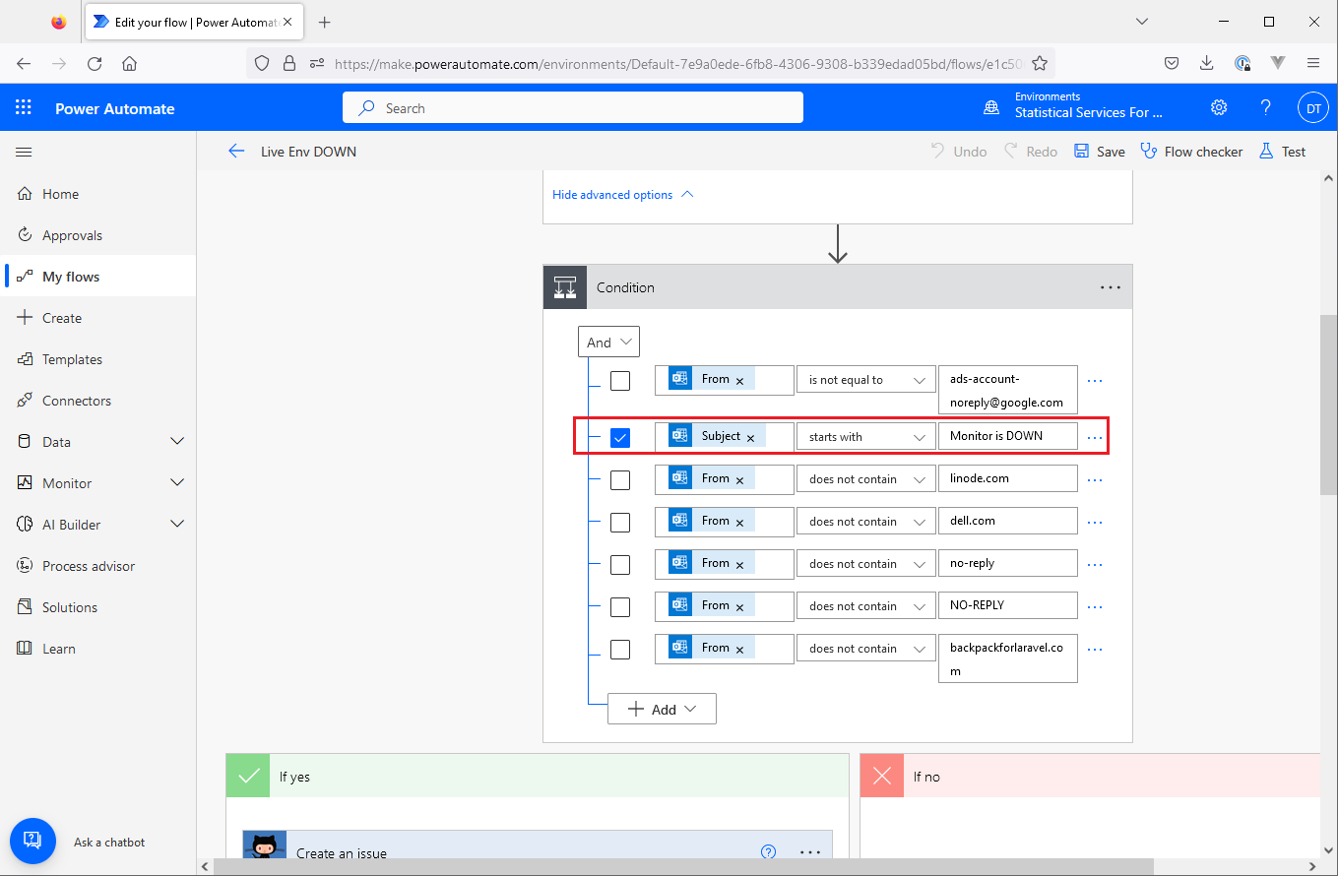

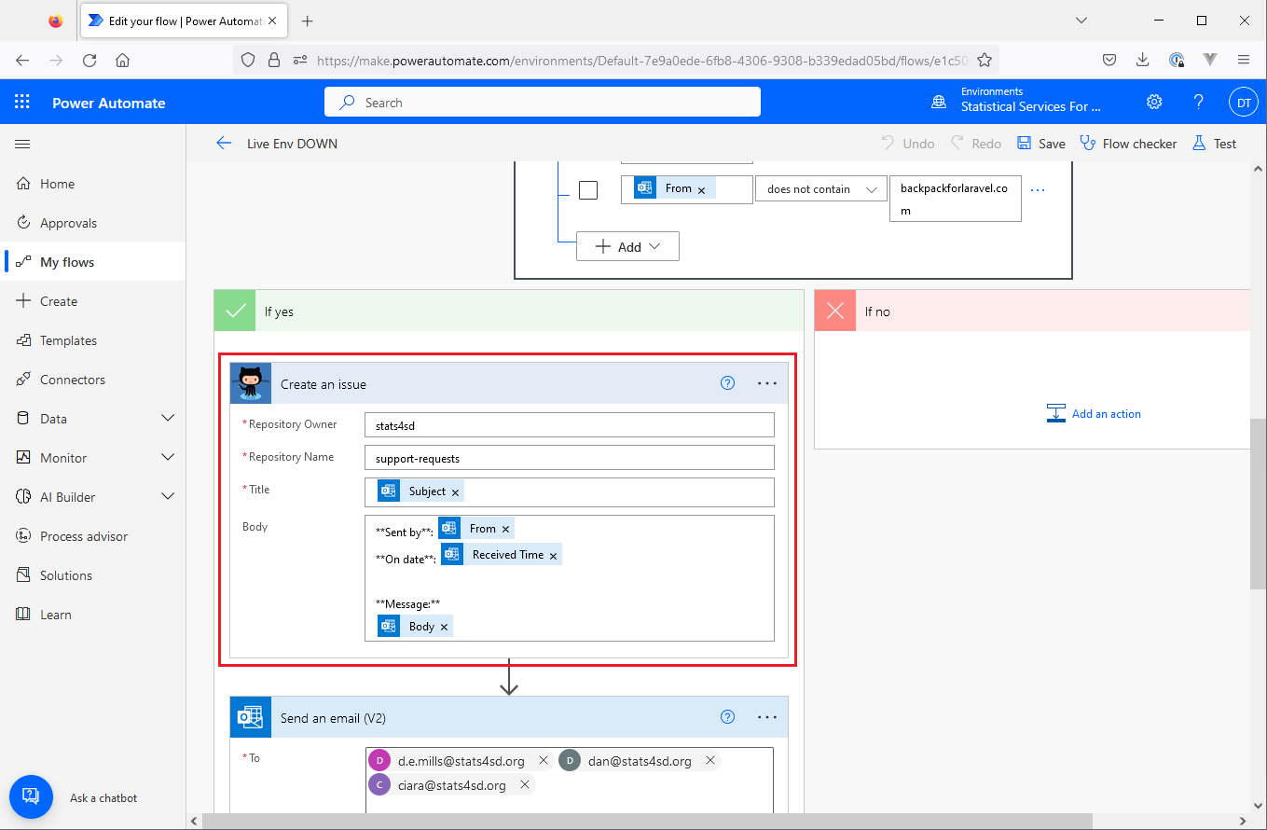

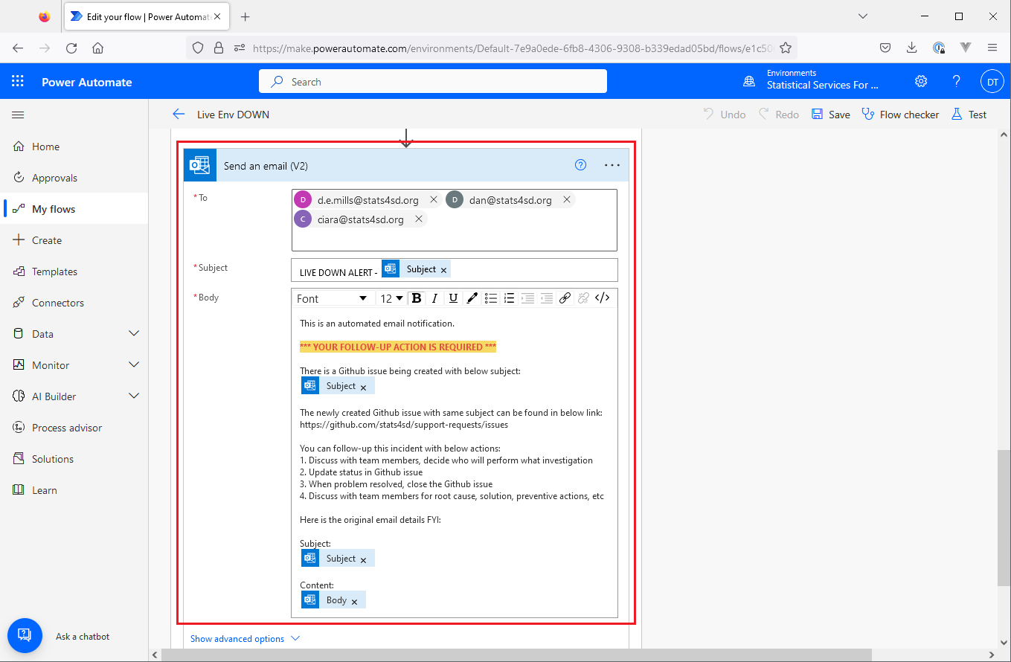

P.S. In case you need to create a new workflow in MS Power Automate, please kindly contact engineering team members to share the existing flows as your template.