Course Report AG2110 2023
A few changes were made to the course this year given feedback from students last year. I completely redesigned the topic of the UN Role Play. The new topic that students worked with was the “Adverse impact of climate change on the full realization of the right to food” based on the report issued in July 2023 by the Secretary General. This report was requested by the Human Rights Council in Resolution 50/9 which was adopted by the council on July 7th 2022. As delegates, students develop their country’s position reacting to the conclusions and recommendations of the Secretary General’s report and then present and negotiate over two days to generate a new resolution on the topic. I chose this topic based on requests by students in last year’s evaluation to have material on the challenge of climate change. By choosing this topic, students were exposed to one aspect of global governance in response to this challenge. I also redesigned the structure of paper writing seminars in AG2110. I changed the structure so that there was a collective presentation of the seminar topic by groups of students and leading of the seminar discussion by those same students. This was also based on feedback from last year’s evaluations. The students thought that individual presentations were isolating and created redundancy in what was covered. This is why I revised the structure of the presentations. Finally, Kristen Kao was given an additional 2 hour lecture, and she added a question to the final takehome exam to expand the section of the course dealing with the challenge of migration.
Unfortunately, just 13 students out of 35 responded to the evaluation, approx. 37% of those who took the course. In this case, one could argue that the results are potentially not representative of the universe of students that took the course. That said, all aspects of the course were rated rather good or very good by the majority of students. Thus, overall, the course was rated favorably by the students.
In the student comments, there were two recurrent very critical comments on many aspects of the course. To summarize, these comments argued that the material was too broad and simple, the lectures were not engaging, some of the literature was outdated, the seminars were not structured enough, student seminar papers were not engaged with enough in the seminars, and the topic of the seminar papers were too broad. These comments are the most critical written comments the course has received since I have been a course coordinator of this course. I will take these comments into consideration in thinking of ways to improve the course for next year.
In addition, there was one comment about an incident in one of the seminars. A student used the word “backwards” in reference to the global South in a slide that was covering dilemmas in creating legitimacy and consensus in the local adoption of global standards. The presenting student was highlighting the potential tendency for the global South to be perceived as backwards compared to Western, HICs and how this prejudice created legitimacy problems for adoption of global standards by non-Western LICs. Another student misunderstood the slide and thought the presenting student was labeling the global South as backwards. I tried to mitigate the disagreement by pointing out that some of the authors the students had read had raised this dilemma and used the same language as the presenting student. However, it is clear by the comment raised in the evaluation on this incident that the offended student still misunderstood the situation. There has never been an incident like this before, but I will try to guide seminars in the future so that misunderstandings like these do not occur.
Below is a summary of how the course was rated based on responses to each of the questions on the course.
Overall, how would you assess the course?
Overall, how would you assess the course? Number of responses  Very good 5 (38,5%)  Rather good 6 (46,2%)  Neither good nor bad 1 (7,7%)  Rather bad 1 (7,7%)  Very bad 0 (0,0%)  Total 13 (100,0%) | 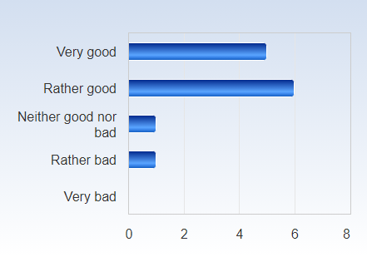

 | Mean | Standard Deviation | Coefficient of Variation | Min | Lower Quartile | Median | Upper Quartile | Max
Overall, how would you assess the course? | 1,8 | 0,9 | 48,7 % | 1,0 | 1,0 | 2,0 | 2,0 | 4,0

Overall, how would you assess the lectures?
Overall, how would you assess the lectures? Number of responses  Very good 4 (30,8%)  Rather good 5 (38,5%)  Neither good nor bad 1 (7,7%)  Rather bad 2 (15,4%)  Very bad 1 (7,7%)  Total 13 (100,0%) | 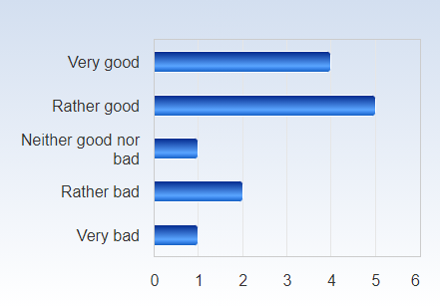

 | Mean | Standard Deviation | Coefficient of Variation | Min | Lower Quartile | Median | Upper Quartile | Max
Overall, how would you assess the lectures? | 2,4 | 1,5 | 63,0 % | 1,0 | 1,0 | 2,0 | 3,0 | 6,0

Overall, how would you assess the teachers?
Overall, how would you assess the teachers? Number of responses  Very good 6 (46,2%)  Rather good 5 (38,5%)  Neither good nor bad 2 (15,4%)  Rather bad 0 (0,0%)  Very bad 0 (0,0%)  Total 13 (100,0%) | 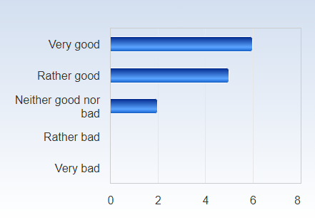

 | Mean | Standard Deviation | Coefficient of Variation | Min | Lower Quartile | Median | Upper Quartile | Max
Overall, how would you assess the teachers? | 1,7 | 0,8 | 44,4 % | 1,0 | 1,0 | 2,0 | 2,0 | 3,0

Overall, how would you assess the literature?
Overall, how would you assess the literature? Number of responses  Very good 4 (30,8%)  Rather good 6 (46,2%)  Neither good nor bad 1 (7,7%)  Rather bad 2 (15,4%)  Very bad 0 (0,0%)  Total 13 (100,0%) | 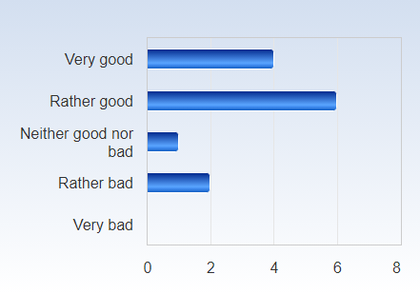

 | Mean | Standard Deviation | Coefficient of Variation | Min | Lower Quartile | Median | Upper Quartile | Max
Overall, how would you assess the literature? | 2,1 | 1,0 | 50,0 % | 1,0 | 1,0 | 2,0 | 2,0 | 4,0

Overall, how would you assess the seminars?
Overall, how would you assess the seminars? Number of responses  Very good 6 (46,2%)  Rather good 5 (38,5%)  Neither good nor bad 1 (7,7%)  Rather bad 0 (0,0%)  Very bad 1 (7,7%)  Total 13 (100,0%) | 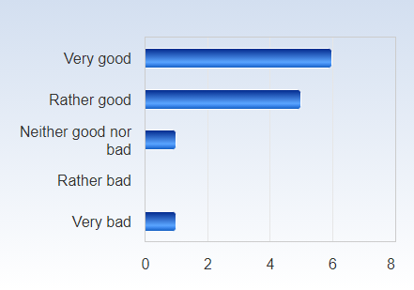

 | Mean | Standard Deviation | Coefficient of Variation | Min | Lower Quartile | Median | Upper Quartile | Max
Overall, how would you assess the seminars? | 1,9 | 1,4 | 71,9 % | 1,0 | 1,0 | 2,0 | 2,0 | 6,0

Overall, how would you assess the seminar papers?
Overall, how would you assess the seminar papers? Number of responses  Very good 4 (30,8%)  Rather good 6 (46,2%)  Neither good nor bad 1 (7,7%)  Rather bad 2 (15,4%)  Very bad 0 (0,0%)  Total 13 (100,0%) | 

 | Mean | Standard Deviation | Coefficient of Variation | Min | Lower Quartile | Median | Upper Quartile | Max
Overall, how would you assess the seminar papers? | 2,1 | 1,0 | 50,0 % | 1,0 | 1,0 | 2,0 | 2,0 | 4,0

Overall, how would you assess the UN Role Play?
Overall, how would you assess the UN Role Play? Number of responses  Very good 6 (46,2%)  Rather good 4 (30,8%)  Neither good nor bad 2 (15,4%)  Rather bad 1 (7,7%)  Very bad 0 (0,0%)  Total 13 (100,0%) | 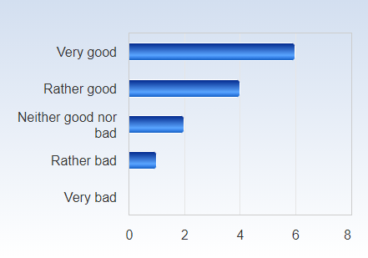

 | Mean | Standard Deviation | Coefficient of Variation | Min | Lower Quartile | Median | Upper Quartile | Max
Overall, how would you assess the UN Role Play? | 1,8 | 1,0 | 53,5 % | 1,0 | 1,0 | 2,0 | 2,0 | 4,0

Overall, how would you assess the Take Home Exam?
Overall, how would you assess the Take Home Exam? Number of responses  Very good 2 (15,4%)  Rather good 9 (69,2%)  Neither good nor bad 2 (15,4%)  Rather bad 0 (0,0%)  Very bad 0 (0,0%)  Total 13 (100,0%) | 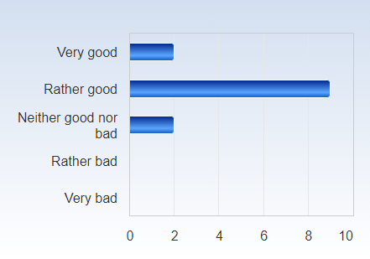

 | Mean | Standard Deviation | Coefficient of Variation | Min | Lower Quartile | Median | Upper Quartile | Max
Overall, how would you assess the Take Home Exam? | 2,0 | 0,6 | 28,9 % | 1,0 | 2,0 | 2,0 | 2,0 | 3,0

How would you assess the organization of the course, including the information on Canvas (information, schedule, administration)?
How would you assess the organization of the course, including the information on Canvas (information, schedule, administration)? Number of responses  Very good 7 (53,8%)  Rather good 6 (46,2%)  Neither good nor bad 0 (0,0%)  Rather bad 0 (0,0%)  Very bad 0 (0,0%)  Total 13 (100,0%) | 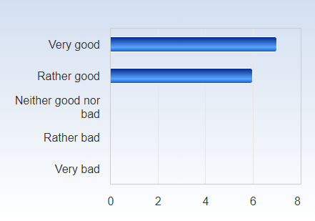

 | Mean | Standard Deviation | Coefficient of Variation | Min | Lower Quartile | Median | Upper Quartile | Max
How would you assess the organization of the course, including the information on Canvas (information, schedule, administration)? | 1,5 | 0,5 | 35,5 % | 1,0 | 1,0 | 1,0 | 2,0 | 2,0

What is your assessment of the amount of work you have been requested to carry out during the course? Do you consider the course:
What is your assessment of the amount of work you have been requested to carry out during the course? Do you consider the course: Number of responses  Much too demanding 1 (7,7%)  Somewhat too demanding 1 (7,7%)  OK 9 (69,2%)  Not that demanding 2 (15,4%)  Not at all demanding 0 (0,0%)  Total 13 (100,0%) | 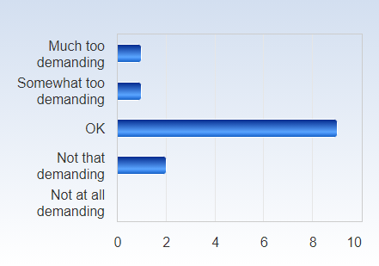

 | Mean | Standard Deviation | Coefficient of Variation | Min | Lower Quartile | Median | Upper Quartile | Max
What is your assessment of the amount of work you have been requested to carry out during the course? Do you consider the course: | 2,9 | 0,8 | 26,0 % | 1,0 | 3,0 | 3,0 | 3,0 | 4,0

On average, approximately how much time do you spend on coursework, both in and outside of the classroom, per week?
On average, approximately how much time do you spend on coursework, both in and outside of the classroom, per week? Number of responses  Less then 10 hours 3 (23,1%)  11-20 hours 1 (7,7%)  21-30 hours 4 (30,8%)  31-40 hours 5 (38,5%)  More than 40 hours 0 (0,0%)  Total 13 (100,0%) | 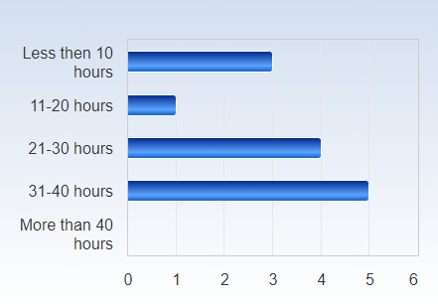

 | Mean | Standard Deviation | Coefficient of Variation | Min | Lower Quartile | Median | Upper Quartile | Max
On average, approximately how much time do you spend on coursework, both in and outside of the classroom, per week? | 2,8 | 1,2 | 42,7 % | 1,0 | 2,0 | 3,0 | 4,0 | 4,0

