Course report for AG2500 Spring term 2023

The 2023 round of the course registered 48 students, of which 16 were students from previous years who had not yet completed their thesis, and 32 were from the graduating class. In total, 36 have submitted their thesis to date (either in May or in September). The grade distribution was 8 High Pass, 26 Pass, and 2 Conditional Pass. 12 either have not submitted or were encouraged to withdraw their thesis, continue revising and resubmit at a later submission opportunity.
The course retained the same structure as in previous years. One change that was introduced the screening of theses. During the September 2022 and February 2023 rounds of seminars, several theses required sufficient reworking that they received a failing grade rather than a conditional pass (also called pass with revisions). Students who do not pass must resubmit their theses at a later deadline, are assigned two examiners and present their thesis at a seminar, as well as act as discussant a second time. As this is resource-demanding for both the students and the program, in the new system, examiners screen the theses directly after the submission deadline. If a thesis is deemed at risk of receiving a failing grade, the examiner encourages the student to withdraw the thesis and to resubmit at the next submission opportunity.
The course evaluation received a total of 13 responses or about one-third of those who completed the course. Regarding the course as a whole, 4 rated it as ‘very good’ and 6 and ‘good’, and with respect to supervision, 11 responded ‘very good’. In comments, students emphasized that they’d received ample and constructive feedback and felt supported by their supervisor. A number of students cited an example of a student they’d understood had received too little support, which is of course an issue we need to address.
Assessments of the course organization and seminars were less positive. One issue noted in open responses is that students could fairly easily detect which theses had been withdrawn after screening. In the future, the schedule will not be published until all screening is complete. Responding students felt the workload to be about right, with most reporting working 31 or more hours a week.
The remaining questions in the course evaluation asked students for input on how well the methods courses had prepared them for the thesis project. One student of SF2321 (Applied Statistical Methods) would have wanted more instruction on how to write up results. A student of the Qualitative Course (SF2322) found it to be too introductory. A student of SF2323 noted the challenges of group work when students’ prior knowledge diverge markedly. Students of 2324 found the course helpful, even if they did not use quantitative methods in their thesis projects.

AG2500 V23 Master Thesis for International Administration and Global Governance
Respondents: 58
Answer Count: 13
Answer Frequency: 22,41 %

1 Overall, how would you assess the course?
Overall, how would you assess the course? Number of responses  Very good 4 (30,8%)  Rather good 6 (46,2%)  Neither good nor bad 2 (15,4%)  Rather bad 1 (7,7%)  Very bad 0 (0,0%)  Total 13 (100,0%) | 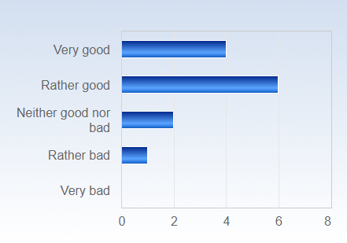

2 Overall, how would you assess the supervision of the thesis?
Overall, how would you assess the supervision of the thesis? Number of responses  Very good 11 (84,6%)  Rather good 1 (7,7%)  Neither good nor bad 1 (7,7%)  Rather bad 0 (0,0%)  Very bad 0 (0,0%)  Total 13 (100,0%) | 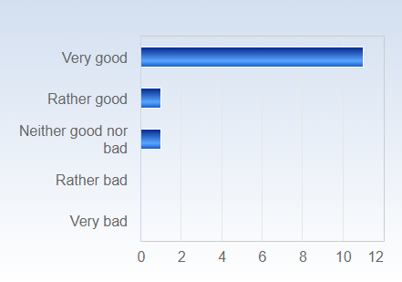

3 Overall, how would you assess the thesis seminars?
Overall, how would you assess the thesis seminars? Number of responses  Very good 2 (15,4%)  Rather good 5 (38,5%)  Neither good nor bad 6 (46,2%)  Rather bad 0 (0,0%)  Very bad 0 (0,0%)  Total 13 (100,0%) | 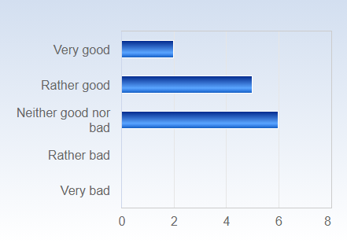

4 How would you assess the organization of the course, including the information on Canvas (information, schedule, administration)?
How would you assess the organization of the course, including the information on Canvas (information, schedule, administration)? Number of responses  Very good 6 (46,2%)  Rather good 3 (23,1%)  Neither good nor bad 4 (30,8%)  Rather bad 0 (0,0%)  Very bad 0 (0,0%)  Total 13 (100,0%) | 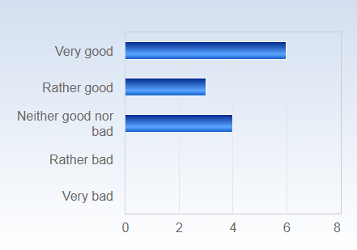

5 What is your assessment of the amount of work you have been requested to carry out during the course? Do you consider the course:
What is your assessment of the amount of work you have been requested to carry out during the course? Do you consider the course: Number of responses  Much too demanding 0 (0,0%)  Somewhat too demanding 2 (15,4%)  OK 9 (69,2%)  Not that demanding 1 (7,7%)  Not at all demanding 1 (7,7%)  Total 13 (100,0%) | 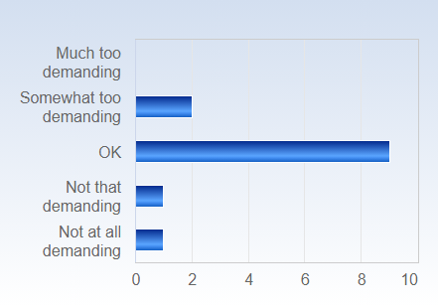

6 On average, approximately how much time do you spend on coursework, both in and outside of the classroom, per week?
On average, approximately how much time do you spend on coursework, both in and outside of the classroom, per week? Number of responses  Less then 10 hours 0 (0,0%)  11-20 hours 2 (15,4%)  21-30 hours 1 (7,7%)  31-40 hours 5 (38,5%)  More than 40 hours 5 (38,5%)  Total 13 (100,0%) | 