Course Report: SF2324 Introduction to Applied Research Design and Quantitative Research Methods for Social Scientists, HT25

Background and course Information
The course ran between November 2025 and January 2026. As in previous years the course is given by a team of teachers. Marina Nistotskaya and Georgios Xezonakis were the instructors for lectures while Hilma Lindskog, Jana Schwenk, Leonie Reicheneder and Albert Wendsjö run the seminars. Supervision and grading of the final papers was done by Nicholas Charron, Georgios Xezonakis, Jana Schwenk and Leonie Reichennder.
62 students were enrolled at the start of the course. This number is higher from the previous year as students from other departments and master courses (e.g Criminology students) take this course every other year. We expect this number to fall the following year to about 40. From those 62 about 86% submitted a final paper on the original deadline. A marked difference from previous years but comparable to last year. At the time of the writing we have an overall completion rate of about 60%. This is mainly because grades for some assignments (especially make up assignments for missing the final seminar) have not been registered yet. The rule change implemented two years ago whereby High Pass was not possible if the student submitted at a later date other than the official deadline, seems to be driving the timely completion of an important component of course work such as the final paper. This year we have operated with somewhat larger lab and seminar groups as clock hours available to the course have been reduced.
Student evaluation
The course survey was answered by 29 students, a response rate of about 50%. Students’ evaluations are markedly lower than the preceding year. The averages for the course overall and the lectures have dropped from around 4.2 (in 5 point scale) in the previous year to about 3.3. Evaluation of the teachers also has a lower score (3.7 vs 4.4 last year). Lectures are evaluated at 3.2 (vs 4.3 last year), the research design seminar at 3.3 (vs 3.9) and the labs 3.2 (vs 3.8). Students express somewhat more difficulty to complete the lab assignments. It is worth noting that the lab assignments have remained exactly the same as last year after the overhaul we did for H24. Regarding the final paper the students evaluated it somewhat lower than last year but the drop is not as marked as in other components. The students also express less satisfaction with the organization of the course (3.1to 3.8)
Overall, a marked drop in the evaluation for SF2324 across the board. We should note that we do get a drop in evaluations in years when the group of students is very diverse (in terms of discipline and previous training in methods) and something like this might be at work this year as well. Following experience from previous years we have taken steps to provide a better integration of students from other departments but from some open-ended questions it appears there was room for improvement. Worth noting that this was the last year that the course would be available to students from programmes other than the ones the Department of Political Science is responsible for.
From the answers to the open-ended questions one of the more consistent comments has been the time allowed for training on the STATA software and the time allocated to do the lab exercises. The latter is a perennial comment, and we have in the past increased that time to address it. However, the demands of the course are such that we have limited room to maneuver in that area.
The survey results have been appended to this document.
The course in HT26
The course will be given next year as well with a smaller group of students. Numbers in lab groups will remain the same as this year but we will move from three lab groups to two given the smaller size of the course. From previous years we already extended the time they had to submit a lab exercise (the time between the actual lab and when the exercise was due). We also extended that time by a few hours in the last year as well (lab was due at 12.00 on a specific day and that was extended 17.00). However, in the interest of getting feedback to students more quickly we had to cut this last extension, to allow time for teachers to grade papers, and this will be the case for next year as well. Given hour constraints we will possibly have to drop the help desk for next year. However, given that next year the group will be more homogenous in terms of skills we expect that we can live without that component and we aim to increase somewhat the time allocated for in person supervision. In the last year the processes instituted to coordinate supervision and the grading of final papers seems to have worked (given the limited comments on this) and we will keep them in place. We need to do more though for coordination between lab teachers. Given that next year we will only have two teachers leading labs this should be easier.

SF2324 H25 Introduktion till tillämpad forskningsdesign och kvantitativa forskningsmetoder för samhällsvetare
Respondents: 67
Answer Count: 29
Answer Frequency: 43.28%

What is your overall evaluation of the course? Please feel free to elaborate on your answer. In particular, are there any topics you feel should have been covered but were not covered in this section of the course, or which should have been discussed more than they were? Think about your expectations, learning outcomes, etc.
What is your overall evaluation of the course? Please feel free to elaborate on your answer. In particular, are there any topics you feel should have been covered but were not covered in this section of the course, or which should have been discussed more than they were? Think about your expectations, learning outcomes, etc. Number of responses Cumulated responses  Very good 5 (17.2%) 5 (17.2%)  Fairly good 11 (37.9%) 16 (55.2%)  Neither good nor bad 4 (13.8%) 20 (69.0%)  Fairly bad 5 (17.2%) 25 (86.2%)  Very bad 4 (13.8%) 29 (100.0%)  Total 29 (100.0%) 29 (100.0%) | 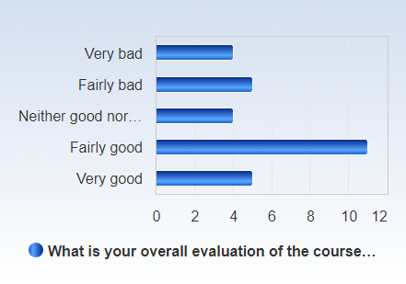

 | Mean | Standard Deviation | Coefficient of Variation | Min | Lower Quartile | Median | Upper Quartile | Max
What is your overall evaluation of the course? Please feel free to elaborate on your answer. In particular, are there any topics you feel should have been covered but were not covered in this section of the course, or which should have been discussed more than they were? Think about your expectations, learning outcomes, etc. | 3.3 | 1.3 | 40.7 % | 1.0 | 2.0 | 4.0 | 4.0 | 5.0

Overall, how would you assess the lectures?
Overall, how would you assess the lectures? Number of responses Cumulated responses  Very good 3 (10.3%) 3 (10.3%)  Fairly good 12 (41.4%) 15 (51.7%)  Neither good nor bad 6 (20.7%) 21 (72.4%)  Fairly bad 4 (13.8%) 25 (86.2%)  Very bad 4 (13.8%) 29 (100.0%)  Total 29 (100.0%) 29 (100.0%) | 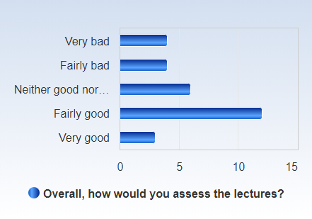

 | Mean | Standard Deviation | Coefficient of Variation | Min | Lower Quartile | Median | Upper Quartile | Max
Overall, how would you assess the lectures? | 3.2 | 1.2 | 38.5 % | 1.0 | 2.0 | 4.0 | 4.0 | 5.0

Overall, how would you assess the teachers?
Overall, how would you assess the teachers? Number of responses Cumulated responses  Very good 7 (24.1%) 7 (24.1%)  Fairly good 13 (44.8%) 20 (69.0%)  Neither good nor bad 5 (17.2%) 25 (86.2%)  Fairly bad 2 (6.9%) 27 (93.1%)  Very bad 2 (6.9%) 29 (100.0%)  Total 29 (100.0%) 29 (100.0%) | 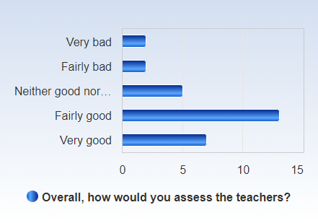

 | Mean | Standard Deviation | Coefficient of Variation | Min | Lower Quartile | Median | Upper Quartile | Max
Overall, how would you assess the teachers? | 3.7 | 1.1 | 30.4 % | 1.0 | 3.0 | 4.0 | 4.0 | 5.0

Overall, how would you assess the literature?
Overall, how would you assess the literature? Number of responses Cumulated responses  Very good 4 (13.8%) 4 (13.8%)  Fairly good 13 (44.8%) 17 (58.6%)  Neither good nor bad 8 (27.6%) 25 (86.2%)  Fairly bad 3 (10.3%) 28 (96.6%)  Very bad 1 (3.4%) 29 (100.0%)  Total 29 (100.0%) 29 (100.0%) | 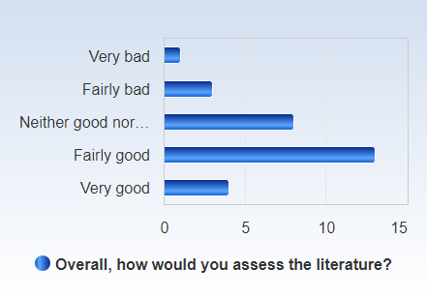

 | Mean | Standard Deviation | Coefficient of Variation | Min | Lower Quartile | Median | Upper Quartile | Max
Overall, how would you assess the literature? | 3.6 | 1.0 | 27.7 % | 1.0 | 3.0 | 4.0 | 4.0 | 5.0

The research design part of the course included one seminar with a written assignment. Please evaluate each of these (seminar and assignment) in terms of whether you felt they helped you understand the issues introduced in the first section of the course (for example case selection, formulating a research question, the role of theory in empirical research, causality, etc):
Research Design Seminar
Research Design Seminar Number of responses Cumulated responses  Very bad 2 (6.9%) 2 (6.9%)  Bad 5 (17.2%) 7 (24.1%)  OK 8 (27.6%) 15 (51.7%)  Good 9 (31.0%) 24 (82.8%)  Very good 5 (17.2%) 29 (100.0%)  Total 29 (100.0%) 29 (100.0%) | 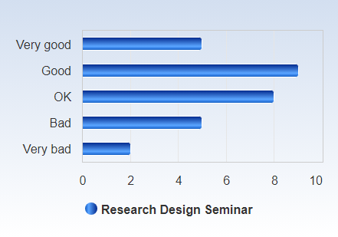

 | Mean | Standard Deviation | Coefficient of Variation | Min | Lower Quartile | Median | Upper Quartile | Max
Research Design Seminar | 3.3 | 1.2 | 35.1 % | 1.0 | 3.0 | 3.0 | 4.0 | 5.0

Research Design written assignment
Research Design written assignment Number of responses Cumulated responses  Very bad 2 (6.9%) 2 (6.9%)  Bad 5 (17.2%) 7 (24.1%)  OK 5 (17.2%) 12 (41.4%)  Good 12 (41.4%) 24 (82.8%)  Very good 5 (17.2%) 29 (100.0%)  Total 29 (100.0%) 29 (100.0%) | 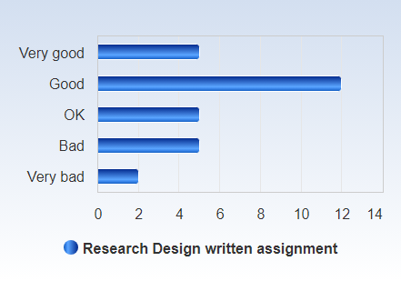

 | Mean | Standard Deviation | Coefficient of Variation | Min | Lower Quartile | Median | Upper Quartile | Max
Research Design written assignment | 3.4 | 1.2 | 34.3 % | 1.0 | 3.0 | 4.0 | 4.0 | 5.0

The course contained 4 lab sessions. Please evaluate these in terms of whether you felt they helped you to further understand the issues introduced during the preceding lectures and prepared you for your lab assignment.
The course contained 4 lab sessions. Please evaluate these in terms of whether you felt they helped you to further understand the issues introduced during the preceding lectures and prepared you for your lab assignment. Number of responses Cumulated responses  Very good 2 (6.9%) 2 (6.9%)  Good 13 (44.8%) 15 (51.7%)  OK 6 (20.7%) 21 (72.4%)  Bad 6 (20.7%) 27 (93.1%)  Very bad 2 (6.9%) 29 (100.0%)  Total 29 (100.0%) 29 (100.0%) | 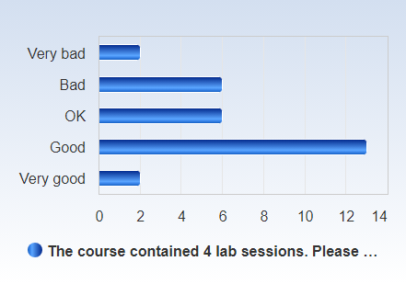

 | Mean | Standard Deviation | Coefficient of Variation | Min | Lower Quartile | Median | Upper Quartile | Max
The course contained 4 lab sessions. Please evaluate these in terms of whether you felt they helped you to further understand the issues introduced during the preceding lectures and prepared you for your lab assignment. | 3.2 | 1.1 | 33.6 % | 1.0 | 2.0 | 4.0 | 4.0 | 5.0

The course contained 4 lab assignments. Please evaluate each of these in terms of their level of difficulty.
Lab 1 Assignment
Lab 1 Assignment Number of responses Cumulated responses  Very easy 1 (3.4%) 1 (3.4%)  Easy 8 (27.6%) 9 (31.0%)  OK 12 (41.4%) 21 (72.4%)  Difficult 4 (13.8%) 25 (86.2%)  Very difficult 4 (13.8%) 29 (100.0%)  Total 29 (100.0%) 29 (100.0%) | 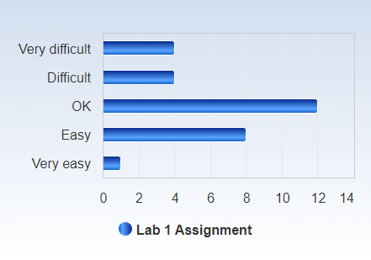

 | Mean | Standard Deviation | Coefficient of Variation | Min | Lower Quartile | Median | Upper Quartile | Max
Lab 1 Assignment | 2.9 | 1.1 | 36.4 % | 1.0 | 2.0 | 3.0 | 4.0 | 5.0

Lab 2 Assignment
Lab 2 Assignment Number of responses Cumulated responses  Very easy 0 (0.0%) 0 (0.0%)  Easy 2 (6.9%) 2 (6.9%)  OK 18 (62.1%) 20 (69.0%)  Difficult 5 (17.2%) 25 (86.2%)  Very difficult 4 (13.8%) 29 (100.0%)  Total 29 (100.0%) 29 (100.0%) | 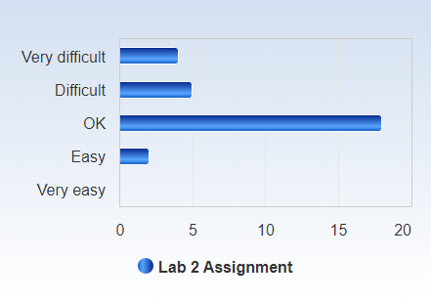

 | Mean | Standard Deviation | Coefficient of Variation | Min | Lower Quartile | Median | Upper Quartile | Max
Lab 2 Assignment | 2.6 | 0.8 | 31.3 % | 1.0 | 2.0 | 3.0 | 3.0 | 4.0

Lab 3 Assignment
Lab 3 Assignment Number of responses Cumulated responses  Very easy 0 (0.0%) 0 (0.0%)  Easy 3 (10.3%) 3 (10.3%)  OK 10 (34.5%) 13 (44.8%)  Difficult 9 (31.0%) 22 (75.9%)  Very difficult 7 (24.1%) 29 (100.0%)  Total 29 (100.0%) 29 (100.0%) | 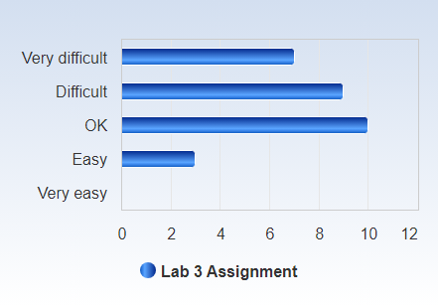

 | Mean | Standard Deviation | Coefficient of Variation | Min | Lower Quartile | Median | Upper Quartile | Max
Lab 3 Assignment | 2.3 | 1.0 | 41.9 % | 1.0 | 2.0 | 2.0 | 3.0 | 4.0

Lab 4 Assignment
Lab 4 Assignment Number of responses Cumulated responses  Very easy 0 (0.0%) 0 (0.0%)  Easy 1 (3.4%) 1 (3.4%)  OK 8 (27.6%) 9 (31.0%)  Difficult 12 (41.4%) 21 (72.4%)  Very difficult 8 (27.6%) 29 (100.0%)  Total 29 (100.0%) 29 (100.0%) | 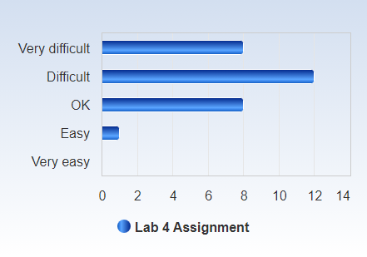

 | Mean | Standard Deviation | Coefficient of Variation | Min | Lower Quartile | Median | Upper Quartile | Max
Lab 4 Assignment | 2.1 | 0.8 | 40.7 % | 1.0 | 1.0 | 2.0 | 3.0 | 4.0

On average, approximately how much time do you spend on coursework, both in and outside of the classroom, per week?
On average, approximately how much time do you spend on coursework, both in and outside of the classroom, per week? Number of responses Cumulated responses  Less than 10 hours 0 (0.0%) 0 (0.0%)  11-20 hours 6 (20.7%) 6 (20.7%)  21-30 hours 8 (27.6%) 14 (48.3%)  31-40 hours 10 (34.5%) 24 (82.8%)  More than 40 hours 5 (17.2%) 29 (100.0%)  Total 29 (100.0%) 29 (100.0%) | 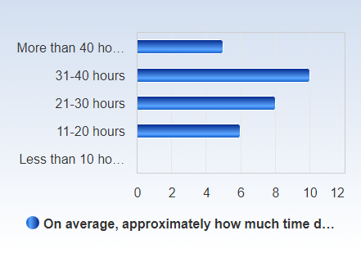

 | Mean | Standard Deviation | Coefficient of Variation | Min | Lower Quartile | Median | Upper Quartile | Max
On average, approximately how much time do you spend on coursework, both in and outside of the classroom, per week? | 3.5 | 1.0 | 29.3 % | 2.0 | 3.0 | 4.0 | 4.0 | 5.0

Before the start of the course, how would you describe your level of training on quantitative research methods?
Before the start of the course, how would you describe your level of training on quantitative research methods? Number of responses Cumulated responses  No training. Total beginner 5 (17.2%) 5 (17.2%)  Very limited previous quantitative training 8 (27.6%) 13 (44.8%)  Familiar with some of the quantitative methodology covered during the course 12 (41.4%) 25 (86.2%)  Familiar with most of the quantitative methodology covered during the course 4 (13.8%) 29 (100.0%)  Course was at or below my level of training on quantitative methodology 0 (0.0%) 29 (100.0%)  Total 29 (100.0%) 29 (100.0%) | 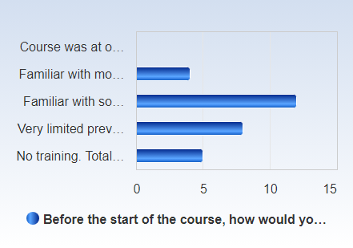

 | Mean | Standard Deviation | Coefficient of Variation | Min | Lower Quartile | Median | Upper Quartile | Max
Before the start of the course, how would you describe your level of training on quantitative research methods? | 2.5 | 0.9 | 37.7 % | 1.0 | 2.0 | 3.0 | 3.0 | 4.0

Overall, how would you assess the final paper as an element of the course work?
Overall, how would you assess the final paper as an element of the course work? Number of responses Cumulated responses  Very good 6 (20.7%) 6 (20.7%)  Fairly good 15 (51.7%) 21 (72.4%)  Neither good nor bad 2 (6.9%) 23 (79.3%)  Fairly bad 5 (17.2%) 28 (96.6%)  Very bad 1 (3.4%) 29 (100.0%)  Total 29 (100.0%) 29 (100.0%) | 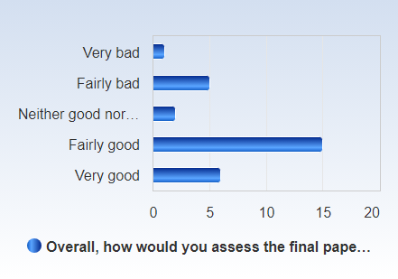

 | Mean | Standard Deviation | Coefficient of Variation | Min | Lower Quartile | Median | Upper Quartile | Max
Overall, how would you assess the final paper as an element of the course work? | 3.7 | 1.1 | 30.0 % | 1.0 | 3.0 | 4.0 | 4.0 | 5.0

Overall, how would you assess the final seminar?
Overall, how would you assess the final seminar? Number of responses Cumulated responses  Very good 0 (0.0%) 0 (0.0%)  Fairly good 12 (42.9%) 12 (42.9%)  Neither good nor bad 8 (28.6%) 20 (71.4%)  Fairly bad 4 (14.3%) 24 (85.7%)  Very bad 4 (14.3%) 28 (100.0%)  Total 28 (100.0%) 28 (100.0%) | 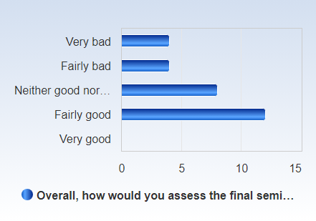

 | Mean | Standard Deviation | Coefficient of Variation | Min | Lower Quartile | Median | Upper Quartile | Max
Overall, how would you assess the final seminar? | 3.0 | 1.1 | 36.3 % | 1.0 | 2.0 | 3.0 | 4.0 | 4.0

How would you assess the organization of the course, including the information on Canvas (information, schedule, administration)?
How would you assess the organization of the course, including the information on Canvas (information, schedule, administration)? Number of responses Cumulated responses  Very good 4 (13.8%) 4 (13.8%)  Fairly good 10 (34.5%) 14 (48.3%)  Neither good nor bad 2 (6.9%) 16 (55.2%)  Fairly bad 10 (34.5%) 26 (89.7%)  Very bad 3 (10.3%) 29 (100.0%)  Total 29 (100.0%) 29 (100.0%) | 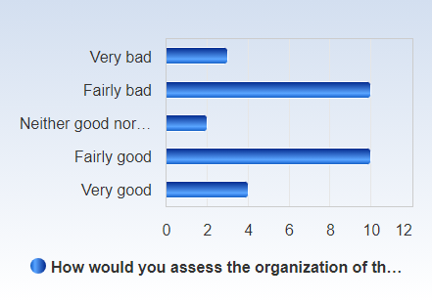

 | Mean | Standard Deviation | Coefficient of Variation | Min | Lower Quartile | Median | Upper Quartile | Max
How would you assess the organization of the course, including the information on Canvas (information, schedule, administration)? | 3.1 | 1.3 | 42.6 % | 1.0 | 2.0 | 3.0 | 4.0 | 5.0

