SK2211 Performance of Democracy Course Report 2025
22 students were registered for the course. At the time of writing the course evaluation, 13 students had completed the course (8 with a VG and 5 with a G). No substantial changes were made to the course this year compared to last year. 7 students completed the course evaluation on which this course report is based. Most aspects of the course were rated fairly good or very good by a majority of students. The assessment of course literature and the final paper assignment were less positively rated. Student comments suggested that less literature be assigned per lecture and that a description of methods be included in the final paper assignment. We will consider changes along these lines in planning the next course. Otherwise, there were very few open-ended responses from the students that suggested any repeating problems with the course. To the contrary, many students wrote about various positive experiences in the course.
Below statistics from the evaluations are included that summarize the students’ responses in their evaluations.

What is your overall evaluation of the course?
What is your overall evaluation of the course? Number of responses  Very bad 0 (0.0%)  Fairly bad 1 (14.3%)  Neither good nor bad 1 (14.3%)  Fairly good 3 (42.9%)  Very good 2 (28.6%)  Total 7 (100.0%) | 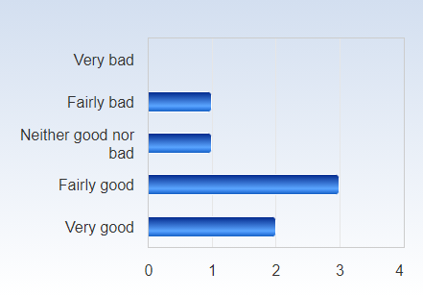

Overall, how would you assess the lectures?
Overall, how would you assess the lectures? Number of responses  Very bad 0 (0.0%)  Fairly bad 0 (0.0%)  Neither good nor bad 1 (14.3%)  Fairly good 4 (57.1%)  Very good 2 (28.6%)  Total 7 (100.0%) | 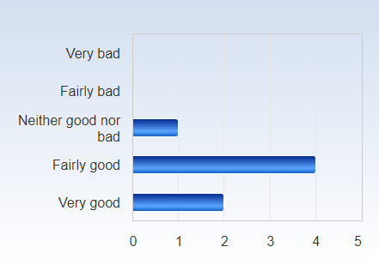

Overall, how would you assess the teachers?
Overall, how would you assess the teachers? Number of responses  Very bad 0 (0.0%)  Fairly bad 0 (0.0%)  Neither good nor bad 1 (14.3%)  Fairly good 3 (42.9%)  Very good 3 (42.9%)  Total 7 (100.0%) | 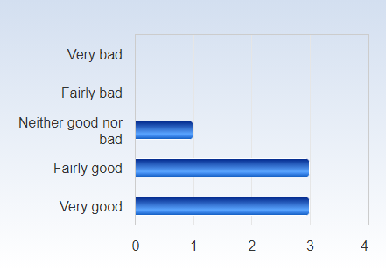

Overall, how would you assess the literature?
Overall, how would you assess the literature? Number of responses  Very bad 0 (0.0%)  Fairly bad 0 (0.0%)  Neither good nor bad 3 (42.9%)  Fairly good 3 (42.9%)  Very good 1 (14.3%)  Total 7 (100.0%) | 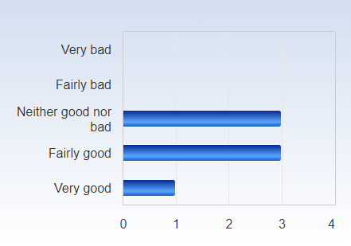

What is your assessment of the amount of work you have been requested to carry out during the course? Do you consider the course:
What is your assessment of the amount of work you have been requested to carry out during the course? Do you consider the course: Number of responses  Too demanding 0 (0.0%)  Somewhat too demanding 0 (0.0%)  About right 5 (71.4%)  Not that demanding 1 (14.3%)  Not at all demanding 1 (14.3%)  Total 7 (100.0%) | 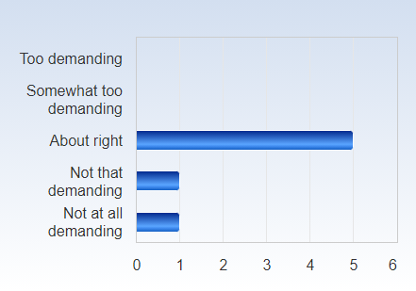

On average, approximately how much time do you spend on coursework, both in and outside of the classroom, per week?
On average, approximately how much time do you spend on coursework, both in and outside of the classroom, per week? Number of responses  Less than 10 hours 0 (0.0%)  11-20 hours 1 (14.3%)  21-30 hours 3 (42.9%)  31-40 hours 3 (42.9%)  More than 40 hours 0 (0.0%)  Total 7 (100.0%) | 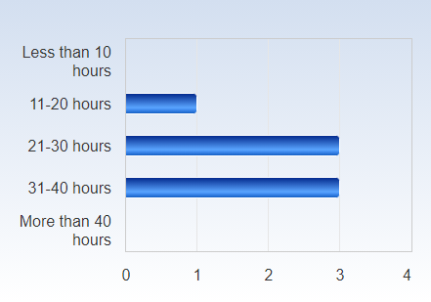

Overall, how would you assess the seminars?
Overall, how would you assess the seminars? Number of responses  Very bad 0 (0.0%)  Fairly bad 0 (0.0%)  Neither good nor bad 3 (42.9%)  Fairly good 4 (57.1%)  Very good 0 (0.0%)  Total 7 (100.0%) | 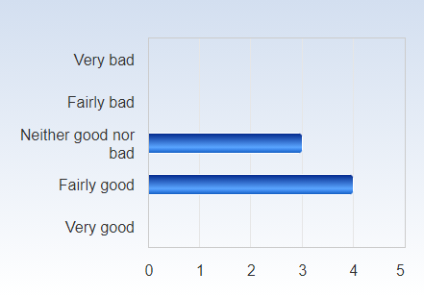

Overall, how would you assess the memo as an element of the course work?
Overall, how would you assess the memo as an element of the course work? Number of responses  Very bad 0 (0.0%)  Fairly bad 1 (14.3%)  Neither good nor bad 1 (14.3%)  Fairly good 2 (28.6%)  Very good 3 (42.9%)  Total 7 (100.0%) | 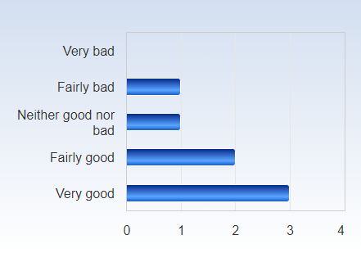

Overall, how would you assess the final paper as an element of the course work?
Overall, how would you assess the final paper as an element of the course work? Number of responses  Very bad 1 (14.3%)  Fairly bad 2 (28.6%)  Neither good nor bad 1 (14.3%)  Fairly good 1 (14.3%)  Very good 2 (28.6%)  Total 7 (100.0%) | 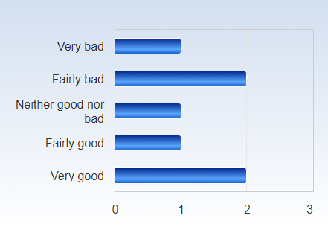

How would you assess the organization of the course, including the information on Canvas (information, schedule, administration)?
How would you assess the organization of the course, including the information on Canvas (information, schedule, administration)? Number of responses  Very bad 0 (0.0%)  Fairly bad 0 (0.0%)  Neither good nor bad 0 (0.0%)  Fairly good 2 (28.6%)  Very good 5 (71.4%)  Total 7 (100.0%) | 