SK 2212 Quality of Government in Comparative Perspective
Course Report V23

Course coordinators: Marina Nistotskaya

Organization of the course
SK 2212 is a 15 credit-course course open to students from all programs at the department of Political Science and Department of Economics at University of Gothenburg. V23 was the first term when the course was not offered to the students at the department of Economics.
There were 26 registered students in spring 2023, including four students who re-took the course. Nine students finished the course with VG and nine with G, eight students didn’t finish the course (either dropped or didn’t get enough points for a passing grade).
The V23 course comprised of ten lectures, six seminars (in groups) and individual tutorials. All learning activities were conducted in person.
The course was taught by five instructors: Victor Lapuente, Petrus Olander, Georgios Xezonakis, Mattias Agerberg and Marina Nistotskaya,
Student evaluation
Of 26 students who took the course 19 filled in the survey questionnaire (76%). Appendix A reports the results of the student evaluation survey. The main takeaway from the evaluation is that, despite some criticism of some elements of the course, most of the student stated that that the course improved their knowledge on the matter of quality of government.

Course coordinator reflection
I served as a course coordinator in spring 2023 despite a request to be substituted (due to my involvement into field research in spring 2023). As a course coordinator I remained available to the students in person and by email, but given the structure of the course, the seminar group leaders carried most of the substantive and organizational interactions with the students. In the assessment of Victor, Petrus and Georgios, the course run smoothly, with students being engaged with the material and each other.
V23 experienced a substantial reduction in the hours allocated to the course: 148 compared to 186 in 2022. The annual changes in the number of hours allocated to the course often requires adjustment to the organization of the course (for example, the number of groups and/or the number of the lectures). V23 was the second year when we did not offer a session on how to write a literature review. In my own assessment and based on the reflection of other teachers this had shown in the quality of students work. This is evidenced, for example, by the most frequent comment on the final papers that a literature review is more than a description of a list of articles.
A discussion with the key QoG course personnel (Victor and Georgios), we felt that the focus on structural determinants of QoG (specifically, geography and history) may need to be reduced since it was tailored to students from the department of economics. In V24 iteration of course, we’ll reduce it to one lecture. At the same time, the seminar on political explanations may need to be allocated more time. We plan to have two seminars on political explanations instead of one.

Appendix A. Student evaluation: SK2212 V23
No of registered students: 26
No of respondents: 19
Response rate: 76%

This course enhanced my knowledge of the role of quality of government on human well-being
This course enhanced my knowledge of the role of quality of government on human well-being. Responses, N(%)  A great deal 13 (68,4%)  To a some degree 4 (21,1%)  Not much 2 (10,5%)  Not at all 0 (0,0%)  Total 19 (100,0%) | 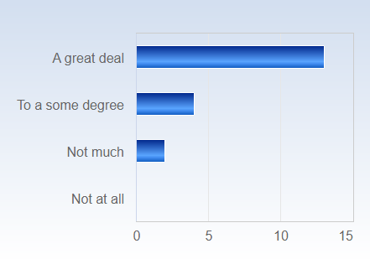

How would you evaluate the role of the lectures in getting knowledge about the course's subject?
How would you evaluate the role of the lectures in getting knowledge about the course's subject? Responses, N(%)  A great deal 13 (68,4%)  To a some degree 4 (21,1%)  Not much 2 (10,5%)  Not at all 0 (0,0%)  Total 19 (100,0%) | 

How would you evaluate the role of the seminars in getting knowledge about the course's subject?
How would you evaluate the role of the seminars in getting knowledge about the course's subject? Responses, N(%)  A great deal 3 (15,8%)  To a some degree 15 (78,9%)  Not much 1 (5,3%)  Not at all 0 (0,0%)  Total 19 (100,0%) | 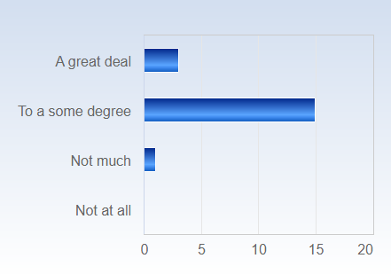
How would you evaluate the role of the assignments in getting knowledge about the couse's subject?
How would you evaluate the role of the assignments in getting knowledge about the course's subject? Responses, N(%)  A great deal 10 (52,6%)  To a some degree 8 (42,1%)  Not much 1 (5,3%)  Not at all 0 (0,0%)  Total 19 (100,0%) | 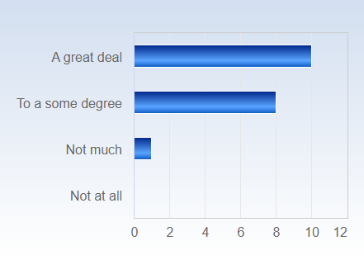

I received useful feedback on the assignments.
I received useful feedback on the assignments. Responses, N(%)  Strongly agree 6 (31,6%)  Agree 9 (47,4%)  Disagree 4 (21,1%)  Strongly disagree 0 (0,0%)  Total 19 (100,0%) | 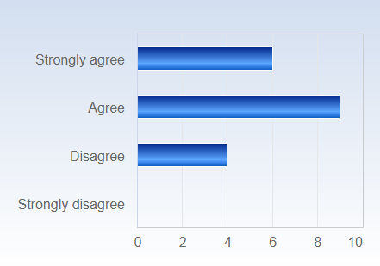

The course developed my ability to read and think critically
The course developed my ability to read and think critically. Responses, N(%)  A great deal 7 (36,8%)  To a some degree 9 (47,4%)  Not much 2 (10,5%)  Not at all 1 (5,3%)  Total 19 (100,0%) | 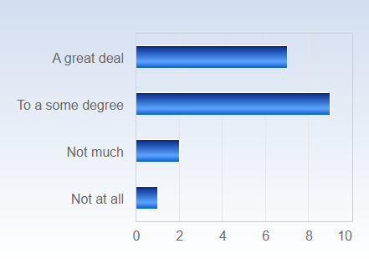
The course improved my ability to evaluate arguments
The course improved my ability to evaluate arguments. Responses, N(%)  A great deal 5 (26,3%)  To a some degree 10 (52,6%)  Not much 3 (15,8%)  Not at all 1 (5,3%)  Total 19 (100,0%) | 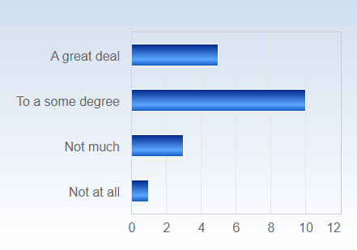

The course helped me to be better at arguing the case more effectively
The course helped me to be better at arguing the case more effectively. Responses, N(%)  A great deal 5 (26,3%)  To a some degree 10 (52,6%)  Not much 3 (15,8%)  Not at all 1 (5,3%)  Total 19 (100,0%) | 

This class has increased my interest in this field of study
This class has increased my interest in this field of study. Responses, N(%)  A great deal 10 (52,6%)  To a some degree 5 (26,3%)  Not much 2 (10,5%)  Not at all 2 (10,5%)  Total 19 (100,0%) | 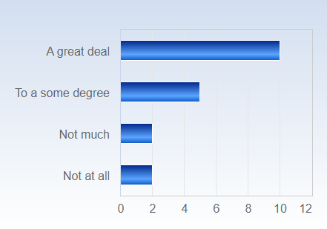

What is your assessment of the about of work you have been requested to carry out during the course? Do you consider the course:
What is your assessment of the abount of work you have been requested to carry out during the course? Do you consider the course: Responses, N(%)  Very demanding 9 (47,4%)  OK 8 (42,1%)  Not at all demanding 2 (10,5%)  Total 19 (100,0%) | 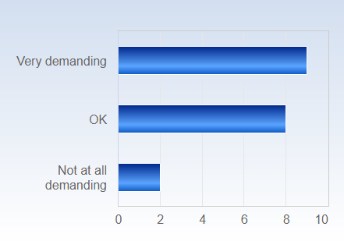

Would you say that you had an “eureka moment” during the course, i.e. a time when you suddenly realized something that you previously did not understand or was aware of? If so, please make a short comment about it below.
Would you say that you had an “eureka moment” during the course, i.e. a time when you suddenly realized something that you previously did not understand or was aware of? If so, please make a short comment about it below. Responses, N(%)  Yes 8 (44,4%)  No 10 (55,6%)  Total 18 (100,0%) | 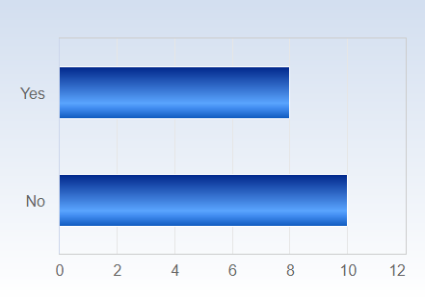

Comments on the ”Eureka moment” question (original spelling)
Maybe the general importance of QoG on public good provisions, economic development, etc. and that it’s not democracy more generally.
i find Quality of Government as absence of impartiality very interesting and something new which i havent studied or thought before. the course or Marinas lecture QOG as an IV gave me a good idea how the impartial policies and absence of corruption leads to social and economic development along with QOG in doing trade or business. in conclusion i would say marinas lecture on qog as IV gave me good idea about what is the course all about and how it has practical importance in life.
I don't know if I had a eureka moment per se, but I did think this course tied together a lot of different subjects well, and the relationships between many things I have studied before became clearer.
Any "euroeka moments" were immdiately squashed by the ammount of writing and lack of breathing space between the assingments.
I was studying at home some weeks ago when I realized how important it is to really look critically at the literature. I mean, it is not that I have been accepting everything I've previously read, but this course made me understand how I can be critical and what to look at.
Maybe not a eureka moment, but as a Swede it's always interesting to problematize democracy since we usually have complete trust that democracy is the solution to everything.
It was an interesting module however, I was not able to grasp its foundational elements since the reading material was complex. The authors did not explicitly state their principal arguments and my evaluations of the reading were mostly wrong, hence I struggled quite a little. The majority of the units in this course involved jargon, even in the lecture's explanations.
that Acemoglu is always portrayed as being anti geography but in fact he says geography determined institutional choice which then influenced development

Do you have any additional points of view you would like to express?

Do you have any additional points of view you would like to express? (original spelling)
The course was occasionally confusing, and the professors were often not correlated. I got the feeling that the grades we got were heavily influenced by who was grading. Meaning that some of the professors graded a lot nicer than others, which I found unfair. The introduction was also rather discouraging, as the professor instead of inspiring us, said for example that " I have more important people to talk to", and other things.
Great tutors, I felt like they all cared about us a great deal. I like the broadness; history, geography, colonialism. Great job Victor of connecting it to the bigger issues. Sometimes I felt that Rothstein was treated as a god. Too many articles that there is no time to really get deep into and are not really used for anything. I felt that impartiality is too much of a narrow concept to make up an entire course.
the course is sometimes not organized. i felt lack of clear guidelines in canvas regarding final paper .Due to this reason i misunderstood what i am supposed to do as discussant.
Both Olander and Lapuente are very capable lectures. I think the memo was a bit poorly positioned in the schedule, and took away from the general effort spent on seminar 3. I think introducing more lectures would strenghten the course.
The course could have been structured better, specifically in terms of information flow. Everything is not in the course guide. For example, there were no instructions on the Georgia seminar in the course guide, as well as very limited information on the final seminar. Why did we only get that information after the submission deadline? Further, I did not really enjoy having to work in such big groups. It is very difficult to do a good job in a group with 7 people. I enjoyed however the take home exams and the final paper.
I feel like the seminars could have been structured more efficient. In Petrus seminars especially, the group as a whole were discussing one presentation. I didn't get out much of those seminar as it was very unstructured and it ended up with people just discussing the same thing over again. I think it would've been better if we first sat in small groups and then took the discussion to a larger group. Also, sometimes the instructions for seminars, assignments etc. could have been more clearer. If instructions were published in Modules it would have been easier to find, as now there were many different documents etc. I also feel like communications between the lecturers could have been better.
the course left no breathing space and i dont feel that i had any time to reflect on the course litterature. One had to jump from assingment to assignemnt without having any breathing room. the last essignment also had far to many words and it would have more proportianate to narrow it down from maximmum 3500 words to a maximum of 3000 words so that oen have time to look for and read the ladditionall litterature one is going to use for the assignments. The complementary assingments are also too big. 1500 words for a missed seminar is not proportional and should be halved. The lack of time for reading and the lack of indepth learning makes me give 3/10 for this course. I can only summarize this course with one word in swedish which is "korvstoppning". I have not learned much.
My feelings about the course are mixed. On the one hand it was an interesting course on the topic I haven't had much previous knowledge and I liked how it challenged the existing notions on how we understand government's role. I thought the lectures were very interesting, Victor is a great story teller. Enjoyed Petrus's lecture too and would've liked to have more of his lectures during the course. While the content of the course was great, I was disappointed in the organization of the course. First of all, the course guide did not address all the aspects of the course. It did not highlight the structure and the tasks of the seminars, especially the final seminar where we had to oppose other students and got an email about it at 5pm on the Friday before. The seminar linkages to the classes/readings were also unclear, as the first 2 seminars had different names from the lectures and this caused confusion. I would also invite you to allocate more time for the Synopsis writing, as we had to give time to prepare for seminar 5 on Georgia for Friday and then submit the synopsis on the following Monday morning.
The course felt somewhat decentralized, to use a QoG-term. Felt like the different lecturers had different views on the course and the course could have benefitted from clearer communication / administration. It was obvious that all the lecturers where highly knowledgeble; Victor did a great job and Petrus grew on me after being too combative in the first seminar.
Yes. All in all, I think that the content of this course has been really good and interesting. However, I wish the supervision for our final paper had been slightly different. I think it was to little with only one supervision - especially since the supervision took place in the beginning of the writing period. I would have been good with another one, approximately one week after the first one. A second one would have helped us students to know if we were on the right track or not.
some lecturers asked that we sent e-mails and they will respond regarding the Final paper supervision. However, the case is different. You send an e-mail and even follow it Canvas but you don't feedback in a timely manner.
I would have liked to have an example paper for the final paper to have some kind of idea of what was expected, I know that the supervisors didn't always give the same information to the students.
It would have been nice with a little more one-on-one time with your supervisor (For the final paper):)
Its an interesting course but it could definitely be simplified for better understanding of the concepts
the course was very intereesting and enriching but felt often unorganized/unccordinated because of 4 different lecturers. also, differences in grading became obvious. For some assignments I did not get any feedback, maybe it was due to the person grading it. workload could be a little less for the seminars since the presentations are unusually time demanding to prepare but seem to give little benefit in contributing knowledge for oneself and even less for audience

