SK2222 V23 Varieties of Democracy and Democratization

The course was held for the 9th time since 2015, in Spring 2023. Two teachers were course responsible (professor Staffan I. Lindberg and Dr. Yuko Sato). Others teaching in 2022 were Dr. Fabio Angiolollo, Dr. Felix Wiebrecht, and Adea Gafuri (PhD student). Maria Lilleste was course administrator.
The course content was a little further adjusted this year to reflect the growing trend of autocratization in the world and the accompanying state of the art in the scientific literature, including a new lecture on authoritarian stability. In other respects, the course remained largely unchanged from the last couple of years when the number of submissions and exams were reduced, and the bar for getting the highest grade (VG) was lowered compared to earlier years. But this year we increased the bar for VG again a little.
Completion Rate
24 students registered this year compared to 28 in 2022 (inclusive of 4 re-registered both years) out of which 16 (67%) completed the course by the time of writing (also 16 and 67% in 2022). 0 failed (U), 12 passed (G), and 4 received a high pass (VG). For 2022 it was 0 U, 8 G, and 8VG. The overall fewer VG reflects the increase in the bar for VG.
Student Evaluations
Only 7 out of 25 students (28%) answered the course evaluation so the results must be taken with a grain of salt, or at least interpreted with care and keeping in mind that most students did not provide their views.
Having said that, on most questions between two-thirds and four out of five rated the course as Very or rather good, and overall five out of seven respondents (71%) rated the course as “very good”, which seems to be an overall positive picture.

Respondents: 24
Answer Count: 7
Answer Frequency: 29 %

Overall, how would you assess the course?
Overall, how would you assess the course? Number of responses  Very good 5 (71,4%)  Rather good 2 (28,6%)  Neither good nor bad 0 (0,0%)  Rather bad 0 (0,0%)  Very bad 0 (0,0%)  Total 7 (100,0%) | 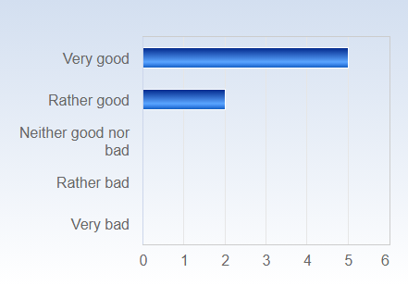

 | Mean | Standard Deviation | Coefficient of Variation | Min | Lower Quartile | Median | Upper Quartile | Max
Overall, how would you assess the course? | 4,7 | 0,5 | 10,4 % | 4,0 | 4,5 | 5,0 | 5,0 | 5,0

Comment
The course was super challenging, but I had the feeling that I learnt a lot during these 3months.

Overall, how would you assess the lectures?
Overall, how would you assess the lectures? Number of responses  Very good 6 (85,7%)  Rather good 1 (14,3%)  Neither good nor bad 0 (0,0%)  Rather bad 0 (0,0%)  Very bad 0 (0,0%)  Total 7 (100,0%) | 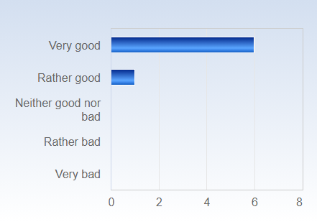

 | Mean | Standard Deviation | Coefficient of Variation | Min | Lower Quartile | Median | Upper Quartile | Max
Overall, how would you assess the lectures? | 4,9 | 0,4 | 7,8 % | 4,0 | 5,0 | 5,0 | 5,0 | 5,0

Comment
Interesting, good group work at some point, sometimes lectures were repeating (The first and the last for example).

Overall, how would you assess the teachers?
Overall, how would you assess the teachers? Number of responses  Very good 5 (71,4%)  Rather good 2 (28,6%)  Neither good nor bad 0 (0,0%)  Rather bad 0 (0,0%)  Very bad 0 (0,0%)  Total 7 (100,0%) | 

 | Mean | Standard Deviation | Coefficient of Variation | Min | Lower Quartile | Median | Upper Quartile | Max
Overall, how would you assess the teachers? | 4,7 | 0,5 | 10,4 % | 4,0 | 4,5 | 5,0 | 5,0 | 5,0

Comment
Propably the best teachers I had so far in my studies.

Overall, how would you assess the literature?
Overall, how would you assess the literature? Number of responses  Very good 7 (100,0%)  Rather good 0 (0,0%)  Neither good nor bad 0 (0,0%)  Rather bad 0 (0,0%)  Very bad 0 (0,0%)  Total 7 (100,0%) | 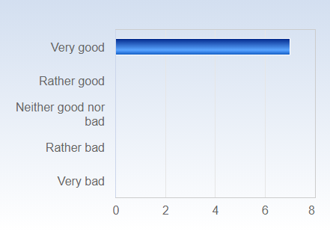

 | Mean | Standard Deviation | Coefficient of Variation | Min | Lower Quartile | Median | Upper Quartile | Max
Overall, how would you assess the literature? | 5,0 | 0,0 | 0,0 % | 5,0 | 5,0 | 5,0 | 5,0 | 5,0

Comment
Good literature, sometimes too much too read!

Overall, how would you assess the seminars?
Overall, how would you assess the seminars? Number of responses  Very good 4 (57,1%)  Rather good 2 (28,6%)  Neither good nor bad 0 (0,0%)  Rather bad 1 (14,3%)  Very bad 0 (0,0%)  Total 7 (100,0%) | 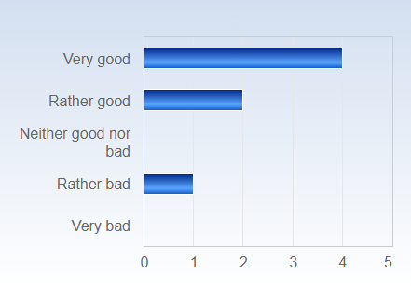

 | Mean | Standard Deviation | Coefficient of Variation | Min | Lower Quartile | Median | Upper Quartile | Max
Overall, how would you assess the seminars? | 4,3 | 1,1 | 26,0 % | 2,0 | 4,0 | 5,0 | 5,0 | 5,0

Comment
Seminars were not really helpful. More feedback about the own written papers would be better.

Overall, how would you assess the course paper tutorials?
Overall, how would you assess the course paper tutorials? Number of responses  Very good 3 (42,9%)  Rather good 2 (28,6%)  Neither good nor bad 1 (14,3%)  Rather bad 1 (14,3%)  Very bad 0 (0,0%)  Total 7 (100,0%) | 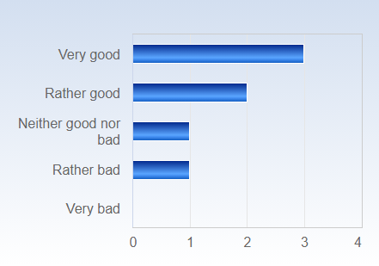

 | Mean | Standard Deviation | Coefficient of Variation | Min | Lower Quartile | Median | Upper Quartile | Max
Overall, how would you assess the course paper tutorials? | 4,0 | 1,2 | 28,9 % | 2,0 | 3,5 | 4,0 | 5,0 | 5,0

Comment
Very helpful! The feedback I recieved have helped me a lot.
the requirements for the written tasks were not clear and instructions were given shortly before the deadline
The first tutorial was not helpful at all. Tutorials would better to have 1-1, not with other students. Second tutorial was good!

Overall, how would you assess the exam (course paper)?
Overall, how would you assess the exam (course paper)? Number of responses  Very good 3 (42,9%)  Rather good 4 (57,1%)  Neither good nor bad 0 (0,0%)  Rather bad 0 (0,0%)  Very bad 0 (0,0%)  Total 7 (100,0%) | 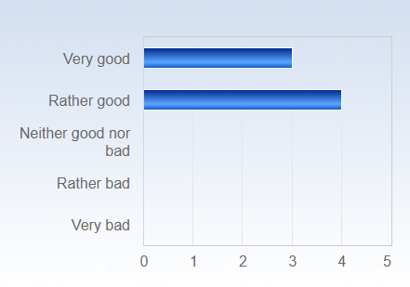

 | Mean | Standard Deviation | Coefficient of Variation | Min | Lower Quartile | Median | Upper Quartile | Max
Overall, how would you assess the exam (course paper)? | 4,4 | 0,5 | 12,1 % | 4,0 | 4,0 | 4,0 | 5,0 | 5,0

Comment
Nice task, challenging but good exercise for later papers.

How would you assess the organization of the course, including the information on Canvas (information, schedule, administration)?
How would you assess the organization of the course, including the information on Canvas (information, schedule, administration)? Number of responses  Very good 2 (28,6%)  Rather good 3 (42,9%)  Neither good nor bad 1 (14,3%)  Rather bad 1 (14,3%)  Very bad 0 (0,0%)  Total 7 (100,0%) | 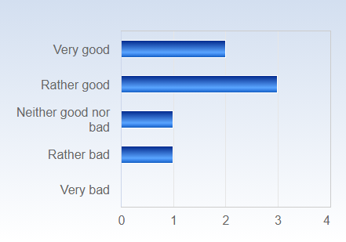

 | Mean | Standard Deviation | Coefficient of Variation | Min | Lower Quartile | Median | Upper Quartile | Max
How would you assess the organization of the course, including the information on Canvas (information, schedule, administration)? | 3,9 | 1,1 | 27,7 % | 2,0 | 3,5 | 4,0 | 4,5 | 5,0

Comment
For paper 2 the elaborated information got sent out only two or three days before deadline. Would have been nice to have that way earlier because a lot of people found the other instructions confusing.
Sometimes information regarding the written assignments were different depending on teachers! More instructions (also for the final paper) would be great.

What is your assessment of the amount of work you have been requested to carry out during the course? Do you consider the course:
What is your assessment of the amount of work you have been requested to carry out during the course? Do you consider the course: Number of responses  Much too demanding 1 (14,3%)  Somewhat too demanding 4 (57,1%)  OK 1 (14,3%)  Not that demanding 1 (14,3%)  Not at all demanding 0 (0,0%)  Total 7 (100,0%) | 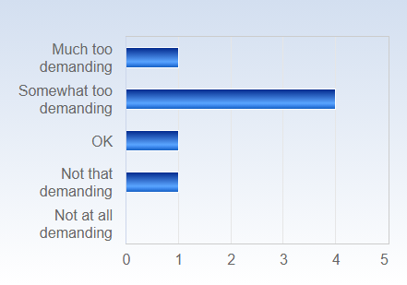

 | Mean | Standard Deviation | Coefficient of Variation | Min | Lower Quartile | Median | Upper Quartile | Max
What is your assessment of the amount of work you have been requested to carry out during the course? Do you consider the course: | 3,7 | 1,0 | 25,6 % | 2,0 | 3,5 | 4,0 | 4,0 | 5,0

Comment
Fair amount of work.
Too much demanding but in the end okay for a master course. the begin was too demanding, maybe give students more time for the deadlines.

On average, approximately how much time do you spend on coursework, both in and outside of the classroom, per week?
On average, approximately how much time do you spend on coursework, both in and outside of the classroom, per week? Number of responses  Less then 10 hours 1 (14,3%)  11-20 hours 2 (28,6%)  21-30 hours 1 (14,3%)  31-40 hours 1 (14,3%)  More than 40 hours 2 (28,6%)  Total 7 (100,0%) | 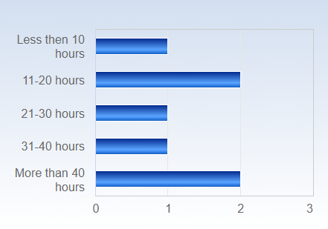

 | Mean | Standard Deviation | Coefficient of Variation | Min | Lower Quartile | Median | Upper Quartile | Max
On average, approximately how much time do you spend on coursework, both in and outside of the classroom, per week? | 3,4 | 2,0 | 58,0 % | 1,0 | 2,0 | 3,0 | 5,0 | 6,0

Would you say that you had an “eureka moment” during the course, i.e. a time when you suddenly realized something that you previously did not understand or was aware of? If so, please make a short comment about it below.

Would you say that you had an “eureka moment” during the course, i.e. a time when you suddenly realized something that you previously did not understand or was aware of? If so, please make a short comment about it below.
It is the best course I have had so far. But I would say that I have missed some lectures that had reduced my understanding.
The course definitely expanded my knowledge on the topics we discussed. I had a few "eureka moments", not just one.
When the measurment procedure was explained.

Do you have any additional points of view you would like to express?

Do you have any additional points of view you would like to express?
Nice course set up with a good mix of paper writing and seminars. Loved the paper subject options. Would have been nice if you were able to recieve a VG on the course even if you did not get VG on 2/3 of the short papers. I got VG on 1/3 and now I do not really have any incentives do put in that extra work on min course paper to get a VG. Since the course paper is that extensive it would make sense that one would be able to get a VG on the course if the course paper is a VG and you have at least one VG from before. Of course I will still do my best with the course paper but it would have been nice to have that extra motivation
The topics discussed are very interesting and helping one to expand his knowledge. It was also great that we discussed countries from all over the worlds as examples, so there was for every one of us an interesting case to look at.
One more lecture on the measurement procedure would be great! And maybe also one day for visiting the V-Dem team and gain more insights on site how they work and how it looks like to work there.

