Midterm
  - STAT 218
Name: _________________________

Instructions

- You have the entire class period to complete this exam.

- You are not permitted to use your notes, computer, or classmates. Cheating will result in a failing grade for the exam.

- A formula sheet is provided on the last page.

- There are 39 points on this exam

- If you have questions regarding what the question is asking, you may ask your instructor. However, your instructor will not assist in answering any questions.

Part 1 (1 pt for each question)
Identify the following variables as categorical or quantitative.

- Number of leaves on oak trees ____________________
- Color of front doors in a certain city ____________________
- Hours until a model of lightbulb burns out ____________________
- Brand of car ____________________
For the following plots, identify the skewness (left, right, symmetric) for questions 5-7.

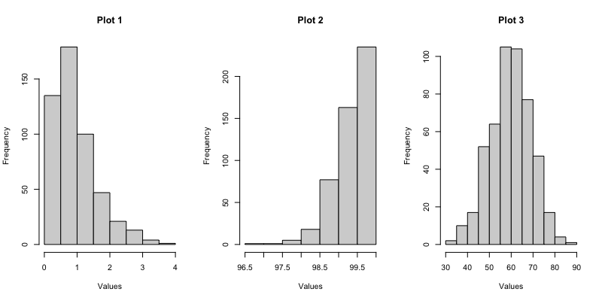

- Plot 1 ____________________
- Plot 2 ____________________
- Plot 3 ____________________
Fill in the following table with the correct symbol notation ( $\overline{x}$, $\hat{p}$, µ, π).

 | Categorical | Quantitative
Population
Sample

Choose the correct phrase to make the statement true.

- When you fail to reject the null hypothesis, it is possible that there is a (Type I / Type II) error.

- A 90% confidence interval has a significance level of (0.01 / 0.05 / 0.1).
- A parameter is a (known / unknown) value from the (population / sample).
- A statistic is a (known / unknown) value from the (population / sample).
- A p-value will always be a numeric value between _____ and _____.
Identify whether to Reject (R) or Fail to Reject the null hypothesis for the following situations:

- Calculate a standardized statistic of -1.3 (Reject / Fail to Reject)
- Calculate a standardized statistic of 3.4 (Reject / Fail to Reject)
- A p-value of 0.002 with a significance level of 0.05 (Reject / Fail to Reject)
- A p-value of 0.04 with a significance level of 0.01 (Reject / Fail to Reject)

Use the following scenario for question 21.
Suppose that a survey of 100 people found that 70% of people prefer travelling to another state when taking a vacation.

- Show how to set up the calculation for the 95% confidence interval.

Part 2: Scenario (3 points for each question)

Use the following scenario for questions 25-29.
Another question on the American Community Survey asks for the time it takes the survey respondent to get to work. For respondents ages 18 to 67 living in Lincoln, Nebraska, the average time it took for the 1,218 respondents to get to work is 14.9 minutes with a standard deviation of 4.03 minutes. You may assume that the data was not strongly skewed. You are tasked with investigating if the amount of time it takes people living in Lincoln, Nebraska to get to work is different than 15 minutes.

- Identify the parameter of interest and assign the appropriate symbol.

- Write down the null and alternative hypotheses, in symbols, that reflect the research question.

- Set up the calculation for the standard error.

- Set up the calculation for the 95% confidence interval.

- The 95% confidence interval is (14.09, 15.71). Does this interval reject or fail to reject the null hypothesis?

- Write a conclusion based off the confidence interval that reflections the research question.

Extra Credit: You may indicate how many extra credit points you want for this question (where 1 point is about 2.5% of the exam grade). However, there is a catch. The average amount points selected for the entire class for this extra credit opportunity may not exceed 1. Should the average exceed 1 point, no students will receive the extra credit for this problem

How many points would you like? _____

Standard Error Formulas
$$SE=\sqrt{\frac{π_{0}\left(1-π_{0}\right)}{n}}$$

$$SE=\sqrt{\frac{\hat{p}\left(1-\hat{p}\right)}{n}}$$

$$SE=\frac{s}{\sqrt{n}}$$

