Midterm
  - STAT 218
Name: _________________________

Instructions

- You have the entire class period to complete this exam.

- You are not permitted to use your notes, computer, or classmates. Cheating will result in a failing grade for the exam.

- A formula sheet is provided on the last page.

- There are 39 points on this exam

- If you have questions regarding what the question is asking, you may ask your instructor. However, your instructor will not assist in answering any questions.

Part 1 (1 pt for each question)
Identify the following variables as categorical or quantitative.

- Number of leaves on oak trees ____________________
- Color of front doors in a certain city ____________________
- Hours until a model of lightbulb burns out ____________________
- Brand of car ____________________
For the following plots, identify the skewness (left, right, symmetric) for questions 5-7.

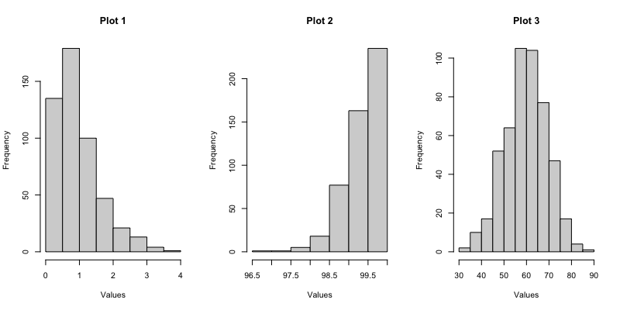

- Plot 1 ____________________
- Plot 2 ____________________
- Plot 3 ____________________
Fill in the following table with the correct symbol notation ( $\overline{x}$, $\hat{p}$, µ, π).

 | Categorical | Quantitative
Population
Sample

Choose the correct phrase to make the statement true.

- When you fail to reject the null hypothesis, it is possible that there is a (Type I / Type II) error.

- A 90% confidence interval has a significance level of (0.01 / 0.05 / 0.1).
- A parameter is a (known / unknown) value from the (population / sample).
- A statistic is a (known / unknown) value from the (population / sample).
- A p-value will always be a numeric value between _____ and _____.
Identify whether to Reject (R) or Fail to Reject the null hypothesis for the following situations:

- Calculate a standardized statistic of -1.3 (Reject / Fail to Reject)
- Calculate a standardized statistic of 3.4 (Reject / Fail to Reject)
- A p-value of 0.002 with a significance level of 0.05 (Reject / Fail to Reject)
- A p-value of 0.04 with a significance level of 0.01 (Reject / Fail to Reject)

Use the following scenario for question 21.
Suppose that a survey asked 100 people approximately how much they spend on vacations. The average was $400 and the standard deviation was $30, and the responses were not strongly skewed.

- Show how to set up the calculation for the standardized statistic.

Part 2: Scenario (3 points for each question)

Use the following scenario for questions 22-27.

One question on the American Community Survey asks for the time it takes the survey respondent to get to work. For respondents ages 18 to 67 living in Lincoln, NE, the proportion of 1,218 respondents reporting that they took longer than 20 minutes to get to work was 0.103. You are tasked with investigating if the proportion of people who take longer than 20 minutes to get to work is different than the historical proportion of 0.08.

- Identify the parameter of interest and assign the appropriate symbol.

- Write down the null and alternative hypotheses, in symbols, that reflect the research question.

- Set up the calculation for the standard error.

- Set up the calculation for the 95% confidence interval.

- The standardized statistic was found to be 2.64. Does this statistic reject or fail to reject the null hypothesis?

- Write a conclusion based off the confidence interval that reflections the research question.

