Introduction
Simple Linear Regression (SLR) is a statistical method that allows us to summarize and study relationships between two continuous (quantitative) variables.

Examples: fuel efficiency of cars and their weights; grade point average and number of classes skipped for high school students

We will be using three methods to look at regression.

- Scatterplots
- Correlation
- Line of best fit

$$y=mx+b$$

- Prediction
- Residuals

Section 10.1
Suppose that researchers are investigative an association between the time it takes students to take and exam and their score on the exam. A sample was taken from one mathematics class. Identify the following:

- Was the study observational or experimental?

- What is the explanatory variable?

- What is the response variable?

The goal is to predict the response variable from the explanatory, which does not require cause-and-effect relationships.

Scatterplots
The first step is to analyze the data graphically through the use of scatterplots.
- May have called them x − y plots
- The explanatory/predictor variable goes on the x−axis
- The response variable goes on the y−axis
- There is a dot on the plot for each point in the data set

To visually analyze, will look at four aspects:
- Direction: positive, negative or no relationship
- Form: Is the association linear (do the points follow a linear pattern) or some more complicated curve?
- Strength
  - How closely do the points follow a pattern?
  - If you imagine a line through the points, the points all fall pretty close to that line, the association is fairly strong
- Unusual Observations
  - Are there any points that do not seem to adhere to the overall pattern

Exam example: The data is plotted below.

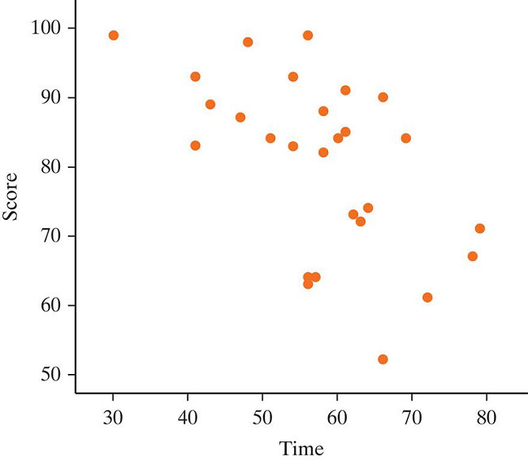

Direction:
- Negative (as time increases, scores tend to decrease)

Form:
- Seems to be linear pattern

Strength:
- Moderately (points tend to fall closely to a line)

Unusual observations:
- None here

Summarizing the Relationship
In addition to graphically, we will want to use numeric summaries.

Correlation Coefficient (r)
- Measures the strength and direction of a linear association
- −1 ≤ r ≤ 1
- Closer to one of the extremes, the stronger the relationship
  - If r = 1 or r = −1, the points fall exactly in a straight line
  - If r=0, no linear relationship
- If r is positive positive relationship (also vice versa)

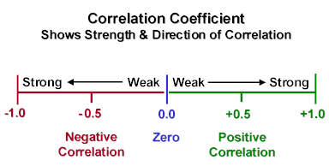

Examples:
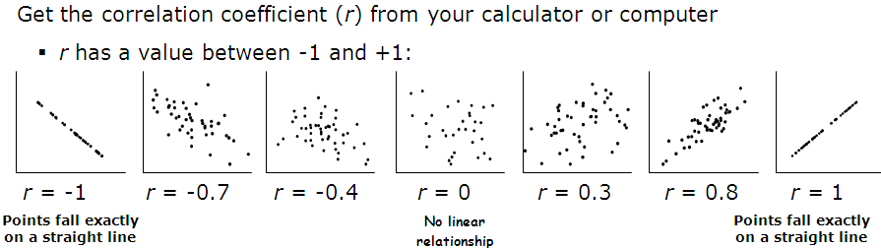

Section 10.2
Through simulation, we can test the if the correlation coefficient is significant or not. This is done by randomizing the explanatory and response pairs and creating a null distribution of correlation coefficients. We will not be focusing on the simulation approach in our class.

Section 10.3: Least Squared Regression
Our goal is to make predictions on the response variable. Unless the points form a perfect line, there won’t be a single line that goes through every point. We will want a line that gets as close as possible to all the points.

We want a line that minimizes the vertical distances between the line and the points
- These distances are called residuals.
- The line we will find actually minimizes the sum of the squares of the residuals.
- This is called a least-squares regression line.

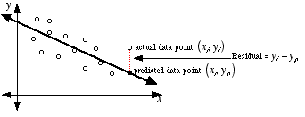

Example: Growing Plates?
Research question: Are dinner plates getting larger?

There are many recent articles and TV reports about the obesity problem. One reason some have given is that the size of differ plates are increasing. Are these black circles the same size, or is one larger than the other?


The circle on the right is about 20% larger than the one on the left. This suggests that people will put more food on larger dinner plates without knowing. This is known as Delboeuf illusion.

Researchers gathered data to investigate the claim that dinner plates are growing by using American dinner plates sold on ebay on March 30th, 2010 (Van Ittersum and Wansink, 2011). The year manufactured and diameter are given below.

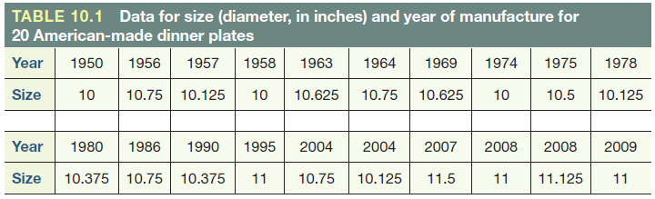

Both year (explanatory) and diameter (response) are quantitative. Each dot on the plot below represents one plate.

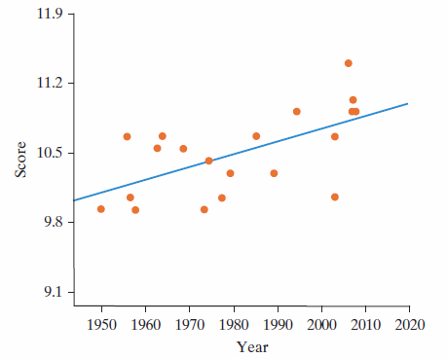

The data is trending upward, which indicates a positive association. We also do not see any curves within the data, which suggests this is a linear trend.

The regression equation is $\hat{y}=a+bx$:
- a is the y-intercept
- b is the slope
- x is a value of the explanatory variable
- ŷ is the predicted value for the response variable

For a specific value of x, the corresponding distance $y-\hat{y}$ (or actual – predicted) is a residual

Residual
A residual is the vertical distance from a point to the regression line. This can also be described as the difference between an observed response and the corresponding predicted response.

Residual = Observed - Predicted
- Negative residuals fall below the line (overestimate)
- Positive residuals are above the line (underestimate)
- Each observational unit has a residual

Regression Line for Growing Plate example
Software will calculate the coefficients for us. The least squares line for the dinner plate data is $\hat{y}=-14.8+0.0128x$

Or $\hat{diameter}=-14.8+0.0128(year)$

- This allows us to predict plate diameter for a particular year.

What is the predicted diameter for a plate manufactured in 2000?
-14.8 + 0.0128(2000) = 10.8 in.

What is the predicted diameter for a plate manufactured in 2001?
  - -14.8 + 0.0128(2001) = 10.8128 in.

How does this compare to our prediction for the year 2000?
  - 0.0128 larger

Slope b = 0.0128 means that diameters are predicted to increase by 0.0128 inches per year on average

Slope is the predicted change in the response variable for one-unit change in the explanatory variable. Both the slope and the correlation coefficient for this study were positive.
  - The slope is 0.0128
  - The correlation is 0.604

The slope and correlation coefficient will always have the same sign.

The y-intercept is where the regression line crosses the y-axis or the predicted response when the explanatory variable equals 0.
- We had a y-intercept of -14.8 in the dinner plate equation. What does this tell us about our dinner plate example?
  - Dinner plates in year 0 were -14.8 inches.
- How can it be negative?
  - The equation works well within the range of values given for the explanatory variable, but fails outside that range.
- Our equation should only be used to predict the size of dinner plates from about 1950 to 2010.

Coefficient of Determination
While the intercept and slope have meaning in the context of year and diameter, remember that the correlation does not. It is just 0.604. However, the square of the correlation (coefficient of determination or r²) does have meaning.

- r² = 0.604² = 0.365 or 36.5%
- 36.5% of the variation in plate size (or the response variable) can be explained by its linear association with the year (the explanatory variable).

Testing Significance of the Regression Model
Both the slope and the intercept of a Simple Linear Regression model can be tested for significance. The calculation of these go beyond the scope of our class, but essentially a standard error can be calculated for both the slope and intercept (and for more advanced models, this can also apply to more terms). Using the standard error, the t-statistic can be calculated. The meaningful values to test against are zero slope and zero for the intercept. We test against zero in both cases so that we can determine if there is a difference from the model and having no association or no intercept.

Key Concepts
- Describe the scatterplot
  - Form, Direction, Strength, Unusual Observations

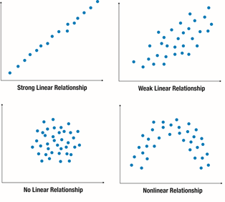

- Coefficient of Correlation $(r)$
  - Between -1 and 1
- Coefficient of Determination $(R^{2})$
  - ___% of the variation in Explanatory Variable is explained by its linear association with Quantitative Variable.
- Explanatory Variable (x) – what we know and are using to make our prediction better
- Response Variable (y) – what we want to predict
- $\hat{y}=mx+b$
- $\hat{y}=$ predicted value (this is the y value shown by the line)
- $m=$ slope coefficient (rise over run)
  - For every one value increase in explanatory variable (x) the response variable (y) increases/decreases by m.
- $b=$ y-intercept (this is the value in which x=0, crosses the y-axis)
  - When explanatory variable (x) is 0, the response variable (y) has a value of b.
  - This may or may not have meaning.
- Extrapolation: Can only predict in the range you have collected data.

