Section 3.1: Confidence Intervals

Introduction
Up until now, we have been using hypothesis tests to determine if a value for a parameter is plausible. Our new goal is estimation: what values of the parameter are plausible?

Confidence Interval: a range of likely values for the ____________________

Example: Legalization of Medical Marijuana
In February of 2014, a Star Tribune Minnesota poll asked a random sample of adults in Minnesota, “Do you support or oppose legalizing marijuana for medical purposes in Minnesota?” Of the 800 adults surveyed, 408 (51%) answered that they would support this.

Ultimately, the Star Tribune conducted this poll because they wanted to estimate the proportion of adults in Minnesota that felt (at the time of the survey) that medical marijuana should be legalized. Keep this in mind as you answer the following questions.

Source: http://www.startribune.com/politics/statelocal/245910931.html

Answer the following questions:

- What is the population of interest?

- What is the parameter of interest?

- What is the sample?

- What is the observed statistic of interest? This is also called a point estimation.

- What would happen if you took a different sample of 800 Minnesota adults?

Hypothesis
Null: The long run proportion of Minnesotans who feel medical marijuana should be legalized is equal to _____.

In symbols: $H_{0}:π=$

Alternative: The long run proportion of Minnesotans who feel medical marijuana should be legalized is different from _____.

In symbols: $H_{A}:π≠$

Calculate the p-value from the Theory Based Inference Applet.

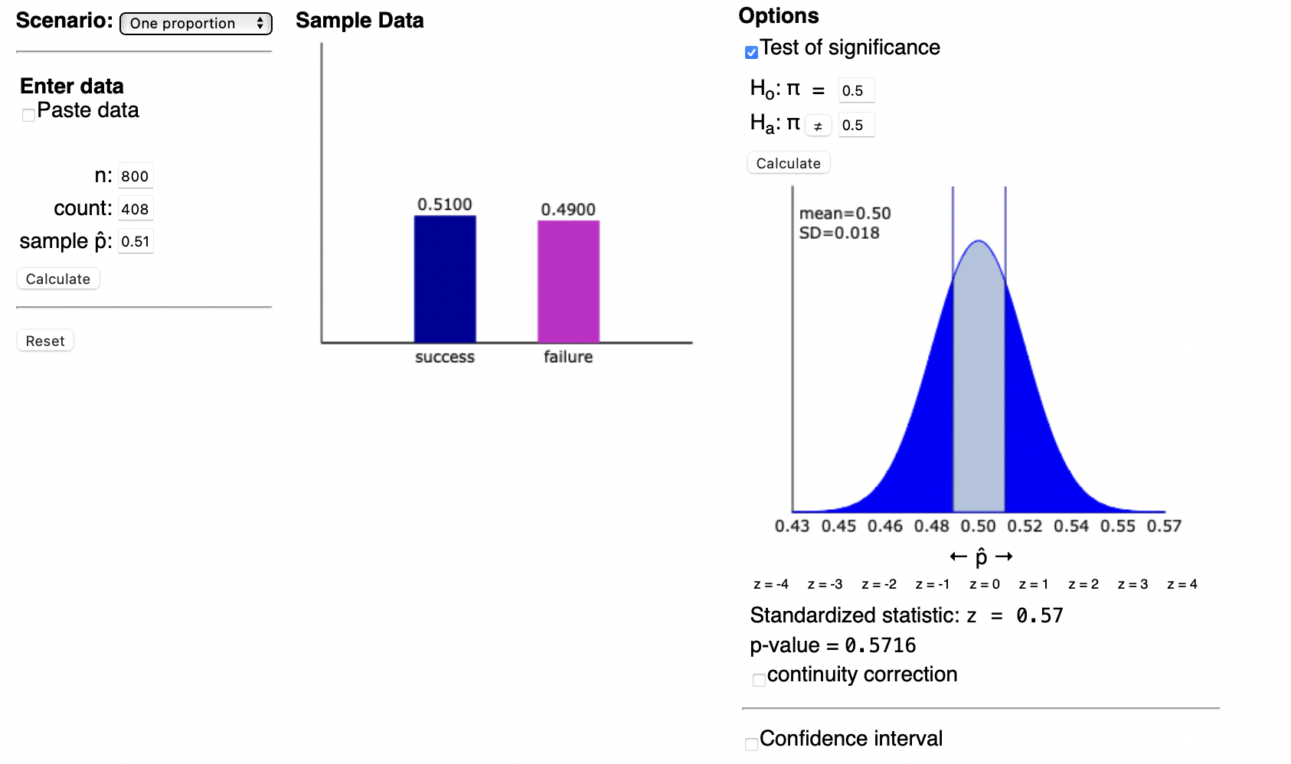
Note: when setting up the applet, you either enter the number of successes into the “count” box or the point estimation into “sample $\hat{p}$”. The other box will automatically fill in.

- Based off the p-value, would you Reject (R) or Fail to Reject (FTR) at a significance level of 0.05?

The general idea behind constructing a confidence interval is that we can use our sample to provide a plausible range of parameter values.
Using the Theory Based Inference applet, change the values of π to fill in the following table. (i.e., change the hypothesis test for different parameter values while using the same sample)

π | 0.45 | 0.46 | 0.47 | 0.48 | 0.49 | 0.50 | 0.51 | 0.52 | 0.53 | 0.54 | 0.55
p-value
R/FTR

- What trends do we see?

- When we Fail to Reject, are we saying the null or alternative is plausible?

- What is the interval of plausible values?

Interpretation: We are 95% confident that the long-run proportion of Minnesotans who feel that medical marijuana should be legalized is between _____ and _____.

General Form of a Confidence Interval
Notice how the confidence interval is centered around the point estimate.

$$\text{Confidence Interval (CI)}=\text{Point Estimate}±\text{Margin of Error}$$

In the previous example, the confidence interval can be expressed as:

51% ± 3.5% (i.e., 47.5% ≤ π ≤ 54.5%).

Significance Levels ($α$)
Significance Level + Confidence Level = 100%

When $α=0.10$,
- Relates to a 90% CI
- Rejects when p-value < 0.10
- Narrower than 95% CI
- Rejects the null more often (remember than $α=0.10$ means that we reject the null 10 percent of the time)

When $α=0.05$,
- Relates to a 95% CI
- Rejects when p-value < 0.05

When $α=0.01$,
- Relates to a 99% CI
- Rejects when p-value < 0.01
- Wider than 95% CI
- Rejects the null less often than 95% CI

Using the 95% confidence interval as a reference, draw what you would expect from the 90% confidence interval and 99% confidence interval

95% CI

90% CI

99% CI

Technical Note About Confidence Intervals
We say that we are “$100-α*100\%$ confident” because $100-α*100\%$ of the confidence intervals generated from samples of a given population will cover the true parameter value. In the instance of $α=0.05$, this means that 95% of confidence intervals generated from samples within a population will cover the true parameter value. In Section 3.3, we will look at an applet that will demonstrate what this means. This is NOT the same as saying that the probability of the parameter being in the confidence interval is $100-α*100\%$

Section 3.2: Confidence Intervals for One Proportion

Formula
The general formula for confidence intervals is as follows:

$$\text{Observed Statistic}±\text{Multiplier}⋅\text{Standard Error}$$

Unlike in Chapter 1, we now have a new formula for the standard error:

$$SE=\sqrt{\frac{\hat{p}⋅\left(1-\hat{p}\right)}{n}}$$

Notice how we are no longer using π in the calculation, but rather $\hat{p}$.

To construct a 95% Confidence interval, the multiplier we will use in this course is 2. This gives us the confidence interval for one proportions to be:

$$CI=\hat{p }±2* \sqrt{\frac{\hat{p}*\left(1-\hat{p}\right)}{n}}=(Lower Limit, Upper Limit)$$

Technical aside: if you look into confidence intervals from sources outside of our class, you will notice that the multiplier value for a 95% confidence interval will likely be 1.96. However, we will only use a multiplier value of 2 for this course.

Example: Legalization of Medical Marijuana
Recall the medical marijuana survey question from Section 3.1. Calculate the 95% confidence interval.

In February of 2014, a Star Tribune Minnesota poll asked a random sample of adults in Minnesota, “Do you support or oppose legalizing marijuana for medical purposes in Minnesota?” Of the 800 adults surveyed, 408 (51%) answered that they would support this.

$$\hat{p}=$$

$$n=$$

$$SE=\sqrt{\frac{\hat{p}*\left(1-\hat{p}\right)}{n}}=$$

$$\hat{p }±2*SE=$$

Conclusions Based Off of Confidence Intervals
Recall the general interpretation of a confidence interval.
- We are 95% confident that the long run proportion of “context” falls between (lower limit) and (upper limit).

If the null hypothesis value is __________ of the interval
- It is a likely value
- Fail to Reject

If the null hypothesis value is ___________ of the interval
- It is not a likely value
- Reject

Conclusion: We (do/do not) have evidence to conclude (restate alternative in context).

In the context of the medical marijuana example,
- Hypothesis
  - $H_{O}:π=0.5$
  - $H_{A}:π≠0.5$

- Confidence Interval
  - $(0.47, 0.55)→Fail to Reject since 0.5 falls inside our interval$

- Interpretation of Confidence Interval
  - We are 95% confident the long run proportion of adults in Minnesota who feel medical marijuana should be legalized falls between 0.47 and 0.55.

- Conclusion in context
  - We do not have evidence to conclude the long run proportion of adults in Minnesota who feel medical marijuana should be legalized is different from 0.5

Conclusions
 | P-value | Standardized Statistic | Confidence Interval
Reject | < 0.05 | “Outside the 2’s” | Hypothesized value outside of the CI
Fail to Reject | > 0.05 | “Between the 2’s” | Hypothesized value inside of the CI

Section 3.3: Confidence Intervals for Single Means

Formula
The general formula for confidence intervals also applies to single means.

$$Observed Statistic ± Multiplier * Standard Error$$

Before calculating the confidence interval, be sure that the validity conditions are met for the theory approach (sample size greater than 20 and the distribution is not strongly skewed).

The formula for the standard error is the same as from Chapter 2.

$$SE=\frac{s}{\sqrt{n}}$$

95% Confidence interval

$$CI=\overline{x}±2*\frac{s}{\sqrt{n}}=(Lower Limit, Upper Limit)$$

Example: Textbooks
Suppose that two Winona State University students gathered data on prices for a random sample of 30 textbooks from the campus bookstore. They found the average price was $165.02 and the standard deviation was $31.42. The data is plotted below.

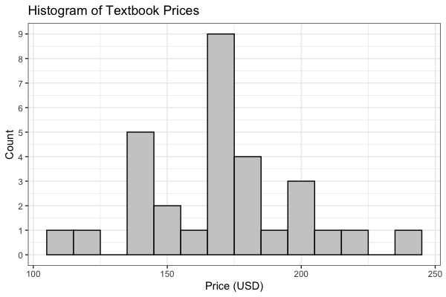

Answer the following questions to get the confidence interval.

- What is the point estimate ($\overline{x}$)?

- What is the sample standard deviation (s)?

- Are the validity conditions met?

- Calculate the 95% confidence interval.

- Interpretation: We are _____ confident that the long-run __________ price of textbooks at Winona State University is between _____ and _____.

Let’s explore what is meant by 95% confidence in this example. Check out the applet located at https://twiedrw.shinyapps.io/confidence_intervals/. Suppose we know that in the previous academic year that the population was normally distributed with an average textbook price of $150 and a population standard deviation of $35. Enter the information into the applet so that it looks like this:

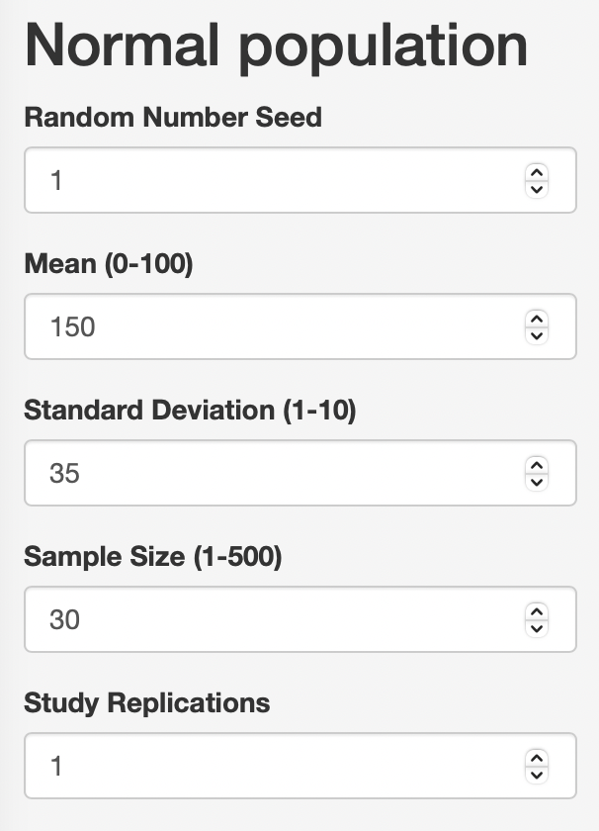

(Note: ignore the limits on the mean and standard deviation in the applet)

This applet simulates drawing random samples from a known population (a luxury that we almost never have in practice). The “Study Replications” is the number of samples that you draw from the population and calculate the confidence interval.

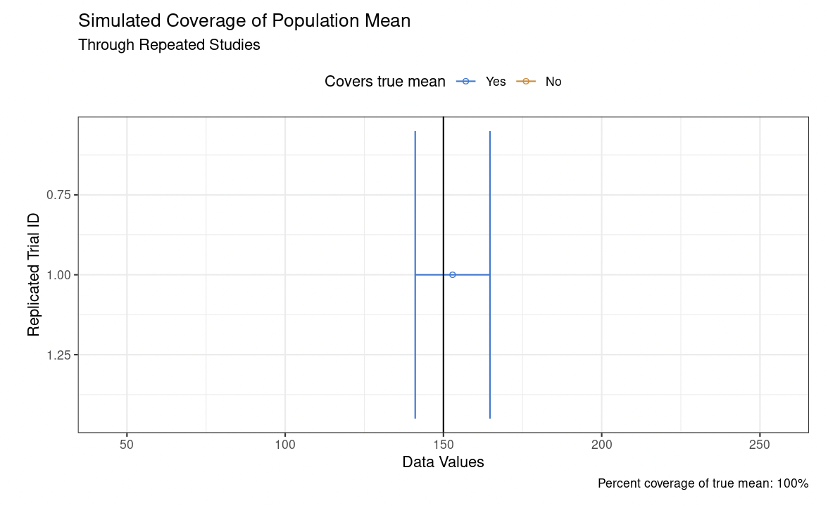

In this instance, the confidence interval calculated from the sample covered the true population mean of 150. Suppose now that we change the “Study Replications” to 5.

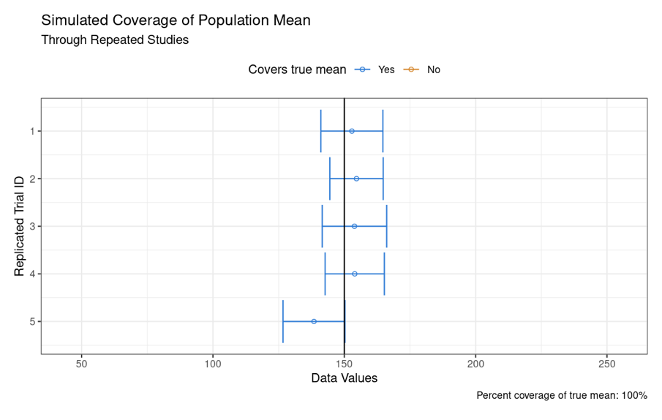

All 5 studies covered the population mean. With study #5, you can see that the confidence interval almost narrowly misses population mean, but it is still contained within the interval. Recall the technical definition of a confidence interval: $100-α*100\%$ of the confidence intervals generated from samples of a given population will cover the true parameter value. Change the number of study replications to 100.

- What percentage of the confidence intervals cover the true population mean?

- What does a single confidence interval represent?

- What happens as you increase the sample size? Does this impact the percent coverage of the true mean?

Section 3.4: Width of Confidence Intervals

Factors Influencing the Confidence Interval
There are three factors that affect the width of a confidence interval: confidence level, sample size, and standard error.

Confidence level
Significance Level + Confidence Level = _______

- Confidence Level Increases $→$ Significance Level ___________
  - Rejecting Less Often $→$ More Likely Values
  - Interval Widens

- Confidence Level Decreases $→$ Significance Level ____________
  - Rejecting More Often $→$ Fewer Likely Values
  - Interval Narrows
  - “If you want to be more confident you have to cover more values.”
- Hypothetical: what would a 100% confidence interval look like?

Sample Size
Recall what happened when increasing the sample size on the applet in Section 3.3.

Larger sample size

Smaller sample size

“Larger sample sizes make you more precise in your answer.”

Draw the relation between a large sample size and a small sample size.

Large sample size

Small sample size

Standard Error
General Formula
$$Observed Statistic ± Multiplier * Standard Error$$

Standard Error Increases
- Margin of Error Increases

Standard Error Decreases
- Margin of Error Decreases

Technical Aside
Mathematically, why do the effects of sample size and standard error make sense? Recall the standard error formulas for both proportion and means below.

One Proportion | $$SE=\sqrt{\frac{\hat{p}\left(1-\hat{p}\right)}{n}}$$
One Mean | $$SE=\frac{s}{\sqrt{n}}$$

From the general formula for the confidence interval, we know that the sample size and standard error do not affect the observed statistic or the multiplier. As the sample size increases, the denominator of the standard error increases, which decreases the value for the standard error.

- What would happen if you took an infinitely large sample size?

