Stat 801 Homework 5 Due October 31, 4:30pm
Fall 2016

- A randomized comparative experiment to investigate the effect of a plant extract on glucose levels in pre-diabetic women was conducted. The researchers wanted to see if this plant extract would cause a reduction in fasting blood glucose levels. A treatment group of 21 women received the plant extract for 12 weeks, and a control group of 21 women received a placebo during the same period. All subjects had their fasting blood glucose levels measured before and after the 12-week period and the reduction in fasting blood glucose levels was determined. The following table summarizes these reductions in fasting blood glucose levels:

Group | Treatment
1 | Plant extract | 21 | 4.0 | 16.00
2 | Placebo | 21 | 2.0 | 9.00

- State the null and alternative hypothesis symbolically.

$$H_{0}: μ_{1}-μ_{2}=0 vs H_{A}: μ_{1}-μ_{2}>0$$

- Calculate the pooled variance.

$${s_{p}}^{2}=\frac{{ (n_{1}-1)s_{1}}^{2}+{ (n_{2}-1)s_{2}}^{2}}{n_{1}+n_{2}-2}=\frac{\left(21-1\right)\left(16\right)+(21-1)(9)}{21+21-2}=12.5$$

- Find a 90%CI for the mean difference in reduction in fasting blood glucose levels between the two treatment groups.

$${\overline{x}}_{1}-{\overline{x}}_{2} =4-2=2$$
$$\sqrt{\frac{{s_{p}}^{2}}{n_{1}}+\frac{{s_{p}}^{2}}{n_{2}}}=\sqrt{\frac{12.5}{21}+\frac{12.5}{21}}=1.09$$

$$t_{\frac{α}{2},n_{1}+n_{2}-2}=t_{0.05,40}=1.684$$

${Margin of Error =t}_{\frac{α}{2},n_{1}+n_{2}-2}\sqrt{\frac{{s_{p}}^{2}}{n_{1}}+\frac{{s_{p}}^{2}}{n_{2}}}=(1.09)(1.684)$=1.84

The 90% confidence interval is 2±1.84

- In a complete sentence, state your conclusion based on the original research question.

Since the confidence interval does not contain 0, we conclude that the plant extract cause a reduction in fasting blood glucose level at alpha=0.05.

- Test to see if the two variances are equal and write a conclusion.

$H_{0}:{σ_{1}}^{2}={σ_{2}}^{2}$ vs $H_{a}:{σ_{1}}^{2}≠{σ_{2}}^{2}$

$$F=\frac{{s_{1}}^{2}}{{s_{2}}^{2}}=\frac{16}{9}=1.778$$
$$F_{0.025,20,20}=2.46, F_{0.975,20,20}=\frac{1}{F_{0.025,20,20}}=\frac{1}{2.46}=0.407$$

Since the F statistics is between the two critical values, we fail to reject the null hypothesis at alpha=0.05, and conclude that the two variances are equal.

- In the context of the above question, the same researchers further investigated the effect of this plant extract on glucose levels in different groups of patients: pre-diabetic women, Type I diabetic women, and Type II diabetic women. They wanted to see if the effect of this plant extract would differ on these subgroups of diabetic patients. In this study, all patients received the treatment of plant extract, and their fasting blood glucose level was measured before and after the 12-week period of treatment. The following table summarizes the reductions in fasting blood glucose levels:

Group
Pre diabetic | 21 | 4 | 16.00
Type I diabetic | 20 | 2.5 | 10.00
Type II diabetic | 22 | 2.5 | 10.00

- State the null and alternative hypothesis symbolically.

Let $μ_{1}, μ_{2}, and μ_{3}$ be the population means of the Pre diabetic, Type I diabetic and Type II diabetic groups, respectively.
$$H_{0}: μ_{1}= μ_{2}= μ_{3} vs H_{A}: at least one inequality$$

- Fill in the following ANOVA Table.
Source | Df | SS | MS | F
Treatment | 2 | 31.5 | 15.75 | 1.3125
Error | 60 | 720 | 12 | -----
Total | 62 | 751.5 | ----- | -----
- Based on your results and an α=0.05, circle the correct F value you need to use to compare your calculated F
$$F_{0.05,3,63}=2.76, F_{0.05,2,60}=3.15, F_{0.05,2,57}=3.16, F_{0.05,2,63}=3.14.$$
- Based on your results what can you conclude based on the researchers’ original question?
Since the F statistics is smaller than the critical value, we conclude that the plant extract has no difference in its effect on fasting blood glucose level reductions among different groups of patients.

- In fact, you can complete the ANOVA table without the Treatment SS and Error SS given by the instructions, because you can compute them from the summary statistics of the reductions of fasting glucose levels given in this question. Please work out the math, and show how you would do it.
The overall mean of all samples $\overline{y}=\frac{21*4+20*2.5+22*2.5}{21+20+22}=3$
$$Treatment SS=\sum_{i=1}^{3}{n_{i}{\left({\overline{y}}_{i.}-\overline{y}\right)}^{2}=}21{\left(4-3\right)}^{2}+20{\left(2.5-3\right)}^{2}+22{\left(2.5-3\right)}^{2}=31.5$$
$$Error SS=\sum_{i=1}^{3}{\sum_{j=1}^{n_{i}}{{\left(y_{ij}-{\overline{y}}_{i.}\right)}^{2}}=\sum_{i=1}^{3}{(n_{i}-1)s_{i}^{2}}=}20*16+19*10+21*10=720$$
Then I can fill the rest of the ANOVA table as I did before.

- Four specimens of each of five brands of denim material used in making blue jeans are subjected to a friction test. A measure of wear is determined for each specimen. The manufacturer wants to know if there are differences among the materials in how they wear. The lower the friction test, the better the wear. The following table presents the results

ACME | CHAMP | AJAX | TUFFY | XTRA
2.3 | 2.2 | 2.2 | 2.4 | 2.3
2.1 | 2.3 | 2.0 | 2.7 | 2.5
2.4 | 2.4 | 2.3 | 2.6 | 2.3
2.5 | 2.6 | 2.1 | 2.3 | 2.4

- State the null and alternative hypothesis symbolically

Let $μ_{1}, μ_{2}, μ_{3}, μ_{4} and μ_{5}$ be the population means of the ACME, CHAMP, AJAX, TUFFY and XTRA brands, respectively.
$$H_{0}: μ_{1}= μ_{2}= μ_{3}= μ_{4}= μ_{5} vs H_{A}: at least one inequality$$

- By hand, draw a dot plot of the data. Looking at the dot plot, do you think there may be differences among the 5 materials in how they wear?

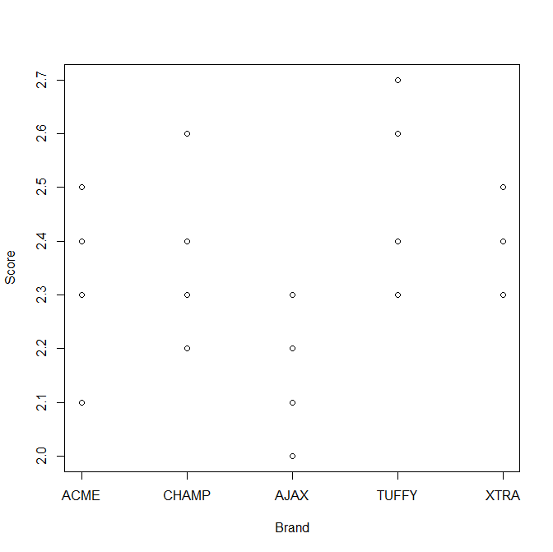
It seems that there are no significant differences among the five brands.
Note: you can also say that there may be some differences among them.

- Fill in the following ANOVA Table.

Source | Df | SS | MS | F
Treatment | 4 | 0.257000 | 0.06425 | 2.734
Error | 15 | 0.352500 | 0.0235 | -----
Total | 19 | 0.6095 | ----- | -----
- Based on your results and an α=0.05, circle the correct F value you need to use to compare your calculated F
$$F_{0.05,4,20}=2.866, F_{0.025,4,20}=3.515, F_{0.05,4,15}=3.056, F_{0.05,5,15}=2.901$$
- Based on your results what can you conclude based on the manufacturer’s original question?
Since the F statistic is smaller than the critical value, we fail to reject the null, and conclude that there is no difference in friction test score among these five brands.
- Based on the data, create an ANOVA table using software. Please attach your output.
R code I used to produce the output:
setwd("C:\\Users\\howardr\\Documents\\Stat801\\Fall_2016\\Assignments\\Homework\\hw5")
data<-read.csv("problem3_data.csv")
attach(data)
fit = lm(Friction ~ as.factor(Material))
anova(fit)
R output:
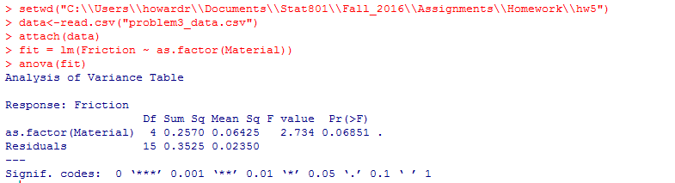

4. A food scientist wants to compare the variability of two ground beef packaging machines. Machine A is the older of the two and will be replaced if it has a variance larger than the variance of machine B. Because of the extra cost of a new machine, the most expensive error is to erroneously conclude machine A's variance is larger than machine B's. Eight ground beef packages are randomly sampled from a daily production run of each of the machines. The sample variances are:

S_{A}² = 37.3 S_{B}² = 24.2 .

- Test the most appropriate hypothesis at the .01 level of significance, explicitly following the steps of testing a statistical hypothesis.

Since we want to know if Machine A is more variable than Machine B, our null hypothesis is
H₀ : σ²_{A} ≤ σ²_{B} and our alternative hypothesis is H_{A} :σ²_{A} > σ²_{B}, where σ²_{A} and σ²_{B} are the variances of Machines A and B estimated by sample variances s²_{A} = 37.3 and s²_{B} = 24.2, respectively. This is a one-tailed test using the F distribution with numerator and denominator degrees of freedom df_{A} = n_{A}−1 = 8−1 = 7 and df_{B} = n_{B}−1 = 8−1 = 7, respectively. We are assuming that both machines have normal packing distributions.
Our test statistic is F =s²_{A}/ s²_{B}=37.3 24.2 ≈ 1.5413. The critical value of F_{α},_{dfA,dfB} = F_{0.01,7,7} = 6.993 is much larger than our calculated test statistic of F ≈ 1.5413, so we fail to reject at the α = 0.01 level of signiﬁcance. Moreover, the p-value associated with the observed test statistic F ≈ 1.5413 is 0.2912, which again leads us to fail to reject at the α = 0.01 level of signiﬁcance. That is, we fail to reject the null hypothesis that Machine A’s variance is larger than Machine B’s variance. We do not ﬁnd a signiﬁcant diﬀerence between the variances of Machine A and Machine B at the cautious α = 0.01 level of signiﬁcance.

b. BONUS QUESTION Assume the food scientist will reject the null hypothesis if the ratio of the two sample variances (S_{A}²/S_{B}² ) is larger than two. Approximately how many packages should be sampled from each machine if the food scientist wants to be sure that α is no more than .05? Assume equal sample sizes.

If the critical level of F =s²_{A}/s²_{B}= 2 can be no more than α = 0.05, then the numerator and denominator degrees of freedom must be df_{A} = df_{B} = 24, assuming equal sample sizes and thus equal degrees of freedom. Since the degrees of freedom are n−1, where n is the sample size from each machine, then n−1 = 24 means that we need a sample size of at least 25 ground beef packages. Therefore, approximately 25 packages should be sampled from each machine if the food scientist wants to be sure that α is no more than 0.05 and we assume equal sample sizes.

