2. In an investigation of the properties of synthetic rubber, 10 varying compounds were prepared which had varying levels of hardness. These compounds with varying hardness were then tested for abrasion loss. The investigator was interested in seeing if there was a linear relationship between the hardness of the compound and the loss. The following data were collected:

Hardness (x): 45 55 61 66 71 71 81 86 53 60
Abrasion loss (y): 372 206 175 154 136 112 55 45 221 166

The following summary statistics were calculated from these data:

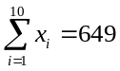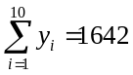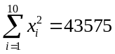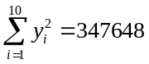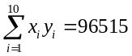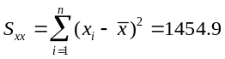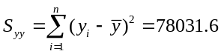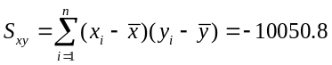

- Estimate the slope coefficient (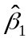)

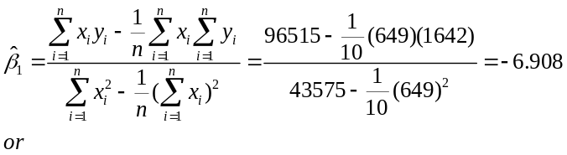
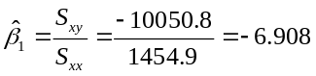
- Estimate the intercept (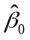)

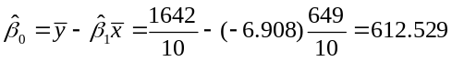
- Test the 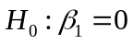 versus 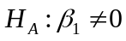 at alpha=0.05

First need to calculate the MSE. I realized that I didn’t stress how to use the easy formula for this, only the “theoretical” one.
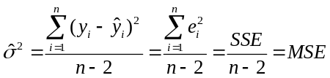
The easy formula, as many of you discovered is on the bottom of page 134, under the table of Inferences related to regression
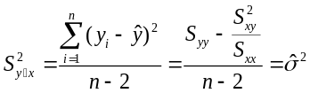
is the other way to calculate MSE
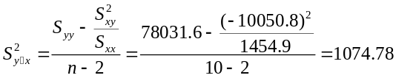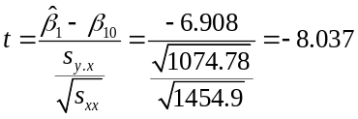
Compare to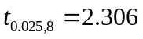 Reject the null hypothesis.

- What can the researcher conclude?
The investigator can conclude that there is a negative linear relationship between the hardness of the compound and the loss. For each unit increase in hardness, there is an 8 unit decrease (or loss) due to abrasion.

