Purpose of this document to enable users create basic dashboard using Kibana that is packaged with Velocity.

Prior to creation of dashboards, appropriate configuration is necessary on velocity and iTE. Please look at screen shots in Configuration section and configure your instances accordingly.

**Configuration:**

Enable Elastic search indexing in Velocity:

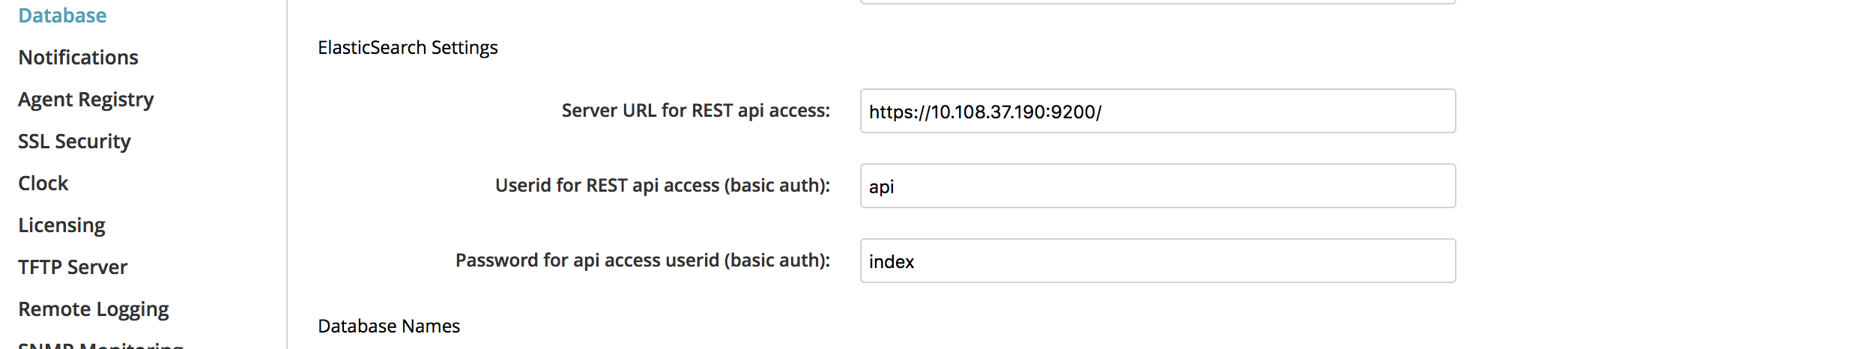

Enable Elastic search in Team Essentials:

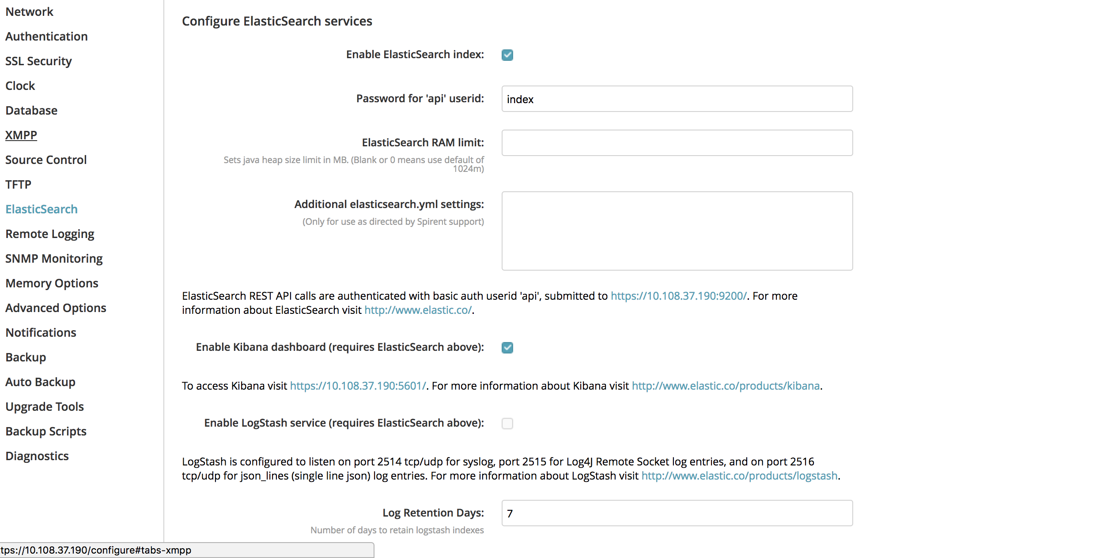

User needs to have data in the database for indexing purposes. Following section gives you an idea of what type of tests you should develop for their results to showup in dashboard. This is only a sample. You can use existing tests and can create dashboards out of the results generated by the execution of those tests.

**Script Creation:**

1. Create CheckInterfaces.fftc and create an analysis rule for Pass
2. Create CheckVersion.fftc and create an analysis rule for Fail.
3. Create CheckRegister.fftc and create an analysis rule for Indeterminate.

Scripts mentioned above need not have any logic but a basic pass/fail criteria to create dashboard.

**Agents:**

1. Verify functionality of execution agents (appropriately queuing and executing velocity requests)

Execution:

Schedule Test execution of above created scripts 10 times (at least, can be more).

**Creation of Dashboards:**

Creating a dashboard involves

1. Adding appropriate index
2. Creating Visualization
3. Creating Dashboard using visualization.

Adding appropriate index:

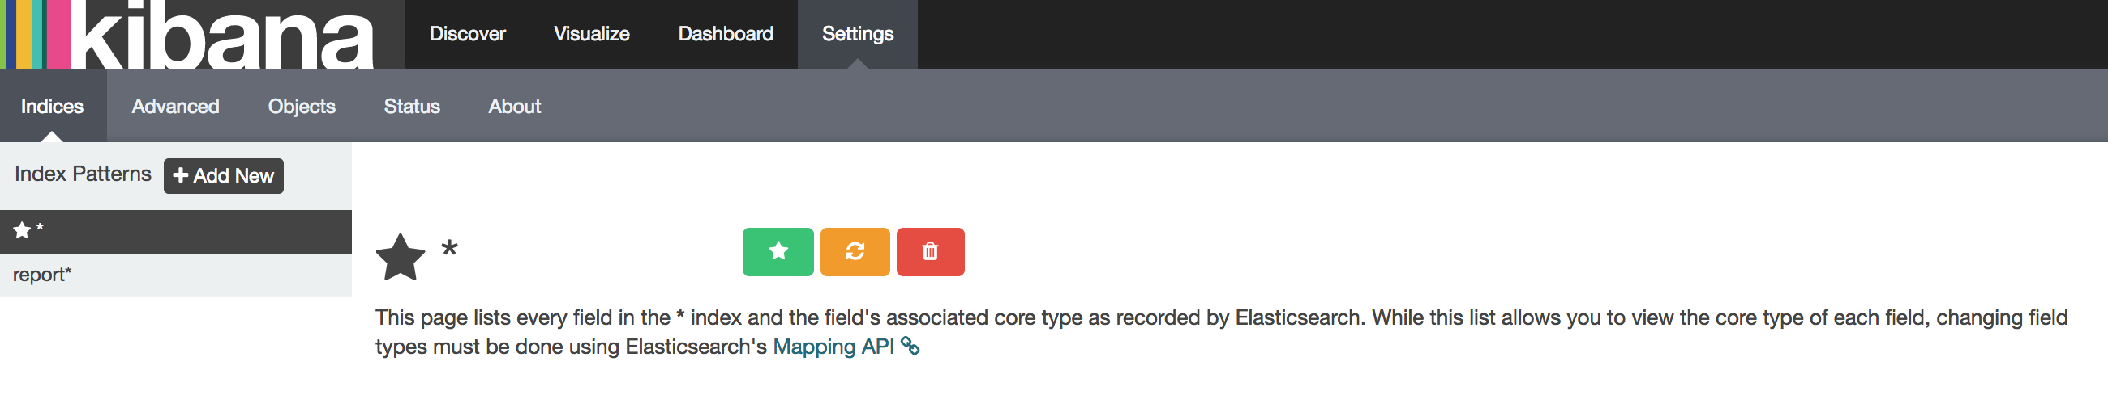

1. As shown in the snapshot above, please click on settings.
2. In the left frame, click on “Add New”
3. In the index name or pattern, type *. As soon as you type *, you will get to select time-field name (you can select createTime)
4. Click on Create (see snapshot below)
5. Click on “Set as default” index for the above created index.

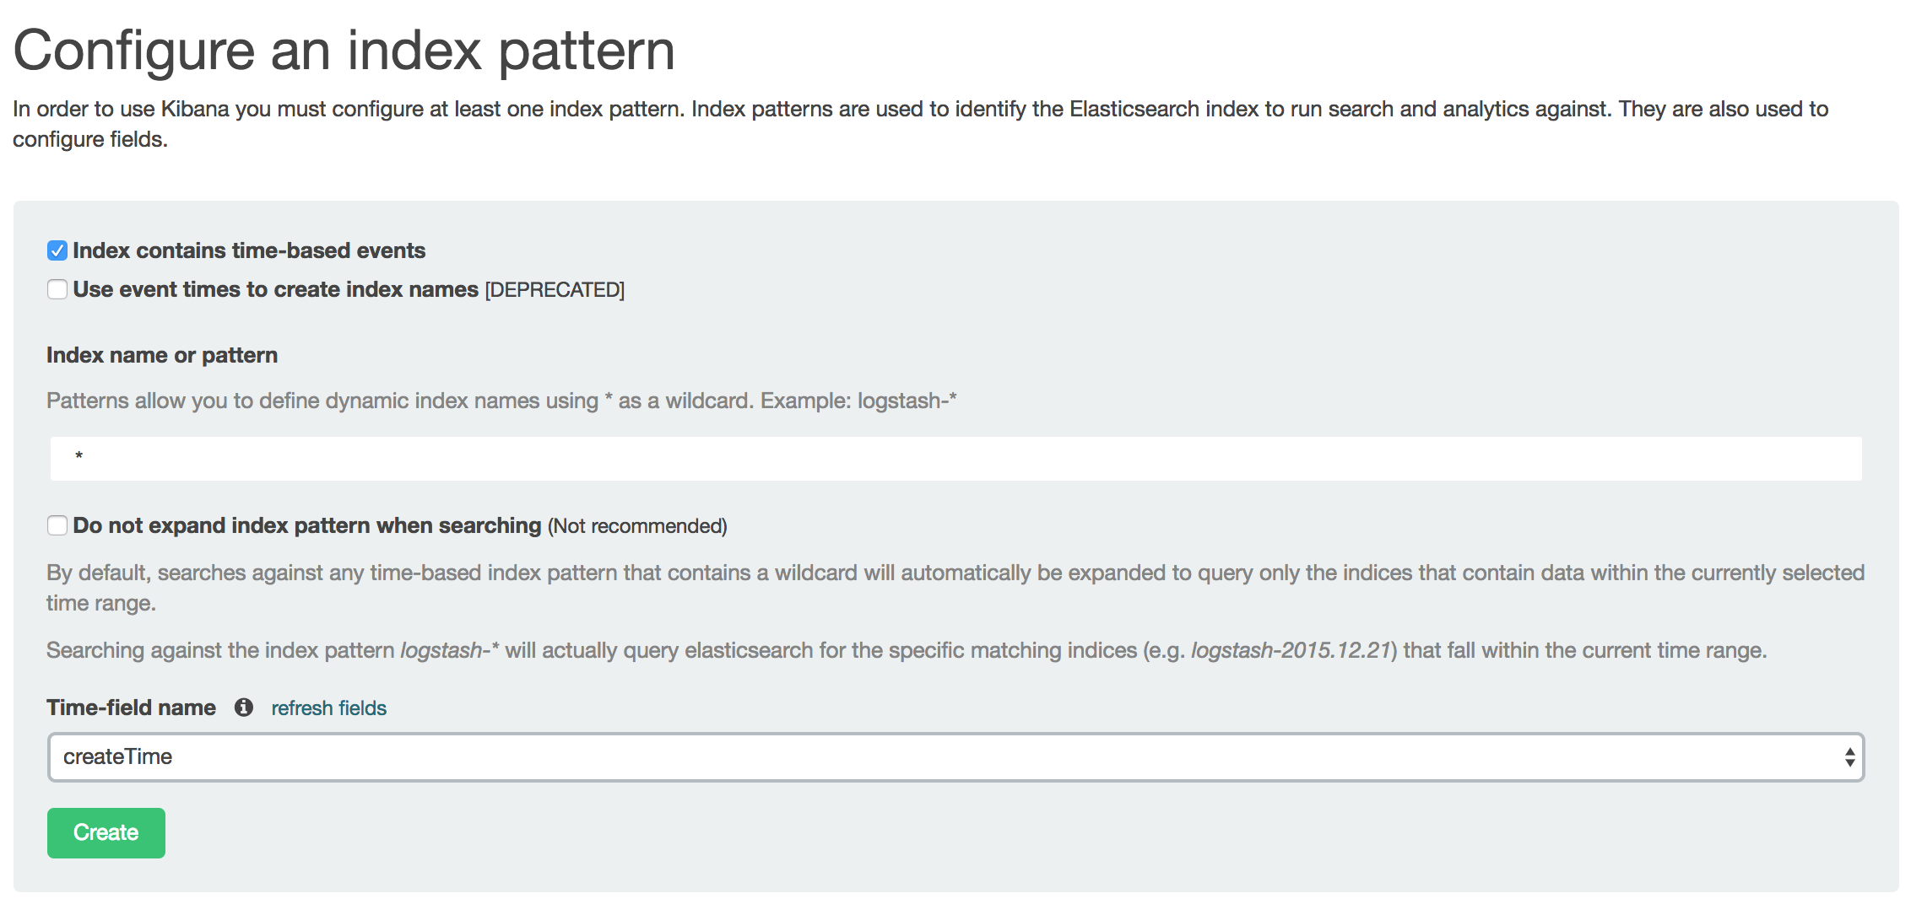

Creating Pie Chart Visualization:

Creating visualization is to create histograms/pie charts by using the elastic search index described above.

1. Click on Visualize tab on the top of the page.
2. Click on Pie chart (under Create a new visualization section)
3. You will go to next page, select a search source – from a new search.
4. Select an index pattern (*) – created in earlier section
5. Select split slices
   1. Under Aggregation (drop down list), select Terms
   2. Under Field, select “result” from drop down list
   3. Select metric:Count under Order By
   4. Click on Play button on top
6. As soon as you click on play button on top, you will see pie chart on the right hand side.
7. Click on “Save visualization” button on the right top corner and give it a name.

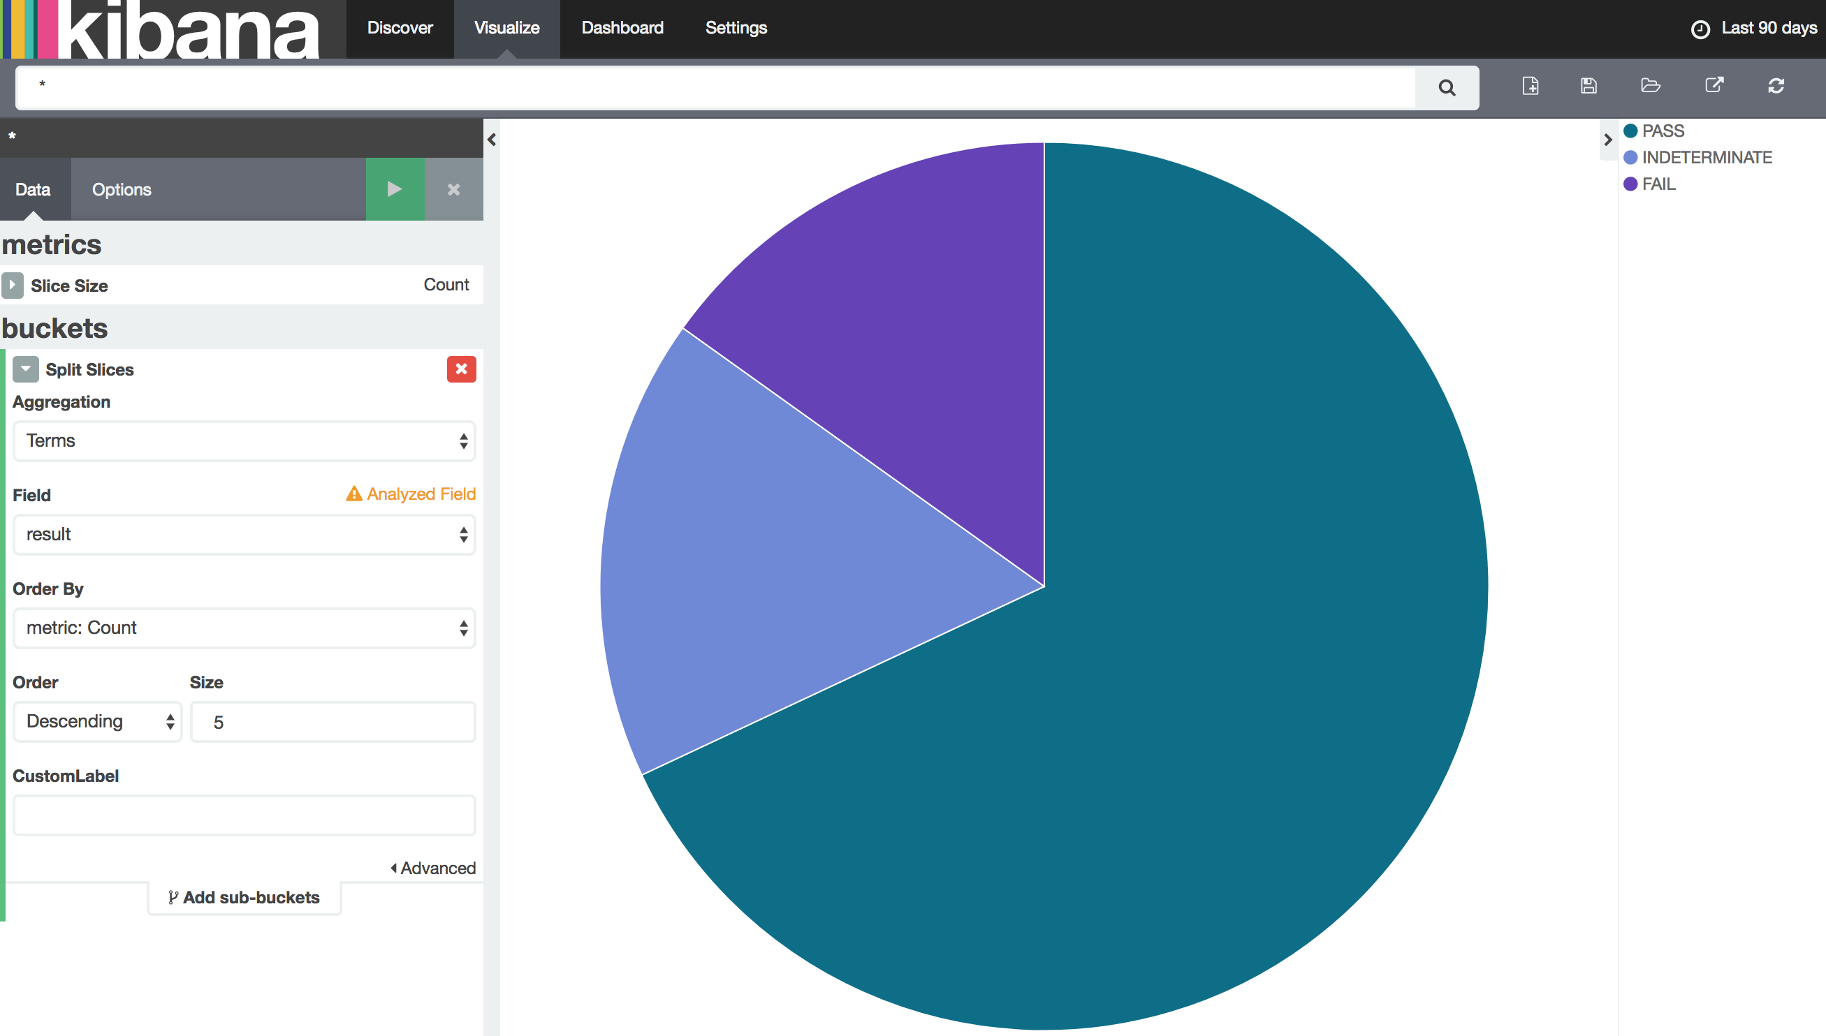

Creating Area chart Visualization:

1. Click on Visualize tab on the top of the page.
2. Click on Area Chart (under Create a new visualization section)
3. You will go to next page, select a search source – from a new search.
4. Select an index pattern (*) – created in earlier section
5. Under buckets, click on X-Axis
   1. Select Terms from drop down list for Aggregation
   2. Select result from drop down list for Field
   3. Select Term from drop down list for Order By
   4. Select Descending order and by size 5
   5. Click on green play button on top, you will see area chart in right frame
6. Save the Visualization with any given name.

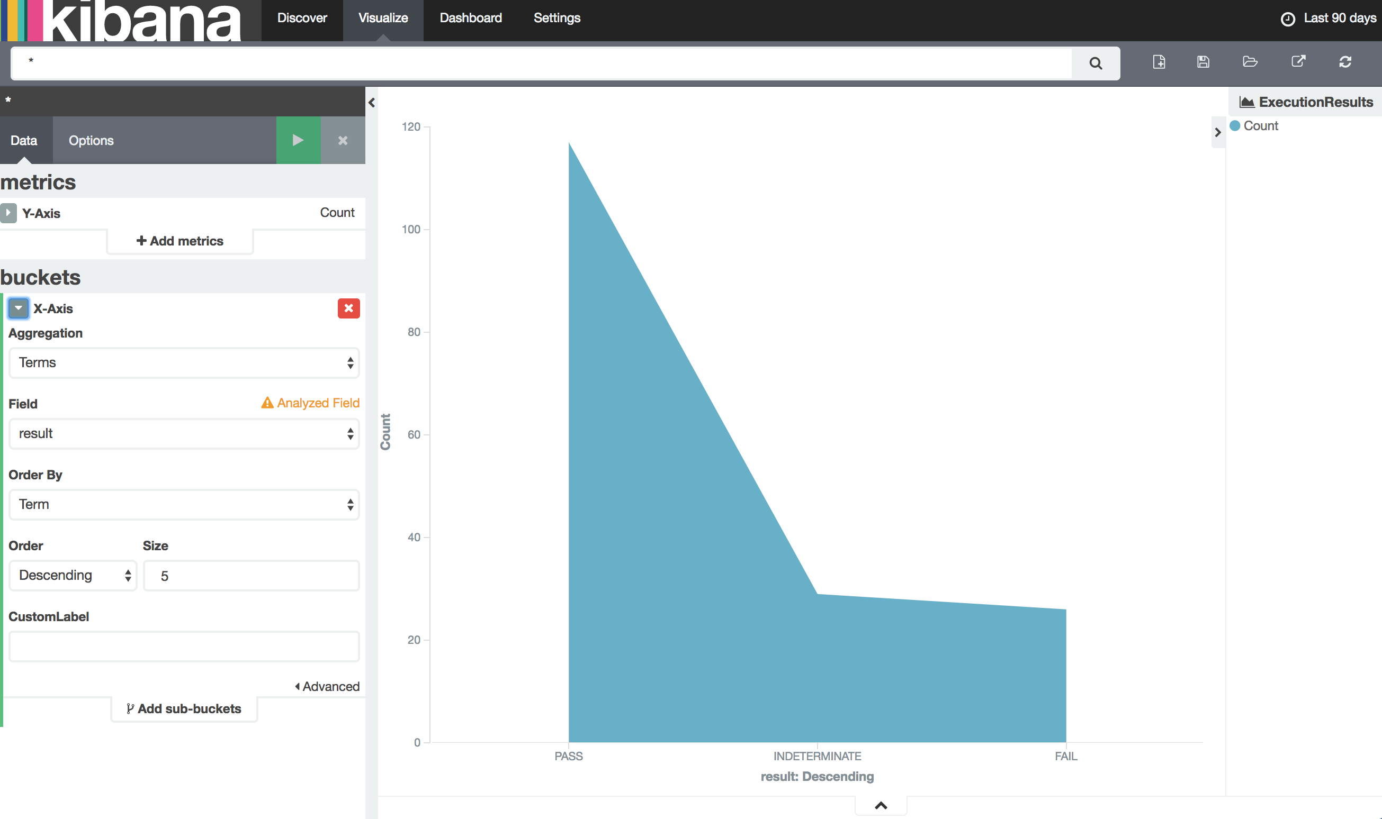

Creation of histogram visualization:

1. Click on Visualize tab on the top of the page.
2. Click on Histogram (under Create a new visualization section)
3. You will go to next page, select a search source – from a new search.
4. Select an index pattern (*) – created in earlier section
5. Under buckets, click on X-Axis
   1. Select “Date Histogram” from drop down list for Aggregation
   2. Select startTime from drop down list for Field
   3. Select Auto from drop down list for Interval
6. Click on green play button at top
7. On right hand frame, you will see histogram.
8. Save the visualization with any given name.

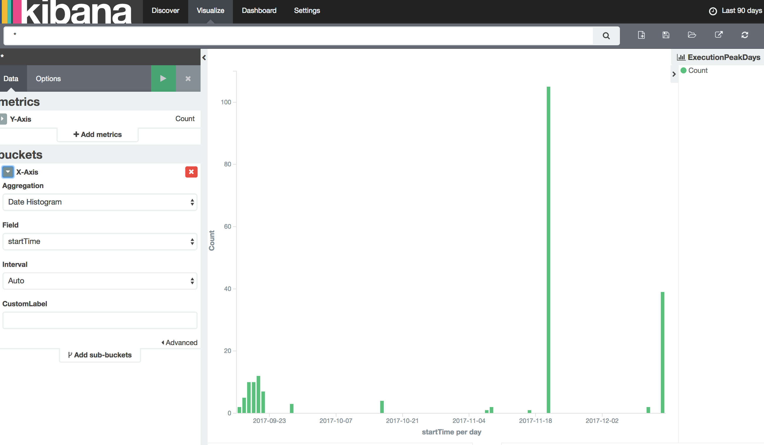

Creation of Dashboard by using visualizations:

Click on “New Dashboard” on the right hand top corner icons.

Click on + sign and you will see all visualizations you have created earlier.

Click on visualization. Visualization will appear at the bottom part of the browser window. Resize it if you do not see graphs.

Select visualizations as per your needs and save the dashboard.

Once you save the dashboard, you can select for what time frame you would like to see the dashboard populated. You can select time frame on top right hand corner.

