**Defining the problem:**

The [World Health Organisation has reworked their guidelines](https://www.moneycontrol.com/news/photos/environment/who-issued-new-air-quality-guidelines-take-a-look-7505231.html) for annual emissions of pollutants:

1. PM 2.5 - 5μg/m³
2. PM 10 - 15μg/m³
3. NO2 - 10μg/m³

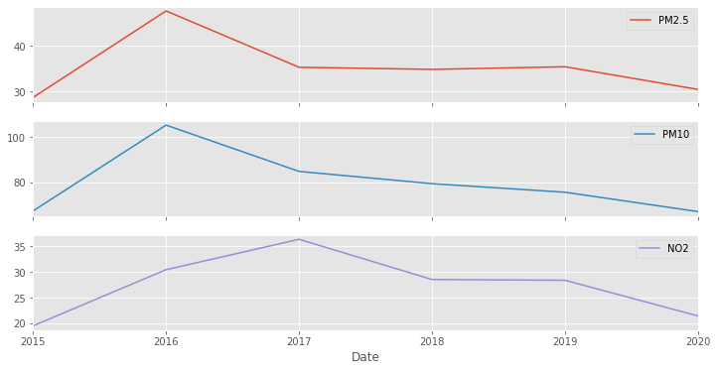

Figure 1: Bangalore Struggles to Meet the WHO Guidelines.

Bangalore has struggled to adhere to these guidelines from 2015 – 2020, and as a consequence, [last year alone, 12,000 lives were lost to air pollution](https://www.thehindu.com/news/cities/bangalore/air-pollution-led-to-12000-deaths-in-bengaluru-last-year/article33874517.ece). However, massive strides in the right direction were observed during the COVID lockdowns. The idea behind this analysis, is to look at the COVID-19 lockdowns for hints/takeaways to help better the air pollution problem in Bangalore.

**Summary of Solution:**

To dig deeper into the impact of COVID-19 lockdowns on air quality, it was treated as an experimental setup – one where pre-pandemic could be viewed as the control group, and post pandemic could be seen as the test-group.

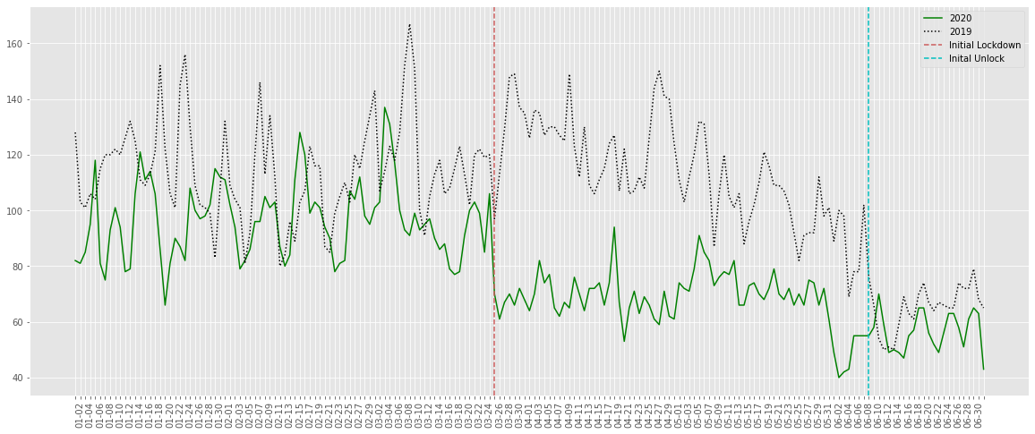

Figure 2: Dramatic Improvement in Air Quality Was Observed During the Lockdown when Compared to 2019.

First, it was important to assess whether or not the pandemic actually had a significant impact on air quality. For this, hypothesis testing was conducted to deduce whether there was a statistically significant change in air pollution during the lockdowns. The details of the test were as follows:

* **Null Hypothesis:** There is no statistically significant difference between the average AQI during the lockdown period in 2020 and the same time period in 2019.
* **Test:** One-way Analysis of Variance (ANOVA).
* **α:** 0.05.
* **Outcome:** The null hypothesis was rejected with a p-value of 2.7 * 10⁻²⁷.

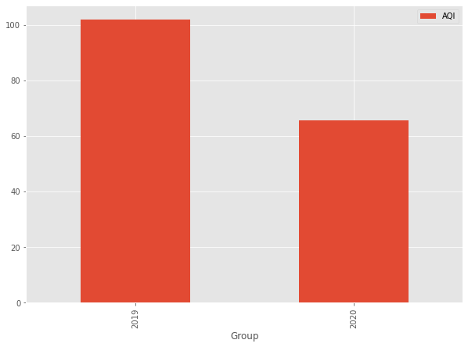

Figure 3: Mean of AQI from Mar-June in 2019 vs 2020.

Next, to be able to derive actionable insight from the lockdowns, it was crucial to break down the causes of the previously observed improvement in air quality. Some problems with this were:

1. The lockdown was an extreme event, so actionable insight would require a degree of reproducibility outside of the bounds of the pandemic.
2. The lockdown was also a vast event, which included things such as shutting/limiting economic activity and domestic transport, which are traits that are tough to find data on/analyse.

To address the latter of these issues, we dive into satellite image data and more specifically, night-time lights data. This data is derived from the remote sensing of night-time lights, and these lights can be from various sources, but due to the wavelength at which the data is recorded, one of the most prominent sources that is collected is human-made lights, which makes this a good indicator of economic activity, transportation and population during a given time.

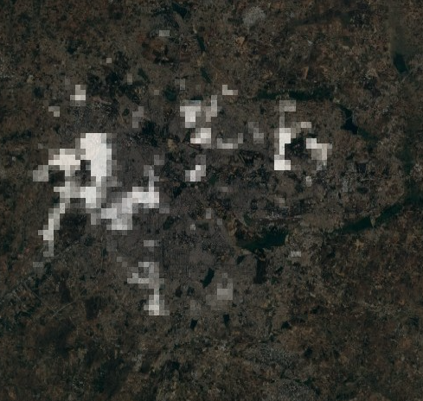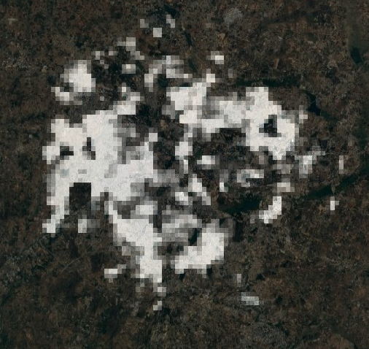

Figure 4: Change in Night Time Lights from Feb to May 2020.

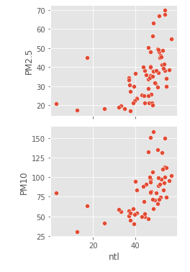The specific dataset used for this analysis was the VIIRS-DNB night-light data since it has better spatial and temporal resolution than its open-source alternatives. Google’s Earth Engine module and GEEMap were used to visualise and analyse this data. Further, Bangalore’s urban boundaries were derived and used for this analysis with the help of [this tutorial](https://courses.spatialthoughts.com/end-to-end-gee.html) by Ujaval Gandhi.

The average radiance of Bangalore’s night-time lights was calculated for a clipping of its urban boundaries for each month from March 2015 to July 2020 and it was measured against a monthly average of AQI, PM 2.5 and PM 10 levels during the same time period. This analysis showed prominent rank correlation with particulate matter ejections, i.e, 64% with PM 2.5 and 66% with PM 10 and based on Figure 5, it was observed that particulate matter levels drop drastically when the average radiance goes from 50+ to ~40 and that reaching its pandemic-low of <10 is not a necessity to see a sharp drop in particulate matter emissions. During 2020 alone, night-time lights displayed a rank (Spearman) correlation of 96% with AQI and PM 10, and 100% with PM 2.5.

This provides opportunity in both individual action and ESG implementation that can be explored to better utilize resources to reduce particulate matter emissions and trend in a direction that is more in line with the guidelines republished by the WHO.

Figure 5: Correlation of Night Time Lights with Pm2.5 and PM10 Emission.

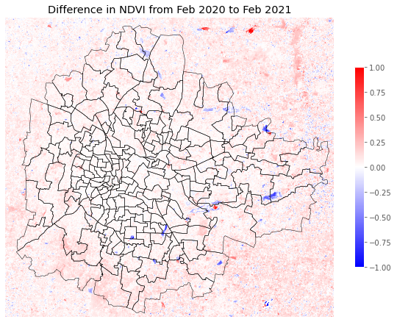Along with night-time lights, urban vegetation was also analysed, this is because there is [historical evidence](https://storymaps.arcgis.com/stories/733157be098144b7af2a591460bb6c00) of industrialization and urbanization leading to a loss of photosynthetic resources and [the importance of said resources](https://climate.nasa.gov/news/3043/study-urban-greenery-plays-a-surprising-role-in-greenhouse-gas-emissions/) in balancing the pollutants in our ecosystem. To do this, multispectral Sentinel-2 Satellite Imagery was sourced from [Sentinel Hub’s EO Browser](https://apps.sentinel-hub.com/eo-browser/) and a metric called Normalized Difference Vegetation Index (NDVI) was generated by dividing the difference of the Near Infrared and Red bands by their sum. More information on NDVI can be found [here](https://www.sciencedirect.com/topics/earth-and-planetary-sciences/normalized-difference-vegetation-index).

Figure 6 showcases the difference in NDVI between Feb 2020 and Feb 2021. Visually, it is apparent that the surface vegetation of Bangalore increased a fair amount, when analysed further it was revealed that the average NDVI of the raster increased by ~6%, as against approximately -2% and +1% in the previous two years. This tells us that COVID likely had a massive impact on the increase in vegetation due to curbed industrialization.

Figure 6: Difference in NDVI between Feb 2020 to Feb 2021.

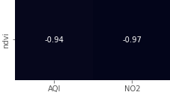When looking at the mean NDVI of given rasters and their corresponding average Air Quality and Nitrogen Dioxide levels for the month of February in the years 2018 to 2021, we see that the values are extremely linearly (Pearson) inversely correlated at -97% correlation between mean NDVI and NO2, and -94% between mean NDVI and Air Quality Index. This provides another avenue for exploration, especially in a City like Bangalore where decaying of vegetation due to poor rainfall is rarely an issue, in terms of individual efforts at maintaining a greener city and even more in terms of governance efforts in reforestation.

Figure 7: Correlation between NDVI and AQI, NO2.

**Key Takeaways:**

1. **The Problem:** The WHO has published new guidelines for PM 2.5, PM 10 and NO2 annual emissions that Bangalore currently falls far short on.
2. **The Solution:**
   1. **Can this problem be fixed?**

Through hypothesis testing, we found that in conditions such as the covid-19 lockdown, the air quality conditions can be improved drastically within the City, so yes, there are possible, albeit extreme, ways to tackle this problem.

* 1. **Can it be fixed in a non-extreme setting such as a lockdown?**

**PM 2.5 and PM 10:** With the use of night-light data, we saw that while the massive changes of the pandemic had a massive positive impact, even smaller changes in economic activity can lead to exponential improvements in particulate matter emissions.

**Nitrogen Dioxide:** Further, when urban vegetation data was used, it was seen that the NDVI has an almost entirely linear negative correlation with air quality index and nitrogen dioxide emissions. This opens the door to the possibility that with active efforts to improve urban vegetation air quality can also be improved.

1. **Some Suggestions:**
   1. **Based on night-time lights data:**
      * Modifying our means of transport, including carpooling and switching to cycles/electric vehicles.
      * Increasing the ratio of remote jobs to curb the explosive population growth of Bangalore due to an influx of working professionals (while also curbing mandatory travel).
      * Working on restoring the large water-bodies of Bangalore (since Water Bodies reflect less light, they also correlate with the ratio of night-time lights).
   2. **Based on NDVI:**
      * Preserving hyperlocal vegetation such as parks and gardens. This also carries with it the cultural value of Bangalore's image as the 'Garden City'.
      * Supporting NGOs in stopping large scale deforestation projects.
      * Supporting other corporations that have reforestation programs.
      * Cultivating personal plant-life, since any step (done by enough people) pushees things in the right direction.

**Use of Geospatial Data:**

This analysis uses mainly two types of Geospatial Data:

1. The Visible Infrared Imaging Radiometer Suite – Day/Night Band Dataset (VIIRS – DNB) was used to obtain night-time light sensing data and it was used to understand the impact of covid-19 on urbanization, industrialization and transportation. Further, it was used to assess how changes in night-time lights, both large and small, affect air quality and particle matter. The data was sourced from Google’s Earth Engine module.
2. Band 4 (Red) and Band 8 (Near Infrared) from the Sentinel-2 L2A Satellite Images were used to calculate NDVI for Bangalore from 2018 – 2021. The images were procured using Sentinel Hub’s EO Browser, and were used to explore the impact of COVID-19 on Bangalore’s vegetation. Further, strong correlation was found between NDVI and air quality, and also nitrogen dioxide.

**Scope for Improvement:**

1. **Data:**
   1. The temporal resolution of the data can be improved to understand more granular changes and relationships. This is especially true with the Sentinel-2 data, as the current analysis carries the caveat of having only 4 samples due to the size of raster files and the fact that Bangalore has very high cloud coverage from May through November.
   2. Using an API could have given us more updated data for AQI and pollutants, in its current version the data for Feb 2021 had to be manually collected and averaged from the CPCB website, which itself has a lot of issues and missing data.
   3. More external data (population data, economic data, traffic data) could have been utilized.
2. **Methodology:**
   1. The narrative here relies on some assumptions, especially in the use of night-time lights data, and while a lot of the ground truths play into the narrative, it is difficult to claim them with statistical confidence. This could be mitigated with the introduction of the aforementioned external data or by running additional hypothesis tests.
   2. The argument of correlation vs causation has scope to be better delineated. Alternatively, more robust statistical methods than correlation could have been used in conjunction with the geospatial data.