

NATIONAL AND KAPODISTRIAN UNIVERSITY OF ATHENS

SCHOOL OF SCIENCE
DEPARTMENT OF INFORMATICS AND TELECOMMUNICATION

BSc THESIS

Fake News Detection on news articles using Machine Learning Techniques

Stavroula G. Iatropoulou

Supervisor: | Alexandros Ntoulas, Assistant Professor

ATHENS

JULY 2020
BSc THESIS

Fake News Detection on news articles using Machine Learning Techniques

Stavroula G. Iatropoulou
S.N.: 1115201500048

SUPERVISOR: | Alexandros Ntoulas, Assistant Professor

ABSTRACT
In the recent years a widespread proliferation of fake and fabricated content has been witnessed among various online web platforms, leading to the formation of a distorted and most of the times manipulated public opinion towards political, social or other everyday issues. Therefore, there have been many efforts to develop fake news detection systems to contribute in the unveiling and debunking of deceptive news.

In this thesis we will be working on three different fake news datasets, trying to spot the linguistic differences between fake and truthful articles providing a visualization of the results. The aim of the project is to compare five different machine learning classifiers as well as to develop an ensemble method of different combinations of classification models to investigate which gives best universal results for all three data sources.

The methodology that is followed in this project starts with applying natural language processing and feature extraction techniques which aim to prepare the data to be “fed” into each classification model for training and tuning parameters for each classifier. The results are then presented and compared using confusion matrices and precision–recall curves.

SUBJECT AREA: Machine Learning, Data Mining, Data Visualization
KEYWORDS: fake news detection, natural language processing, classification model
ΠΕΡΙΛΗΨΗ

Τα τελευταία χρόνια παρατηρείται εκτεταμένη διάδοση ψευδούς και κατασκευασμένου περιεχομένου μεταξύ διαφόρων διαδικτυακών πλατφορμών διαδικτύου, με αποτέλεσμα τη διαμόρφωση διαστρεβλωμένης και συχνά χειραγωγούμενης κοινής γνώμης σε πολιτικά, κοινωνικά ή άλλα καθημερινά θέματα. Ως εκ τούτου, έχουν καταβληθεί πολλές προσπάθειες για την ανάπτυξη συστημάτων ανίχνευσης ψευδών ειδήσεων για να συμβάλλουν στην αποκάλυψη και στην κατάρριψη παραπλανητικών ειδήσεων.

Σε αυτή την πτυχιακή εργασία θα δουλέψουμε πάνω σε τρία διαφορετικά σύνολα δεδομένων ψευδών ειδήσεων, προσπαθώντας να εντοπίσουμε τις γλωσσικές διαφορές ανάμεσα σε ψευδή και αληθή άρθρα, παρέχοντας μια απεικόνιση των αποτελεσμάτων. Σκοπός της εργασίας είναι η σύγκριση πέντε διαφορετικών ταξινομητών μηχανικής μάθησης, καθώς και η ανάπτυξη μιας μεθόδου συνόλου διαφορετικών συνδυασμών μοντέλων ταξινόμησης για να εξετάσουμε ποια δίνουν τα καλύτερα γενικά αποτελέσματα και για τις τρεις πηγές δεδομένων.

Η μεθοδολογία που ακολουθείται σε αυτή την εργασία αρχίζει με την εφαρμογή τεχνικών επεξεργασίας φυσικής γλώσσας και τεχνικών εξαγωγής χαρακτηριστικών που στοχεύουν στην προετοιμασία των δεδομένων τα οποία πρόκειται να “τροφοδοτηθούν” σε κάθε μοντέλο ταξινόμησης για την εκπαίδευση και την ρύθμιση παραμέτρων για κάθε ταξινομητή. Τα αποτελέσματα παρουσιάζονται στη συνέχεια και συγκρίνονται χρησιμοποιώντας πίνακες σύγχυσης και καμπύλες ακριβείας - ανάκτησης.

ΘΕΜΑΤΙΚΗ ΠΕΡΙΟΧΗ: Μηχανική Μάθηση, Εξόρυξη Δεδομένων, Οπτικοποίηση Δεδομένων
ΛΕΞΕΙΣ ΚΛΕΙΔΙΑ: εντοπισμός ψευδών ειδήσεων, επεξεργασία φυσικής γλώσσας, μοντέλο κατηγοριοποίησης

To my family.

ACKNOWLEDGMENTS
I would like to thank my supervisor, Prof. Alexandros Ntoulas, for giving me the opportunity to work on this subject and helping me with his guidance and useful advice on obstacles that came up while implementing this thesis.

CONTENTS

PREFACE 12
1. INTRODUCTION 14
1.1 Problem/Topic Definition 14
1.2 Importance of problem/Challenges 13
1.3 Related Work 13
1.4 Objective 13
2. DATASETS 20
2.1 ISOT Fake News Dataset 20
2.1.1 Description 20
2.1.2 Data Visualization 20
2.2 Fake News Net Dataset 21
2.2.1 Gossipcop Dataset 20
2.2.2 Gossipcop Data Visualization 20
2.2.3 Politifact Dataset 20
2.2.4 Politifact Data Visualization 20
2.3 Data Preprocessing 21
2.3.1 Tokenization and cleaning 21
2.3.2 Stemming 21
2.4 Features Extraction 22
2.4.1 TF-IDF 22
2.4.2 Singular Value Decomposition 22
3. ALGORITHMS/CLASSIFIERS 23
3.1 Support Vector Machines 23
3.2 K-Nearest Neighbours 23
3.3 Logistic Regression 23
3.4 Decision Trees 23
3.5 Random Forest 23
3.6 Ensemble Classifier 23
4. EXPERIMENTS 24
4.1 Tuning Classifiers 24
4.2 Results for each Dataset 24
4.2.1 Results on ISOT Fake News Dataset 24
4.2.2 Results on Gossipcop Dataset 24
4.2.3 Results on Politifact Dataset 24
4.3 Results of Ensemble Classifier 25
4.3.1 Ensemble Classifier on ISOT Fake News Dataset 25
4.3.2 Ensemble Classifier on Gossipcop Dataset 25
4.3.3 Ensemble Classifier on Politifact Dataset 25
4.4 Mixing Classifiers and Datasets 26
4.4.1 Evaluating Gossipcop Dataset using Politifact Models 26
4.4.2 Evaluating Politifact Dataset using Gossipcop Models 26
5. CONCLUSION 27
5.1 Discussion on Results 24
5.2 Future Work 24
TABLE OF TERMINOLOGY 23
ABBREVIATIONS - ACRONYMS 24
ANNEX Ι 25
ANNEX ΙΙ 26
REFERENCES 27

LIST OF FIGURES

Figure 1: Word cloud representing most used terms in true articles (ISOT). 17
Figure 2: Word cloud representing most used terms in fake articles (ISOT). 18
Figure 3: Sentiment (polarity score) in both fake and true articles (ISOT). 18
Figure 4: Text length in both fake and true articles (ISOT). 19
Figure 5: Word count in both fake and true articles (ISOT). 20
Figure 6: Occurrence difference of most used words in fake and true articles (ISOT). 22
Figure 7: Word cloud representing most used terms in true articles (Gossipcop). 23
Figure 8: Word cloud representing most used terms in fake articles (Gossipcop). 23

(TODO: Fix the links)

LIST OF IMAGES
Εικόνα 1: Ερημικό τοπίο κατά το ηλιοβασίλεμα σελ. 17

LIST OF TABLES
Πίνακας 1: Συντομογραφίες χωρών σελ. 15
Πίνακας 2: Πίνακας ορολογίας με τις αντιστοιχίσεις των ελληνικών και ξενόγλωσσων όρων σελ. 21
Πίνακας 3: Ακρωνύμια και ανάπτυξή τους σελ. 22

PREFACE
The work for this thesis was conducted between October 2019 and June 2020 at the Department of Informatics and Telecommunications of the National and Kapodistrian University of Athens and was supervised by Assistant Professor Alexandros Ntoulas. The project was developed on a Linux machine using the Python programming language. For the development of the project, it was of great importance to understand and get familiar with sklearn library and the concepts of machine learning, that it implements.

INTRODUCTION
The following section summarizes the topic, the related research that has been carried out regarding this topic as well as the objective of this thesis.

Topic definition
The topic of fake news is not something that came up in the recent years along with the technological revolution. The roots of the problem date back to the time when the news started spreading widely after the invention of printing press in 1439 [1]. Any piece of information can be characterized as fake content as long as it can be confirmed that is false and has been intentionally fabricated [1].
Therefore, when building a fake news detection system, not only the linguistic patterns of the information but also the social and political context should be considered. When it comes to fake news, there are three types of fake that should be mentioned: a) serious fabrications (yellow press, tabloids, etc.), b) large-scale hoaxes and c)humorous fake such as satire or news parody [2].
Given various features (title, text, user social engagements, etc.) f for a news article α, the task of fake news detection is to predict whether the news is a fake news piece or not, such F : f {0, 1} that,
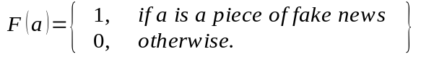 (1)
where F is the prediction function we want to learn [1]. In this thesis, the input f from which we extract the important information we need to classify an article α is the title and text from the ISOT dataset (2.1 ISOT Dataset) and only the text from Gossipcop (2.2.1 Gossipcop Dataset) and Politifact datasets (2.2.3 Politifact Dataset).

Importance of Problem/Challenges
Social media are becoming more and more popular for news consumption and the amount of people’s time spent on social media platforms is increasing day by day due to their fast and easy access. This convenience, though is opposed by the exposure to a large “pool” of fake news that is constantly propagating. Therefore, the process of identifying and debunking fabricated piece of information is crucial not only on individual level but also has a significant social and political impact.
However, the process of developing a fake news detection system faces challenging obstacles. First, the way that fake news are constructed aims to deceive people into believing false information and, thus, shape public opinion in favor or against specific directions, depending on the social and political situation that applies. Therefore, except news content, secondary features, such as user engagements in social media, should be taken into consideration to help the identification.
Secondly, one major challenge that needs to be addressed is the scarcity of well-structured and complete datasets. Social media data is multi-modal, mostly user-generated and noisy [3]. Moreover, as happens to other Machine Learning fields of study, it is highly challenging to find a dataset that can be objective and at a certain point representative of the different classes that need to be taken into account. Some of these difficulties came up during the implementation of this thesis and will be described on Section 2 (Datasets).

Related Work
Different approaches have been emerging recently concerning how to address the problem of the wide spread of fake news and lead to as accurate as possible detection of false information.
Niall J. Conroy et al. [5] propose linguistic cue and network analysis approaches to support the development of fake news detection systems. Linguistic approach consists of finding correlations between language patterns and deception during analysis of the deceptive news content. “Bag of words” or n-grams are simple data representation methods to measure word or term frequencies and reveal patterns of deception. However, these methods may separate words from useful surrounding information leading to misunderstanding of content. In order to tackle the disadvantage of word analysis, deep syntax methods, such as Probability Context Free Grammars (PCFG), are used for deception detection.
Classifiers, such as Support Vector Machines (SVM) and Naive Bayes, trained with the results of the linguistic and sentiment analysis are promising but it may be difficult to generalize because of the real-time nature of news. Network analysis makes use of knowledge networks to build fact-checking methods. It is based on querying publicly available structured networks and analyzing social media behavior. Both the two approaches have set the ground for accurate detection of fake content but combined in a hybrid model may bring better results.
This thesis is based on a similar project described on paper Detection of Online Fake News Using N-Gram Analysis and Machine Learning Techniques, in which n-gram features and machine learning techniques are utilized to perform text analysis aiming to detect fake news [4]. Different methods of features extraction and six different classifiers are proposed and compared during an experimental evaluation conducted on a ISOT dataset (2.1 ISOT Fake News Dataset), which is also used in my project. The common ground between this project and my work is the machine learning techniques on data collected from different sources with the initial ambition to build classification models that lead to universal encouraging results among this data.

Objective
The objective of this thesis is to to compare five different machine learning classifiers as well as to develop an ensemble method of different combinations of classification models to investigate which gives best universal results for all three data sources. My work also aims to collect and construct well-balanced and as representative as possible datasets (2.2.1 Gossipcop Dataset, 2.2.3 Politifact Dataset).
The project is implemented on Python 3.6.9 accompanied with various python libraries. For the web crawling part that took place, BeautifulSoup (Python library for pulling data out of HTML and XML files) was used. During the preprocessing of the datasets, re, string and gensim libraries are utilized. As far as algorithms are concerned, sklearn (machine learning library for python) is mainly used. As for the data visualization stage, wordcloud (python library for generating wordclouds), matplotlib (plotting library for Python), scikitplot (visualization library or “the result of an unartistic data scientist’s dreadful realization that visualization is one of the most crucial components in the data science process, not just a mere afterthought.” [6]) and seaborn (Python data visualization library based on matplotlib) were used to construct different plots, tables and diagrams.

DATASETS
When structuring a Machine Learning project, it is of crucial importance to work with datasets that are well-structured and as representative as possible so as to deliver an objective intuition of the different data classes that they represent. This section summarizes the content of the datasets that were used, the collection process and presents interesting data visualizations to provide a first look on the data. (Note: Fake articles are labeled as 1, true articles as 0)

ISOT Fake News Dataset

Description
The ISOT (Information Security and Object Technology) Fake News Dataset is a compilation of several thousands (44898, true: 48%, fake: 52%) fake news and truthful articles, obtained from different verified news sites and sites indicated to be untrustworthy by Politifact and Wikipedia. The truthful articles were collected by crawling articles from Reuters. The articles refer to different topics, but most of them emphasize on political and World news topics and are divided into 2 sets, train (70%) and test set (30%).

Data Visualization
- Word clouds
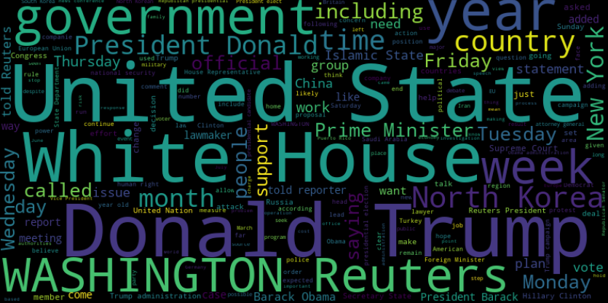Figure 1: Word cloud representing most used terms in true articles (ISOT).
Word clouds were generated for both true and fake news articles. It is noticeable that in fake articles (Figure 2) the frequency is equally balanced among many of the words ( except for terms “Donald Trump” ) whereas in true articles (Figure 1) there are terms that stand out from the others ( “United State”, “White House”, “Donald Trump”, “WASHINGTON Reuters” ,”government”).
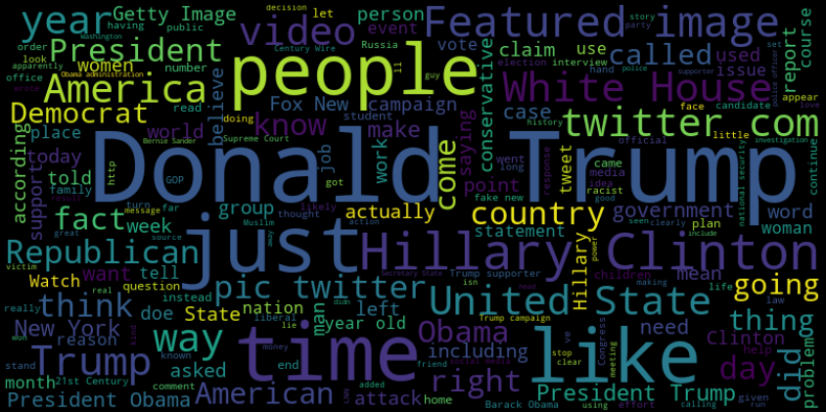Figure 2: Word cloud representing most used terms in fake articles (ISOT).
- Histograms
Histograms were used to point out the linguistic features (text_length, word_count) and sentiment dimension of the article text of ISOT dataset.
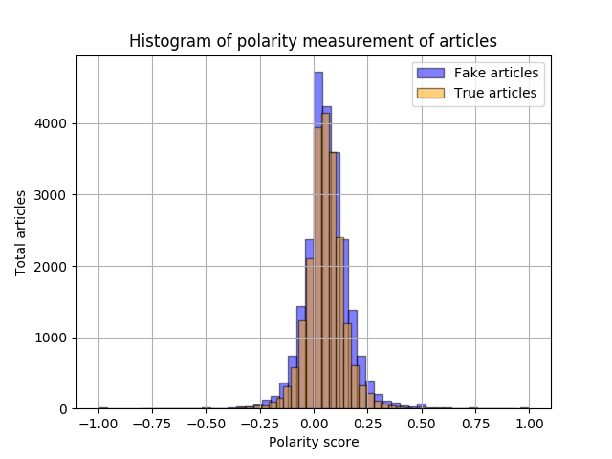Figure 3: Sentiment (polarity score) in both fake and true articles (ISOT).
The sentiment histogram (Figure 3) shows that both true and fake articles are equally distributed around 0 which means that the corpus of the specific dataset consists of neutral sentiment texts.
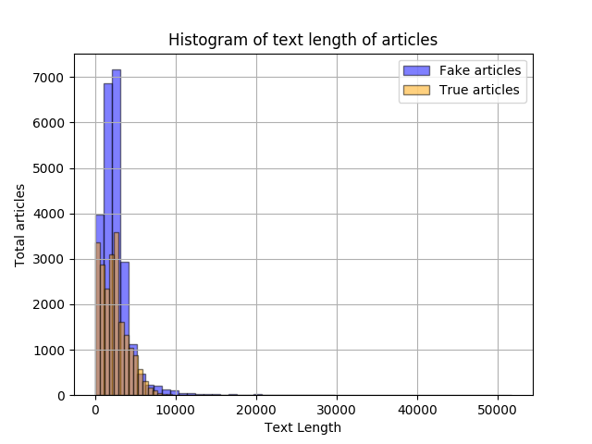Figure 4: Text length in both fake and true articles (ISOT).

Figure 5: Word count in both fake and true articles (ISOT).
Both texts of true and fake articles range between ~10-1000 total text length (Figure 4). As far as the amount of words used (Figure 5), true articles use up to 1000 words, whereas fake texts consists mostly of around 500-600 reaching max of 2000 words in some articles.
- Barplots
Figure 6: Occurrence difference of most used words in fake and true articles (ISOT)
By summing up the frequency of the common terms in both types of articles and computing the differences, it seems to be helpful to understand which common words could make a difference in classifying an article as truthful or fake. For example, the word “trump” is dominant in both categories, as shown in Figure 1 and Figure 2, but its occurrence in fake articles is more than 15000 more frequent than in true articles.

Fake News Net Dataset
Fake News Net Github repository provides python code for web crawling urls of several political and gossip websites. Because of the privacy and cookies policy of the most websites, the python script fails to obtain the text of the article and “stucks” on the “Accept cookies…” message. I attempted to write a new python script (scraper.py), using the urls provided from the repository, that surpasses this obstacle in many cases but manual handling and cleaning of the dataset was a time-consuming task but crucial for both Gossipcop and Politifact dataset.

Gossipcop Dataset
Regarding Gossipcop dataset, #articles: 18044, true articles: 77%, fake articles: 23%, divided also into 3 sets, train and test set.

Gossipcop Data Visualization
- Word Clouds
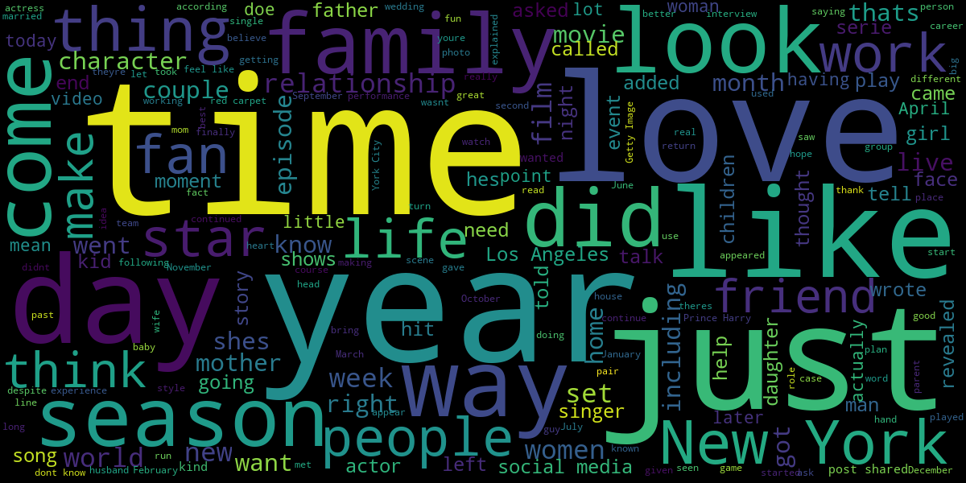Figure 7: Word cloud representing most used terms in true articles (Gossipcop).
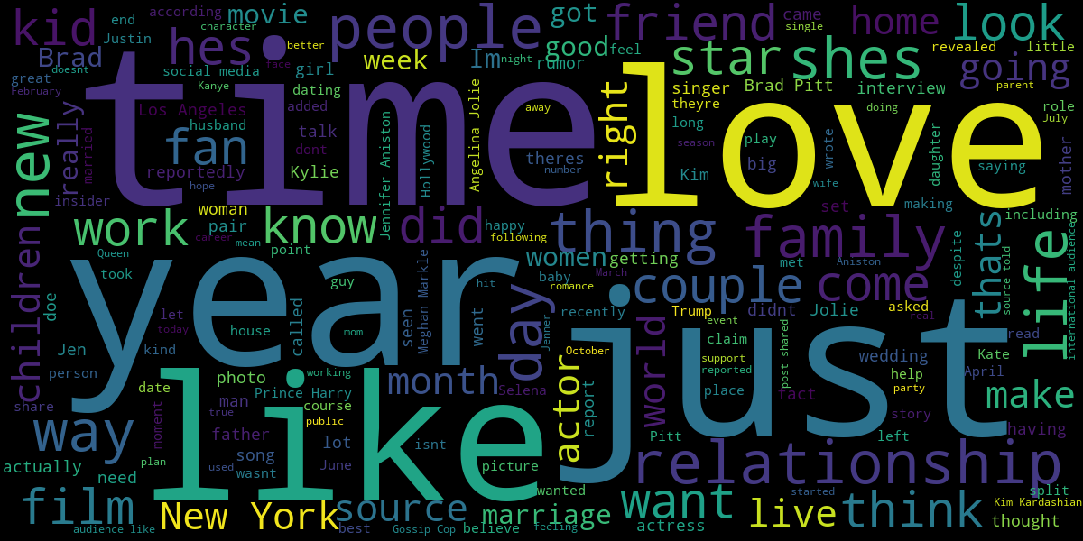Figure 8: Word cloud representing most used terms in fake articles (Gossipcop).
The word clouds indicate that true and fake texts use almost the same words more frequently, but there are differences in less frequent terms.
- Histograms
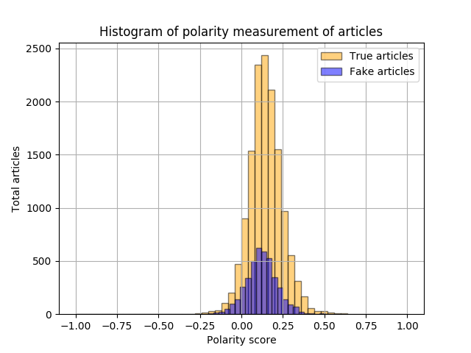Figure 9: Sentiment (polarity score) in both fake and true articles (Gossipcop).
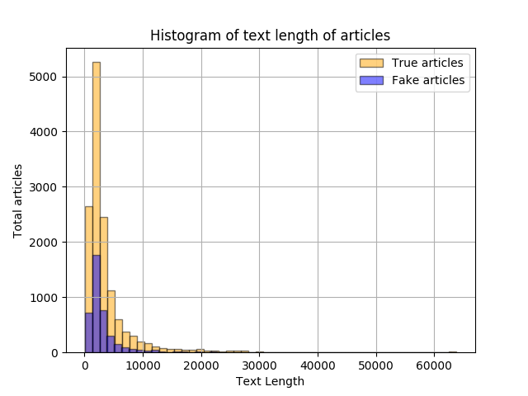Figure 10: Text length in both fake and true articles (Gossipcop).
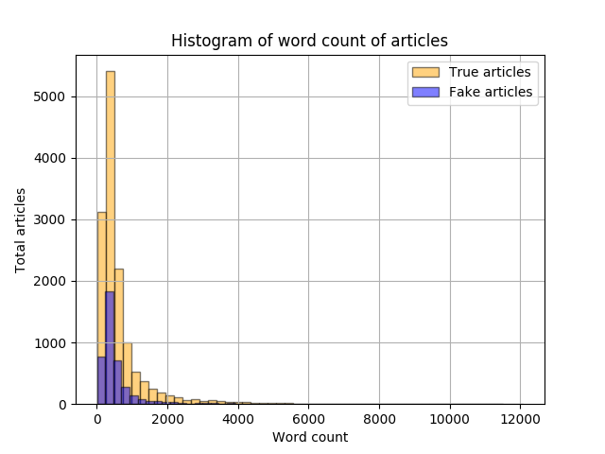Figure 11: Word count in both fake and true articles (Gossipcop).
The general sentiment that texts emit is neutral to positive in both classes (Figure 9). As for the linguistic features, fake articles are around 400-600 length and 500-1000 words on average. True content fluctuates between the same numbers, but there also articles that reach 20000 text length and others that use more than 2000 words to elaborate.
- Barplots
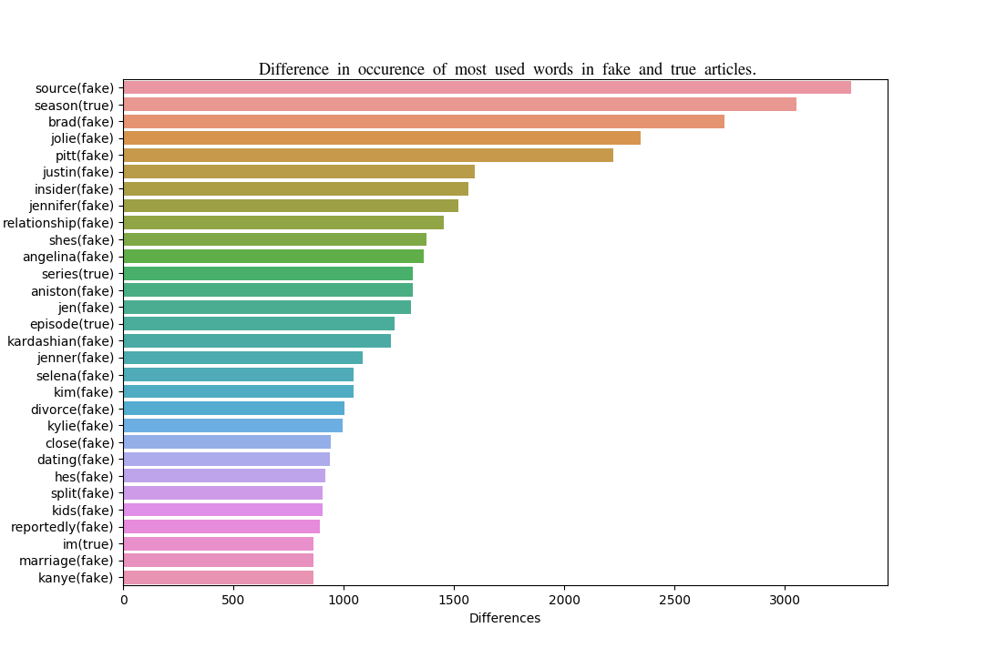Figure 12: Occurrence difference of most used words in fake and true articles (Gossipcop)
It seems to be more helpful to understand from the occurrence difference barplot (Figure 12) than from word clouds (Figure 7, 8) which common words could make a difference in classifying an article as truthful or fake, as it eliminates the words that prevail in both texts.

Politifact Dataset
After the cleanup, regarding Politifact dataset, #articles: 699 , true artilces: 53% , fake articles: 47%, divided into 2 sets, train and test set.

Politifact Data Visualization
- Wordclouds
Figure 13: Word cloud representing most used terms in true articles (Politifact).
True terms word cloud (Figure 13) consist of neutral and abstract words mainly, whereas fake terms word cloud (Figure 14) comprises names and terms that refer to political topics.
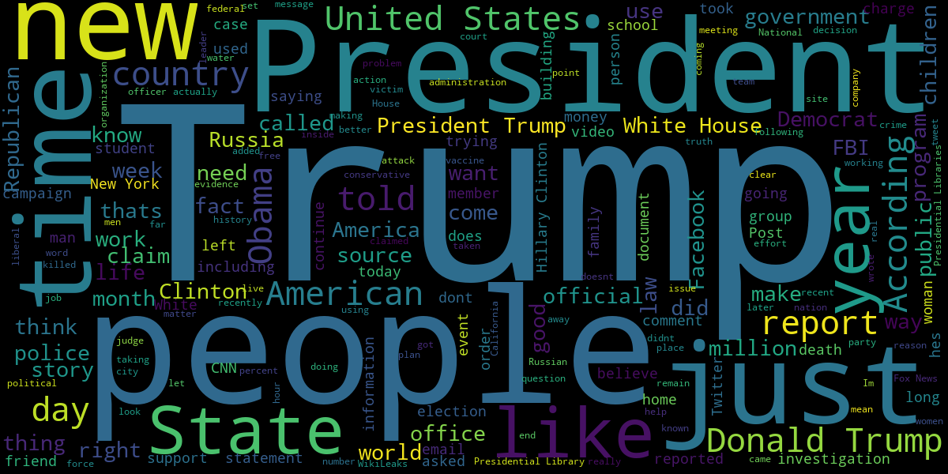Figure 14: Word cloud representing most used terms in fake articles (Politifact).

- Histograms
Figure 15: Sentiment (polarity score) in both fake and true articles (Politifact).
The words used fake articles emit a neutral general sentiment, whereas true content tend to a more positive angle, but with not a difference that stands out.
Figure 16: Text length in both fake and true articles (Politifact).
The corpus of fake texts is, compared to truthful content, shorter and fewer terms are used. True articles consists of various word count and text length content ranging from 1000-60000 characters (Figure 16) and from 100-11500 words (Figure 17) .
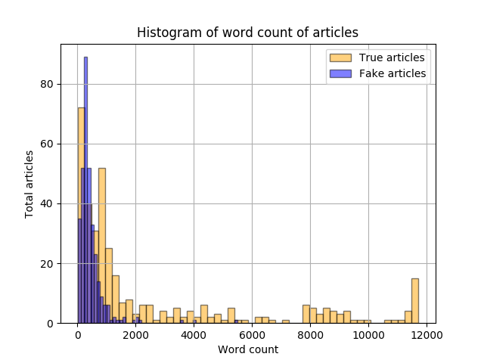Figure 17: Word count in both fake and true articles (Politifact).

- Barplots
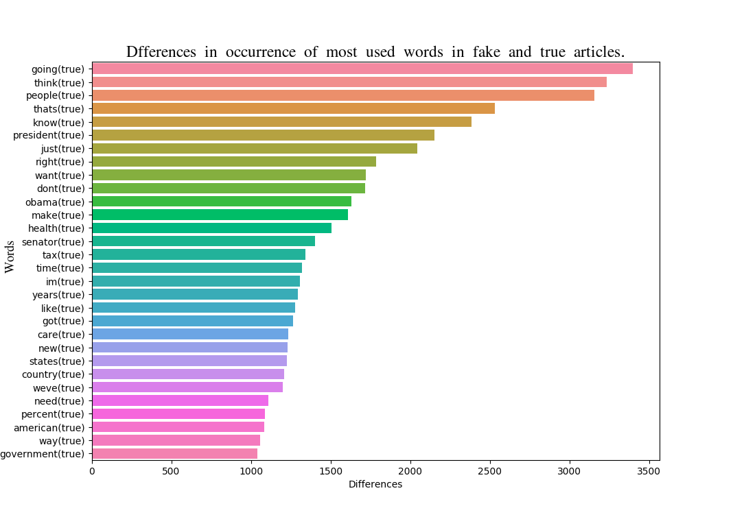Figure 18: Occurrence difference of most used words in fake and true articles (Politifact).
The fact that was pointed out before, that the truthful articles are larger and richer in words, is also depicted in the occurrence difference barplot (Figure 18), as it comprises common words that are found more frequent in true content.

Data Preprocessing
In Machine Learning filed, after the collection of the data, it is of utmost importance that the data will be prepared and brought to a form that is easily interpreted and analyzed by machines.

Tokenization and cleaning
Tokenization is the process of demarcating and possibly classifying sections of a string of input characters [7]. It is a necessary step, as the process of converting a document into a vector, so it can be valid input for machine learning model, goes through extracting tokens from sequential strings. Equally important is the cleaning of these tokens. It is highly possible that the data, except of useful information, also, consist of a lot of “noise”. In the aforementioned datasets, symbols like emojis were manually cleaned and symbol punctuation as well as non-alphanumeric characters were eliminated using a Python script by utilizing re, string libraries.

Stemming
In linguistic morphology and information retrieval, stemming is the process of reducing inflected (or sometimes derived) words to their word stem, base or root form—generally a written word form [8]. For example, the words “detection”, “detected”, “detects” and “detector” will reduce to “detect”. Therefore, the stemming process is important step in NLP as it reduces the volume of text data reserving the essence of the original terms. For this project, the stemming algorithm that is used is Porter Stemmer, gensim library for topic modelling, which is found to be more efficient and with smaller error ratio than other stemming algorithms.

Features Extraction
Features extraction techniques need to be implemented when dealing with large amount of data, as most of it can be redundant and irrelevant causing computations to be time-consuming and bring misleading classification results.

TF-IDF
Stop Word Removal

Singular Value Decomposition

ALGORITHMS/CLASSIFIERS

Support Vector Machines

K-Nearest Neighbors

Logistic Regression

Decision Trees

Random Forest

Ensemble Classifier

EXPERIMENTS

Tuning Classifiers

Results for each Dataset

Results on ISOT Fake News Dataset

Results on Gossipcop Dataset

Results on Politifact Dataset

Results of Ensemble Classifier

Ensemble Classifier on ISOT Fake News Dataset

Ensemble Classifier on Gossipcop Dataset

Ensemble Classifier on Politifact Dataset

Mixing Classifiers and Datasets

Evaluating Gossipcop Dataset using Politifact Models

Evaluating Politifact Dataset using Gossipcop Models

CONCLUSION

Discussion on Results

Future Work

TABLE OF TERMINOLOGY
Ξενόγλωσσος όρος | Ελληνικός Όρος
Reliability | Αξιοπιστία
Editor | Επιμελητής
Recommendations | Υποδείξεις

ABBREVIATIONS - ACRONYMS
ISOT | Information Security and Object Technology
ML | Machine Learning
NLP | Natural Language Processing
PCFG | Probability Context Free Grammars
SVM | Support Vector Machine
SVD | Singular Value Decomposition
TF-IDF | Term Frequency-Inverted Document Frequency

ANNEX Ι

ANNEX ΙΙ

REFERENCES
- Kai Shu, Amy Sliva, Suhang Wang, Jiliang Tang, and Huan Liu. Fake news detection on social media: A data mining perspective. ACM SIGKDD Explorations Newsletter, 2017
- Victoria L. Rubin, Chen, Y. & Conroy N. J. Deception detection for news: three types of fakes. Proceedings of the 78th ASIS&T Annual Meeting: Information Science with Impact: Research in and for the Community, 2015. American Society for Information Science, 83.
- Shu, K., Bernard, H.R., & Liu, H. (2019). Studying Fake News via Network Analysis: Detection and Mitigation. ArXiv, abs/1804.10233.
- Ahmed, Hadeer & Traore, Issa & Saad, Sherif. (2017). Detection of Online Fake News Using N-Gram Analysis and Machine Learning Techniques. 127-138. 10.1007/978-3-319-69155-8_9.
- Conroy, N.J., Rubin, V.L., Chen, Y.: Automatic deception detection: methods for finding fake news. In: Proceedings of the Association for Information Science and Technology (2015)
- “Scikit-plot Documentation.” [Online]. Available: https://scikit-plot.readthedocs.io/en/stable/.
- “Tokenization” [Online]. Available: https://en.wikipedia.org/wiki/Lexical_analysis#Tokenization.
- “Stemming” [Online]. Available: https://en.wikipedia.org/wiki/Stemming.

- W.M. Newman and R.F. Sproull, Principles of Interactive Computer Graphics, McGraw-Hill, 1979, p. 402.
- M.A., Arbib, ed., The Handbook of Brain Theory and Neural Networks, MIT Press,1998.
- M. Weiser, “Program Slicing”, Proc. 14th Int'l Conf. Data Eng. (ICDE 98), IEEE CS Press, 1998, pp. 439-449.
- Y. Yao et al., “Web Intelligence (WI): Research Challenges and Trends in the New Information Age”, Web Intelligence: Research and Development, LNAI 2198, N. Zhong et al., eds., Springer-Verlag, 2001, pp. 1-17.
- R. Focardi and R. Gorrieri, eds., Foundations of Security Analysis and Design, LNCS 2171, Springer-Verlag, 2001.
- B. Fagin, “A Parallel Execution Model for Prolog”, doctoral dissertation, Dept. Computer Sciences, Univ. California, Berkeley, 1987.
- Ν. Πλατής, «Τεχνικές πολλαπλών αναλύσεων στην απλοποίηση τριγωνικών και τετραεδρικών πλεγμάτων», Διδακτορική Διατριβή, Τμήμα Πληροφορικής & Τηλεπικοινωνιών, Εθνικό και Καποδιστριακό Πανεπιστήμιο Αθηνών, 2005.
- M. Nichols, “The Graphical Kernel System in Prolog”, master's thesis, Dept. Computer Science and Eng., Rensselaer Polytechnic Inst., 1985.
- Β. Πρεμέτη, «Ασφάλεια στην ηλεκτρονική διακυβέρνηση μεθοδολογία και διεθνής εμπειρία», Διπλωματική Εργασία, Τμήμα Πληροφορικής & Τηλεπικοινωνιών, Εθνικό και Καποδιστριακό Πανεπιστήμιο Αθηνών, 2003.
- F. Kaplan, “From Baghdad to Manila: Another Lousy Analogy for the Occupation of Iraq”, Slate, 21 Oct. 2003; http://slate.msn.com/id/2090114/. [Προσπελάστηκε 15/1/08]
- R. Bartle, “Early MUD History» Nov. 1990; www.ludd.luth.se/mud/aber/mud-history.html [Προσπελάστηκε 15/1/08]
- Recommendation ITU-R BT.601, Encoding Parameters of Digital Television for Studios, Int'l Telecommunications Union, 1992.
- IEEE Std. 1596-1992, Scalable Coherent Interface (SCI), IEEE, 1992.
- MPEG-21 Overview, ISO/MPEG N5231, MPEG Requirements Group, Oct. 2002.
- N. Mitra, SOAP v.1.2, Part 0: Primer, World Wide Web Consortium (W3C) recommendation, June 2003; http://www.w3.org/TR/soap12-part0/ [Προσπελάστηκε 15/1/08]
- D. Box et al., Simple Object Access Protocol (SOAP) 1.1 World Wide Web Consortium (W3C) note, May 2000; http://www.w3.org/TR/SOAP/. [Προσπελάστηκε 15/1/08]
- Unix System V Interface Definition, no. 2, vol. 2, AT&T, Murray Hill, N.J., 1986.

https://docs.python.org/3/library/re.html
https://docs.python.org/3/library/string.html
https://radimrehurek.com/gensim/parsing/porter.html

