Comprehensive Data Science Project Report
Breast Cancer Diagnostic Classification Using Supervised Machine Learning
Week 5: Comprehensive Reporting and Strategic Recommendations

1. Executive Summary
This report consolidates the machine learning work completed during the preceding project phase into an end-to-end data science study. The project addresses a binary classification problem using the Breast Cancer Wisconsin (Diagnostic) dataset available through scikit-learn. The objective is to classify tumor samples as malignant or benign using 30 quantitative features derived from digitized fine needle aspirate (FNA) images. The dataset contains 569 samples, including 357 benign and 212 malignant observations, with no missing values or duplicate rows.
The analytical workflow included exploratory data analysis, stratified train-test splitting, feature scaling, supervised model development, cross-validation, and multi-metric evaluation. Logistic Regression and a depth-4 Decision Tree were selected because they provide complementary approaches: Logistic Regression offers a strong interpretable linear baseline, while the Decision Tree provides rule-based, non-linear decision-making.
Logistic Regression was the stronger model, reaching approximately 98.2% test accuracy, 98.6% precision, 98.6% recall, 98.6% F1-score, and 0.995 ROC-AUC. The Decision Tree achieved approximately 93.9% accuracy and a 0.934 ROC-AUC. The Logistic Regression confusion matrix contained only two errors in the 114-sample test set, including one malignant case classified as benign. The results support selecting Logistic Regression as the preferred benchmark model for this dataset, while emphasizing that the model is a research/educational artifact and not a clinical diagnostic system.

2. Introduction and Project Objective
The purpose of the project is to demonstrate how a complete data science workflow can convert structured medical-image-derived measurements into an evidence-based classification model. The central research question is: Can supervised machine learning accurately distinguish malignant from benign breast tumor samples using the available numerical measurements?
The project also emphasizes responsible evaluation. In a diagnostic-support context, false negatives are more concerning than false positives because a malignant tumor incorrectly predicted as benign could delay further investigation. Therefore, the analysis considers recall, precision, F1-score, ROC-AUC, and confusion matrices rather than relying on accuracy alone.

3. Methodology

3.1 Dataset and Data Preparation
The Breast Cancer Wisconsin (Diagnostic) dataset contains 569 observations and 30 numerical predictors. The target is encoded as 0 for malignant and 1 for benign. The dataset is moderately imbalanced, with benign samples representing about 62.7% and malignant samples about 37.3%.

3.2 Exploratory Data Analysis
Exploratory analysis examined class distribution and correlations among the mean-value features. The correlation analysis highlights strong relationships among geometrically related measurements such as radius, perimeter, and area. This is important when interpreting Logistic Regression coefficients because correlated variables can make individual coefficient values less stable.
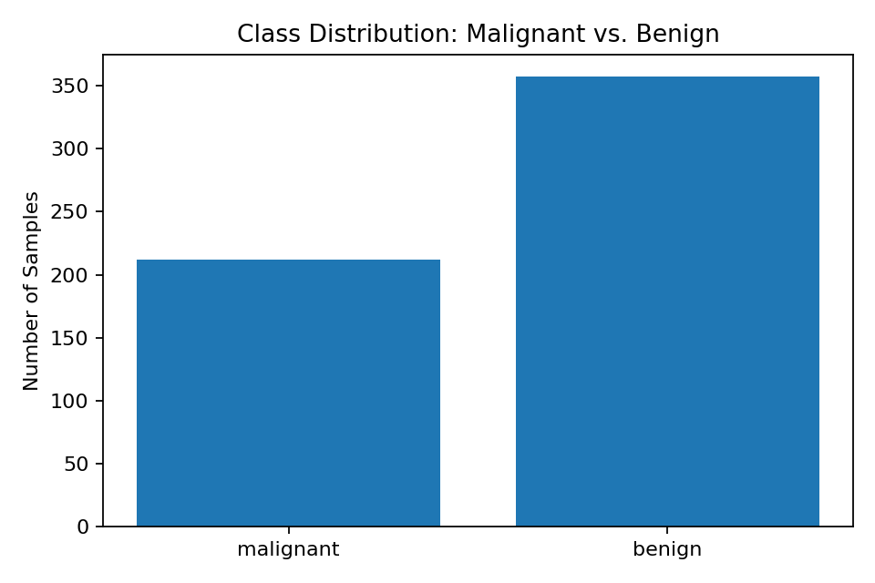
Figure 1. Distribution of malignant and benign samples.
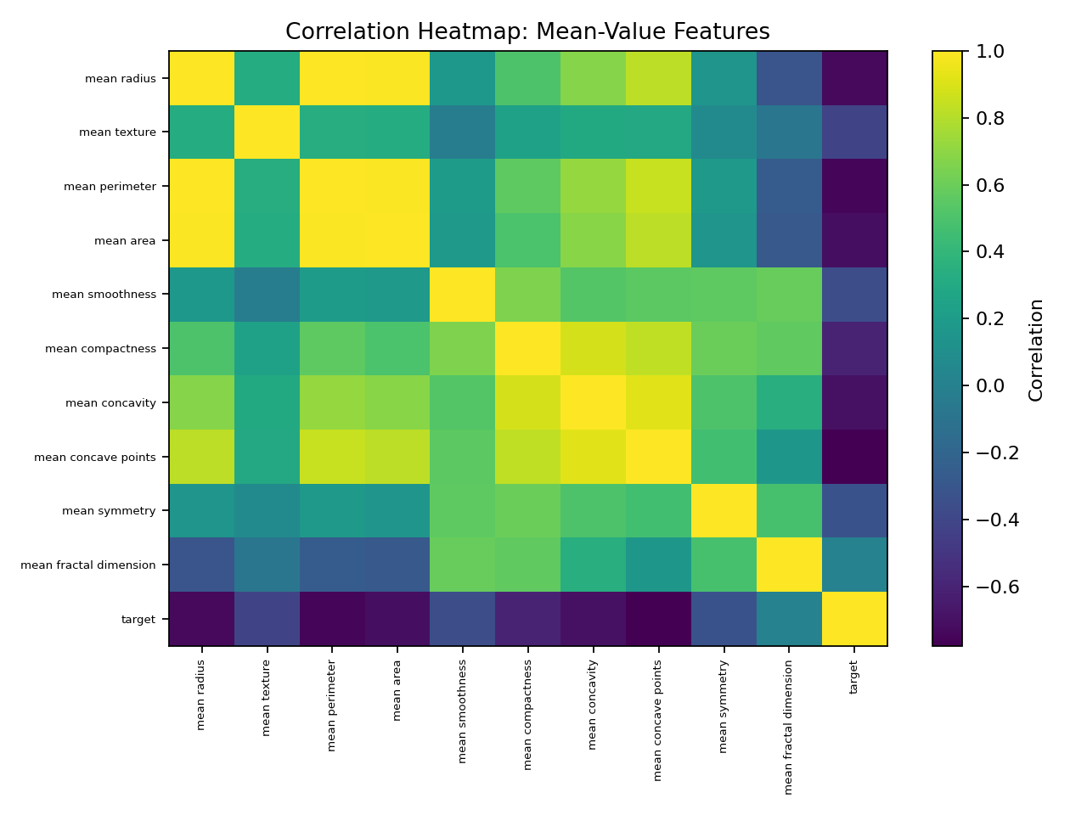
Figure 2. Correlation structure of mean-value features.

3.3 Preprocessing
The features and target were separated, followed by an 80/20 stratified train-test split. StandardScaler was fit only on the training data and then applied to the test data, preventing information leakage. Logistic Regression used the scaled features, while the Decision Tree used the original features because tree-based splits do not require standardization.
X_train, X_test, y_train, y_test = train_test_split(
X, y, test_size=0.20, random_state=42, stratify=y
)
scaler = StandardScaler()
X_train_scaled = scaler.fit_transform(X_train)
X_test_scaled = scaler.transform(X_test)

3.4 Model Development
Two supervised classification algorithms were trained. Logistic Regression was selected as the primary baseline because it is interpretable and well suited to binary classification. A Decision Tree with max_depth=4 was used as a comparison model to provide a non-linear, rule-based alternative while limiting excessive complexity.
log_reg = LogisticRegression(max_iter=5000, random_state=42)
log_reg.fit(X_train_scaled, y_train)
tree = DecisionTreeClassifier(max_depth=4, random_state=42)
tree.fit(X_train, y_train)

4. Detailed Results and Analysis
Both models were evaluated on the held-out test set using accuracy, precision, recall, F1-score, ROC-AUC, and 5-fold cross-validation accuracy. The results show a clear performance advantage for Logistic Regression.
Model | Accuracy | Precision | Recall | F1 | ROC-AUC | 5-Fold CV
Logistic Regression | 0.982 | 0.986 | 0.986 | 0.986 | 0.995 | 0.980
Decision Tree | 0.939 | 0.958 | 0.944 | 0.951 | 0.934 | 0.938
The Logistic Regression model achieved 98.2% accuracy and a ROC-AUC of 0.995, compared with 93.9% accuracy and 0.934 ROC-AUC for the Decision Tree. The higher recall and F1-score of Logistic Regression are particularly important because they indicate stronger overall classification performance while reducing the number of malignant cases incorrectly labeled as benign.
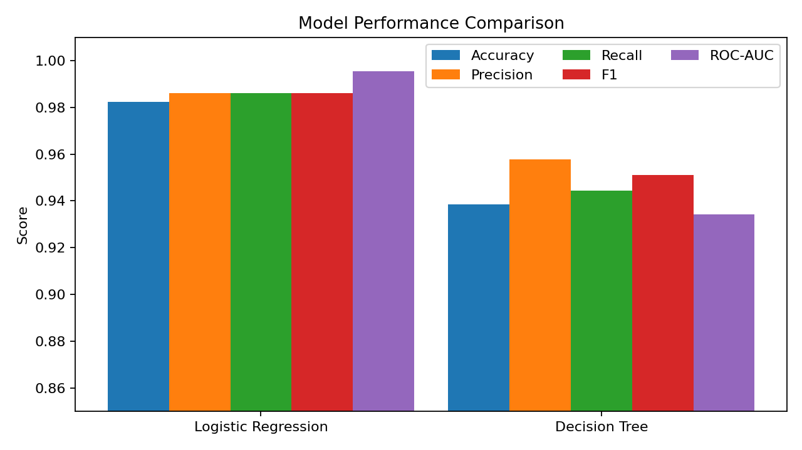
Figure 3. Comparative performance of the two classification models.
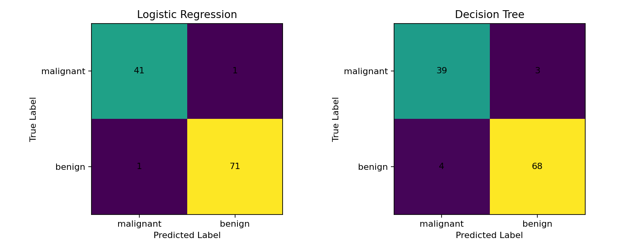
Figure 4. Confusion matrices for Logistic Regression and Decision Tree.
On the 114-sample test set, Logistic Regression produced only two misclassifications: one malignant sample classified as benign and one benign sample classified as malignant. The Decision Tree produced seven errors, including four malignant cases predicted as benign. This difference is strategically significant because the false-negative error is the more consequential error in this problem setting.
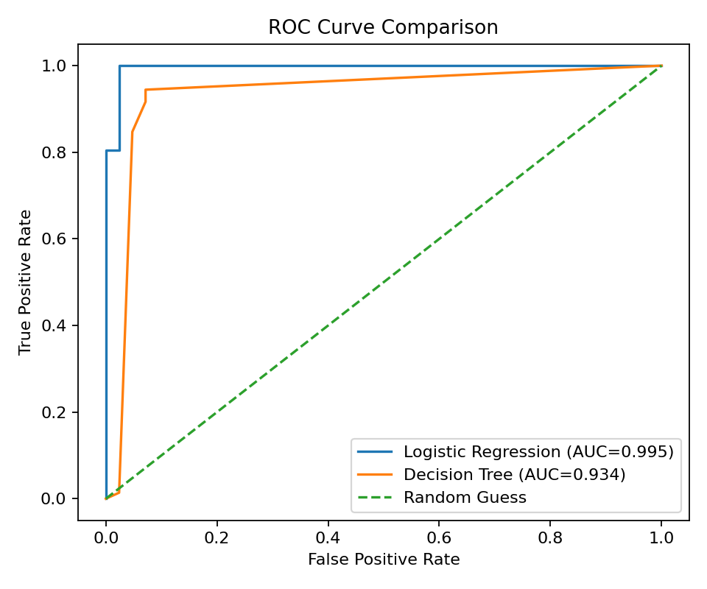
Figure 5. ROC curve comparison showing overall discriminative performance.

5. Strategic Analysis and Recommendations
The findings provide several actionable recommendations for a stakeholder considering this project as a research or decision-support prototype:
Adopt Logistic Regression as the benchmark model: Its higher accuracy, recall, F1-score and ROC-AUC make it the strongest of the two tested approaches and its coefficients provide useful interpretability.
Prioritize false-negative reduction: For diagnostic-support research, threshold tuning should be investigated so that malignant cases are less likely to be missed, even if this increases some false positives.
Use ensemble models for further experimentation: Random Forest or Gradient Boosting should be evaluated as non-linear alternatives that may reduce the variance associated with a single Decision Tree.
Perform systematic hyperparameter tuning: GridSearchCV or similar procedures should be used to optimize Logistic Regression regularization and Decision Tree parameters instead of relying only on fixed settings.
Validate externally before real-world use: The model should be tested on independent datasets from different populations, imaging systems and acquisition procedures before any clinical-adjacent application.
Improve data diversity and scale: A larger and more demographically diverse dataset would improve confidence in generalization and allow analysis of performance across relevant subgroups.

6. Potential Business Impact / Research Outcomes
Although this project is not intended for direct clinical deployment, the workflow demonstrates how organizations can use data science to build repeatable classification pipelines from structured diagnostic measurements. A high-performing benchmark can support future research into automated screening assistance, prioritization of cases for human review, and comparative evaluation of more advanced algorithms.
From an operational perspective, a reliable decision-support model could potentially help prioritize attention toward higher-risk observations and provide a consistent analytical second opinion. However, these potential benefits depend on independent validation, appropriate threshold selection, monitoring, data governance, and qualified human oversight.

7. Limitations
- The dataset contains only 569 samples, so individual test-set observations can noticeably affect reported metrics.
- The class distribution is moderately imbalanced, making accuracy alone an insufficient evaluation measure.
- Several features are strongly correlated, which can reduce the stability of individual Logistic Regression coefficients.
- The underlying measurements and labels can contain measurement or labeling noise.
- The dataset originates from a specific historical clinical source, so distributional shift may reduce performance on newer or different populations.
- The current study compares only two relatively simple models and does not establish clinical validity.

8. Future Improvements
- Evaluate Random Forest, Gradient Boosting and other ensemble classifiers.
- Use PCA or L1-regularized Logistic Regression to address multicollinearity and improve feature parsimony.
- Perform systematic hyperparameter optimization and nested cross-validation.
- Tune the classification threshold using the specific cost of false negatives and false positives.
- Add precision-recall curves and calibration analysis to complement ROC-AUC.
- Validate the final model on an independent external dataset.
- Investigate model fairness and subgroup performance before any deployment-oriented study.

9. Conclusion
This comprehensive project demonstrates an end-to-end supervised machine learning workflow, from dataset exploration and leakage-aware preprocessing through model development, evaluation and strategic interpretation. Logistic Regression emerged as the stronger model, achieving approximately 98.2% test accuracy and 0.995 ROC-AUC, while also producing fewer false negatives than the Decision Tree. The results show that careful model selection and evaluation can produce strong performance on this benchmark dataset.
The most important outcome is not simply the high accuracy, but the integration of technical evidence with decision-oriented recommendations. The model should be treated as a research and educational prototype rather than a clinical diagnostic tool. External validation, larger and more diverse datasets, threshold optimization, and stronger models are essential next steps before considering any real-world application.

10. Selected Code Documentation
The following excerpts summarize the key implementation stages used in the project.
# Model evaluation
y_pred = model.predict(X_test_data)
y_proba = model.predict_proba(X_test_data)[:, 1]
accuracy = accuracy_score(y_test, y_pred)
precision = precision_score(y_test, y_pred)
recall = recall_score(y_test, y_pred)
f1 = f1_score(y_test, y_pred)
roc_auc = roc_auc_score(y_test, y_proba)
The complete reusable Python implementation is supplied separately with this report. It reproduces the data preparation, model training, evaluation and visualization workflow.

